**Candidate’s Name: ………………………………………………………… Assessment Number: …………………………………………**

**School Name: ……………………………………………………………………. School Code: …………………………………………………………**

**Candidate’s Signature: ………………………………..…………….Date: …………………………………………………….…………….**

**COMPETENCE BASED EDUCATION**

**KENYA JUNIOR SCHOOL EDUCATION ASSESSMENT**

**703:** **MATHEMATICS**

**JUNE 2025 Time: 2 hours**

**INSTRUCTIONS TO CANDIDATES**

1. Write your details as required in the spaces provided above.
2. This question paper consists of TWO sections: A and B.
3. Answer **ALL** the questions in section A on the separate **ANSWER SHEET** provided.
4. Answer **ALL** the questions in section B in the spaces provided in this **QUESTION PAPER**.
5. Show all the workings in section B in the spaces provided.
6. Non-programmable calculators **should NOT be used** in this examination.
7. Give non-exact numerical answers, correct to 3 significant figures, and one decimal place for angles in degrees, unless a different level of accuracy is specified in the question.
8. For π, use $\frac{22}{7}$ ​where necessary.
9. Do **NOT** remove any page from this question paper.
10. Answer **ALL** the questions in English.

**For official use only**

|  |  |  |  |  |
| --- | --- | --- | --- | --- |
| **Section** | **Task** | **Question Numbers** | **Max. Score** | **Score** |
| B |  |  |  |  |
|  | Task 1 | 21, 22, 23 | 16 |  |
|  | Task 2 | 24, 25 | 14 |  |
|  | Task 3 | 26, 27, 28 | 20 |  |
|  | Task 4 | 29, 30, 31 | 18 |  |
|  | Task 5 | 32, 33 | 12 |  |
|  |  | **Total** |  |  |

This paper consists of 18 printed pages. Candidates should check the question paper to ascertain that all the pages are printed as indicated and that no questions are missing.

© 2025, The Competence Based Assessment **Turn over**

**SECTION A (20 marks)**

**Answer all the questions in this section.**

1. You have been given this question paper and a separate answer sheet. Answer All the questions in Section A on the separate answer sheet provided.
2. When you have chosen your answer, mark it on the **ANSWER SHEET**, not in this question paper.

**HOW TO USE THE ANSWER SHEET**

1. Use an ordinary HB pencil.
2. Confirm that the answer sheet you have been provided with has the following:

**YOUR ASSESSMENT NUMBER** **YOUR NAME**

**NAME OF YOUR SCHOOL** **NAME OF THE SUBJECT**

1. Keep the answer sheet clean, dry and **DO NOT** fold it.
2. For each of the questions 1 – 20, four answers are given. The answers are lettered A, B, C and D. In each case, only **ONE** of the four answers is correct. Choose the correct answer.
3. On the answer sheet, the correct option is to be shown by drawing a dark line inside the box in which the letter you have chosen is written.

Example:

In the Question Booklet:

* 1. What is the place value of the digit 5 in the number 45218? A. Thousands B. Hundreds C. Tens D. Units

The correct answer is A.

On the answer sheet, in the set of boxes given for number 8, draw a dark line inside the box with the letter A printed in it as indicated below.

8.[~~A~~] [B] [C] [D]

1. Your dark line **MUST** be inside the box.
2. For each question, **ONLY ONE** box is to be marked in each set of four boxes.

**SECTION A (20 marks)**

*Answer all the questions in this section.*

1. What is the total value of the digit 6 in the number 3,675,421? A) 6,000 B) 60,000 C) 600,000 D) 6,000,000
2. What is the place value of the digit 4 in the number 12.345? A) Tenths B) Hundredths C) Thousands D) Thousandths
3. What is the product of 35.35 and 18 in two decimal places? A. 63.63 B. 53.50 C. 63.00 D. 64.00
4. Which one of the following numbers is a prime number? A. 1 B. 9 C. 13 D. 15
5. Convert the fraction 83​ to a decimal. A) 0.375 B) 0.38 C) 0.125 D) 0.83
6. Evaluate 5x−3 when x=4. A. 2 B. 17 C. 20 D. 23
7. Solve the equation y+6=14. A. y=8 B. y=9 C. y=20 D. y=−8

**WORKING SPACE**

1. 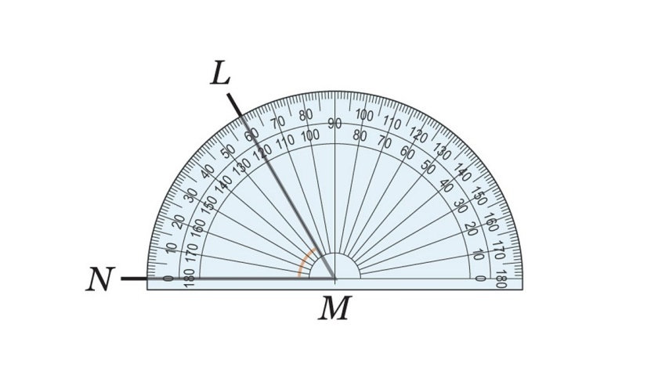Measure the angle below.

What is the measure of the angle **NML**? A. 40∘ B. 60∘ C. 120∘ D. 0∘

1. Which one of the following angles is known as the obtuse angle?∘?

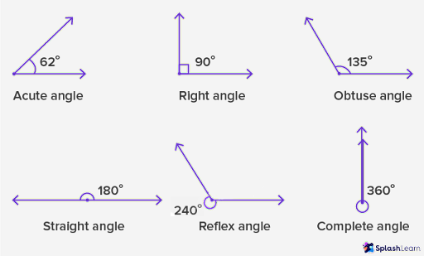

A



B



C



D

**WORKING SPACE**

1. Which one of the following is a composite number? A. 2 B. 7 C. 11 D. 14
2. A shopkeeper bought a jacket for Ksh 2,500. He sold it at a profit of 20%. Later, a customer returned it, and he agreed to sell it to another customer at a 10% discount on the *original selling price*. What was the final selling price of the jacket? A) Ksh 2,000 B) Ksh 2,700 C) Ksh 2,750 D) Ksh 3,000
3. Two buses leave a station at 6:00 am. Bus A returns to the station every 45 minutes, and Bus B returns every 60 minutes. At what time will both buses next be at the station at the same time? A) 7:00 am B) 7:30 am C) 8:00 am D) 9:00 am
4. A rectangular garden has a length that is 5 meters more than its width. If the perimeter of the garden is 50 meters, what is the width of the garden? A) 10 meters B) 15 meters C) 20 meters D) 22.5 meters
5. A tank is ¼ ​ full of water. When 30 litres of water are added, the tank becomes $\frac{2}{3}$ ​ full. What is the total capacity of the tank? A) 36 litres B) 48 litres C) 72 litres D) 120 litres

**WORKING SPACE**

1. A car consumes 0.12 litres of fuel per kilometre. If the car travels a distance of 85.5 kilometres, how much fuel does it consume? A) 1.026 litres B) 10.26 litres C) 102.6 litres D) 1026 litres
2. A square piece of land has an area of 196m2. If a fence is to be placed around the entire piece of land, what is the total length of the fence? A) 14 m B) 28 m C) 56 m D) 98 m
3. If a=3, b=2, and c=−1, what is the value of

2a2−bc? A) 16 B) 18 C) 20 D) 22

1. A learner needs to score at least 50 marks on a test to pass. The learner has already scored 35 marks on the first part of the test. If the second part is out of 60 marks, which inequality shows the possible marks (m) the learner needs on the second part to pass the test? A) m>15 B) m≥15 C) m<15 D) m≤15
2. A class has 30 learners. The teacher wants to arrange them into equal groups for an activity. Which of the following is NOT a possible number of learners in each group? A) 5 B) 6 C) 8 D) 10

**WORKING SPACE**

1. A composite shape made of the following shape

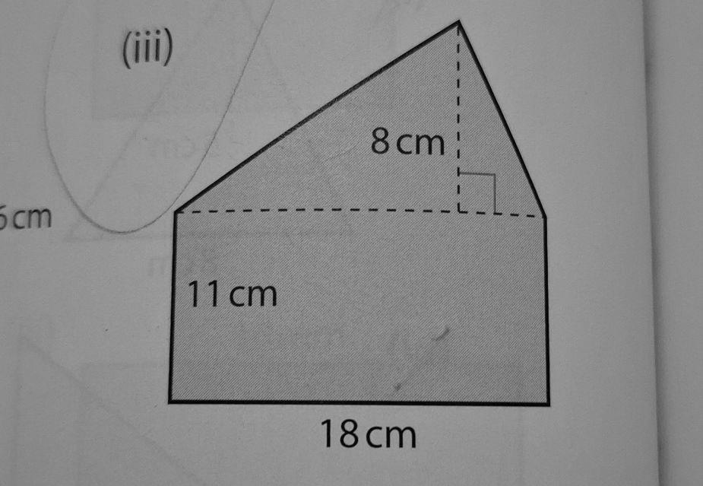

If the shape represents a piece of cardboard, and the cost of the cardboard is Ksh 5 per square centimetre, what is the total cost of this piece of cardboard? A) Ksh 150 B) Ksh 109 C) Ksh 750 D) Ksh 546

**WORKING SPACE**

**SECTION B (80 marks)**

Answer all the questions in the spaces provided. Show all your working.

**Task 1 (16 Marks)**

1. A tailor bought 3 rolls of fabric. One roll was 15.75 metres, the second was 12.5 metres, and the third was 18.25 metres.

(a) Calculate the total length of the fabric bought. **(2 marks)**

(b) If the tailor used 28.5 metres of the fabric, what length of fabric remained? **(2 marks)**

1. A bus travelled $\frac{3}{4}$ ​ of a journey which was 180 km.

(a) What fraction of the journey was remaining? **(1 mark)**

(b) Calculate the total length of the journey in kilometers. **(2 marks)**

(c) Calculate the distance remaining in kilometers. **(2 marks)**

1. In a school of 500 learners, 40% are boys.

(a) Calculate the number of boys in the school. **(2 marks)**

(b) Calculate the number of girls in the school. **(2 marks)**

1. The ratio of the price of a pen to the price of an exercise book is 2:5. If the price of the pen is Ksh 40, calculate the price of the exercise book. **(3 marks)**

**Task 2 (14 Marks)**

1. Simplify the following algebraic expressions:

(a) 7m+4n−3m−n **(2 marks)**

(b) 2(3y+5)+3y **(3 marks)**

1. Solve for the unknown in the following equations:

(a) p+12=25 **(1 mark)**

(b) 4k=36 **(1 mark)**

(c) 5x​=7 **(1 mark)**

(d) 2a−6=10 **(3 marks)**

(e) 5(b+1)=20 **(3 marks)**

**Task 3 (20 Marks)**

1. The floor of a rectangular room is 8.5 metres long and 6 metres wide.

(a) Calculate the perimeter of the floor. **(2 marks)**

(b) Calculate the area of the floor in square metres. **(2 marks)**

* 1. If the floor is to be covered by square tiles of side 50 cm, calculate the number of tiles needed. **(4 marks)**

1. A triangle has a base of 10 cm and a height of 7 cm.

(a) Calculate the area of the triangle. **(2 marks)**

1. A rectangular swimming pool is 20 m long, 10 m wide, and 2 m deep. (a) Calculate the volume of the swimming pool in cubic metres. **(2 marks)**

(b) Calculate the capacity of the swimming pool in litres. **(2 marks)**

1. Convert the following units:

(a) 5000 grams to kilograms. **(1 mark)**

(b) 1.5 kilometres to metres. **(1 mark)**

(c) 180 minutes to hours. **(1 mark)**

**Task 4 (18 Marks)**

1. Use a ruler and a protractor to construct an angle of 75∘ at point A on the line AB below. **(2 marks)**

A B

1. The diagram below shows intersecting lines.

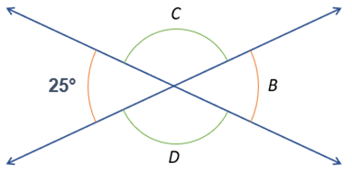

Calculate the size of the angles marked C, B, and D. **(2 marks)**

C = ___________.

B = ___________.

1. Mercy bought 50 kg of mangoes at Ksh 60 per kg. She spent Ksh 300 on transport.

a) Calculate the total cost price of the mangoes, including transport. (2 Marks)

b) If she sold 30 kg of mangoes at Ksh 90 per kg, calculate the income from the sale of these 30 kg. (1 Mark)

c) She sold the remaining mangoes at a 10% discount on the price of the first 30 kg. Calculate the selling price per kg for the remaining mangoes. (1 Mark)

d) Calculate the total income from the sale of all the mangoes. (1 Mark)

e) Calculate the total profit or loss Mercy made from the business. (1 Mark)

1. A bus leaves town P at 7:30 am and travels towards town Q at an average speed of 60 km/h. At the same time, a car leaves town Q and travels towards town P at an average speed of 80 km/h. The distance between town P and town Q is 420 km.

a) Calculate the distance covered by the bus in the first 1 hour. (1 Mark)

b) Calculate the distance covered by the car in the first 1 hour. (1 Mark)

c) What is the combined speed of the bus and the car (relative speed)? (1 Mark)

d) Calculate the time taken, in hours, for the bus and the car to meet. (3 Marks)

e) At what time do the bus and the car meet? (2 Marks)

**Task 5 (12 Marks)**

1. The table below shows the number of different coloured pens in a box.

|  |  |
| --- | --- |
| **Colour** | **Number of Pens** |
| Red | 10 |
| Blue | 15 |
| Green | 5 |
| Black | 10 |

(a) How many pens are in the box altogether? **(1 mark)**

(b) Represent the data using a bar graph on the grid provided below. **(5 marks)**

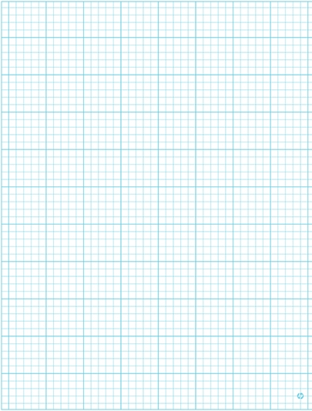

1. A cylindrical water tank has a diameter of 2.8 meters and a height of 2.5 meters. (Use π=722​)

a) Calculate the radius of the tank in meters. (1 Mark)

b) Calculate the base area of the tank in square meters. (1 Mark)

c) Calculate the volume of the tank in cubic meters. (1 Mark)

d) Convert the volume of the tank to litres, given that 1 cubic meter = 1000 litres. (1 Mark)

e) If water is pumped into the tank at a rate of 400 litres per minute, calculate the time taken, in minutes, to fill the tank completely. (2 Marks)

**THIS IS THE LAST PRINTED PAGE.**

ANSWERS

SECTION A (20 marks)

1. C
2. B
3. A
4. C
5. A
6. B
7. A
8. C
9. D
10. D
11. B
12. D
13. A
14. C
15. B
16. C
17. B
18. B
19. C
20. A

SECTION B (80 marks)

Task 1 (16 Marks)

1. (a) Total length = 15.75 m + 12.5 m + 18.25 m = 46.50 m (2 marks) (b) Remaining length = 46.50 m - 28.5 m = 18.0 m (2 marks)
2. (a) Remaining fraction $= 1 – ¾ =\frac{4}{4}– ¾ =\frac{1}{4}$ (1 mark)

(b) Total length = 180 km (Given) (2 marks) (c) Remaining distance = $\left(\frac{1}{4}\right)X 180 km$ = 45 km (2 marks)

1. (a) Number of boys = 40/100 X 500 = 200 boys (2 marks) (b) Number of girls = 500 - 200 = 300 girls (2 marks)
2. Price of exercise book $= \left(\frac{5}{2}\right)X Ksh 40 = Ksh 100$ (3 marks)

Task 2 (14 Marks)

1. (a) 7m + 4n - 3m - n = (7m - 3m) + (4n - n) = 4m + 3n (2 marks) (b) 2(3y + 5) + 3y = 6y + 10 + 3y = 9y + 10 (3 marks)
2. (a) p + 12 = 25 => p = 25 - 12 = 13 (1 mark)

(b) 4k = 36 => k = 36 / 4 = 9 (1 mark)

(c) x/5 = 7 => x = 7 X 5 = 35 (1 mark)

(d) $2a - 6 = 10 => 2a = 10 + 6 => 2a = 16 => a = 16 / 2 =$ 8 (3 marks)

(e) 5(b + 1) = 20 => b + 1 = 20 / 5 => b + 1 = 4 => b = 4 - 1 = 3 (3 marks)

Task 3 (20 Marks)

1. (a) Perimeter = 2(length + width) = 2(8.5 m + 6 m) = 2(14.5 m) = 29 m (2 marks) (b) Area = length X width = 8.5 m X 6 m = 51 m² (2 marks) (c) Area of one tile = 50 cm X 50 cm = 2500 cm² = 0.25 m² Number of tiles = Area of floor / Area of one tile = 51 m² / 0.25 m² = 204 tiles (4 marks)
2. (a) Area of triangle = 1/2 X base X height = 1/2 X 10 cm X 7 cm = 35 cm² (2 marks)
3. (a) Volume = length X width X depth = 20 m X 10 m X 2 m = 400 m³ (2 marks) (b) Capacity = Volume X 1000 litres/m³ = 400 m³ X 1000 litres/m³ = 400,000 litres (2 marks)
4. (a) 5000 grams = 5000 / 1000 kg = 5 kg (1 mark) (b) 1.5 kilometres = 1.5 X 1000 metres = 1500 metres (1 mark) (c) 180 minutes = 180 / 60 hours = 3 hours (1 mark)

Task 4 (18 Marks)

1. (Construction of a 75° angle at point A using a ruler and protractor. (2 marks))
2. C = 180° - 110° = 70° (Angles on a straight line) B = 110° (Vertically opposite to the given 110° angle) D = 180° - 110° = 70° (Angles on a straight line) C = 70°, B = 110°, D = 70° (2 marks)
3. a) Total cost price = (50 kg X Ksh 60/kg) + Ksh 300 = Ksh 3000 + Ksh 300 = Ksh 3300 (2 Marks) b) Income from 30 kg = 30 kg X Ksh 90/kg = Ksh 2700 (1 Mark) c) Discount = 10/100 X Ksh 90 = Ksh 9 Selling price per kg for remaining mangoes = Ksh 90 - Ksh 9 = Ksh 81 (1 Mark) d) Remaining mangoes = 50 kg - 30 kg = 20 kg Income from remaining mangoes = 20 kg X Ksh 81/kg = Ksh 1620 Total income = Ksh 2700 + Ksh 1620 = Ksh 4320 (1 Mark) e) Total profit = Total income - Total cost price = Ksh 4320 - Ksh 3300 = Ksh 1020 (1 Mark)
4. a) Distance by bus in 1 hour = 60 km/h X 1 h = 60 km (1 Mark) b) Distance by car in 1 hour = 80 km/h X 1 h = 80 km (1 Mark) c) Combined speed = 60 km/h + 80 km/h = 140 km/h (1 Mark) d) Time to meet = $Total distance/ Combined speed$ = 420 km / 140 km/h = 3 hours (3 Marks) e) Time they meet = 7:30 am + 3 hours = 10:30 am (2 Marks)

Task 5 (12 Marks)

1. (a) Total number of pens = 10 + 15 + 5 + 10 = 40 pens (1 mark) (b) Bar graph representing the data: - X-axis: Colour (Red, Blue, Green, Black) - Y-axis: Number of Pens (scale from 0 to 15 or 20) - Bars with heights corresponding to the number of pens for each colour.

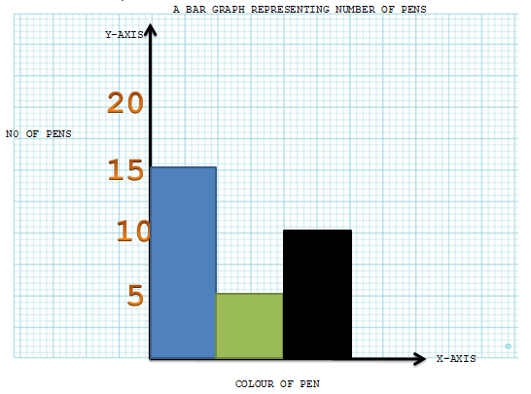(5 marks)

1. a) Radius = Diameter / 2 = 2.8 m / 2 = 1.4 m (1 Mark) b) Base area = πr² = (22/7) X (1.4 m)² = (22/7) X 1.96 m² = 22 X 0.28 m² = 6.16 m² (1 Mark) c) Volume = Base area X height = 6.16 m² X 2.5 m = 15.4 m³ (1 Mark) d) Volume in litres = 15.4 m³ X 1000 litres/m³ = 15400 litres (1 Mark) e) Time to fill = Total volume in litres / Rate of pumping Time = 15400 litres / 400 litres/minute = 38.5 minutes (2 Marks)

**THIS IS THE LAST PAGE OF THE MARKING SCHEME**