**Candidate’s Name: ………………………………………………………… Assessment Number: …………………………………………**

**School Name: ……………………………………………………………………. School Code: …………………………………………………………**

**Candidate’s Signature: ………………………………..…………….Date: …………………………………………………….…………….**

**COMPETENCE BASED EDUCATION**

**KENYA JUNIOR SCHOOL EDUCATION ASSESSMENT**

**711/2** **CREATIVE ARTS AND SPORTS (Theory)**

**Paper 2**

**TIME: 1 Hour 40 Minutes**

**INSTRUCTIONS TO CANDIDATES**

1. Write your name and assessment number in the spaces provided above.
2. Write the name and code of your school in the spaces provided above.
3. Put your signature and write the date of the assessment in the spaces provided above.
4. This paper consists of two sections A and B.
5. Each section has **THREE** parts: **Part I** - Performing Arts, **Part II** - Sports, **Part III** -Visual Arts.
6. Section A comprises Multiple Choice Questions number: **1 to 30**.
7. Section B comprises short structured and analysis questions number: **31 to 39**.
8. Answer **ALL** the questions in section A on the separate answer sheet provided.
9. Answer **ALL** the questions in section B in the spaces provided on this question paper for **Part I** - Performing Arts and **Part III** -Visual Arts.
10. For **Part II** - Sports, questions **34 and 35** are **COMPULSORY**. Choose **EITHER** question **36 or 37**.
11. Do not remove any page from this question paper.
12. Answer all questions in English.

**For official use only SECTION B**

|  |  |  |  |  |
| --- | --- | --- | --- | --- |
| **Part** | **Task Number** | **Question Number** | **Maximum score** | **Candidate’s Score** |
| **Part I: Performing Arts** | 1 | 31 | 04 |  |
|  | 2 | 32 | 04 |  |
|  | 3 | 33 | 08 |  |
| **Part II: Sports** | 4 | 34 | 04 |  |
|  | 5 | 35 | 04 |  |
|  |  | 36 | 08 |  |
| **OPTIONAL** | 6 | 37 | 08 |  |
| **Part III: Visual Arts** | 7 | 38 | 04 |  |
|  | 8 | 39 | 08 |  |

This paper consists of **10** printed pages. Candidates should check the question paper to ascertain that all the pages are printed as indicated and no questions are missing.   © 2025 The Competence Based Assessment ***Turn over***

**SECTION A: MULTIPLE CHOICE QUESTIONS (30 Marks)**

**Read the instructions carefully.**

1. You have been given this question paper and an answer sheet. This section of the question paper consists of 30 multiple-choice questions.
2. Answer **ALL** questions on the answer sheet provided, **NOT** on the question paper.
3. Do all the necessary rough work on the question paper.

**HOW TO USE THE ANSWER SHEET**

1. Use an ordinary HB pencil.
2. Confirm that the answer sheet you have been provided with has the following:

**YOUR ASSESSMENT NUMBER** **YOUR NAME**

**NAME OF YOUR SCHOOL** **NAME OF THE SUBJECT**

1. Keep the answer sheet clean, dry and **DO NOT** fold it.
2. For each of the questions 1 – 30, four answers are given. The answers are lettered A, B, C and D. In each case, only **ONE** of the four answers is correct. Choose the correct answer.
3. On the answer sheet, mark the correct answer by drawing a dark line inside the box as shown in the example below.

**17. Understanding the role of colour is important for artists to effectively communicate their ideas.**

**Which of the following best describes the role of colour as an art element?**

**A. Colour is used to make artwork visually appealing.**

**B. Colour helps to show emotions and mood in artworks.**

**C. Colour plays a role in realistic and abstract artworks.**

**D. Colour enhances the subject matter in an artwork.**

The correct answer is ‘B’.

On the answer sheet, in the set of boxes given, draw a dark line inside the box with the letter **B** printed in it as marked below.

[A] **[~~B~~]** [C] [D]

1. The dark line **MUST** be within the box. **DO NOT** make any marks outside the boxes.
2. For each question, mark **ONLY ONE** box.

**SECTION A:**

Answer all questions in this section

**PART I : PERFORMING ARTS**

1. The highness or lowness of a musical sound is called? A. rhythm B. melody C. pitch D. tempo
2. 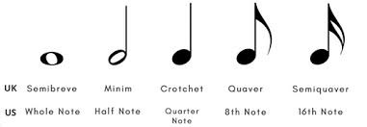Which of the following symbols represents a crotchet note?

A B C D

1. When telling a story, varying the loudness and softness of your voice is an example of? A. articulation B. projection C. dynamics D. phrasing
2. A group of singers performing together is called a? A. solo B. duet C. choir D. orchestra
3. 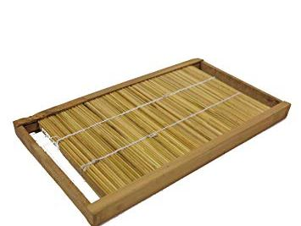Which of the following is a traditional Kenyan wind instrument?

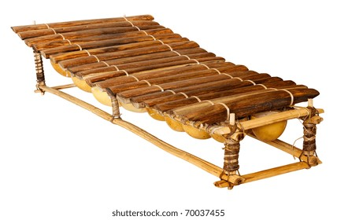A B

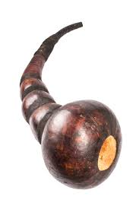

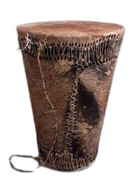C D

1. A short, repeated musical phrase is called a? A. scale B. chord C. motif D. harmony
2. Using clear and understandable pronunciation when speaking or singing is called? A. expression B. diction C. posture D. gesture
3. Learners clapped the following French rhythm names:

"ta", "ta-te", "taa".

Which of the following rhythmic notations matches what they clapped? A.♩♪♪♩ B.♪♩♩ C.♩♪♩ D.♪♪♩

1. 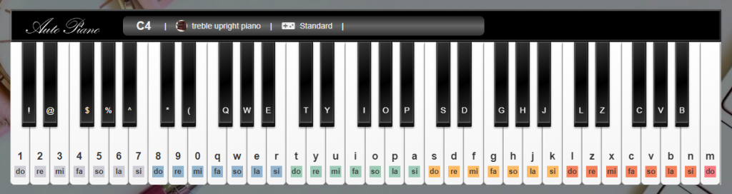On a keyboard,

The black keys are arranged in groups of? A. two and three B. three and four C. four and five D. five and six

1. Creative Arts and Sports help us to appreciate different? A. school subjects B. types of food C. cultures and traditions D. mathematical formulas

**PART II: SPORTS**

1. Running at a moderate pace over a long distance is called __________. A. sprinting B. jogging C. skipping D. hopping
2. In a game of football, using your feet to move the ball along the ground is called?

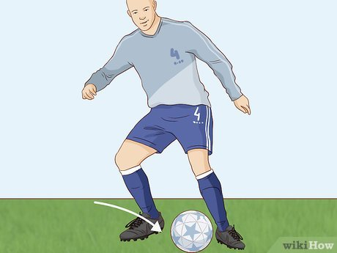

A. passing B. shooting C. dribbling D. tackling

1. Which of the following is a piece of equipment used in the sport of swimming? A. Hockey stick B. Badminton racket C. Goggles D. Javelin
2. 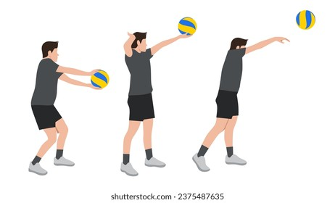Allan was observed playing the sport below. This type of sport is called?

A. Basketball B. Volleyball C. Rugby D. Handball

1. A race where teams of runners take turns to complete a set distance is called a? A. marathon B. sprint C. relay D. hurdle race
2. 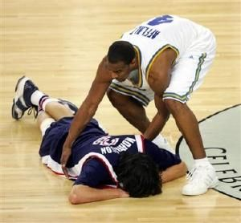During a game. One of the players fainted on the pitch.

One of the players from the opponents helped the player. This show? A. poor sportsmanship B. cheating C. good sportsmanship D. anger

1. Following the rules of a game is important for __________. A. only the referee B. ensuring fair play C. making the game confusing D. stopping the game
2. Substances that athletes are not allowed to use to improve their performance are called __________. A. vitamins B. minerals C. banned substances D. healthy foods

**PART III: VISUAL ARTS**

1. The basic elements of art include __________. A. paintings and sculptures B. museums and galleries C. line, shape, colour, texture, form, space, and value D. brushes and pencils
2. A shape that has height and width but no depth is __________. A. a cube B. a sphere C. two-dimensional D. three-dimensional
3. Mixing two primary colours together creates a __________. A. tertiary colour B. secondary colour C. neutral colour D. monochromatic colour
4. The lightness or darkness of a colour is called its __________.

A. hue B. saturation C. value D. intensity

1. An artwork that shows a variety of different elements has __________. A. unity B. balance C. contrast D. rhythm
2. Creating a pattern by repeating lines, shapes, or colours is an example of __________. A. emphasis B. harmony C. rhythm D. proportion
3. 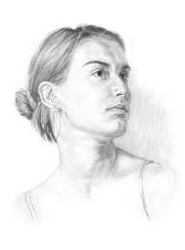Mwangi drew a the following image on his book.

A drawing of a person's head and shoulders is called a __________. A. landscape B. still life C. portrait D. abstract

1. Daudi was making a beautiful artwork from wood.

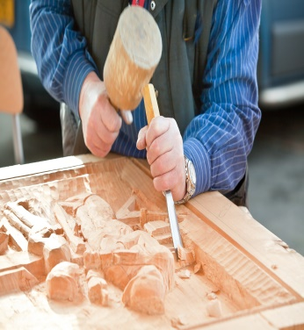

Making a sculpture by carving away material from a block of wood or stone is called __________. A. modelling B. casting C. carving D. assembling

1. Colours that are next to each other on the colour wheel are called __________. A. complementary colours B. analogous colours C. contrasting colours D. warm colours
2. An artwork that has a sense of stability and equal visual weight on both sides has __________. A. movement B. balance C. emphasis D. unity
3. In animation, a sequence of drawings that tells a story is called a __________. A. background B. character design C. storyboard D. frame
4. When printing with a stencil, the areas that are cut out will __________. A. hold the ink B. resist the ink C. create a border D. add texture

**SECTION B: (30 marks)**

**PART I: PERFORMING ARTS**

**Answer ALL the questions in the spaces provided after each question**

1. (a) Name two ways in which music is used in your community. (2 marks)

(i) _________________________________________________________________________

(ii) _________________________________________________________________________

(b) Give two reasons why it is important to listen respectfully when someone is performing. (2 marks)

(i) _________________________________________________________________________

(ii) _________________________________________________________________________

1. The following is a descant recorder:

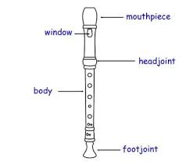

iv

iii

i

ii

(a) Identify the parts labeled. (2 marks)

(i) _______________________________ (ii) _____________________________

(iii) _____________________________ (iv) ____________________________

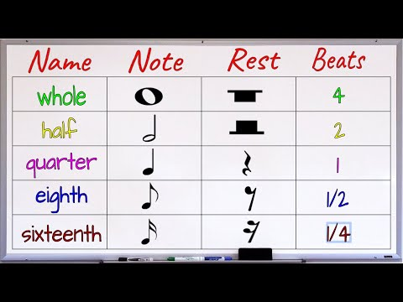(b) Draw a rest after each note below. (2 marks)

________________ _________________

1. Learners are preparing a short play to perform for their class.

(a) Identify three important elements they should consider when planning the staging (arrangement of the performance space). (3 marks)

(i) _________________________________________________________________________

(ii) _________________________________________________________________________

(iii) _________________________________________________________________________

(b) Suggest two simple props they could use in their play and explain how each prop would contribute to the storytelling. (3 marks)

(i) Prop: _____________________________________________________________

Contribution: _________________________________________________________

(ii) Prop: ____________________________________________________________

Contribution: __________________________________________________________

(c) Briefly explain two ways the learners can use their facial expressions to communicate their characters' emotions to the audience. (2 marks)

(i) _________________________________________________________________________

(ii) _________________________________________________________________________

**PART II: SPORTS**

**Answer questions 34 and 35. For question 36 and 37, answer only ONE of them.**

1. Learners are learning about the basic skills in netball.

(a) Name two basic passing techniques used in netball. (2 marks)

(i) _________________________________________________________________________

(ii) _________________________________________________________________________

(b) What is the importance of warming up before participating in any sports activity? (2 marks)

__________________________________________________________________________

_________________________________________________________________________

1. In athletics, different races cover different distances.

(a) Give one example of a short-distance race in athletics. (1 mark)

_______________________________________________________________________

(b) Give one example of a field event in athletics. (1 mark)

_______________________________________________________________________

(c) Explain two reasons why it is important to cool down after participating in a sports activity. (2 marks)

(i) _________________________________________________________________________

(ii) _________________________________________________________________________

1. Learners are being taught the basic skills of playing volleyball.

(a) Describe the correct hand position for performing a volley (underarm pass). (2 marks)

________________________________________________________________________

________________________________________________________________________

(b) Outline three basic rules of the game of volleyball. (3 marks)

(i) _________________________________________________________________________

(ii) _________________________________________________________________________

(iii) _________________________________________________________________________

(c) Explain one way that teamwork is important in a volleyball game. (3 marks)

_________________________________________________________________________

________________________________________________________________________

1. Learners are participating in a simple tagging game.

(a) Briefly describe how a tagging game is typically played. (2 marks)

___________________________________________________________________________

___________________________________________________________________________

(b) State three simple rules that could be used in a basic tagging game to ensure safety and fairness. (3 marks)

(i) _________________________________________________________________________

(ii) _________________________________________________________________________

(iii) _________________________________________________________________________

(c) Explain one benefit of playing tagging games for physical fitness. (3 marks)

________________________________________________________________________

________________________________________________________________________

**PART III: VISUAL ARTS**

**Answer ALL the questions in the spaces provided after each question**

1. (a) Name two primary colours. (2 marks)

(i) _________________________ (ii) _________________________

(b) Name two tools or materials that can be used for drawing. (2 marks)

(i) _________________________ (ii) _________________________

1. Learners have created drawings of different objects in their classroom.

(a) Explain how they can use shading (light and dark areas) to make their two-dimensional drawings look more three-dimensional. (3 marks)

___________________________________________________________________________

___________________________________________________________________________

___________________________________________________________________________

(b) Describe two different ways they could create texture in their drawings. (3 marks)

(i) _________________________________________________________________________

________________________________________________________________________

(ii) _________________________________________________________________________

________________________________________________________________________

(c) Why is it important for artists to observe objects carefully before drawing them? (2 marks)

___________________________________________________________________________

___________________________________________________________________________

**THIS IS THE LAST PRINTED PAGE**

**MARKING SCHEME**

**SECTION A:**

1. C. pitch
2. B
3. C. dynamics
4. C. choir
5. A
6. C. motif
7. B. diction
8. C. ♩♪♩
9. A. two and three
10. C. cultures and traditions
11. B. jogging
12. C. dribbling
13. C. Goggles
14. B. Volleyball
15. C. relay
16. C. good sportsmanship
17. B. ensuring fair play
18. C. banned substances
19. C. line, shape, colour, texture, form, space, and value
20. C. two-dimensional
21. B. secondary colour
22. C. value
23. C. contrast
24. C. rhythm
25. C. portrait
26. C. carving
27. B. analogous colours
28. B. balance
29. C. storyboard
30. B. resist the ink

**SECTION B: (30 marks)**

**PART I: PERFORMING ARTS (16 marks)**

**31.** (a) Name two ways in which music is used in your community. (2 marks) (i) Entertainment at social gatherings/events/parties/weddings/funerals (1 mark) (ii) Religious ceremonies/worship (1 mark) *Accept other relevant answers such as cultural celebrations, storytelling, work songs, etc.*

(b) Give two reasons why it is important to listen respectfully when someone is performing. (2 marks)

(i) Shows appreciation for the performer's effort/talent. (1 mark)

(ii) Encourages the performer. (1 mark)

*Accept other relevant answers such as to understand the performance better, to learn from the performer, etc.*

**32.** (a) identify the labeled parts. (2 marks)



(b) Draw a rest after each note below. (2 marks)



(1 mark) (1 mark)

*Ensure the correct type of rest is drawn after each note.*

**33.** Learners are preparing a short play to perform for their class. (a) Identify three important elements they should consider when planning the staging (arrangement of the performance space). (3 marks) (i) Visibility of the actors to the audience. (1 mark) (ii) Use of different areas of the stage. (1 mark) (iii) Entrances and exits for the actors. (1 mark) *Accept other relevant answers such as backdrop/scenery, props placement, lighting (if applicable), etc.*

(b) Suggest two simple props they could use in their play and explain how each prop would contribute to the storytelling. (3 marks)

(i) Prop: A letter/scroll (½ mark)

Contribution: Could reveal important plot information/character's feelings/a message. (1 mark)

(ii) Prop: A walking stick (½ mark)

Contribution: Could indicate a character's age/weakness/status/provide support. (1 mark)

*Accept other simple and relevant props with clear explanations of their contribution.*

(c) Briefly explain two ways the learners can use their facial expressions to communicate their characters' emotions to the audience. (2 marks)

(i) Smiling to show happiness/joy/friendliness. (1 mark)

(ii) Frowning/raising eyebrows to show sadness/anger/surprise/confusion. (1 mark)

*Accept other relevant facial expressions and their corresponding emotions.*

**PART II: SPORTS (16 marks)**

**Answer questions 34 and 35 (Compulsory). Answer EITHER question 36 or 37 (Optional).**

**34.** Learners are learning about the basic skills in netball. (a) Name two basic passing techniques used in netball. (2 marks) (i) Chest pass (1 mark) (ii) Shoulder pass (1 mark) *Accept other correct passing techniques such as overhead pass, bounce pass.*

(b) What is the importance of warming up before participating in any sports activity? (2 marks)

Warming up prepares the body for exercise by increasing blood flow to the muscles, raising body temperature, and improving flexibility, which helps to prevent injuries. (2 marks)

*Award marks for mentioning at least two of these benefits.*

**35.** In athletics, different races cover different distances. (a) Give one example of a short-distance race in athletics. (1 mark) 100 meters/200 meters/400 meters/110 meters (1 mark)

(b) Give one example of a field event in athletics. (1 mark)

Long jump/high jump/shot put/discus throw/javelin throw/triple jump/pole vault/hammer throw (1 mark)

(c) Explain two reasons why it is important to cool down after participating in a sports activity. (2 marks)

(i) Helps the body to gradually return to its resting state, preventing dizziness or fainting. (1 mark)

(ii) Aids in the removal of waste products (like lactic acid) from the muscles, reducing muscle soreness and stiffness. (1 mark)

**36. Learners are being taught the basic skills of playing volleyball. (a) Describe the correct hand position for performing a volley (underarm pass). (2 marks)** Hands should be together, forearms parallel and facing upwards, with flat surfaces to contact the ball. (2 marks) *Award marks for mentioning the key aspects of hand and forearm position.*

**(b) Outline three basic rules of the game of volleyball. (3 marks)**

(i) Players cannot hit the ball twice in a row. (1 mark)

(ii) A team is allowed a maximum of three hits to return the ball over the net. (1 mark)

(iii) Players must rotate their positions clockwise after their team wins a serve. (1 mark)

*Accept other basic and correct rules of volleyball.*

(c) Explain one way that teamwork is important in a volleyball game. (3 marks)

Teamwork allows players to coordinate their movements and strategies, such as setting up a spike after a dig and pass, which increases the chances of successfully returning the ball and scoring points. Effective communication and understanding of each other's roles are crucial for a successful team. (3 marks)

*Award marks for explaining the link between coordination/strategy/communication and success in the game.*

**OR**

**37.** Learners are participating in a simple tagging game. (a) Briefly describe how a tagging game is typically played. (2 marks) One or more players are designated as "it" and try to chase and touch the other players ("not it"). When a player is tagged, they become "it". (2 marks)

(b) State three simple rules that could be used in a basic tagging game to ensure safety and fairness. (3 marks)

(i) No pushing or tripping. (1 mark)

(ii) Tagging should be done with a light touch. (1 mark)

(iii) Boundaries should be clearly defined and respected. (1 mark)

*Accept other relevant safety and fairness rules.*

(c) Explain one benefit of playing tagging games for physical fitness. (3 marks)

Tagging games involve running, dodging, and quick changes in direction, which improves cardiovascular fitness, agility, and reaction time. (3 marks)

*Award marks for linking the physical actions in the game to specific fitness benefits.*

**PART III: VISUAL ARTS (14 marks)**

**38.** (a) Name two primary colours. (2 marks) (i) Red (1 mark) (ii) Blue (1 mark) *The third primary colour is yellow. Any two of these are correct.*

(b) Name two tools or materials that can be used for drawing. (2 marks)

(i) Pencil (1 mark) (ii) Charcoal (1 mark)

*Accept other correct drawing tools/materials such as crayons, markers, pens, pastels, etc.*

**39.** Learners have created drawings of different objects in their classroom. (a) Explain how they can use shading (light and dark areas) to make their two-dimensional drawings look more three-dimensional. (3 marks) By adding darker values to areas that are away from the light source and lighter values to areas that are closer to the light source, artists can create the illusion of volume and depth. This contrast in value suggests how light falls on a three-dimensional object, making it appear to have form and solidity on a flat surface. (3 marks) *Award marks for explaining the relationship between light source, highlights, shadows, and the illusion of depth/form.*

(b) Describe two different ways they could create texture in their drawings. (3 marks)

(i) By using different types of lines and marks, such as short, broken lines to suggest roughness, or smooth, flowing lines to suggest smoothness. (1 ½ marks)

(ii) By varying the pressure applied to the drawing tool to create different tones and densities, which can visually represent the feel of a surface. (1 ½ marks)

*Accept other valid methods of creating texture such as stippling (dots), hatching (parallel lines), cross-hatching (intersecting lines), rubbing, etc.*

(c) Why is it important for artists to observe objects carefully before drawing them? (2 marks)

Careful observation allows artists to accurately capture the details, proportions, shapes, and forms of the object. This leads to more realistic and believable drawings. It also helps them understand how light and shadow affect the object's appearance and texture. (2 marks)

*Award marks for mentioning aspects like accuracy, detail, proportion, form, and understand

**THIS IS THE LAST PRINTED PAGE OF THE MARKING SCHEME**