KENYA PRIMARY SCHOOL EDUCATION ASSESSMENT
GRADE 6 ASSESSMENTS

END -TERM 2 - 2025
SOCIAL STUDIES & REL ED.

READ THESE INSTRUCTIONS CAREFULLY

- You have been given this question booklet and a separate answer sheet. The question booklet contains 50 questions.

- Do any necessary rough work in this booklet.

- When you have chosen your answer, mark it on the ANSWER SHEET, not in this question booklet.

HOW TO USE THE ANSWER SHEET
- Use only an ordinary pencil.

- Make sure that you have written on the answer sheet:

YOUR ASSESSMENT NUMBER
YOUR NAME
NAME OF YOUR SCHOOL

- By drawing a dark line inside the correct numbered boxes, mark your full Index Number (i.e. School Code Number and three-figure Index Number) in the grid near the top of the answer sheet.

- Do not make any marks outside the boxes.

- Keep your answer sheet as clean as possible and DO NOT FOLD IT.

- For each of the questions 1-50 four answers are given. The answers are lettered A, B, C, D. In each case only ONE
of the four answers is correct. Choose the correct answer.

- On the answer sheet, show the correct answer by drawing a line in the box in which the letter you have chosen is written.

Example
In the Question Booklet:

  - The following are tourist attractions in Kenya. Which one is NOT?
      - Sandy beaches
    - Culture
    - Winter sports
      - Wildlife

The correct answer is C

On the Answer Sheet:

28. [A] [B] [C] [D] 29.[A] [B] [C] [D] 30. [A] [B] [C] [D] 31.[A] [B] [C] [D]

In the set of boxes numbered 28 the box with C printed in it is lined.

- Your line MUST be within the box. Make your line as DARK as possible.

- For each question, ONLY ONE box is to be lined in each set of four boxes.
1

PART I SOCIAL STUDIES.
Study the map below then answer the questions that follow.

CHAMU AREA
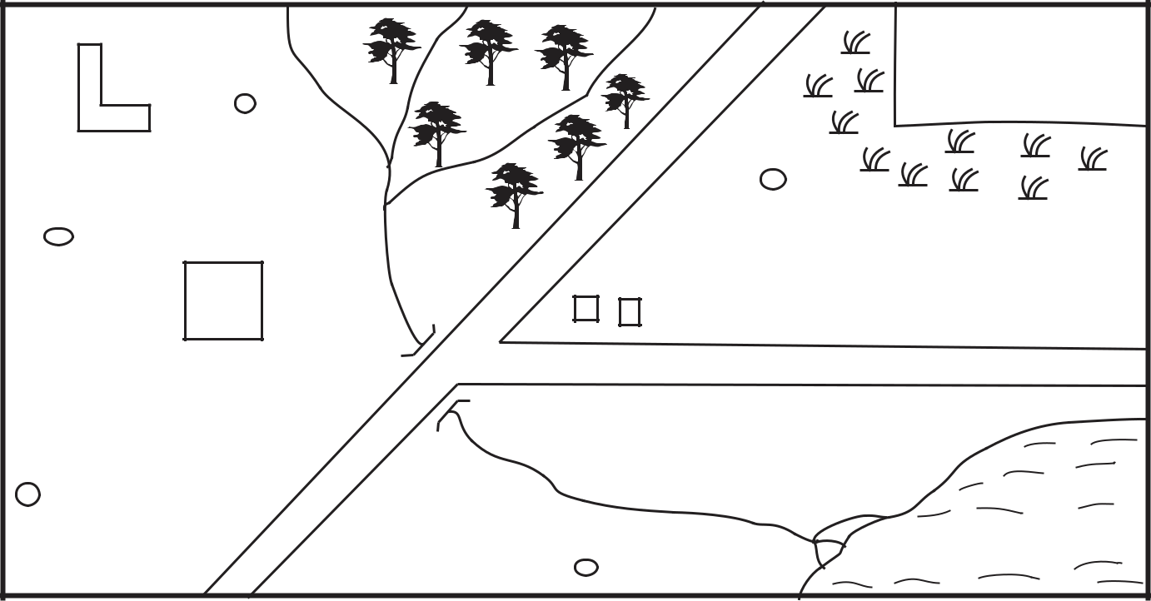

 |  |  |  | GAME PARK
 |  |  | S/M
 |  |  |  | A.S
 |  | H |  | Chamu town
 |  | P.S |  | C.C.O
 |  |  | R. Chamu
 |  |  |  | LAKE CHAMU
Scale
KEY | S.M | Saw mill | H | Hospital
 |  | Scrub | C.C.O | County Commissioner’s office
 | A.S | Airstrip | P.S | Police station
 |  | School | P.S. | Settlement
 |  |  | 3
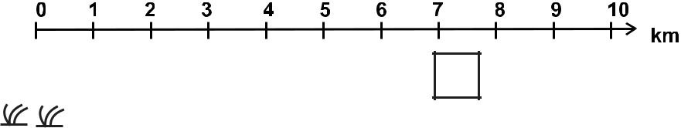


N

1. | What feature is formed at the mouth of R. |  | 10. Who is the head |  |  |  |  |  |  |  |  |  |  |  |  |  |  |  |  |  |  |  |  |  |  |  |  |  |  |  |  |  |  |  |  |  |  |  | of the Judiciary?
 | Chamu? |  |  |  |  | A. President |  |  |  |  |  |  |  |  |  |  |  |  |  |  |  |  |  |  |  |  |  |  |  |  |  |  |  |  |  |  |  |  |  |  |  |  |  | B. Chief Justice
 | A. Delta | B. Estuary |  |  |  | C. Speaker |  |  |  |  |  |  |  |  |  |  |  |  |  |  |  |  |  |  |  |  |  |  |  |  |  |  |  |  |  |  |  |  |  |  |  |  |  | D. Attorney General
 | C. Tributary | D. Confluence | 11. Which one of the following mountains
2. | Tourists who visit game park go there by: |  |  |  |  | was formed through the process below?
A. Road transport |  | B. Railway transport
 | C. Air transport | D. Water transport
3. | Which type of settlement is found in
 | chamu area?
A. Dense |  | B. Sparse
 | C. Linear | D. Clustered |  |  |  | A. Mt. Meru |  |  |  |  |  |  |  |  |  |  |  |  |  |  |  |  |  |  |  |  |  |  |  |  |  |  |  |  |  |  |  |  |  |  |  |  |  | B. Mt. Kenya
 |  |  |  |  |  | C. Mt. Suswa |  |  |  |  |  |  |  |  |  |  |  |  |  |  |  |  |  |  |  |  |  |  |  |  |  |  |  |  |  |  |  |  |  |  |  |  |  | D. Danakil Alps

- Who maintains law and order in Chamu
area |  | 12. Which one of the following aspects of
A. Governor | B. President | traditional culture ought not to be
C. Police | D. MCA | preserved?
5. Which economic activity is practised in |  | A. Traditional food.
 |  | B. Use of elders to solve disputes
the northern part of Chamu area? |  | C. Female circumcision.
A. Cash crop farming |  | D. Respect of human life
B. Lumbering
C. Fishing |  | 13. A group of people who originated from a
D. Mining |  | common ancestor form.
6. Which one of the following is NOT a |  | A. Clan
 |  | B. Age-set
problem facing tourism? |  | C. Age-group
A. Terrorism |  | D. Family
B. Poor roads
C. Low entry charges |  | 14. Which one of the following is a positive
D. High cost of accomodation |  | effect of high population?
7. Three of the following are method of |  | A. Provides adequate market for goods.
 |  | B. Land fragmentation.
marine fishing. Which one is NOT? |  | C. Shortage of food.
A. Trawling | B. Harpooning | D. Low living standards.
C. Purse seining | D. Long-lining | 15. Which mineral is mined at Bamburi in
8. Which one of the following is a challenge
 |  | Mombasa?
facing beef farming in Eastern Africa? |  | A. Fluorspar | B. Soda ash
A. pests and diseases. |  | C. Diatomite | D. Limestone
- availability of veterinary services
- availability of good transport network.
D. adequate market.
9. Which one of the following is not a
contribution of large-scale farming?
A. Source of food.
B. Earns foreign exchange.
C. Undermines trade.
D. creates employment
- Which one of the following language groups is correctly matched with the area they settled in during migration into Eastern Africa?
  - Highland Nilotes - Around Mt. Elgon.
  - Bantus - Along river Nile.
  - Cushites - Around the highlands of Ethiopia.
  - Semites - Around Lake Victoria.
- The fishing method above is used where
  - water is flowing fast.
  - there are few fish.
  - a river is shallow.
  - the sea is deep.
- Which one of the following is a similarity between the traditional government of Buganda Kingdom and the Nyamwezi cheisdom?
  - Their leaders were appointed by the council of elders.
  - They both had hereditary leadership.
  - They both had a traditional parliament.
  - They both had a monarchial government.
- Which one of the following minerals is correctly matched with the method of mining?
  - Gold - Dredging.
  - Copper - Deep shaft.
  - Limestone - Open cast.
  - Soda ash - Drilling. 30.
- Grade 4 learners were asked by their socia! studies teacher to give the main reason why they started an entrepreneurship project in their school, who among them gave the correct answer?
  - Amina- To make use of locally available resources.
  - Peter - To help the school in buying land.
  - Margaret - To help themn raise income.
  - William - To help them create employment in school
- The headteacher of Kabarak Primary Schoool sabarak Primary School invited Mr. Kigen one of the officers from East African Community to talk about challenges facing the organization. Which one of the following was not mentioned as a challenge?
  - Poor roads.
  - Mistrust among members.
  - Use of a common currency.
  - Natural calamities.
- Below are examples of rights and freedoms of Kenya citizens.
  - Freedom of Movement.
  - Right to health care.
  - Right to fair pay.
  - Righi to privacy
  - freedom of speech.
The Which one of these rights and freedoms are grouped as social?
    - (ii) and (iv)
    - (i) and (v)
    - (iii) and (iv)
    - (i) and (ii)

- Study the poster below.
TAXES GRANTS
LOANS COUNTERFINES
- From the above posters, the message communicated is
  - types of expenditure
  - sources of foreign exchange
  - sources of revenue
  - types of taxes.
- Which of the following lakes is correctly matched with its method of formation?
Lake Formation
  - Victoria faulting
  - Masinga downwarping
  - Teleki deposition
  - Tana human activities
- Which one of the following mountains was formed through the process shown in the diagram above?
  - Mt. Elgon.
  - Mt. Kilimanjaro.
  - Mt. Longonot.
  - Danakil alps.
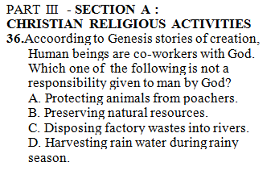
37. Genesis 12:2 "I will bless who bless you, |  |  |  | A. Honesty | B. Obedience
But i will curse those who curse you. And |  |  |  | C. Respect | D. Responsibility
through you i will bless all the nations."
These words were said by God to? |  |  |  | 43. The following are lessons we learn from
A. Noah | B. David |  |  | miracle of raising Lazarus from the dead.
C. Adam | D. Abraham |  |  | Which one is not?
 |  |  |  | A. Jesus likes it when we obey God.
38. Jacob wrestled with an Angel of God at |  |  |  | B. Jesus is the life and resurrection.
Peniel until daybreak. What lesson do we |  |  |  | C. We should have faith in God.
learn from this story? |  |  |  | D. Jesus has power to give life.
A. Being courageous in life.
B. Being determined in life. |  |  |  | 44. Identify a similarity between the birth and
C. Being armed to fight our enemies. |  |  |  | life of Jesus and John the Baptist.
D. Being humble in prayer. |  |  |  | A. Both were baptized by one person.
 |  |  |  | B. Both births were announced by an
39. Christians are reminded on the need to |  |  |  | angel.
always help the needy amongst us. Which |  |  |  | C. Both parents were Joseph and Mary.
parable did Jesus teach about the need to |  |  |  | D. Both taught on repentance
help others. Parable of
A. the rich man and Lazarus. |  |  |  | 45. Grade 6 learners from Peta school were
B. the bleeding woman. |  |  |  | classifying books of the Bible according
C. the friend at midnight. |  |  |  | to either old or New Testament. Which
D. the unforgiving servant. |  |  |  | cluster comprises of the old testament
40. Four classmates in Grade 6 yellow |  |  |  | books only.
discussed the qualities of being a good |  |  |  | A. Acts | B. Exodus
citizen. Who didn't get it right? To be a |  |  |  | Romans | Titus
good citizen.......... |  |  |  | Nahum | Joel
A. Terry- one must be patriotic. |  |  |  | Micah | James
B. Ben - one must participate in election.
C. Tony - one must evade paying tax. |  |  |  | C. Job | D. Luke
D. Shawn - one must obey law. |  |  |  | Judges | Lamentations
 |  |  |  | Ezra | Numbers
41. Grade 6 learners in Kazetu Primary |  |  |  | Exodus | Jude
school brainstormed n the temptation of
Jesus according to Luke 4: 1-13. Which |  |  |  | 46. The following students discussed safety
group ordered the temptations correctly |  |  |  | measures to consider when using social
from the first to the last. |  |  |  | media. All the following were right
(i) If you are God's son, throw yourself |  |  |  | except?
down from here. |  |  |  | A. Kelly - Ignore use of strong
(ii) If you worship me, i will give you all |  |  |  | passwords for your account.
this power and wealth. |  |  |  | B. Cephas - Be careful with posts and
(iii) If you are God's son, order this stone |  |  |  | pictures.
to turn into bread. |  |  |  | C. Nelly - Do not over-friend on social
A. Group A - (iii) (i) (ii) |  |  |  | networks.
B. Group B (ii) (i) (iii) |  |  |  | D. Darrell - Avoid posting your location.
C. Group M (i) (ii) (iii)
D. Group T (iii) (ii) (i) |  |  |  | 47. After reading Mathew 8: 5-13 about the
 |  |  |  | healing of the Roman officers servant, we
42. Shem's mother went to the market and left |  |  |  | learn all following except?
Shem incharge of the baby cousin. |  |  |  | A. Employers should take care of their
However Shem refused and went to play. |  |  |  | workers.
The baby cried the whole day. What value |  |  |  | B. Christians should neglect the sick.
does Shem lack? |  |  |  | C. We should have faith in God.
 |  |  |  | D. We should seek help from God.

- The commandment that guides the youth against irresponsible sexual behaviour is commandment number? ________
A. Fifth B. Sixth
C. Seventh D. First

- After learning how to use their leisure time wisely, Grade 6 learners spent their weekend as follows. Who did not practice what they were taught.
  - Keily - Slept the whole afternoon.
  - Isaac - Helped his grandmother fetch water.

  - Joy - Joined the youth in campaign against child labour.

  - Kellan - visited a home for the orphans.

- Moses worked as a ________ before God called him.
A. Fisherman B. Shepherd
C. Warrior D. Judge

SECTION B: ISLAMIC RELIGIOUS EDUCATION

- The year when Abraha wanted to destroy Kaaba was known as the year of
A. Lion B. Elephant
C. Zebra D. Cow

- There are __________ khutbahs in jumaa prayers
A. 2 | B. | 3
C. 1 | D. | 4

- Allahumaini audhubika is a dua said when
entering the
A. market B. house
C. Toilet D. class

- When someone gives you something we should say.
A. Mashallah B. Jazakallah
C. Subhanallah D. Alhamdulillah

- The Angel of Allah (SWT) who is incharge of wahy is known as
A. Jibril B. Israil
C. Mikail D. Israfil
- Who among the following surahs was the

first to be revealed to the prophet (SAW)
A. Alaq B. Nas
C. Falaq D. Fatiha

- The Mother of prophet Muhammad (S.A.W) is known as
A. Maryam B. Amina
C. Khadija D. Aisha

- Man was created by Allah in order to
A. Worship Him B. Give birth
C. Get married D. Enjoy life

- The Surah of the Quran that talks about
kindness is
A. Zilzala B. Qaariah
C. Maun D. Takathur

- The Surah of the Quran that is knon as
ummul Quran is?
A. Fatina B. Yasin
C. Falaq D. Ikhalas

- Which one among the following things is not Najis
A. urine B. blood
C. Dirt D. Pus

- The pillar of Islam that one cannot
perform in his own home town is
A. Swalah B. Hajj
C. Saum D. Zakat

- The prophet (SAW) describes fasting as a
A. Dua B. Security
C. Shield D. Alaq

- The governor of Yemen who wanted to
destroy the Kaaba was called
A. Najash B. Abraha
C. Nimrud D. Pillar

- The festival of idd ul hajj takes place on the ______________ of Dhul-Hijja
A. 1st | B. | 10th
C. 3rd | D. | 30th

6

1. | A
2. | C

3. B
4. C
5. B
6. C
7. B
8. A
9. C
10. B
11. D
12. C
13. A
14. A
15. D
- A
- D
- B
- C
- C
- C
- A
- C
- A
- D
- A

CRE | IRE
36. C | B
37. D | A
38. B | C
39. A | B
40. C | A
41. D | 41. D
42. B | 42. A
43. A | 43. D
44. B | 44. A
45. C | 45. C
46. A | 46. A
 | 47. C
 | 48. B
 | 49. C
 | 50. B

