THE KENYA PRIMARY SCHOOL EDUCATION ASSESSMENT

SCHOOL BASED ASSESSMENT

SOCIAL STUDIES

GRADE 6

LEARNER’S NAME: GRADE: ________

ASSESSMENT NUMBER: ______________________ DATE: _________

SCHOOL NAME: ______________________________________________

INSTRUCTIONS TO LEARNERS

- This paper consists of 12 questions.
- Answer all the questions in the spaces provided.

- Schools with learners with visual impairment have been provided with an adapted tool, download and Braille it at the school level.

FOR ASSESSORS USE ONLY
Question | 1 | 2 | 3 |  | 4 | 5 |  | 6 |  |  | 7
Mark (s) | 2 | 2 | 1 |  | 2 | 1 |  | 1 |  |  | 2
Score
Question | 8 | 9 |  | 10 | 11 |  | 12 |  |  | TOTAL
 |  |  |  |  |  |  |  |  |  | SCORE
Mark (s) | 2 | 1 |  | 2 | 2 |  | 2 |  |  | 20
Score

This paper consists of 5 pages.

Learners should check the question paper to ascertain all the
pages are printed as indicated and that no questions are missing.
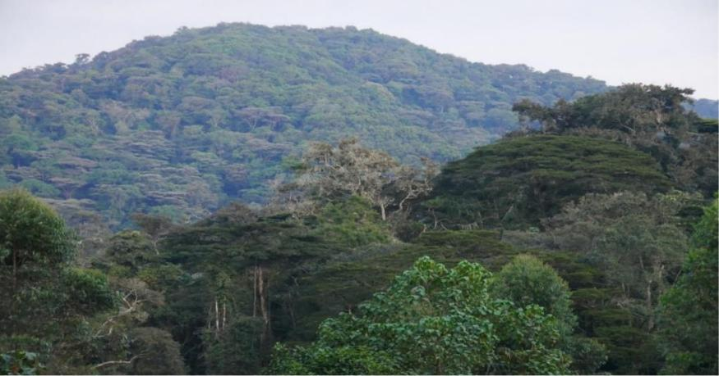

- During the class education tour, grade six learners came across the vegetation shown in the photograph above.

Identify two characteristics of the vegetation. 2 marks

_____________________________________________________________________

_____________________________________________________________________

_____________________________________________________________________

- After the lesson on preservation of culture, Mary found an old pot at home and brought it to class to add to the items in the cultural corner.

Give two ways in which her class would care for the cultural artefacts. 2 marks

____________________________________________________________________

_____________________________________________________________________

_____________________________________________________________________

- Some Grade six learners have joined the local ‘’ kazi kwa vijana ‘’group in their community to take care of the local environment.

In which way are they likely to benefit from this interaction? 1 mark

_____________________________________________________________________

_____________________________________________________________________

- Jeremiah, a Grade 6 Social Studies teacher has invited a clan elder to talk to the learners about the functions of a clan in the traditional community.

Which two functions of the clan could the elder have talked about? 2 marks

_____________________________________________________________________

_____________________________________________________________________

- Your class has visited a farm near the school locality to learn about horticulture farming.

How is the local community likely to benefit from this farm? 1 mark

______________________________________________________________________

______________________________________________________________________

- Tom, a Grade six learner visited his friend Juma and found him fishing in a river near his home. He took him the photograph shown below.
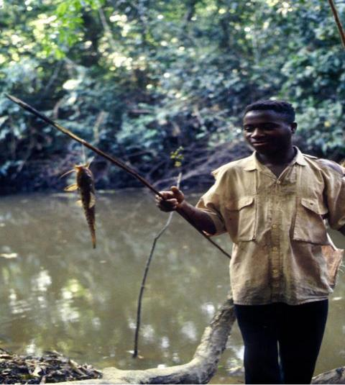

Which method of fishing is Juma using? 1 mark

_____________________________________________________________________

_____________________________________________________________________

- Your Class teacher has provided you with a table of minerals and where they are mined.

Match each mineral with the place where it is mined. |  |  | 2 marks
 | Mineral | Mining area
 | Soda Ash | Turkana
 | Diatomite | Athi River
 | limestone | Lake Magadi
 | petroleum | Kariandusi

- Job, a deaf poultry farmer intends to advertise his produce using a popular means of communication in the area.

Draw a diagram of the most suitable means of communication that Job may use to reach

out to many people. 2 marks

- During the self-directed activities, Grade six learners decided to fill in the word puzzle below.

Circle one quality of a good citizen from the puzzle. |  |  |  |  |  |  |  |  |  | 1 mark
 | L | S | B | A | D | I | R | O
 | O | I | R | D | A | I | R | G
 | Y | B | A | F | A | R | M | T
 | A | D | V | F | P | O | L | T
 | L | L | H | O | N | E | S | T
 | O | K | R | U | G | A | N | T

- Grade five learners were asked to gather information on traditional leaders in Kenya. One learner was told by the grandfather about Kivoi wa Mwendwa.

Give two contributions of chief Kivoi that the learner learnt? 2 marks

_____________________________________________________________________

_____________________________________________________________________

- Your school has planned a world Human Rights Day. You have asked to present a short poem on respect for human rights.

Write two ways of promoting respect for human rights that you will you put in the

poem. 2 marks

_____________________________________________________________________

_____________________________________________________________________

- The diagram below represents the composition of the judiciary in Kenya.

Fill in the empty branches the missing members of the judiciary. 2 marks

