THE KENYA PRIMARY SCHOOL EDUCATION ASSESSMENT

SCHOOL BASED ASSESSMENT

MATHEMATICS

GRADE 6

LEARNER’S NAME: ________________________________________________

ASSESSMENT NUMBER: _____________________ __DATE: ______________

SCHOOL NAME: ____________________________________

Instructions to the learner

- This paper consists of 23 Questions.
- Answer all the questions.
- Show all the working in the spaces provided below each question.

FOR ASSESSORS USE ONLY

The grid below is to be filled by the teacher after marking the learner’s work. During uploading, the
teacher to upload the number of questions correctly scored per sub-strand given.

Strand | Sub strands | Question number | Score | Performance
 |  |  |  | level
Numbers | Whole numbers, | 1,2,3,4,5
 | multiplication, division
 | Fractions and decimals | 6,7,8,9
Measurement | Length, area, time and | 10, 11, 12, 13, 14, 23
 | money
 | Volume and mass | 15, 16(a), 16(b), 16(c)
Geometry, | Lines, angles, 3-D | 17, 18, 19, 20, 21, 22
Data Handling | objects, data
and Algebra | representation and
 | simple equations

This paper has 10 printed pages

Turn Over

Answer ALL the questions in the spaces provided

- A photocopying machine produced thirty five thousand one hundred and six copies of printed papers. Write the number of printed papers in symbols.

- Mukami used the digits 3, 1, 5, 2, 6, 9 to form the largest and the smallest six digit numbers. What was the difference between the largest and smallest numbers formed?

- Tom planted 1296 cabbages in rows and columns in his farm. The number of cabbages in the rows and columns were equal. How many cabbages were in each row?

- A grocer counted 245 oranges in a carton. She had 16 similar cartons containing oranges. How many oranges were packed in all the cartons?

Page 2 of 10
- A forester donated 3918 tree seedlings to 23 schools. By rounding off each number to the nearest 10, estimate the number of tree seedlings donated to each school.

- Ongeri cut a piece of sugarcane from the farm. He chopped the top part and remained with ⁵₆ . He gave his friend Kimutai ²₃ of the piece of sugarcane. What fraction of the piece of sugarcane remained?

- Adhiambo obtained 24 out of 30 marks in a Mathematics assessment. What was the score as a percentage?

- An athlete ran a race in 31.589 seconds. What is the time rounded off to 2 decimal places?

Mathematics – RL, PD, HI

School Based Assessment Grade 6 Page 3 of 10
- A butcher sold 25.148 kg of meat to a customer. He later sold 6.7905 kg

of meat to another customer. How many kilograms of meat were sold altogether?

- A carpenter had a piece of timber measuring 213 cm 5 mm long. He cut the timber into 5 equal small pieces. What was the length of each small piece?

- Alice fetched water using a bottle. The height of the bottle was 26 cm 9 mm. What was the height of the bottle in millimetres?

Page 4 of 10
- Juma travelled from home to his grandmother place which was 5 km 850 m away. Afterwards, he was sent to a shopping centre which was 9 km 632 m and then came back to the grandmother’s place. What was the total distance covered by
Juma for the whole journey?

- A headteacher started a parents’ meeting at the time shown on the clockface.
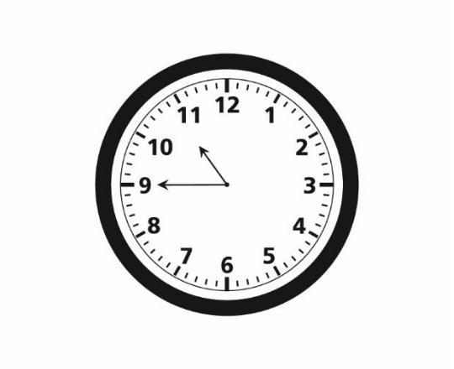

The meeting ended after 2 hours 30 minutes. Show the time that the meeting ended using this clockface.
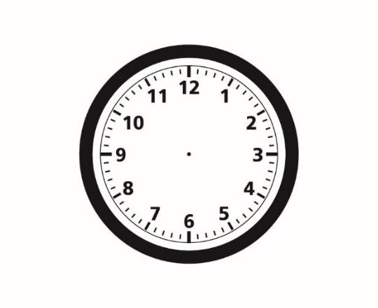

Page 5 of 10
- The following is a price list in a shop:

Item | Price
1 bar of soap | sh 250
1 loaf of bread | sh 60
1 kg of sugar | sh 160
1 packet of tea leaves | sh 50
1 kg of rice | sh 200
1 kg of maize flour | sh 80

Auma bought the following items from the shop:
2 loaves of bread
1 kg of sugar

3 kg of rice

2 packets of tea leaves

Auma gave the shopkeeper a sh 1000 note for the items. How much money did she receive as balance?

- Joy’s dad bought a rectangular jerrican measuring 50 cm by 60 cm by 80 cm. Joy filled the jerrican with water. How many litres of water are in the jerrican?

M
Page 6 of 10
- A classroom was being constructed in a school. A worker in the construction site transported 4 tonnes of sand using a wheelbarrow. The wheelbarrow was used to carry 80 kg of sand in each trip.

  - What was the mass of sand in the construction site in kilograms?

  - The worker made 29 trips on the first day. How many kilograms of sand did the worker transport on that day?

- How many trips were made by the worker to transport all the sand?

Page 7 of 10
- A boy fixed 3 pieces of timber on the ground to make a cowshed. He fixed the 3 pieces of timber A, B and C as shown:
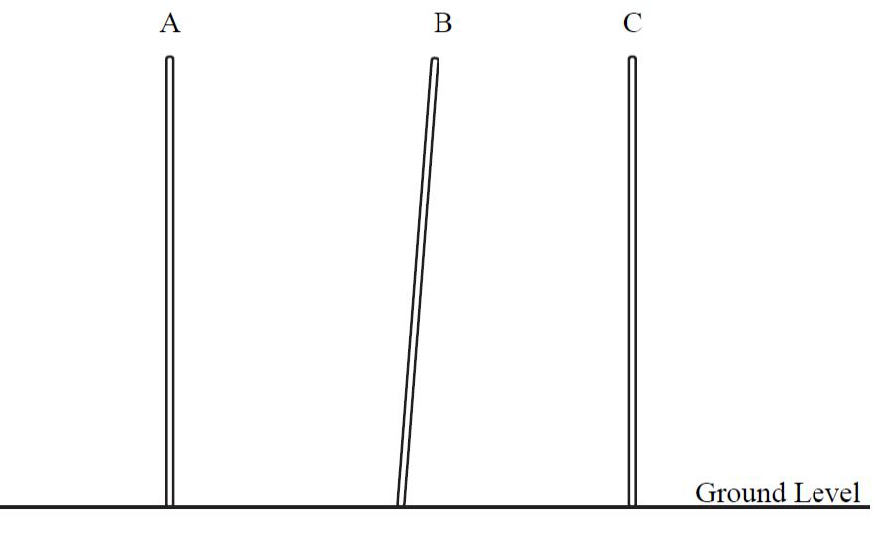

Which two pieces of timber are parallel?

- The figure shows the plan of one side of a house.
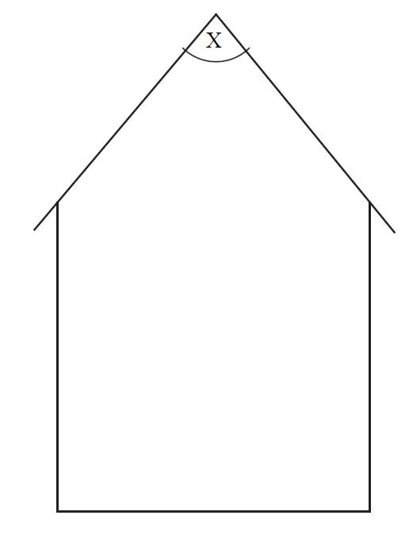

Using a protractor, measure the size of the angle marked X.

Page 8 of 10
- Odhiambo collected a 3-D object from the environment. The object had the following properties:

Has 6 equal faces Has 8 corners All edges are equal

What is the name of the 3-D object that was collected?

- Kizito visited a farmer and collected data of animals found in the farm. He represented some of the information in the table shown.

Type of animal | Tally marks | Number of animals
Camels |  | 6

Cows | //// | ////
Sheep |  | 14
Goats | //// | //// //

Complete the missing information in the table.

- Wasonga had some bottles of soda during a wedding party. He gave 72 bottles of soda to the guests and remained with 48 bottles of soda. Use letter p to represent the number of bottles of soda that Wasonga had in the beginning. Write an equation to represent the information.

Page 9 of 10

- Each learner in a class was given a matchbox. The learners were asked to pile the matchbox on their favourite game. The piles were as shown.
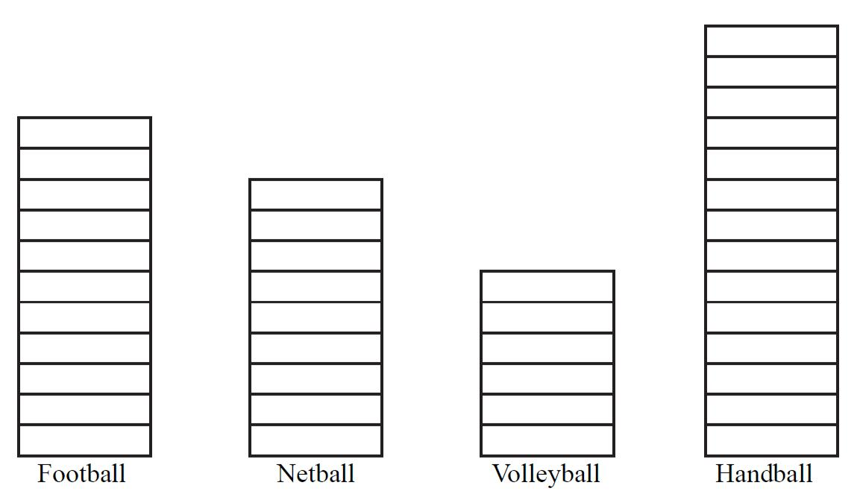

How many more learners chose handball than netball?

- Your teacher has provided you with a cut out. Using a ruler, measure the base and height of the cut out in centimetres. What is the area of the cut out?

THIS IS THE LAST PRINTED PAGE

Page 10 of 10

