Advance Instruction to the teacher on TASK 23

- Using a manilla paper, prepare a right angled triangular cut out with a base of 15 cm and height 10 cm for each learner.

Provide them with a 30 cm ruler.

Question | Answer | Questio Answer
 |  | n
1. | 35106
 |  | 13.
2. | 965321 − 123569 = 841752 | 13.

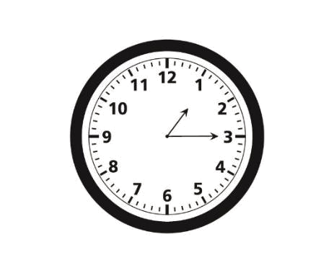
- √1296

  - √2×2×2×2×3×3×3×3
    - 2×2×3×3

      - 36
4. | 245 × 16 = 3920 |  |  |  |  |  |  |  |  |  |  |  |  | 14. |  | 2 |  |  |  |  |  | = ℎ 120
 |  |  |  |  |  |  |  |  |  |  |  |  |  |  |  | 1 |  |  |  |  |  | = ℎ 160
5. | 3918 rounded off to the |  |  |  |  |  |  |  |  |  |  |  |  |  |  | 3 |  |  |  |  |  | = ℎ 600
 | nearest ten is 3920. |  |  |  |  |  |  |  |  |  |  |  |  |  | 2= ℎ100
 | 23 rounded off to the |  |  |  |  |  |  |  |  |  |  |  |  |  |  |  | = |  |  |  |  | ℎ 980
 | nearest ten is 20. |  |  |  |  |  |  |  |  |  |  |  |  |  |  | = ℎ 1000 − 980
 | 3920 ÷ 20 = 196 |  |  |  |  |  |  |  |  |  |  |  |  |  |  |  |  |  |  |  | = ℎ 20
6. | 5 |  |  |  |  | 2 |  | 5 − 4 |  |  |  | 1 |  | 15. | 50×60×80
 |  |  |  | − |  |  | = |  |  |  | = |  |  |  |  |  |  |  |  |  | = 240
 |  |  | 6 |  |  | 3 | = | 6 |  |  | = | 6 |  |  | 1000
7. | 24 |  |  |  | × 100% = 80% |  |  |  |  |  |  |  |  | 16. (a) |  | 4 × 1000 = 4000
 |  | 30
 |  |  |  |  |  |  |  |  |  |  |  |  |  | (b) |  | 29 × 80 = 2320
8. | 31.95 |  |  |  |  |  |  |  |  |  |  |  |  | (b)
 |  |  |  |  |  |  |  |  |  |  |  |  |  | (c) |  |  | 4×1000 | = 50
9. | 25.148 + 6.7905 = 31.9385 |  |  |  |  |  |  |  |  |  |  |  |  | (c)
9. |  |  |  |  |  |  |  |  |  |  |  |  |  | (c) |  |  | 80
10. | 213 5 ÷5=42 7 |  |  |  |  |  |  |  |  |  |  |  |  | 17. |  | A and C
11. | 260 +9=269 |  |  |  |  |  |  |  |  |  |  |  |  | 18. |  | Angle X = 80º
12. | 5 850 +9 632 |  |  |  |  |  |  |  |  |  |  |  |  | 19. | A cube

- 9 632 = 25 114

Question Answer | Question | Answer

20.
20. | Type of | Tally marks |  |  |  | Number of
 | animal |  |  |  |  | animals
 | Camels | //// |  | / |  | 6
 | Cows | //// |  | //// |  | 9
 | Sheep | //// | //// |  | //// | 14
 | Goats | //// | //// |  | // | 12
21. | −72=48


- Handball = 14 Netball = 9
14−9=5
- :

Base = 15 cm Height = 10 cm
1
₂×15×10 =75 ²

