THE KENYA PRIMARY SCHOOL EDUCATION ASSESSMENT

SCHOOL BASED ASSESSMENT

HINDU RELIGIOUS EDUCATION

GRADE 6

LEARNER’S NAME: ______________________________ GRADE: ______________

ASSESSMENT NO: _______________________________ DATE: _______________

SCHOOL NAME: _______________________________________________________

INSTRUCTIONS TO LEARNERS

- This paper consists of 23 questions.

- Answer Question 1 to 22 in the spaces provided.

- Guidance on Question 23 will be provided by the teacher.

Time: 1 Hour (Questions 1 to 22) 2 days for Question 23

FOR OFFICIAL USE ONLY

SCORING GRID (30 scores)

 | Question |  | 1 | 2 |  | 3 |  | 4 |  | 5 |  | 6 |  |  | 7 |  |  | 8 |  | 9 | 10 | 11 | 12 | 13 | 14 | 15 | 16
 | Score (s) |  | 1 | 1 |  | 1 |  | 1 |  | 1 |  | 1 |  |  | 1 |  |  | 1 |  | 1 | 1 | 2 | 1 | 1 | 1 | 1 | 1
 | Score
 | Question | 17 |  | 18 |  | 19 |  | 20 |  |  | 21 |  |  | 22 |  |  | 23
 | Score (s) | 1 |  | 1 |  | 1 |  | 1 |  |  | 2 |  |  | 4 |  |  | 3
 | Score
This paper consists of 5 printed pages.

Learners should check the question paper to ascertain that all the pages are printed as indicated and no questions are missing.

- Saagar learnt in his Hindu Religious Education class that all the four faiths explain

Creation of the Universe differently. The faith that does not believe in Paramatma as the

creator is __________________________________________. (1 mark)

- One of the following statements shows the similarities between Sikhism and Christianity

on their beliefs on Paramatma. Tick the correct statement. (1 mark)

  - Paramatma lives in heaven

  - Paramatma is the creator of only one universe.

  - Paramatma is the provider and sustainer of all creation.

- Choose the picture of the sacred animal that can be seen in front of Derasars and

Mandirs. (1 mark)
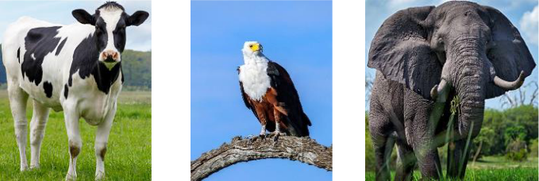

- Grade 5 learners went to visit a farm to buy vegetables and realised that in nature, Plants and Human Beings depend on each other.

List one way in which plants and human beings depend on one another. (1 mark)

______________________________________________________________________

- Tick the box that contains the Jain Scripture that is read during Paryushan Purva in

honour of Lord Mahavir. |  |  |  |  | (1 mark)
 |  |  | Uttradhyayan |  | Kalpasutra
 | Agam |  | Uttradhyayan |  | Kalpasutra

- The following personalities advocated for different values that are learnt from the Ramayan. What one of the following personalities is correctly matched with the value

that he advocated. (1 mark)

7.
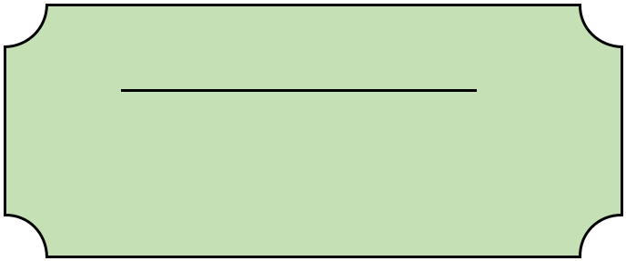

Personality Value

Hanuman Sewa

Raavan Maryada

Lakshman Agyakari

- Rohini was researching on Scriptures and their teachings. She discovered that one of the

Scriptures is from on an epic that was based on defending Dharma righteously. The

Sanatan Scripture she was referring to is _____________________. (1 mark)

- Rajesh and Rajni chant Mantras every morning before they go to school. The main

benefit of chanting mantras is ______________________________. (1 mark)

- Amarjit’s family was to attend a prayer meeting at the place of worship shown below.
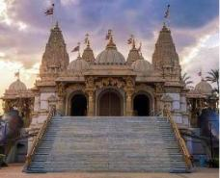

The Place of Worship is _____________________________. (1 mark)

- Standard five pupils visited places of worship and came across the symbols and mantras

shown below. Match the symbol with its correct Mantra (2 marks)


Namo ari hantanam


Satnam karta purakh

- Grade four learners found out that their classmate is unable to go for a school trip due to lack of money. They approached their headteacher and requested to help in raising money needed for the trip. The principle demonstrated by the learners is _________________.
(1 mark)

- While watching videos on Enlightened Beings, Asha realised that there is a snake around the neck of Lord Shiva as shown in the picture below. Tick what the symbol of the snake
reminds the devotees to do. (1 mark)
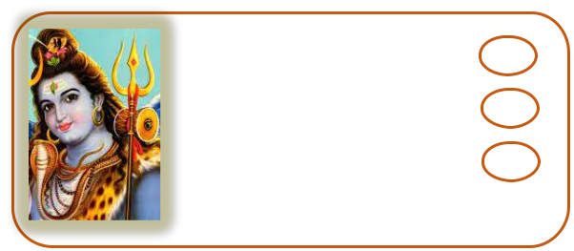

Fear Lord Shiva

Not fear snakes

Respect all creatures

- Rima saw a baby monkey who was hurt in her garden. She took it home and nursed it back to health. The principle that guided Rima is _______________________________
(1 mark)

- During his travels, Guru Nanak Devji was once invited to eat at a poor carpenter’s home.

In the same village, lived a proud rich man. Guru Nanak was invited for a meal there too. The poor man’s rotis oozed milk and the rich man’s roti oozed blood. This story teaches
us the principle of _______________________________________. (1 mark)

- Shri Krishna and Sudama were childhood friends in Gurukul . Shri Krishna became the King of Dwarka and Sudhama worked as a poor Brahim priest. Many years later, Sudham a went to Shri Krishna at his palace. Krishna welcomed Sudhama with open arms. This story teaches us that _____________________________________________________.

(1 mark)

- Grade Six teacher noticed that Parit has been coming to school late. On enquiring, the teacher learnt that Parit’s mother is unwell and Parit is helping with house chores. The teacher visited Parit at home and offered to take his mother to the hospital. The value that the teacher demonstrated is ________________________________________________.
(1 mark)

- The following balloons show ways of developing friendship with Paramatma. Choose

the one that has the best ways. (1 mark)


Praying | Trusting
Chanting | Praying
Meditating | Helping others

- Grade five learners participated in the tree planting exercise that was taking place in their locality. By doing this they were being ______________________________________.

(1 mark)

- A resource person was invited to talk to learners on different types of Utsavs that are

found in different faiths. Give one reason why you celebrate Utsavs. (1 mark)

- The following are Utsavs that are celebrated from various faiths. Match them with their

correct faith. |  |  | (2 marks)
 | UTSAV | FAITH
Maha Shivratri |  | Sikhism
Paryushan Purva |  | Sanatan
Vaisakhi |  | Buddhism
Wesak |  | Jainism
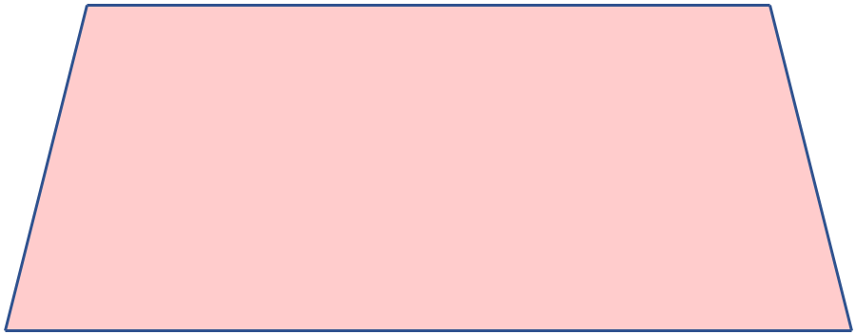

- Sonia was invited by Khilna, a Jain devotee to join them in the celebration of Paryushan Purva. While there __________________________________ activities were performed.

(1 mark)


- A yoga instructor told the learners to perform the of asana shown in the picture

above. What type of asana is it? (1 mark)

______________________________________________________________

- Grade Six learners were tasked by their class teacher to be performing asanas every morning. What are the benefits of performing the asana that is given in

the picture above daily? (3 marks)

______________________________________________________________

______________________________________________________________

______________________________________________________________

PERFORMANCE TASKS:

- The learners to use digital devices and research on Narsimha.

(i) Print a picture of Narsimha coming out of a pillar. (1 mark)

(ii) Make a short presentation about what the picture represents. (2 marks)

THIS IS THE LAST PRINTED PAGE.

