- Buddhism/Jainism

- Paramatma is the provider and sustainer of all creation

- Elephant

- Plants provide food and oxygen to human beings while human beings take care of the plants

- Kalpasutra

- Hanuman – Sewa

- Mahabharat / Bhagwath Gita

- To enhance concentration; to have calm mind; for relaxation

- Derasar


10. | Satnam karta purakh
 | Namo ari hantanam
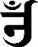

- Friendship/compassion/kindness

- Respect all creatures

- Compassion/care/love/kindness/pranidaya

- Dharam ki kirat

- Status does not matter for friends/loyalty/love

- Generosity

- Praying, chanting and meditating.

- Conserving the environment

- To socialise/strengthen unity

- Mahashivratri - Sanatan Paryushan Purav - Jain

Vaisakhi - Sikh Bhuddhist - Buddhist

- Langar/prayer (akhand path)/prasad/sewa

  - Padmasana/Sukhasana

  - Improves posture/enhances breathing technique/mental peace/improves concentration of the mind.
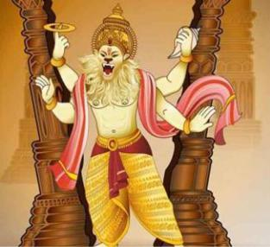

23. i.

The teacher to ensure that the learner

- prints the correct image of the Narsimha.

- In the presentation, the learners to briefly talk about the circumstances that led Narsimha to break through the pillar, and rescue Prahlad.

- Talk about the importance of this Avatar of Lord Vishnu.

Talk about the reason why Lord Vishnu had to appear in this avatar.

Checklist to assess the image and presentation of Narsimha.

Tick to indicate the learner’s demonstration of the stated attributes accordingly.

S/No. | Criteria | Very satisfied | Satisfied | Not satisfied.
i. | The image printed
ii. | Presentation
iii. | Mastery of content
iv.
Learner’s Performance level

