THE KENYA PRIMARY SCHOOL EDUCATION ASSESSMENT

SCHOOL BASED ASSESSMENT
ENGLISH

SECTION B

GRADE 6 – 2025

LEARNER’S NAME: ______________________

GRADE: ________

ASSESSMENT NUMBER: __________________

DATE: __________

SCHOOL NAME: __________________________

Instructions to the Learner

Answer all the questions in the spaces provided.

Time: 1 Hour 30 Minutes

For Teacher’s Use Only

Task 3 | Task 4 | Task 5
Reading | Grammar | Writing
Comprehension | (Questions 17 - 30) | (Question 31)
(Questions 1 - 16)

Learner’s Score

Performance Level

1

SECTION B

TASK 3: READING COMPREHENSION

Read the following story and then answer the questions in the spaces provided.

One day, Boni was sent to fetch water from a borehole far away from home. He had to use a donkey. He tied four empty plastic jerricans on the donkey’s back. Boni’s mother gave him some roasted potatoes, and he set off immediately.

Once outside the gate, Boni jumped onto the back of the donkey. He usually enjoyed riding on it. Suddenly, three huge black dogs appeared from nowhere and started barking while circling the donkey. It kicked several times to keep the fierce dogs away. Then the donkey jumped and sped off dangerously. All this time, Boni was clinging on its back. The jerricans fell off as the donkey galloped away with the dogs chasing it.

Boni lost his grip on the donkey’s back and fell. He tried to stand but was unable to move his legs. He passed out.

When he woke up, he was inside a vehicle with his mother beside him.

“Where are we?” he asked her.

“We are in an ambulance going to hospital,” she answered.

2

Just then, Boni realised he had a deep cut on his left leg. In a few minutes, they reached the hospital where he was treated and allowed to go back home.

1. Why does Boni use a donkey?

___________________________________________________

___________________________________________________

- Why did Boni cling on the donkey’s back?

___________________________________________________

___________________________________________________

3. What lesson did Boni learn from the accident?

___________________________________________________

___________________________________________________

4. The word “galloped” as used in the story means ________.

ran

jumped

moved

Read the following story and then answer the questions in the spaces provided.

Children can do many chores at home after school. The chores can be done both indoors and outdoors. Inside the house, they can make their beds, sweep the floor, and clean the windows. They can also wash utensils and prepare meals.

Outside the house, they can cut grass, clean the compound, care for domestic animals, and help in the farm. Some people think indoor chores are for girls and outdoor ones for boys. This is not correct. Both boys and girls should take part in all types of house chores. This way, children will grow up to become useful and responsible members of the society, who are able to perform different tasks.

- Why should both boys and girls take part in all types of house chores?

_________________________________________________

_________________________________________________

- Which one of the following chores can be done both inside and outside the house?

  - Making beds

  - Cutting grass

  - Sweeping dirt

- The word “chores” means the same as _______.

occupation

service

work

- What will happen if we do not take care of domestic animals?

_________________________________________________

_________________________________________________

Read the following story and then answer the questions in the spaces provided.

“Fire! Fire!” a voice tore into the night. It was clearly the voice of Javan, the boy who was all alone in their house. His parents had just rushed their baby to hospital in an ambulance leaving him to do his homework. We were neighbours. I jumped out of my bed and ran out of the house. In the darkness, I could see smoke from their house. A few people were trying to fight the fire in different ways.

“Please save her!” shouted Javan.

“Relax. We have already called the fire brigade. They are on their way

here,” came my father’s voice. I had not realised he was here too.

“Don’t let her get burnt,” pleaded Javan. Everyone wondered who he was

talking about.

Soon, a siren was heard, and a fire brigade lorry sped into the compound. Four fire fighters jumped off the lorry, pointed the hosepipes at the burning house and within minutes, the fire had been put out.

“Who lives here?” asked the leader of the fire fighters. “It is our house,” said Javan. “But is she safe?” “Who?” asked several voices. “Lola”.

“Who is Lola?” my father asked impatiently.

“My new kitten,” Javan replied.

Suddenly, a cat miaowed inside the house.

“Lola!” shouted Javan and he rushed in. He then came back holding a white kitten close to his chest.

“He must have knocked the paraffin lamp as I slept,” Javan explained.

“Why did you leave the lamp on?” asked the fire fighter.

“I did not want Lola to be frightened by the darkness,” replied Javan.

“You need to be careful next time,” the leader said.

The fire fighters then left. We also went back to our beds. Javan and his kitten had ruined our sleep.

- How did the writer know that it was Javan shouting?

_________________________________________________

_________________________________________________

- Give one way in which the people could have been trying to

fight the fire.

_________________________________________________

_________________________________________________

- What would have happened if the fire fighters had not arrived in time?

_________________________________________________

_________________________________________________

- Which one of the following words best describes the writer’s
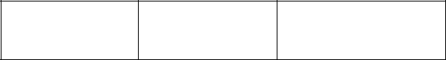

father?

generous brave

responsible

Read the following story and then answer the questions in the spaces provided.

Most telephone conversations are different from face-to-face ones. This is mainly because while talking on phone, we do not normally see the face of the person we are talking with, unless when making a video call. We can tell whether they are happy or not only through what they say. In a face-to-face dialogue, a smile would show friendliness, but in a telephone chat, the smile cannot be seen.

Therefore, while talking on phone, we need to be careful about the words we use. Polite words like “Please”, “Excuse Me”, “May I”, “Thank you”, “it’s my pleasure” and “I beg your pardon” show that we respect and appreciate the person we are talking to on phone. We should try to use these words more frequently not only when talking on phone, but also in our face-to-face conversations.

- How do telephone conversations differ from face-to-face ones?

___________________________________________________

___________________________________________________

- How can we tell that one is not friendly in a telephone conversation?

___________________________________________________

___________________________________________________

- What is the benefit of using words like “Please” and “Thank you” in a telephone conversation?

___________________________________________________

___________________________________________________

8

- Give one word used in the passage that means the same as

“conversation”.

___________________________________________________

___________________________________________________

TASK 4: GRAMMAR

Write in each blank space the correct word from the box.

- Lena did not come to school ______ she was feeling sick.

sinceyetalthough
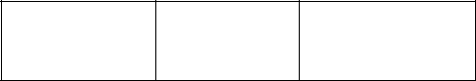
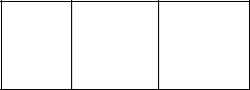

- Abdi was very tired _____ he walked slowly.

so but nor

Fill in the blank spaces with the correct word given in the box.

- This bag is too heavy to carry, ___ it?

isn’t is
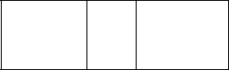

does
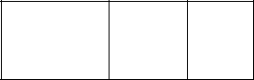

- We do not go to school on weekends, __ we?

don’t did do

Choose a word from the box to complete each of the sentences below.

- It is interesting to watch ducks swim _____ the river. over across about
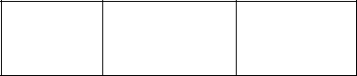

9

- The monkey sat ______ a branch of a tree.

in

on
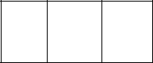

at

- Our teacher told us that we will be _____ parliament next
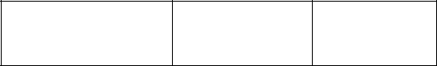

week.

visiting visited visit

Choose a word from the box to complete the sentences below.

- During the art competition, Titi drew a _____ picture than

Kato. | better | good | best

- After weighing ourselves, we discovered that Juma was
_{_____ than I.} heavy heavier heaviest
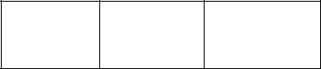
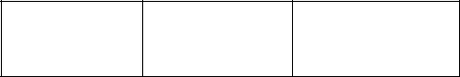

- Amida is ______ careful than her sisters.

most very

more

Choose a word from the box to complete the sentences below.

- We saw the man ____ came to our school last week. who which whom

- When the children arrived at the birthday party, they found
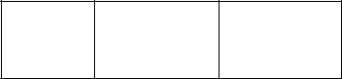

that almost ____ had left.

everybody anybody nobody

10

Rewrite the following sentences according to the instructions given after each.

- Rono carried the bag. (Begin: The bag…)

_____________________________________________________

_____________________________________________________

- Grade 6 learners sang the national anthem. (Begin: The national anthem…)

_____________________________________________________

_____________________________________________________

TASK 5: WRITING

- Write a composition about the day an important visitor came

to your school.

_______________________________________________________________

_______________________________________________________________

_______________________________________________________________

_______________________________________________________________

_______________________________________________________________

_______________________________________________________________

_______________________________________________________________

_______________________________________________________________

_______________________________________________________________

_______________________________________________________________

11

_______________________________________________________________

_______________________________________________________________

_______________________________________________________________

_______________________________________________________________

_______________________________________________________________

_______________________________________________________________

_______________________________________________________________

_______________________________________________________________

_______________________________________________________________

_______________________________________________________________

_______________________________________________________________

_______________________________________________________________

_______________________________________________________________

_______________________________________________________________

_______________________________________________________________

_______________________________________________________________

_______________________________________________________________

_______________________________________________________________

_______________________________________________________________

_____________________________________________________________

THIS IS THE LAST PRINTED PAGE

12

