KENYA PRIMARY SCHOOL EDUCATION ASSESSMENT

SCHOOL BASED ASSESSMENT

AGRICULTURE AND NUTRITION

GRADE 6 - 2025

Learner’s name:…………………………..………….…………………Grade: ……….

School’s Name : ……………………………………Assessment No………………........

Date: …………………….……………………………………………………………….

 | EXCEEDING EXPECTATION | MEETING EXPECTATIONS | APPROACHING EXPECTATIONS | BELOW EXPECTATIONS

- Grade 6 learners wanted to demonstrate soil erosion in class. They prepared the set up shown below.
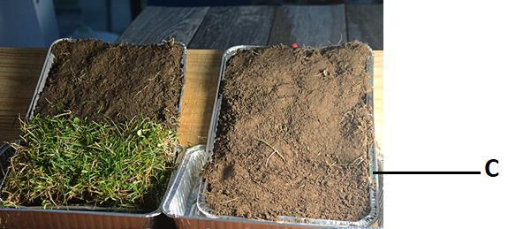

a) | Name one material that can be used for the part labelled C. | (1 mark)
 | __________________________________________________________________
b) | What should the learners do to demonstrate soil erosion using the set up?
 |  | (1 mark)
 | __________________________________________________________________
 | __________________________________________________________________
c) | Name two type of soil erosion that can be demonstrated by the learners using the
 | set up. | (2 marks)
 | __________________________________________________________________
d) | Give two reasons why the grass was included in the set up. | (2 marks)
 | __________________________________________________________________
 | __________________________________________________________________

2. Grade 6 learners prepared a seedbed and planted maize as shown in the picture below.
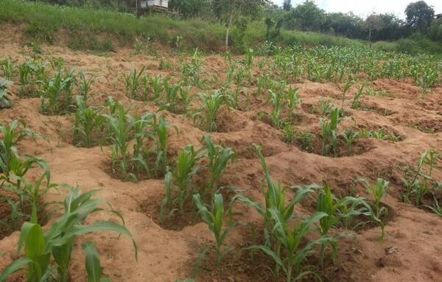

a) Identify the type of seedbed prepared by the learners. (1 mark)

__________________________________________________________________

(b) Why did the learners use the type of seedbed shown in the picture to plant maize?

(1 mark)

__________________________________________________________________

(c) Instead of using the seedbed shown in the picture, give two other ways in which

the learners could have planted the maize. (2 marks)

__________________________________________________________________

__________________________________________________________________

(d) Name two caring practices the learners carried out on the growing maize crop.

(2 marks)

__________________________________________________________________

__________________________________________________________________

3. Grade 6 learners planted the trees shown below in the community.
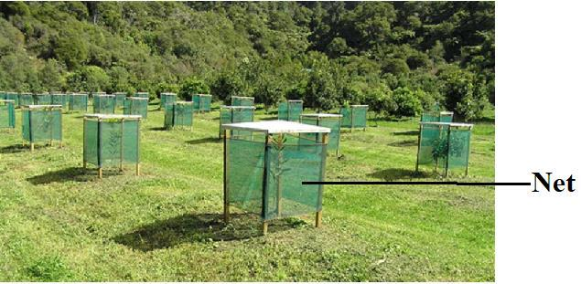

a) | Why did the learners protect the trees as shown above? | (1 mark)
 | __________________________________________________________________
 | __________________________________________________________________
b) | Name two materials that can be used instead of the net. | (2 marks)
 | __________________________________________________________________
 | __________________________________________________________________
c) | Give one other way in which the learners can protect the trees instead of the
 | method shown above. | (1 mark)
 | __________________________________________________________________

4. The picture below shows a creeping crop grown by Grade 6 learners.
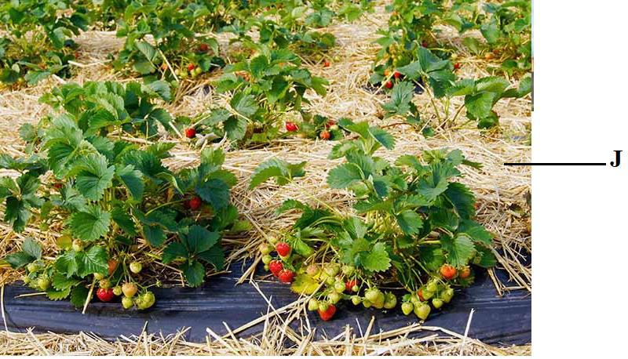

(a) Identify the creeping crop. (1 mark)

__________________________________________________________________

- Name the planting material the learners used to grow the creeping crop. (1 mark)

__________________________________________________________________

(c) Give two ways in which the learners prepared the planting materials. (2 marks)

__________________________________________________________________

__________________________________________________________________

(d) Name the caring practice labelled J. (1 mark)

__________________________________________________________________

__________________________________________________________________

(e) Give two reasons why the caring practice was carried out. (2 marks)

__________________________________________________________________

__________________________________________________________________

5. The picture below shows domestic animals reared at home.
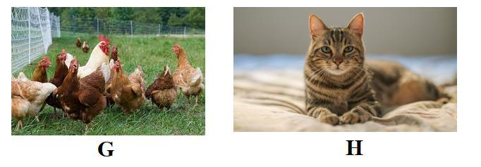

(a) Identify the domestic animal labelled

(i) G

(1 mark)

______________________________________________________________

(ii) H

(1 mark)

______________________________________________________________

(b) Give two reasons for rearing the domestic animal labelled H. (2 marks)

__________________________________________________________________

__________________________________________________________________

- Give two rearing practices carried out for the domestic animals labelled G. (2 marks)

__________________________________________________________________

__________________________________________________________________

- From the picture, how are the domestic animals labelled G protected from wild

animals? (1 mark)

__________________________________________________________________

__________________________________________________________________

- The picture below shows farmers carrying out a caring practice on an organic legume crop.
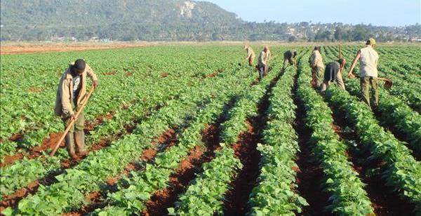

(a) Identify the caring practice being carried out. (1 mark)

__________________________________________________________________

(b) Name three other organic gardening practices carried out on growing legume crop.

(3 marks)

__________________________________________________________________

__________________________________________________________________

__________________________________________________________________

(c) Give two safety measures the farmers should observe when working with the tool

shown in the picture. (2 marks)

__________________________________________________________________

__________________________________________________________________

7. The picture below shows a control measure for a wild animal on the farm.
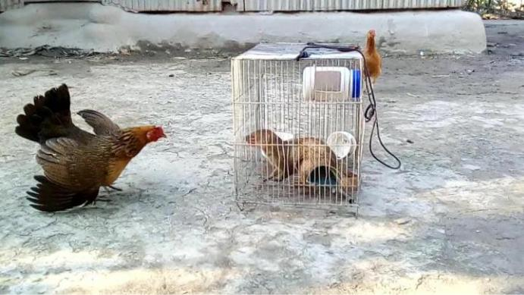

(a) Name the method used to control the wild animal. (1 mark)

__________________________________________________________________

(b) Give one reason why the wild animal is controlled. (1 mark)

__________________________________________________________________

(c) What should the farmer do with the trapped wild animal? (1 mark)

__________________________________________________________________

(d) Give one other way in which the wild animal can be controled. (1 mark)

__________________________________________________________________

- A group of Grade 6 learners were talking about the physical changes that occur during adolescence.

Write two physical changes that occur only in girls. (2 marks)

…………………………………………………………………………………………………………

…………………………………………………………………………………………………………

- Your friend Kanairo’s school uniform is always dirty, and he has developed bad body smell. Write

two good grooming habits you would advise him to practice. (2 marks)

……………………………………………………………………………………………………………

……………………………………………………………………………………………………………

- Mrembo always applies too much make-up and sometimes she applies them on a dirty face. Write two

problems Mrembo is likely to experience with this behaviour. (2 marks)

……………………………………………………………………………………………………………

……………………………………………………………………………………………………………

- Keru is not feeling well and has been advised by his doctor to avoid dust, smoke or cold. Identify the

non-communicable disease Keru is likely to be suffering from. (1 mark)

……………………………………………………………………………………………………………

……………………………………………………………………………………………………………

- (a) Saving is the balance you are given back after paying for items bought from the shop.

True or False. (1 mark)

……………………………………………………………………………………………………………

(b) “I do not need a budget for me to spend my hard earned money.” Daniela overheard her father tell his friend. Write two reasons you will use to convince Daniela’s father on the importance of

making a budget. (2 marks)

……………………………………………………………………………………………………………

……………………………………………………………………………………………………………

- Look at the food item displayed by the teacher.

(a) Identify the mineral found in the food item. (1 mark)

……………………………………………………………………………………………………………

- The following are steps that can be used to preserve the food displayed by the teacher using sun drying method. The steps are not arranged in the correct order.

  - Spread it on a tray or a mat where there is free flow of air.

  - Cover it with a wire net to prevent flies.

  - Wash it thoroughly in clean water to remove dirt.

  - Regularly turn the food as it dries.

  - Put the dried food in a container with a tight lid.

  - Dip the food in hot water for one minute then remove and dip in cold water for one minute. Arrange the steps in the correct order by filling the table below with the letters representing each

step.

STEP 1

STEP 2

STEP 3

STEP 4

STEP 5

(3 marks)

STEP 6

- Kiki is not feeling well. She is complaining of dizziness and sometimes she faints. Her eye lids and

fingernails are also pale. Write the nutritional deficiency Kiki could be suffering from. (1 mark)

…………………………………………………………………………………………………………

…………………………………………………………………………………………………………

- Grade 6 learners at Divine Mercy Junior Primary School have been asked by their teacher to prepare

and preserve meat they are planning to use during a home science lesson. Write two hygiene measures

they should observe while preserving the meat. (2 marks)

…………………………………………………………………………………………………………

…………………………………………………………………………………………………………

…………………………………………………………………………………………………………

- Look at the pictures of fuels below.
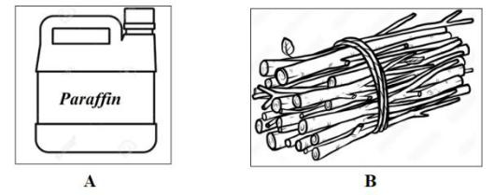

Identify one cooking equipment that uses fuel A and fuel B. A……………………………………………………………………………………….. (1 mark)

B………………………………………………………………………………………… (1 mark)

- Peter, a Grade 6 learner has been visited by his friends. He is planning to serve them lunch. Write

three suitable foods that contain varied nutrients he can serve his friends. (3 marks)

…………………………………………………………………………………………………………

…………………………………………………………………………………………………………

…………………………………………………………………………………………………………

- Jane observed her brother frying meat in a sufuria. He added a little water and then left it to cook over low heat for about 30 minutes in a covered sufuria.

(a) Identify the method of cooking that her brother used. (1 mark)

………………………………………………………………………………………………………..

  - Write one safety measure that Jane’s brother must have observed while cooking the meat. (1 mark)

…………………………………………………………………………………………………………

…………………………………………………………………………………………………………

- Fatuma wants to bake a variety of foods for her sister's birthday party. Apart from baking a cake, write

one other food she can prepare using baking method. (1 mark)

…………………………………………………………………………………………………………

…………………………………………………………………………………………………………

- Look at the needlework tools displayed by the teacher.

Write one way of storing each of the tools displayed after use. Fill the table below. (2 marks)

Tool

X

Y

How to store the tool


- Grade 6 learners at Garissa Academy Primary School were told by their teacher to write the steps followed when washing a white cotton shirt. Below are some of the steps they wrote.
STEP 1:Empty the pockets.

STEP 2:Shake the shirt to remove loose dirt.

STEP 3: | Soak the shirt in cold water for about 15 to 20 minutes.
Write the three steps remaining to complete the process of washing the shirt. |  | (3 marks)
STEP 4: | ______________________________________________________________
STEP 5: | ______________________________________________________________
STEP 6: | ______________________________________________________________

THIS IS THE LAST PRINTED PAGE

