X-ray
12. a) State the energy changes that take place in an X - ray tube
b) Electrons in an X-ray tube are accelerated by a potential difference of 40 kV. If 20 % of the
electrons are converted into X- rays, determine the maximum wavelength of the emitted
electrons.
c) i) Draw a simple circuit consisting of a photocell to show the direction of flow of current
ii) The diagram below shows a wave form displayed on a CR0 screen.
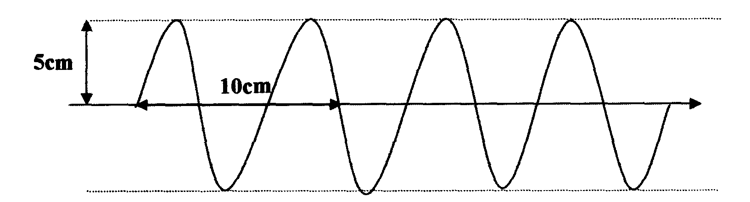

If the Y — gain reads 0.5V cm⁻¹ while the time base is set at 0.1 ms cm⁻¹, determine the amplitude
and frequency of the wave.

X-ray
1. Give one use of X –rays in medicine
2. State the factor that affects:-
(i) The intensity of X-rays
(ii) The strength of X-rays
3. An x-ray tube must be highly evaluated. Give a reason for this
4. a) In the production of X- rays, electrons are directed at a tungsten target. State a reason why
the target is made of tungsten
b) How can the intensity of the X-rays tube be increased?
5 a) Arrange the following waves in order of increasing frequencies: microwaves, x-rays,
Infra-red, ultra-violet
b) The table below shows the electromagnetic spectrum;
Gamma  rays | A | Ultra  violet | B | Infra red | Radio  waves
i) Identify A and B
ii) State one use for each

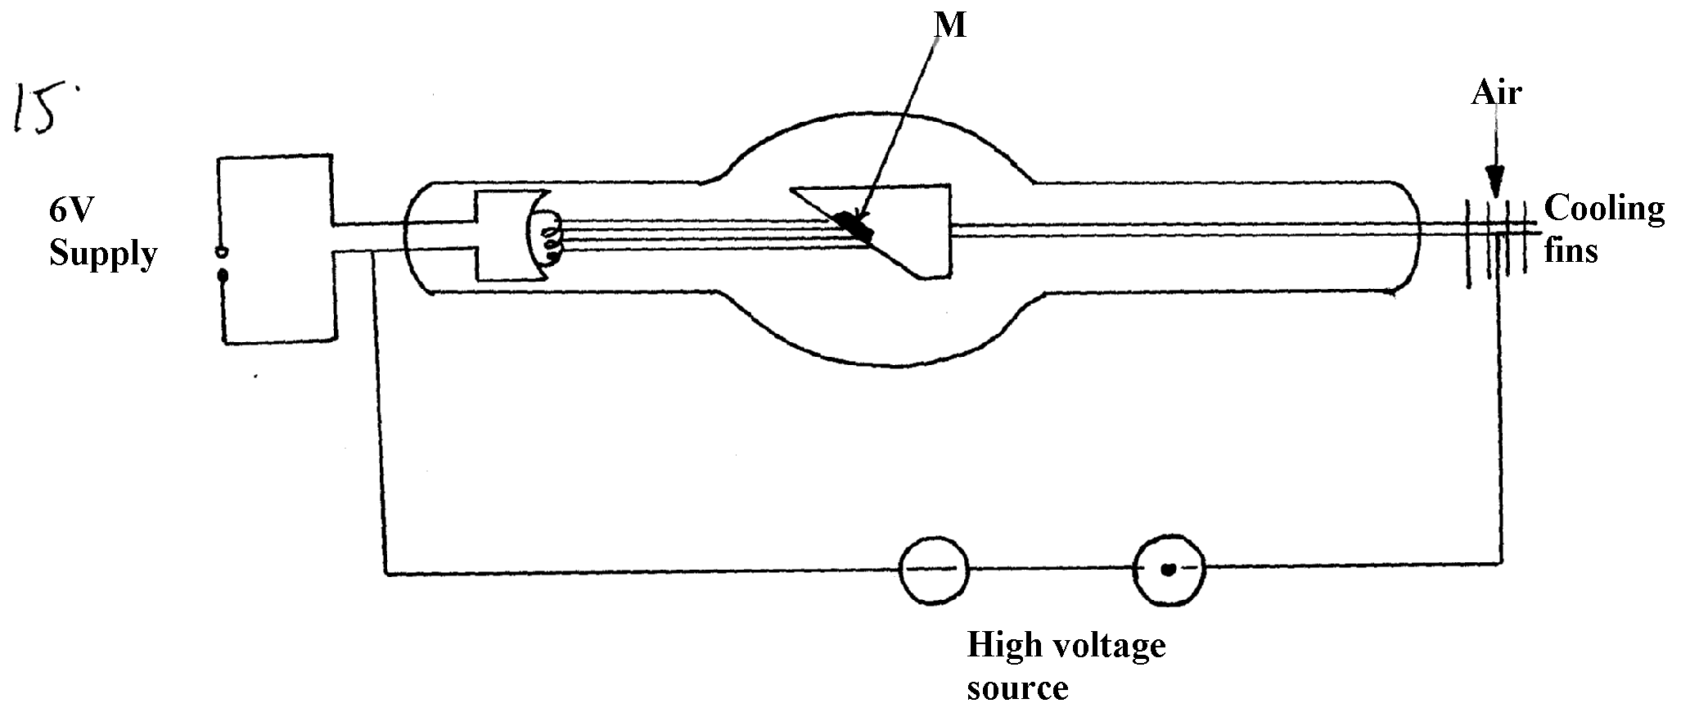
6. Figure 12 below shows an x-ray tube:
figure 12

•

(a) Indicate on the diagram the path of x-ray beam supplied by the tube
(b) Why is M set at angle of 45º relative to the electron beam?
(c) Name a suitable metal that can be used for part M and give a reason for your choice
(d) State how the following can be controlled:-
(i) Intensity
(ii) Penetrating power (iii) The exposure to patients
(e) An x-ray tube is operating with an anode potential of 12Kv and a current of 10.0m.A:
(i) Calculate the number of electrons hitting the anode per second
(ii) Determine the velocity with which the electrons strike the target
(iii) State one industrial use of x-rays

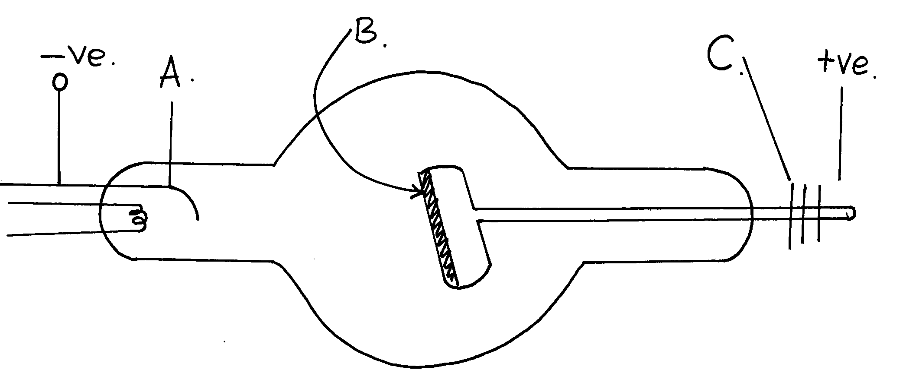
7. (i) The diagram below shows simplified diagram of an x-ray tube,
Figure 8

(a) Name the parts A, B, and C.
(b) What adjustments would be made to:
(i) Increase the penetrating power of the x-rays produced.
(ii) Increase the intensity of the rays produced.
(c) Name a suitable material for the part marked B and give a reason for your choice.
(d) Name a suitable material for the part marked C and sate its purpose.
(e) Why is it necessary to maintain a vacuum inside the tube?
(f) State one use of x-rays in the following areas; -
(i) In medicine
(ii) In Industry.

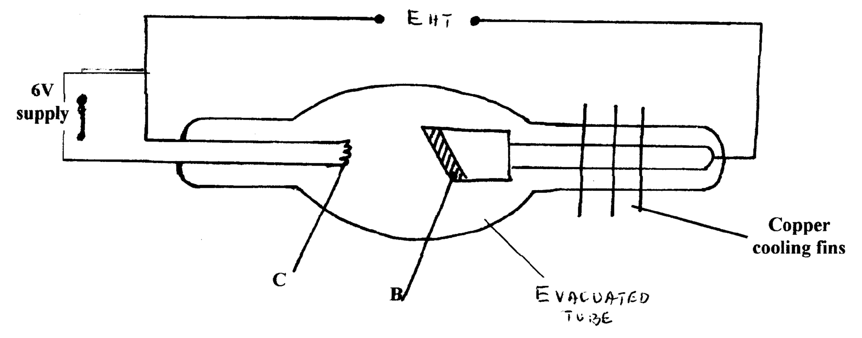
8. a) The figure shows the circuit of a modern X-ray tube
EHT

Evacuated tube

i) Indicate the path of the X-ray beam supplied by the tube
ii) Name the part labeled C and state its function (2 mks)
iii) If the tube above is operated at an accelerating potential of 100kV and only 0.05% of
the energy of the electrons is converted to X – rays, calculate the wave length of the
generated X-rays. (Take electric charge e = 1.602 x10⁻¹⁹C, planks constant
h = 6.63 x 10⁻³⁴ Js, and speed of light c = 3.0 x 10⁸m/s)
iv) State two properties of X-rays
v) State one industrial application of X-rays

9. Below is a nuclear reaction
²³²
⁹⁰
K
²²⁸
⁸⁸
^{X}
^{Y}
Y- radiation
A B C

i) Identify radiation K
ii) Determine the value of X and Y

10. a) State the energy changes that take place in an X - ray tube
b) Electrons in an X-ray tube are accelerated by a potential difference of 40 kV. If 20%
of the electrons are converted into X- rays, determine the maximum wavelength of the
emitted electrons.
c) i) Draw a simple circuit consisting of a photocell to show the direction of flow of current
ii) The diagram below shows a wave form displayed on a CR0 screen.

If the Y — gain reads 0.5V cm⁻¹ while the time base is set at 0.1 ms cm⁻¹, determine the
amplitude and frequency of the wave.

11. The table below shows results obtained in an experiment to determine the internal resistance
of a cell
V(V) | 0.4 | 0.5 | 0.6 | 0.7 | 08 | 1.3
R(Ω) | 0.45 | 0.65 | 0.80 | 1.05 | 1.40 | 2.4
¹/_{V} (V⁻¹)
¹/_{R}(Ω⁻¹)

i. Complete the table for values of ¹/_{V} and ¹/_{R} giving your answers to 3 d.p
ii. Plot a graph of ¹/_{V} against ¹/_{R}
iii. Use the graph to determine the e.m.f E and the internal resistance r of the cell given that
E = r 1
+
V R

X-ray
1. Treatment of cancer, tumors
2. (i) Size of heater current/filament current



(ii) Accelerating potential/kinetic energy of elctrons/anode Voltage
3. To avoid collisions between the moving electrons and air particles
4. a) – Tang stein has high melting point and therefore it would not met at elevated temperatures
b) – Increasing filament voltage or heating current
5. a) Micro waves, infrared, ultra violet X – rays
b) i) A – X – rays B – visible light
ii) - X – rays – viewing bone fracture/ foreign objects in the body
- Visible light – ordinary photography/ optical fibre
6. (a)
1

1
(b) - To direct x-rays out of the tube through the window on the shield.
1
(c) - Tungsten or molybodenum.
1
- High melting point thus it can withstand high temperature.

(d) (i) Heater current (Filament current)
(ii) Anode potential (operating potential)
(iii) - Covering with protective materials where x-rays are not required
- Minimize exposure time as much as possible
- Reduce number of exposure as much as possible (any 1-1mk
(e) (i) Q = Jt = 10 x 10-3C (= 1.6 x 10-19C)
10 x 10⁻³C = 1.6 x 10⁻¹⁹ x n
n = 10x 10⁻³ = 6.25 x 1016 electrons
1
1.6 x 10⁻¹⁹
1

(ii) ½ m_{e}V² = eV
V = 2eV
1
me
= 2 x 1.6 x 10-19 x 12000
1
9.1 x 10-31
1
= 4.2198 x 10¹⁵
= 6.496 x 107m/s

(iii) - Detecting fault in metals or other structures.
- Controls quality of manufacturer items e.g tyres, thickness of sheets, papers e.t.c.
- Analysis of gem stones. (Any one-1mk

7. (a) A – cathode B – Anode C – Cooling fins
(b) (i) increase the p.d at the anode (B)
(ii) : increase the cathode heater current
(c) Tungsten:- It has a high melting point so the heat produced will not melt it easily
(d) Copper – it is used to cool/conduct heat away from the anode
(e) So that the electrons do not collide with gas molecules which could result in loss of energy.
(f) (i)Detecting fracture in bones
(ii) Detecting flaws in metals



8. a) i) Name the part labeled C and state its function
- C is the cathode.
- It produces electron thermionically
iii) (Take electric charge e = 1.602 x10-19C, planks constant
h = 6.63 x 10-34 Js, and speed of light c = 3.0 x 108m/s
Energy of X –rays f = 8.01 X 10⁻¹⁶
£ = 5/100 X 100 kV X 1.602 X 10 -19 c
6.63 X 10 ⁻ ³⁴
= 8.01 X 10 ⁻¹⁶ j = 1.208 X 10 ¹⁸ HZ
λ = c λ = 3.0 X10⁸ m/s
f 1.208 X 10¹⁸HZ
= 2.483 X10 ⁻¹⁰m
iv)- They penetrate matter
-They obey properties of electromagnetic waves
  - Diffraction
  - Reflection
  - Obey inverse square law
v) -Used to detect defects in metals in industries
-Used to sterilize medical equipment.
9. i) K- X ii) X = 88 Y= 288

