**Name …………………………………………........... Index No………………………. /………….**

**511/3 Candidate’s Signature……………………**

**MUSIC**

**Paper 3 Date…………………………………………**

**July 2024**

2 ½ Hours

**MOKASA 2 2024**

**Kenya Certificate of Secondary Education**

**MUSIC**

**Paper 3**

2 ½ Hours

**Instructions to candidates**

1. *Write your name and index number in the spaces provided.*
2. *Sign and write the date of examination in the spaces provided.*
3. *Answer all the questions in this paper except in question 4 where you will choose* ***any two*** *of the questions numbered (a)(b)(c) and (d).*
4. *All answers must be written in the spaces provided.*
5. *This paper consists of 10 printed pages.*
6. *Candidates should check the question paper to ensure that all the pages are printed as indicated and that no questions are missing.*

**For Examiner’s Use Only**

|  |  |  |  |
| --- | --- | --- | --- |
| **Section** | **Question** | **Maximum**  **Score** | **Candidate’s**  **Score** |
| **A** | **1a** | **9** |  |
| **1b** | **6** |  |
| **2** | **15** |  |
| **B** | **3** | **14** |  |
| **4** | **14** |  |
| **5** | **10** |  |
| **6** | **10** |  |
| **7** | **06** |  |
| **C** | **8** | **16** |  |
| **Total Score** | | **100** |  |

**SECTION A: BASIC SKILLS (30 Marks)**

**1.**

(a) Continue the following opening to make a melody of sixteen bars for voice introducing a duplet and at least one articulation mark. (9marks)

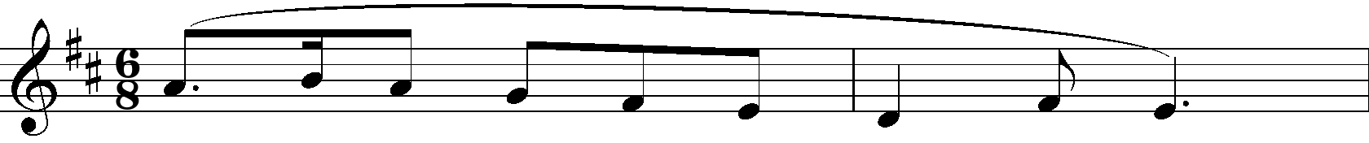









(b) Using Staff Notation, compose a melody and set it to the lyrics below. Add phrase marks.(6 marks)

***‘Oh! The beauty of the spring time, as we travel through the country,***

***Red trees, yellow trees blue and green, oh! what a beauty to explore.”***









1. Harmonize the following melody for Soprano, Alto, Tenor and Bass (SATB). Choose appropriate chords from: I, ii, IV, vi and VI. Use a **dominant 7th**, and a **passing six four**. (15marks)

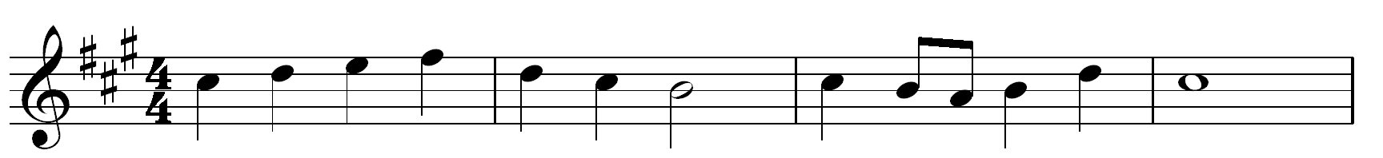





**SECTION B: HISTORY OF MUSIC (48 MARKS)**

**3. AFRICAN MUSIC**

1. Outline any **two** of themain performance styles of African folksongs. (4marks)

………………………………………………………………………………………………………………………………………………………………………………………………………………

1. Identify the instrument and answer the questions that follow.

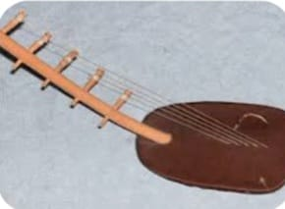

1. Name and origin…………………………………………………………………. (1 mark)
2. Method of tuning………………………………………………………………… (1 mark)
3. Name **two** parts and their roles in sound production (4 marks)

…………………………………………………………………………………………………

…………………………………………………………………………………………………

…………………………………………………………………………………………………

…………………………………………………………………………………………………

1. State how each of the following dances acquire their names. (2marks)
2. Owalo…………………………………………………………………………………………………………..
3. Mabumbumbu…………………………………………………………………………………
4. State any **two** rolesof a Chapuo in an African dance performance. (2marks)

………………………………………………………………………………………………………………………………………………………………………………………………………………………………………………………………………………………………………………………………………………………………………………………………………………………………………………

1. **WESTERN MUSIC.**

*Answer* ***any two*** *of the following questions (a), (b), (c) and (d)*

1. **Thomas Talis**
2. State **two** responsibilities Talis had while at Dover Priory. (2 marks)

……………………………………………………………………………………………………………………………………………………………………………………………………………….

1. Outline **three** benefits of the patent Talis and Byrd were granted by Queen Elizabeth in the year 1575. (3 marks)

………………………………………………………………………………………………………………………………………………………………………………………………………………………………………………………………………………

1. List **two** influences on Tallis’ music career. (2 marks)

………………………………………………………………………………………………………………………………………………………………………………………………………………

1. **G.F. Handel**
2. Outline **two** characteristic features of Handel’s Oratorio (2 mark)

…..……...……………………………………………………………………………………………………

……….………………………………………………………………………………………………………

1. State **two** reasons that led to Handel shifting from composing Operas to Oratorios.

(2marks)

*…………………………………………………………………………………………………………*……………………………………………………………………………………………………

1. Name **two** Operas Handel composed for the Royal Academy of Music to be staged at the Kings theatre in London. (2marks)

*…………………………………………………………………………………………………………*………………………………………………………………………………………………………………………

iv. Name the last Oratorio composed by Handel. (1marks)

………………………………………………………………………………………………………

1. **C. P.E. Bach**

i. C.P.E Bach’s style of composition was described as *‘Sensitive style’*. What were the two characteristics of this style of composition? (2 marks)

………………………………………………………………………………………………………………………………………………………………………………………………………………………………

ii. Which media were the following works by C.P.E Bach composed for? (3 marks)

*-Sei concerti per il cembalo concertato………………………………………………………………………..*

*-Magnificat in D- …………………………………………………………………………………………………*

*-Sonata in A minor- ………………………………………………………………………………………………..*

iii. List any **two** contributions of C.P.E Bach to music during his musical career. (2 marks)

………………………………………………………………………………………………………………………………………………………………………………………………………………………………………………………………………………………………………………………………………………

1. **F. Schubert** 
   * 1. Outline any **two** characteristics features of Schubert’s lieder. (2 marks)

....................................................................................................................................................................................................................................................................................................................................................

* + 1. State **two** roles Schubert played in the student’s orchestra at Stadt Konvikt boarding school. (2 mark)

....................................................................................................................................................................................................................................................................................................................................................

* + 1. Name Schubert’s most popular chamber work. (1 mark)

……………………………………………………………………………………………………….

* + 1. Name one of each of the following works by Schubert. (2 marks)

-Incidental music ……………………………………………………………………….

-Overture ………………………………………………………………………………..

|  |
| --- |
|  |

**5.PRESCRIBED TRADITIONAL AFRICAN MUSIC**

***Kipsigis Planting/Harvest song- Tenwek Primary (KMF)***

1. In what three ways has consistency been achieved in the recording? (3 marks)

………………………………………………………………………………………………………………………………………………………………………………………………………………………………………………………………………………………………………………………………………………………………………………………………………

1. List two styles of performance in the recording. (2 marks)

……………………………………………………………………………………………………………………………………………………………………………………………………

1. Describe the ending of the performance. (3 marks)

…………………………………………………………………………………………………………………………………………………………………………………………………………………………………………………………………………………………………………………………………………………………………….……………………………………

1. Outline two roles of the vocal ornaments used in the performance. (2 marks)

……………………………………………………………………………………………………………………………………………………………………………………………………………………………………………………………………………………………………….

1. **PRESCRIBED WESTERN MUSIC**

***Aria: O Rest in the Lord: Mendelssohn***

1. Analyse the vocal part from bar 11-20 in terms of the following: - (3marks)
2. Tonality

……………………………………………………………………………………

……………………………………………………………………………………

1. Melodic devices used

……………………………………………………………………………………

……………………………………………………………………………………

1. Notate the commonly used rhythmic motif

……………………………………………………………………………………

1. Describe the dynamic range of this work. (1mark)

………………………………………………………………………………………………………………

………………………………………………………………………………………………………………

1. Name the 2nd chord formed at bar 32. (1mark)

…………………………..……………………………………………………………………………………

1. Describe the form of this work citing bar numbers. (2marks)

……………………………………………………………………………………………………………………….……………………………………………………………………………………………………………………….……………………………………………………………………………………………………………………………………………………………………………………………………………….

1. Citing bar numbers, identify any three ways through which variation has been achieved. (3marks)

…………………………………………………………………………………………………………………………………………………………………………………………………………………………………….…………………………………………………………………………………………………….…………….……………………………………………………………………………………………………………………………………………………………………………………………………

**7. Unprepared Analysis**

**Study the music excerpt and answer the questions that follow.**

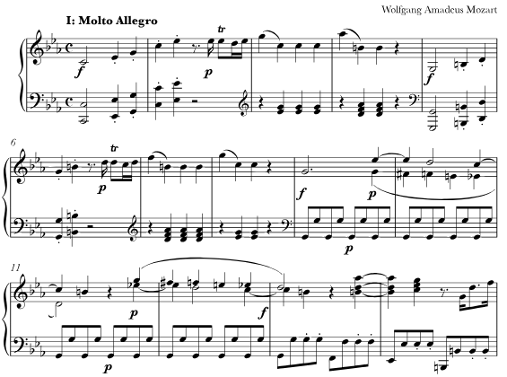

1. State the tonic key of this music. (1mark)

………………………………………………………………………………………………………

1. What is this music scored for? (1mark)

………………………………………………………………………………………………………

1. What term would be used to describe the dynamics in this music? (1mark)

………………………………………………………………………………………………………

1. Citing bar numbers identify a chromatic scalic passage. (1mark)

………………………………………………………………………………………………………

1. In which period was this music composed. (1mark)

………………………………………………………………………………………………………

1. Identify the tempo of this music and give its meaning. (1mark)

…………………………………………………………………………………………………………

**8. SECTION C: GENERAL MUSIC KNOWLEDGE (16 MARKS)**

a) Rewrite the following music as it would be played. (4marks)

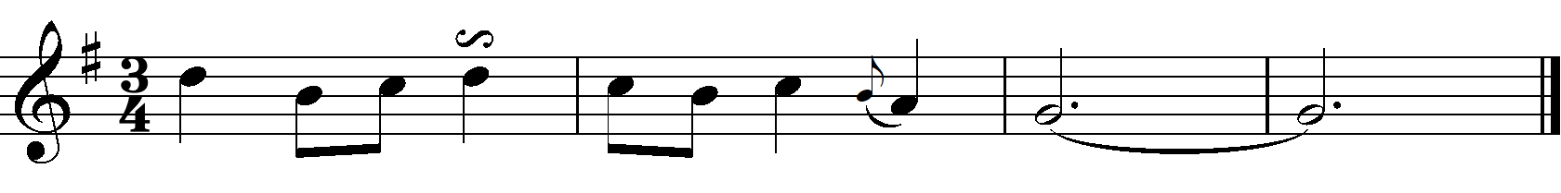



b) Outline any **four** characteristics of the music of the Romantic Period. (4marks)

……………………………………………………………………………………………………………………..…………………………………………………………………………………………………………………………………………………………………………………………………………………………

……………..…………………………………………………………………………………………………

1. State any **two** considerations in the adjudication of each of the following: (4marks)
2. Western choral music

………………………………………………………………………………………………………

………………………………………………………………………………………………………

1. Western instrumental music

………………………………………………………………………………………………………

………………………………………………………………………………………………………

d) i. Outline one positive and one negative effect of social media on the Music industry in Kenya. (2 marks)

…………………………………………………………………………………………………………………………………………………………………………………………………………………………………………………………………………………….…………………………………………………………

ii. Give two important roles played by a manager in a musician’s career. (2 marks)

………………………………………………………………………………………………………………………………………………………………………………………………………………………………………………………………………………………………………………………………………………………………………………………………………………………………………………