- length
1. Two coils which are made by winding copper wire of different gauges and length have the same mass. The first coil is made by winding 270 metres of wire with cross sectional diameter 2.8mm while the second coil is made by winding a certain length of wire with cross-sectional diameter 2.1mm. Find the length of wire in the second coil . (4 marks)
2. The figure below represents a model of a hut with HG = GF = 10cm and FB = 6cm. The four slanting edges of the roof are each 12cm long.

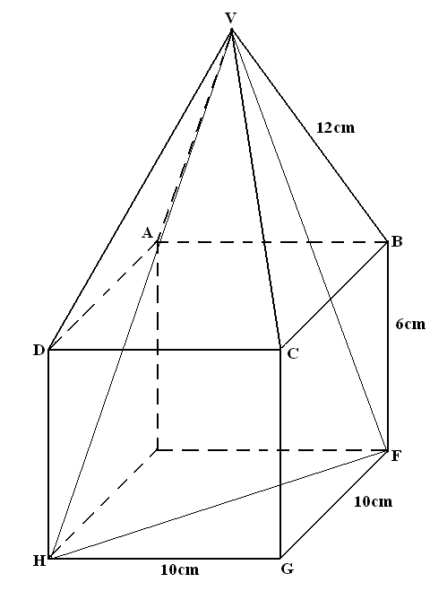

Calculate
  - Length DF. (2 mks)
  - Angle VHF (2 mks)
  - The length of the projection of line VH on the plane EFGH. (1 mk)
  - The height of the model hut. (2 mks)
  - The length VH. (1 mk)
  - The angle DF makes with the plane ABCD. (2 mks)
3. A square floor is fitted with rectangular tiles of periemeter 220 cm. each row (tile length wise) carries 20 less tiles than each column (tiles breadth wise). If the length of the floor is 9.6 m.
Calculate:
a. The dimensions of the tiles (6 marks)
b. The number of tiles needed (2 marks)
c. The cost of fitting the tiles, if tiles are sold in dozens at sh. 1500 per dozen and the labour cost is sh. 3000 (2 marks)
4. Simplify; by factorization:
15x² + xy – 6y²
5x² - 8xy + 3y²

5. Given the matrices M = 3 0 , R = -1 2 and N = ²/₃ 1 . Find the value of value
of 3n + ½ (R-M) -1 4 0 0 2 4

