- Length

1. | Mass = Density x volume  But Density is constant.  x y  Vol (270000 x 2.8): x2.1  = 270000 x 2.8 = 360m  2.1 | M1  M1  M1  A1
 |  | 4
2.  a.)  b.)  C.  d.  e.  f. | 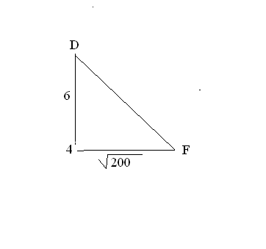  DF₁ = √6² + (√200)²  = 15.362291  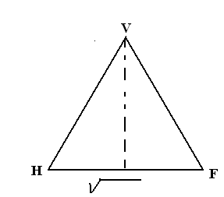  ½ 200  ₂  144 – ½ 200  = 9.6953597  6  + 15. 6953597  Tan Ө = 15.6953597  7.0710678  = 2.219659  Ө = 65.747499º  ½ HF  ½ x √200  = 7.0710678  V  h 12 7.071  D B  √200  √144 – 50 = 9.6953597  Height = 9.6953597 + 6  = 15.69536  V  25.13234  15.219544  H  14.142136  14.142136² + 15.219544²  = 25.13234  BDF  D 14.142136 B  Ө  15.362291 6 cm  F  Ө = 90  6 15.362291  Ө = 90 X 6  15.362291  = 35.15⁰ | M1  A1  M1  A1  B1  M1  B1  B1  M1  A1  10
65^{O}
3 | Dimensions 30 by 80 cm  No of tiles =  Cost =
 |  | 10

4. 3x + 2y) (5x – 3y)
(5x – 3y) (x-y)
= 3x + 2y
x -y

5. 3N + ½ (R-M)
²/₃ 1
2 4
-1 2
0 0
3 0
-1 4
-4 2 1 4
6 12
= 3 + ½ -
2 3
6 12

= + ½
2 3
6 12
-2 1
0.5 -2
= + =
0 4
6.5 10

