**Hygiene Notes Grade 2**

**Topic 1: Healthy practices**

**1:Healthy habits**

Healthy habits are things we do everyday to keep our bodies healthy. Some of the healthy habits are;

* Bathing everyday
* Playing
* Having enough sleep
* Washing our hands before eating and after visiting the toilet
* Brushing our teeth
* Wearing clean clothes
* Drinking boiled water
* Eating healthy foods

**The food we eat in the morning**

The meal we eat in the morning is called breakfast.

We eat breakfast everyday

We should eat breakfast before we go to school

**Foods we eat for breakfast**

Examples of food we eat for breakfast are;

* Tea
* Milk
* Bread
* Boiled green maize
* Sweet potatoes
* Eggs
* Porridge
* Yams
* Banana
* Pumpkins

**Why do we eat breakfast?**

We eat breakfast everyday because;

* It gives us energy to learn and play
* Breakfast makes us healthy
* It is good habit to eat breakfast

**2: Oral hygiene**

**Good oral habits**

Good oral habits are the things we do to keep our mouth and teeth clean

Good oral habits keep our teeth healthy and strong.

Good habits are;

1. Brush your teeth twice a day __ brush in the morning,brush in the evening before going to bed. Use toothbrush, toothpaste and clean water to brush your teeth.
2. Eat hard foods__ hard foods make our teeth strong. Examples of hard foods are; sugarcane,apples,pears
3. Drink milk ___ milk is good for our teeth and bones
4. Visit a dentist ___ visit a dentist at least two times a year.

**Dentist** is a doctor who treats our teeth

**Bad oral habits**

Bad oral habits are bad things we do to our teeth.

These are the bad oral habits. Do not do them

1. Do not bite your finger nails
2. Do not chew sticks and pencils
3. Do not suck your fingers
4. Do not use toothpicks

**Use of different rooms in our house**

**Our house**

Tend lives in Noveti village. He lives with his family. Their house has five rooms. It has one kitchen. There is one living room. There are two bedrooms. Tenda has his own bedroom. There is one bathroom and a toilet in the house.

**Answer the questions**

1. Tenda lives in _____ village
2. The house has ______ rooms
3. Is there a living room ( yes/ no)
4. There are two _____ in the house.

A house has several rooms

1. Sitting room/ living room
2. Bedroom
3. Bathroom
4. Kitchen
5. Toilet
6. Dining room
7. Store

**Uses f rooms in our house**

We use different rooms in our house for different purposes

1. We cook in the kitchen
2. We rest in the living room
3. We sleep in the bedroom
4. We take bath in the bathroom
5. We eat our meals in the dining room
6. We store food and other items in the store.

**Things found in a house**

Some of the things found in a house are;

* Furniture like tables,chairs, cupboards, beds
* Utensils like spoons, plates, sufurias
* Electronics like TV, radio,phones,computers
* Beddings eg blankets, mattress

**Cleaning things in the house**

We clean our house to remove dirt.

Dirt can give a house a bad smell

Dirt can bring rats and cockroaches into our house

Keep the house clean everyday

**Cleaning utensils**

Why do we clean utensils?

We clean utensils after every meal

Dirty utensils can bring cockroaches into the house

Eating food in dirty utensils make us sick

**Utensils** are items we use to cook and serve food.

**Materials used in cleaning utensils**

* Soap,
* drying rack
* Steel wool
* Sponge
* Sisal fibre
* Maize cobs

**How to clean utensils**

Use soap and clean water to wash utensils

1. Put some warm water in a basin. Add soap
2. Wash each utensil in the warm soapy water. Scrub the sufurias with steel wool
3. Rinse the utensils in clean water.
4. Place them on a rack to dry.
5. After, drying store the utensils in a clean place

**Dangers of second hand smoke**

**Things that people smoke**

Some people smoke tobacco

Others smoke cigarettes.

Smoking is bad for our health. It can cause bad diseases.

Never smoke

Use polite language to tell people not to smoke.

**How can you tell if a person has been smoking?**

People who smoke smell tobacco

Some may have stained teeth.

Smoking can make the eyes to look red.

People who smoke may have burnt fingers tips

Smoking can make a person to cough

**What is second hand smoke?**

When people smoke around us,we get second hand smoke.

Second hand smoke is smoke that comes from a person who is smoking

Second hand smoke is bad for our health. It can make us sick.

Stay away from people who are smoking

Use polite language to ask them to stop smoking

**Keeping water safe**

**What is water contamination?**

Water contamination means making clean water dirty.

Doing these things can make water dirty

1. Washing clothes in a river
2. Going for a short call or long call near a river
3. Throwing papers in water
4. Throwing soil in water
5. Animals can also make water dirty.

**How does contaminated water look like?**

Contaminated water has dirty colour.

It has a bad smell

It has dirt in it

Contaminated water is not good for drinking. It can make us sick

**How to prevent water contamination**

We can prevent water contamination by doing these things

1. Covering water containers
2. Covering water wells
3. Not putting dirty things in water
4. Watering animals away from the river
5. Using toilets and latrines

**Reusing water and soap at home**

**What do we use water and soap for?**

We use water at home for;

1. Drinking
2. Washing clothes and utensils
3. Washing vegetables and fruits
4. Washing our bodies

**Reusing water at home**

Reusing water means using water again

* Water used to wash clothes can be reused to clean the floor
* Water used to wash vegetables can be reused to water plants
* Water used to wash hands can also be reused to water plants

**Reusing soap**

When we use soap at home , small pieces of soap remain behind.

The small pieces of soap that remain after using soap are called **soap flakes**

**Soap flakes** can be reused to make a soap gel and a bar soap

**How to make a soap gel**

You will need

Soap flakes, open container, plastic bottles and warm water.

Procedure

1. Cut the soap flakes into small pieces
2. Put them in water
3. Stir the water until the flakes are finished
4. Pour the liquids in bottles. The liquid is called soap gel.
5. Use the soap gel to wash hands

**How to make a bar soap**

You will need

Soap flakes, open container and warm water

Procedure

1. Put the flakes in an open container
2. Add some warm water
3. Leave them to become soft
4. Remove the flakes from the water
5. Press them together to make one big soap
6. Mould the soap into the shape you want.

We reuse water to reduce wastage

We reuse soap to reduce wastage

We should always save water and soap.

**Topic 2: Personal Hygiene**

**Personal items**

Things we use to clean our body

The items we use to clean our bodies are:

* Toothbrush
* Toothpaste
* Towel
* Handkerchief
* Comb
* Nail cutter
* Socks

**Things we should not share**

Personal items should not be share with other people.

Items we should not share are:

* Toothbrush
* Comb
* Face towel
* Handkerchief
* Inner wears/ panties

**How to make personal items**

* We can make a toothbrush from a chewed stick
* We. Can make a handkerchief from an old piece of cloth
* We can make a face towel from an old piece of cloth
* We can also use salt as toothpaste

**Care for personal items**

**Handkerchief**

Use a handkerchief to clean your nose

Use a handkerchief when sneezing

Do not blow your nose with your fingers. This can spread germs to other people.

Do not share your handkerchief. It can make you sick.

**How to clean a handkerchief**

Things you will need are: a basin,soap,salt, clean water and a handkerchief

1. Put some water in a basin
2. Add some soap
3. Add some little salt. Stir the water
4. Wash your handkerchief in the water.
5. Rinse on clean water. Hang to dry.

Wash your handkerchief with soap and salty water.

The salt makes the dirt soft

Always use a clean handkerchief

**Face towel**

A face towel is a piece of cloth we use to dry out face

Wash your face towel when it gets dirty

Do not share your face towel

**How to clean a face towel**

Things you will need are: a basin, soap, water and a face towel

1. Put some water in a basin.
2. Add some soap
3. Wash your face towel
4. Rinse in clean water
5. Hang to dry.

**Combs and hairbrushes**

We use combs and hairbrushes to comb our hair.

Do not share your comb or hairbrush

Sharing combs and hairbrushes can spread ringworms and lice

**How do we clean combs and handkerchief?**

Things you will need: warm water, basin, soap and a small Stick

1. Use a small Stick to remove pieces of hair from the hairbrush and comb. You can also use your fingers.
2. Wash the comb and hairbrush in warm soapy water
3. Rinse in clean water
4. Shake to dry
5. Put the comb and hairbrush in a clean place.

**Toothbrush**

Do not share your toothbrush with other people

Sharing your toothbrush can make you sick.

Sometimes put your toothbrush in warm salty water for about 30 minutes

The warm salty water kills germs.

**Topic 3 : Foods**

**Tastes of food**

Some foods have a sweet taste e.g a ripe banana,ripe mangoes

Some foods have a salty taste e.g cooked food like meat,rice,githeri

Some foods have a bitter taste eg pepper

Other foods have a sour taste.e.g lemon,sour milk

**Eating habits**

Foods and drinks our family and friends like

Our family and friends like some foods

They also do not like some foods

People can like or not like foods because of taste, colour or smell.

Some people do not like unhealthy foods

Unhealthy foods are called junk foods

**Junk foods** are foods that are bad for our health.

**Meals and snacks**

Meals taken in a day

We eat three main meals in a day

We eat breakfast in the morning

We eat lunch in the middle of the day

We eat supper in the evening.

**Snacks**

Snacks are the foods we eat between the main meals.

We can eat a snack at break time in school

We can also eat a snack in the evening before supper.

Examples of foods we eat as snacks are fruits, boiled maize,mandazi, porridge, milk, samosas sweet potatoes, arrow roots and many others

**Grouping of foods**

Foods we get from plants

We get food from different parts of a plant.

Some foods are leaves like cabbages and Sukuma wiki

Some foods are fruits like oranges, tomatoes

Some foods are roots like potatoes, yams, cassava

Some foods are seeds like maize and beans

Some other foods are stems like sugar cane, pineapples, onions

**Foods we get from animals**

Foods we get from animals are: milk,eggs,fish,meat, chicken,

**Foods for school going children**

How much food do you eat

Eat enough food.

Do not eat little food

Do not eat too much food

Share food with those who do not have

**Dangers of eating little food**

Eating little food can make us weak.

Eat enough food everyday

Eat food from plants and animals.

**Dangers of eating too much food**

Eating a lot of food can give us stomach problems

It can make us to vomit

It can make us to pass loose stool

We can become very fat if we eat a lot of food everyday

Being very fat ca make us sick.

**Good eating habits**

**How to serve food on a plate**

Some foods we eat give us energy.

Potatoes and some grains give us energy

Other foods make us grow.

Meat and beans make us grow.

Other foods keep us healthy

These foods are fruits and vegetables

Eat different foods to be healthy

Serve enough food. Do not waste food

**Food advertisement**

**What is food advertisement?**

Food advertisements are messages that tell us to buy some foods.

The messages can be given on television and radio

They can also be written on newspapers, magazines and posters

**How food advertisement make us feel**

Food advertisements can make us like some foods

They can also make us want to buy some foods

Do not buy foods because of an advertisement

Buy foods that are good for your health

**Keeping cooked food clean**

Cook and serve food in clean utensils.

Wash your hands before touching food

Put cooked food in clean utensils. Cover the food

Wear an apron and cover your hair when cooking

**Buying cooked food**

Always buy food from clean place

Buy food from people who are clean

Buy food that is in clean containers

Always buy food that is fresh. Do not buy food that has a bad smell.

Food from dirty places can make us sick.

**Topic 4: Safety Education**

**Keeping our classroom clean**

Things that make our classroom dirty

Things that make our classroom dirty are: bottle tops, waste bottles, waste papers, small sticks, cobwebs and pencil shavings

**Where do we put dirt in the classroom?**

The containers we put dirt in are called classrooms.

When the dustbin is full, the dirt is taken to a rubbish pit.

A rubbish pit is dug in the school compound

Empty the classroom dustbin everyday.

**Collecting and putting away dirt in the classroom**

Keep the class clean by collecting and putting dirt away.

This helps in preventing diseases like sneezing

It also helps in keeping away fleas and jiggers.

Fleas and jiggers can cause illness

**Common accidents.**

Accidents are injuries that happen to our body.

Accidents can cause cuts and pricks.

They can also cause bumps and grazes

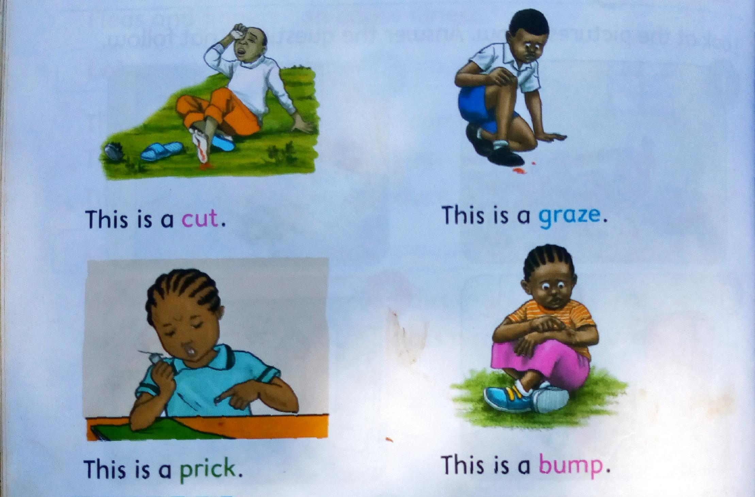

**Things that can cause accidents in the classroom.**

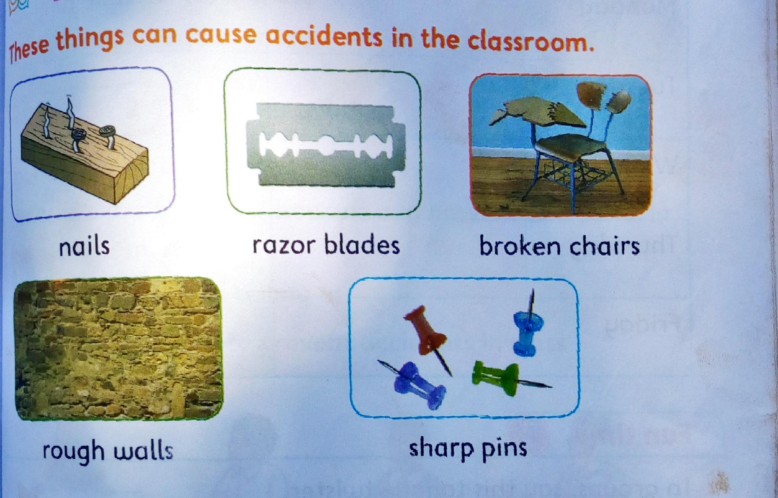

Razor blades can cause cuts

Pins and nails can cause pricks

Rough surfaces of walls can cause grazes.

We can knock our heads on walls and get bumps

Broken desks and chairs can also cause injuries.

**How to prevent accidents in the classroom**

* Keep the class clean
* Arrange desks and tables
* Remove broken objects from class
* Always use sharpener to sharpen your pencil

**Basic first aid**

First aid for common accidents in the classroom

First aid is the help we give to an injured person.

We can give first aid to people who get injuries

If the injuries are big, the person is taken to the hospital

**First aid for a cut**

We can get cut when our skin is hurt by sharp objects.

The first aid procedure for a cut are:

1. Press the cut with your hand to stop the bleeding
2. Clean the wound with clean running water
3. Dry the wound with a clean cloth
4. Cover the wound with a bandage or clean cloth

**First aid for a prick**

We get pricks when our skin is hurt by things with sharp points.

Pins and needles can cause pricks

The first aid procedure for a prick are:

1. Press the injured part with your finger to stop the bleeding.
2. Clean the wound with clean running water.
3. Dry the wound with clean cloth
4. Cover the wound with clean cloth.

**First aid for a graze**

We get grazes when our skin is injured by a rough surface.

The first aid procedure for a grace is :

1. Clean the injured part with clean water
2. Dry the injured part with a clean cloth
3. Apply jelly on the injured part.
4. Leave the part to dry and heal

**First aid for a bump**

You can get a bump when you hit your head on a hard surface like a wall

The first aid for for a bump is:

1. Pour cold water on a clean piece of cloth
2. Place the cold cloth on the bomp for ten minutes
3. Apply jelly on the bump. Leave the part to heal

**END OF THE BOOK**

**REVISION QUESTIONS FROM ALL TOPICS**

1. I eat breakfast _______ going to school ( before, after)
2. Name three foods you eat for breakfast
3. Name the foods in the pictures below

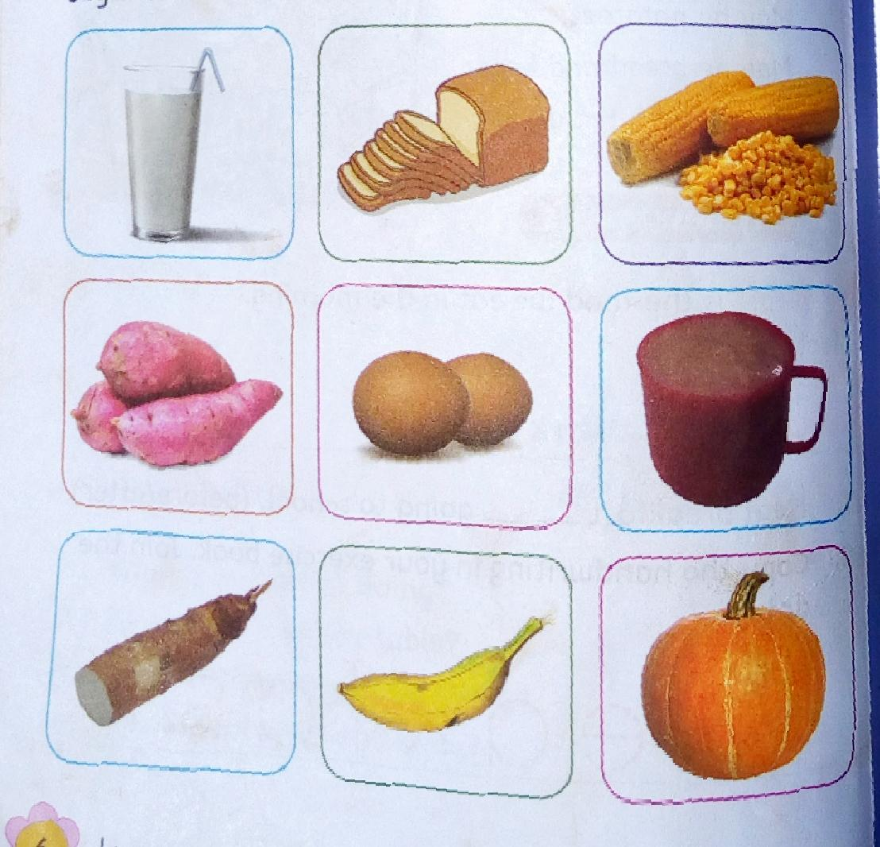

1. I eat breakfast in the ______(morning, evening)
2. Breakfast makes me_____( strong,weak)
3. Good oral habits keep _____healthy( body, teeth)
4. Name two good oral habits
5. Brush your teeth ____a day( once,twice)
6. Hard foods make our teeth ____ (strong,weak)
7. Name two examples of hard foods ______,______
8. A person who treats our teeth is called ____( doctor, dentist)
9. Name two bad oral habits____,______
10. Name the names of the rooms found in your house
11. Where do we cook food in our house _______
12. Where do we rest in our house_____
13. Name the rooms in the pictures below