**GRADE 5**

**SOCIAL STUDIES**

**LESSON NOTES**

**NATURAL AND BUILT ENVIRONMENTS**

**Elements of a map**

A **map** is a drawing that represents the earth or part of it on a flat surface.

The key elements of a map include:

* **Title** - is the name given to a map. It is usually written at the top or the bottom of the map
* **Frame** - is the border that is drawn around a map
* **Key/legend** - contains the symbols and signs that have been used on a map. It shows what the signs and symbols represent. Symbols are small pictures, drawings or letters. They represent real objects on a map.
* **Scale** - shows the relationship between the distance on the map and the real distance on the ground.
* 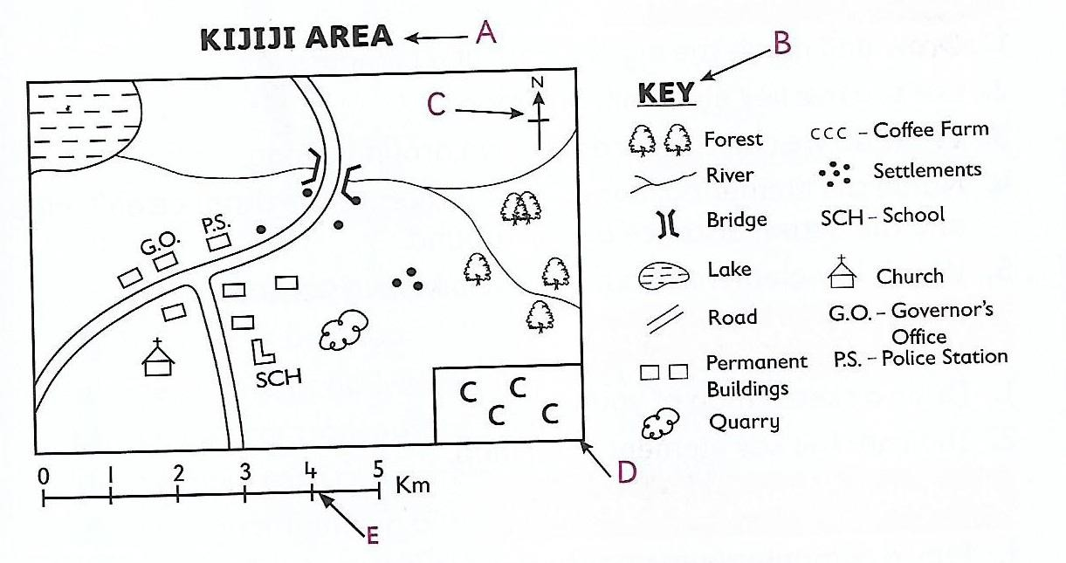**Compass** - shows the direction of places on a map. A good map should have the five key elements.

### Importance of maps include:

1. Locating the directions and position of places
2. Identifying the direction and position of places
3. Identifying our neighbours
4. Locating various physical features

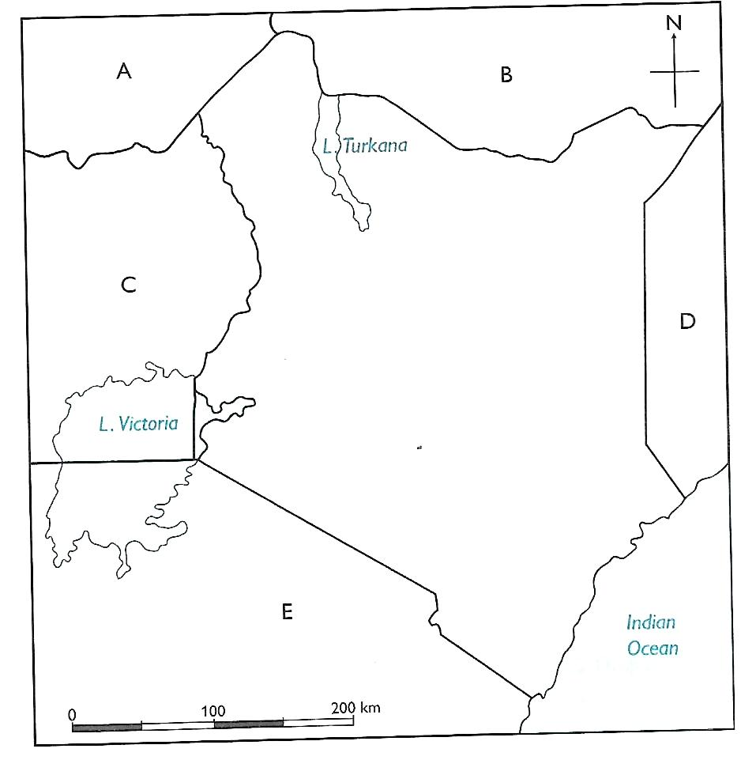

1. Guiding tourists to their destination.

### Map interpretation

This referred to giving meaning to the features and symbols used on a map.

We use the key elements of a map to read and interpret maps. Symbols and signs helps us to identify the different features, areas and activities on a map e.g.

The presence of a **quarry** shows that mining is taking place in the area.

* **Market** - shows that trading activities is taking place in the area
  + **Game reserved** - shows the presence of wild animals.
  + **A sawmill** - shows that timber processing takes place in the area.
  + **Scrubland** - shows that the area is dry.

### Location, position and size of Kenya

Position of Kenya in relation to her neighbours

Kenya has several neighbouring countries. Kenya is surrounded by:

* Tanzania is to the south
* Uganda is to the west
* Ethiopia is to the north
* Somalia is to the east
* South Sudan is to the north west
* Indian ocean to the south east.

### Ways in which Kenya maintains good relations with her neighbours.

1. **Trade** - Kenya exports and imports goods from her neighbours e.g. Bananas from Uganda.
2. **Games and sports** - kenya participates in games such as football, with her neighbours.
3. **Ambassadors** - Kenya has an ambassador in each of her neighbouring countries. These ambassadors represent Kenya in these countries.
4. Free movement of people from Kenya to her neighbours and from her neighbours to Kenya.

**Use of common language** - Kenya shares a common language (Kiswahili) with some of her neighbours, for example, Tanzania. This helps to maintain good relations.

### The size of Kenya

Kenya covers an area of about 582, 646km square.

It is about 850 km from East to West and about 1025 km from North to South.

### Main Physical features In Kenya.

Physical features are natural things found on the earth's surface.

The physical features are divided into two main categories i.e. relief and drainage features.

**Relief features** are physical features that are seen above the surface of the earth.

Relief features include:

* Mountains
* Hills
* Plains
* Valleys
* Plateaus

Drainage features are physical features that are associated with water. They include

* Swamps
* Rivers
* Lakes
* Oceans
* Dams

## Weather and climate in Kenya

Weather is the condition of the atmosphere of a place at a particular time. The weather of a place changes from time to time.

Elements of weather are the conditions of the atmosphere, they include:

* Rainfall - rain, supports the growth of vegetation.
* Wind - warm and moist winds bring rain
* Temperature - the hotness or coldness of a place
* Cloud cover - heavy cloud cover brings heavy rainfall

The weather conditions of a place can be observed, measured and recorded for a period of time. The recorded observations are used to calculate the average weather conditions of that place.

Climate - refers to the average weather conditions of a particular place over a long period of time. Climate can be described as wet, dry, hot, cold, warm or cool.

The characteristics of climatic regions in Kenya are:

### *Modified equatorial climate*

* Covers the coastal areas near Indian ocean and Lake Victoria.
* Experiences heavy convectional rainfall 1000 mm - 1500 mm.
* It has two rainy seasons - long and short rains.
* The region receives convectional rainfall. This type of rainfall is formed by warm air which rises from the surface of the Indian Ocean or Lake Victoria.
* Rainfall is well distributed throughout the year
* Rainfall is affected by the winds blowing from the ocean to the coast.
* Temperature range between 250C - 3O0C
* The region is mainly hot and wet.

### *Modified tropical climate*

Coversthe Kenya highlands and parts of the Rift valley

The area receives rainfall throughout the year

Rainfall is between 1200 mm - 2000 mm

Low temperatures ranging between 18 0 C - 210 C

The region is mainly cools and wet

It is modified by the high altitude.

### Mountain climate

* The region covers areas with high mountains like Mount Kenya and Mount Elgon.
* Experiences cool and wet conditions
* The region is cold and wet
* Temperatures range from 00C - 150 C
* High rainfall of between 1250mm and 2200 mm.
* The region is characterized by two sides, the leeward side and the windward side.
* The windward side receives relief rainfall and the leeward side is drier.
* The climate is mainly influenced by altitude.

### Tropical Climate

* The region covers Kwale, taita and Narok areas
* Experiences high temperatures
* It has one rainy season
* In some parts the dry season lasts up to five months
* Rainfall of not above 1000mm per year.

### Semi-desert climate

* Covers areas in Northern, North-eastern and some parts of Eastern Kenya.
* Temperatures are high during the day and low at night.
* Experiences high temperatures which may rise to 380C
* Mainly hot and dry
* Low rainfall of below 250mm per year
* The sky is clear.

### Desert Climate

* + Experienced in Chalbi and Taru deserts
  + Most of the months are dry causing droughts
  + High temperatures throughout the year - average 380C
  + Clear skies
  + High daytime temperatures and low night temperatures.

### THE BUILT ENVIRONMENTS

These are structures/environments that remind us of our history or where we have come from.

They include:

***Fort Jesus***

***Tom mboya monument National museum of Kenya Jomo Kenyatta monument Nyayo monument***

Importance of historic built environments

* They remind us and teach us about our culture
* They are sources of employment for people who work there
* They attract tourists who bring money to our country
* They are sources of information for learning
* They allow us interact with other people when we visit them
* They are used as recreational areas for relaxation Caring for Historic built Environments in our country
  + - Repair the destroyed parts of historic built environments
    - Handle items in the historic environments with care
    - Develop conservation messages and place them at historic built environments
    - Educate other people on the importance of historic built environments.

# PEOPLE AND POPULATION

Language groups in Kenya

The main language groups in Kenya are

* Bantu
* Nilotes
* Cushites
* Asians
* Europeans

**THE BANTU**

They originate from Congo Forest

They are the largest group in Kenya

They consist of Abakuria, Abagusii, Abaluhya, Abasuba, Agikuyu, Ameru, Aembu, Mbeere, Akamba, Mijikenda (Giriama, Digo, Duruma, Kambe, Kauma, Jibana, Chonyi, Rabai and Ribe), Wapokomo, Wataita, Wataweta, and Waswahili)

**THE NILOTES**

They originated from Bahr- el- ghazal in South Sudan.

They kept animals and grew crops such as millet and sorghum.

They consist of Nandi, Kipsigis, Keiyo, Markawet, Tugen, Pokot, Sabaot, Terik, Luo, Maasai, Samburu, Iteso, Turkana and Elmolo.

**THE CUSTHITES**

They originated from the Horn of Africa, popularly known as Somalia.

They consist of the Dahalo, Sanye, Makogode, Sniah, Borana, Rendile, Burji, Oromo, Ormo, Awera and Gabbra

**THE ASIANS**

They originated from Asia

They include the Indians, Japanese and Chinese.

They live in towns and work as traders and business people.

**THE EUROPEANS**

They came from Europe

They were interested in african land in order to get raw materials and settle.

They include people from Germany, France, Italy and Spain.

### Interdependence of Language groups in Kenya

Language groups in Kenya depend on each other through various means. They include:

* Food
* Treatment
* Education
* Market

Benefits of interdependence among the language groups in Kenya include:

* It promotes love and unity among different language groups
* It brings development e.g. the development of roads which connect different communities.
* It discourages tribalism, racism and corruption
* It leads to the exchange of culture, goods and services.

**POPULATION DISTRIBUTION IN KENYA**

* Population refers to the total number of people living in an area at a particular time.
* The total number of people living in Kenya makes up the population of Kenya.
* The population of an area can either be sparse or dense.
* If an area has many people the area is said to be densely populated.
* If an area has few people it is said to be sparsely populated.
* Population density is the number of people living in an area per square kilometre.
* Population density can be described as high, medium or low.
* Areas of high population in Kenya include:
* Highlands such as western highlands and central highlands, parts of Machakos.
* Lake basins such as Nyanza region, especially north of Lake Victoria
* Coastal areas
* Major towns such as Nairobi, Mombasa and Kisumu, Nakuru and Eldoret

**8** |Grade 5 CBC lesson notes

* Areas of low population density include:
* Deserts like Chalbi and Taru
* Steep slopes of mountains.
* Restricted areas such as near game parks and airports

**CULTURE AND SOCIAL ORGANIZATION**

* Culture is the way of life of people. It includes how they eat, what they eat, how they dress, their religion among other things.
* African traditional education is a form of learning in traditional african societies in which knowledge, skills and attitudes of the community were passed from elder to children to prepare them for adult life.
* Methods of instructions used in african traditional education include:
* Apprenticeship
* Songs and dances
* Storytelling
* Narratives or narrations
* Proverbs
* Riddles
* Ceremonies
* Learning from specialist
* Skills taught to girls included:
* Cooking
* Fetching water
* Looking after young ones
* And fetching firewood
* Skills taught to boys included:
* Herding
* Hunting
* Cultivating the land

### Importance of african traditional education in promoting values

* It emphasizes the value for respect for all
* It emphasizes obedience
* It encourages honesty among all members of the community
* It encourages responsibility and hard work
* It encourages faithfulness.
* It promotes generosity and kindness as people take care of each other.
* It encourages people to live together in peace and unity.

### SCHOOL ADMINISTRATION

Administrative leaders in school They include:

The headteacher

The deputy head teacher



The senior teacher

Teachers (class teacher)



Children’s government

**Duties of administrative leaders in school**

1. Duties of the head teacher

Overall in charge of the school

Links the school to the department of the school

Admits new learners

**.**

**Maintains school records**

* + Oversees day-to-day running of the school
  + Allocates tasks to other members of staff and supervises
  + In charge of funds and security of the school
  + Overall in charge of discipline.

1. **Duties of the deputy head teacher**
   * Assistant to the head teacher
   * In charge of discipline
   * Secretary to staff meetings
   * Prepare the school timetable and routine
   * Ensure safety and security of learners
   * Teaches learners
2. **Duties of the senior Teacher**
   * Assists in administration in the absence of the headteacher and deputy headteacher.
   * Helps supervising curriculum development in school
   * Guide and counsels learners
   * Teaches the learners
3. **Duties of teachers (class teachers)**
   * Prepares and maintains class register
   * Maintains class discipline
   * Provides guidance services to learners
   * Resolves conflicts arising in class
   * Teaches subjects assigned
4. **Duties of children’s government**

* Acts as a linkage between the students and the school administration
* Acts as a role model to other learners
* Supervises school activities including maintaining cleanliness
* Provides feedback to the school administration concerning student affairs.

**.**

# RESOURCES AND ECONOMIC ACTIVITIES

***Resources in Kenya***

* A resource is something that we can use to create wealth. Kenya has many natural resources such as land, minerals, water and forests.
* Economic activity - is what one does with the resources to make money or wealth.
* These resources can be used for the benefit of the people. When people use resources to make money, we say they are carrying out economic activities.
* We use land in growing crops like tea, coffee, vegetables and also keep animals like sheep, carmels and goats.
* Minerals are valuable substances that are naturally found on earth. Minerals found in Kenya include: soda sh, limestone, salt, diatomite and petroleum.
* We use water to rear fish. Fish found in Kenya include Tilapia and mud fish. Water is also used to water crops and animals as well as in industries.
* Forests act as homes for wild animals which attract tourists to our country.

Caring for resources found In Kenya

We care for resources in Kenya through the following ways:

* Planting new trees when we cut old ones
* Adding manure and planting cover crops to take care of soil.
* Keeping water sources clean.
* Using minerals wisely
* Protecting forests by not lighting fires and destroying them.

### AGRICULTURE

This is the growing of crops and keeping animals.

### Farming methods:

Subsistence farming - it is a type of farming whereby farmers grow crops for use at home.

### Characteristics of subsistence farming

* Farmers grow crops and keep animals mainly for home use

**.**

* The farms are divided into small portions
* Farmers use simple tools such as hoes, ox ploughs and pangas to do cultivation.
* Farmers grow crops such as maize, beans, millet, cassava, yams and arrowroots in small quantities.
* Animal waste is used as manure
* Family labour is used
* A few animals such as cows, sheep, goats and chicken are kept.

### Small scale farming

Is the type of farming whereby the farmer grows crops and keeps livestock on small pieces of land.

### Characteristics of small scale farming

* It is practical in areas which are densely populated. The land available for farming is limited.
* It is practised in areas which have fertile soil and which receive enough and reliable rainfall.
* Improved methods of farming such as rotation, application of fertilizer and spraying are used.
* Farmers plant crops and keep animals for food and also for sale.
* Family labour is used by farmers.
* Food crops and cash crops such as coffee, tea,sugarcane, pyrethrum, fruits, vegetables and flowers.

**Importance of farming**

* It’s a sources of income for farmers
* It’s a source of raw materials for industries
* Source of food for many people
* Promotes better standards of living
* Earns revenue for the government
* Promotes proper use of land.

### DAIRY FARMING IN KENYA

This refers to the keeping of cattle for the production of milk and milk products. It can be carried out on a small and large scale.

### The following factors favour dairy farming in Kenya:

**.**

* Cool temperatures, which discourages breeding of ticks
* High and reliable rainfall to enable pastures to grow.
* Good transport system to ensure quick transportation of milk
* Enough land to grow grass to feed the cattle.
* Plenty of water for animals in order to produce enough milk.
* Veterinary services to give advice to farmers and treat animals when they are sick.
* A large market to buy dairy products which have to be sold quickly. Areas where dairy farming is mainly practised include Meru, Embu, Kirinyaga, Murang’a, Nakuru, Nyandarua, Laikipia, Nyeri, Kiambu, Kisii, Nyamira, Nandi, Bungoma, Uasin Gishu and Trans-Nzoia counties.
* Dairy products include: Milk, cheese, yoghurt, ghee, butter and cream.

### Benefits of dairy farming

* Improves the living standards of people
* Provides people with milk and other milk products such as yoghurt.
* Farmers can earn income when they sell milk
* It’s a source of employment
* Government gets revenue from milk exports
* Milk is a source of protein and thus it improves our health
* Hides and skins are used in the leather industry to make shoes and belts.

### Challenges facing dairy farming in Kenya

Dairy farming is very expensive to practise and needs a lot of money.

* Lack of enough capital
* Lack of enough storage and cooling facilities to store milk
* Poor means of transport because the roads are damaged
* Lack of adequate market for milk
* Delay of payment of farmers by the buyers
* Lack of enough pasture during the dry period
* High cost of commercial feeds.
* Competition from cheap imported dairy products.

**.**

**HORTICULTURE IN KENYA**

* Horticulture is the growing of flowers, fruits and vegetables.
* Horticulture farming is done in green houses under natural conditions e.g. flowers grown in Kenya are: Roses, lilies, hibiscus, carnations and orchids
* Fruits grown in Kenya are: Oranges, grapes, lemons, mangoes and pineapples.
* Vegetables grown in Kenya include: onions, tomatoes, cabbages, carrots and sukuma wiki (kale) among others
* It is mainly practised in the following areas:
* Mount elgon
* Kitale
* Cherangany hills
* Mois Bridge
* Nyahururu
* Taveta
* Naivasha
* Ngong
* Kisii
* Embu
* Eldoret
* nairobi
* Naivasha is the main horticultural growing area in Kenya. Contribution of horticulture to the Economy of Kenya
* It earns the country foreign exchange when they are exported.
* Improves living standards when farmers get their money.
* It’s a source of employment. People are employed to work in farms.
* They are a major source of food for the people of Kenya
* Some horticultural crops are used as raw materials in industries.

**.**

### MINING IN KENYA

* + - Minerals are valuable substances that are naturally found on earth or underneath.
    - Mining refers to the process of removing minerals from the rocks in the ground.
    - Major minerals found in kenya include:
* Soda ash - mined at Lake Magadi
* Diatomite - mined at Kariandusi near Gilgil.
* Limestone - mined at Athi River near Nairobi and Bamburi in Mombasa.
* Salt - mined in Lake Magadi and also along the coast at Malindi and Ngomeni.
* Petroleum - mined in Turkana county.

### Importance of minerals in our country.

* They earn our country foreign exchange when they are exported.
* They are important in the construction industry e.g cement mixed with sand.
* Different minerals are used as raw materials in industries that manufacture different products such as cement, glass, soap and chemicals.
* Some minerals are used in our homes to add taste to our food e.g. salt.

### Problems facing mining in Kenya

* Poor transport system
* Lack of skilled labour
* Insecurity in the mining areas
* Collapsing of mines which causes death or injury to the miners.
* Inadequate capital.

### FISHING IN KENYA

* Fishing refers to the harvesting of fish from water for use directly as food at home or for sale in the market.
* Fishing can be done in lakes, oceans, rivers or ponds.
* A fishing ground is an area where fishing is carried out.

**.**

### METHODS OF INLAND FISHING

* Inland fishing is carried out in freshwater bodies like lakes, rivers and fish farms (ponds) located on the main inland fishing grounds in Kenya
  + - Lakes: Victoria, Turkana, Naivasha, Jipe and Baringo.
    - Rivers: Tana, Yala, Sagana, Nzoia and Nyando.
    - Dams: Masinga and Kiambere.
    - Fish farms: Naromoru, Nanyuki, Borabu, Bamburi and Aruba.

### Methods of inland fishing include:

1. **Harpooning or spear method**. - this is mostly done in clear water. Fishermen catch fish by spearing them.

A spear is aimed at the fish in the water. It is a method used in catching a few fish for home use.

1. **Net drifting** - a net is placed vertically in a lake. The net is supported by floats at the top and has weights at the bottom. Fish swim into the net and get trapped and cannot move.
2. **Lamp attraction method** - lamps are lit in boats over the water surface to attract fish at night. As the fish move towards the light, they are caught using baskets and nets. This method is commonly used in Lakes like Victoria, Turkana to catch small fish like ***Omena***
3. **Hook and line method**- a string with a hook on the head is tied to a rod. A bait is then put on the hook, which is dipped into the water. The bait could be a piece of meat or an insect. The fish get attracted to the bait and are caught by the hook. Only one fish is caught at a time.
4. **Use of baskets** - a conical-shaped basket is pushed into the river where the water flows very fast. After some time, the basket is removed from the water with whatever may have got in. this method is used in rivers and near banks of lakes

### Contribution of fishing to the economy of kenya

* Tourist attraction - tourists come to kenya to do fishing as a sport and for enjoyment.
* Fish is exported to earn the country foreign exchange.

**.**

* Fish is a source of food e.g. source of protein.
* Fishing is a source of employment for many e.g. in industries that process fish, fish farms.
* It's a source of income- selling fish earns fishermen income thus improving their living standards.
* Fish is a source of medicine - fish contains the cod liver that is used as medicine.
* Fishing has led to the growth of other dependent industries that make fertilizers, animal feeds and fish processing.

### Wildlife and Tourism in Kenya National park and Game reserve

* **A national park** is a wildlife protection area controlled directly by the national government through the Kenya wildlife service. In national parks people are not allowed to settle.
* **A game reserve** is a wildlife protection area managed by the local county government. In game reserves, people are allowed to live and graze their cattle.

### Locating National Parks and Game reserves in Kenya (map)

**Importance of wildlife in our country**

* Wildlife is an important natural resource in kenya. The following are some reasons why wildlife is important:
  + It is a major tourist attraction in kenya. National parks and game reserves have rare kinds of animals which tourists pay to see. The government gets revenue from the tourists.
  + It creates job opportunities for many people. Some people are employed to work in national parks and game reserves .

others are employed as tour guides or workers in hotels.

* + It helps us to make good use of unproductive lands. Game parks and reserves are located in areas which cannot support domestic animals and crops.

**.**

* + Some wild animals are eaten as food. This happens when the population of wild animals is high. E.g. gazelles, crocodiles, giraffes,zebras and impalas.
  + It promotes cultural exchange. When tourists interact with Kenyans, they exchange ideas, beliefs and cultural values and practices.
  + It is a national heritage and it contributes to the beauty of the land.
  + It promotes development of transport and communication facilities in Kenya. Roads leading to game parks and reserves have been improved.
  + Some wild animals have medicinal value and are used in the manufacture of medicine.

### *Tourists attractions in Kenya*

* A tourist is someone who travels to various places for leisure or enjoyment.
* Tourism is the practice of offering services to tourists with the intention of making money.
* Tourist attractions are things that tourists come to see or the places they visit.
* The main tourist attractions in Kenya are:
  1. Wildlife- this is the main tourist attraction. Tourists come to see animals such as the big five and flamingos in Lake Nakuru.
  2. Historic built environments - such as Fort Jesus, Gedi Ruins and the Nairobi National Museum.
  3. Sandy coastal beaches- tourists visit the beaches to relax and sunbathe.
  4. Culture- Kenya has varied and unique cultures. These include dances, artefacts, ways of dressing and shelters.
  5. Warm climate - Kenya experiences a warm climate most of the year. This attracts tourists when it is cold in their countries.
  6. Sports - some sports such as mountain climbing, sport fishing and motor vehicle rallies attract tourists.

**.**

* 1. Conference facilities - Kenya has modern conference facilities such as Kenya International Conventional Centre (KICC) , UNEP headquarters and several five-star hotels.
  2. Beautiful scenery - this includes the Great Rift valley, the hot water springs at Olkaria and the snow peaks of Mount Kenya

### Contribution of Tourism to the economy of Kenya

* Tourism contributes to the economy of Kenya in the following ways:
* It is a source of foreign exchange
* It creates employment for Kenyans
* Tourists bring new ideas when they visit our country
* Hotels where tourists stay promote the growth of agriculture in those areas. They create a market for crops grown by farmers.
* It leads to growth of urban centres. For example, Narok town has grown due to the presence of Maasai Mara Game reserve.
* It provides a market for locally made items such as baskets and ornaments.

### Ways of promoting tourism in Kenya

* Ensuring safety and security of tourists.
* Constructing electric fences around game parks and reserves to prevent human wildlife conflicts.
* Conserving all the natural forests and planting more trees to sustain the wild animals.
* Establishing anti-poaching units in all game parks and game reserves.
* Charging affordable fees at all tourist attractions.
* Building modern hotels and lodges for tourists.
* Ensuring that roads to tourist attraction sites are well maintained.

### TRANSPORT IN KENYA

Modern forms of transport in Kenya

* Transport is the movement of people or goods from one place to another.
* There are various forms of transport used in Kenya.these are: road, railways, water, air and pipeline.

**.**

* Road transport is the oldest and most common form of transport. People and goods are transported using cars, bicycles, buses, matatus,motorbikes, lorries and trailers.
* Water transport involves the movement of goods and people over water. It is the most suitable form of transportation for bulky goods. However it is slow.
* Railway transport involves the movement of people and goods on a railway line.
* Air transport involves the movement of people and goods using aircraft. It is the fastest and most expensive form of transport.
* Pipeline transport is mainly used to transport water,oil and gases.

***Causes of road accidents in Kenya***

* Ignorance of traffic rules and road signs
* Driving beyond the speed limit
* Driving vehicles that are not in good condition
* Overloading of goods and passengers
* Driving under the influence of alcohol or harmful drugs
* Poor state of roads

***Ways of reducing road accidents in Kenya***

* Educating drivers and other road users on the proper use of roads
* Constructing footbridges, tunnels and pedestrian paths
* Enforcing traffic rules to stop driving beyond the speed limit. Using speed governors on public service vehicles to control their speed.
* Constructing speed bumps on roads
* Placing correct road signs at the right places along the roads
* Punishing and penalising drivers who do not obey traffic rules
* Inspecting vehicles regularly to ensure that they are roadworthy.
* Not using mobile phones when driving.

### Road signs and their meanings (pic pg. 120)

**Ways of observing road safety in Kenya**

Observe road signs on your way.

**.**

At pedestrian crossing, look left, right and again then cross when the road is clear.

Fasten your seat belts when in a moving vehicle

Do not play near the roads

Always use sidewalks.

***Communication in Kenya Modern means of communication.***

* Communication is the sending or receiving of information. Examples of modern means of communication in Kenya include:
* Mobile phones and telephones - this is the fastest and most reliable way of sending and receiving messages. It can be used to send both written and spoken messages.
* Magazines, newspapers, journals - they are produced either daily, weekly or monthly. They report information about events happening in the country and around the world. They report on politics, business, sports and other happenings.
* Radio - this method sends messages to many people at the same time. These messages are aired in English, Kiswahili and local languages.
* Television - this is sending messages using visual aids and sending to many at once.
* Internet - this involves sending of emails using electronic means among others like video conferencing.
* Postal services - this is the delivery of written messages in the form of letters and parcels from one place to another. This service is offered through post offices.
* Courier services - this is sending and receiving of letters and parcels to people living far away . In this service, the parcels are delivered to the owners personally. It is fast and reliable

**.**

**POLITICAL SYSTEMS AND GOVERNANCE**

Leadership and Political change

### Traditional leaders in Kenya

* A traditional leader is someone who was chosen by his or her community to lead them.
* A traditional leader was someone who was famous for one reason or another. Sometimes they were wisemen and women. At other times they were brave warriors, famous medicine people or successful traders.they were obeyed and respected. People would go to them for advice and guidance.

### Contribution of Traditional Leaders in Kenya Kivoi wa Mwendwa

* Kivoi wa Mwendwa was born in 1780 in Kitui.
* He was a great long distance trader who travelled between Mombasa and Mt. Elgon.
* He was able to organize hunting and raiding activities to acquire trade goods in the region
* When he took the goods to the coast, he exchanged them for clothes, cowrie shells, ornaments, knives, daggers, spices and glassware from Arab traders.
* In 1846, he met Dr. Krapf for the first time at Rabai and they became great friends.
* In 1849, Dr. Krapf visited Chief Kivoi in his home in Kitui from where he saw a snow-capped mountain. It was amazing to find such information along the equator.
* When Ludwig Krapf inquired about it, Chief Kivoi informed him that the name of the mountain was “Kinyaa”, which Krapf interpreted as Kenya, the present-day name of our country.
* His Friendship with Dr. Krapf led to the spread of Christianity among his people.

### Mekatilili wa Menza

She was born in 1840

**.**

* She was a prophetess and a political leader of the Agiriama people
* Mekatilili was opposed to hut tax and forced labour, slavery, the destruction of the Kayas (traditional shrines) and recruitment of Giriama youths who were forced to work on European farms. She led her people to fight against the occupation of Giriama land along River Sabaki.
* They attacked European settlements and traders passing through their land.
* During the fight she was arrested and deported to Kisii.
* After this, the Agiriama lost their political power.
* She escaped from Kisii prison and trekked back to Kilifi.
* She was re-arrested and deported to Kismayu in August 1914.
* She died in 1920.
* Mekatilili wa Menza was a famous army general and a great pride of the Agiriama community, an inspiration to present-day women due to her toiling spirit.

### Differences and similarities between Kivoi wa Mwendwa and Mekatili wa Menza

|  |  |
| --- | --- |
| Similarities | Differences |
| Both leaders were respected by their communities | Kivoi wa Mwendwa was a long distance trader while Mekatilili wa Menza was a prophetes. |
| Both leaders were symbols of unity to their communities | Kivoi wa Mwendwa welcomed the European missionaries while Mekatilili wa Menza resisted them |
| Both leaders interacted with Europeans | Mekatilili wa memnza was arrested and deported to Kisii and Kismayu while Kivoi wa Mwendwa was not arrested. |
| Both leaders defended the welfare | Kivoi wa Mwendwa was a chief |

**.**

|  |  |
| --- | --- |
| of their people | while Mekatilili wa Menza was a military leader |
|  | Mekatilili wa Menza united her people against the British through oaths while Kivoi wa Mwendwa did not give any oath. |

### Early forms of Government

**Early Forms of government among the Maasai.**

* The Maasai belong to the Nilotes.
* They live in the plains where they can get enough pasture for their animals
* The Maasai were ruled by a council of elders.
* The community had age sets and each age set had its time of leadership.
* Moran was the most active age set.
* The Olaiguani was the title of the military captain.
* The spiritual leader of the Maasai was known as Oloibon.
* Lenana was a famous Oloibon in their social life.
* The maasai worshipped a supreme being called Enkai. Enkai was the source of life and punished bad people.
* The Laibon prayed to God on behalf of other people in the community.
* There was a council of elders that settled disputes amongst the Maasai.
* The Morans defended the community against external attacks. They also raided other communities to get cattle.

### Early Forms of government among the Maasai.

* The Ameru are Bantu speakers who live around Mt. Kenya.
* The traditional system of Ameru was based on the age set system.
* There were to sets of rulers: the Kiruka and the Ntiba.each of these age sets was headed by a council of elders and ruled at a particular time before handing over to the other.

**.**

* The handing over of the ceremony was marked by a ceremony called Ntuiko.
* The generation in power had a council of elders called the Njuri Ncheke. This council was made up elderly men who were selected because of their ability and wisdom.
* They dealt with murder, land issues, witchcraft and theft.
* They also made laws in the community.
* They settled disputes, maintained law and order, presided over religious matters, protected the environment and advised on the best economic activity for the community.
* Law breakers were punished by a council of elders called Nkomango.
* Matters that were difficult to handle were dealt with by selected members of Njuri Ncheke called Njuri Impeere.
* They had a religious leader called Mugwe. He blessed major events like sacrifices to ancestors, declared curses on matters of public interest, declared things taboo and prohibited, and conducted rites when age sets were being promoted

### Differences and similarities between the Maasai and the Ameru.

|  |  |
| --- | --- |
| Similarities | Differences |
| In both communities there was a council of elders who settled disputes | The Maasai had a prophet and a medicine man while the Ameru did not |
| In both communities leadership was in form of age sets | The Maasai were led by Oloibon while the Ameru were led by a council of elders |
| In both communities, Law and order was maintained by the elders | The Maasai leadership was hereditary while the Ameru was not. |

**.**

**Citizenship**

Good citizenship in Kenya

### Ways of becoming a Kenyan Citizen

* A citizen is a person who belongs to a particular country.
* Citizenship is the state of being a member of a given country.
* In Kenya, citizens are issued with identity cards to show that they are Kenyans. A person can become a Kenyan citizen in two ways.

1. By Birth

* A child born of Kenyan parents becomes a Kenyan Citizen. The child is registered and given a birth certificate. At the age of 18 he or she can use the birth certificate to get an identity card.
* If the child is born in Kenya by parents who are foreigners, the child has the option of becoming a Kenyan citizen or not.
  1. By registration
* A person born outside Kenya who has attained the age of 21 years can apply to be registered as a Kenyan citizen.
* He or she must fulfil the following conditions.
* He or she must have been living in Kenya for at least seven years
* One of his or her parents must be a Kenyan citizen
* He or she must have knowledge of Kiswahili or English.
* He or she must be of good character and make a good citizen.

## Requirements for Dual Citizenship

Dual citizenship is the state whereby a person is a citizen of more than one country under the laws of those countries.

A Kenyan citizen by birth does not lose Kenyan citizenship by acquiring citizenship of another country, as long as he or she can

**.**

prove that one or both parents were Kenyan citizens at their time of birth.

Someone who qualifies for dual citizenship is required to be of good conduct, law abiding and should show interest in becoming a dual citizen

He or she should also present the following documents:

* Two passport photographs
* Copy of birth certificate
* Copy of Kenyan passport
* Copy of Kenyan identity card
* Copy of the other country’s passport
* Copy of the other country’s certificate of citizenship
* Copy of police clearance certificate.

### Ways in which one May lose Kenyan Citizenship

* Kenyans who obtain citizenship of another country are required to disclose their other citizenship within three months of becoming a dual citizen. Failure to do so is an offence.
* If a person acquired the citizenship by registration, the citizenship may be lost if one:

1. Is discovered to have used false documents during registration
2. Fails to renew citizenship when it expires
3. Is convicted of an offence which has a penalty of at least seven years imprisonment within five years of registration
4. Is convicted of planning to overthrow the government (treason).
5. Is working with an enemy of Kenya to fight Kenya.
6. Willingly denounces Kenyan citizenship

If a person acquired the citizenship by birth, the citizenship may be lost if:

1. The age of the person is discovered and reveals that the person was older than eight years when he or she was found on Kenyan soil.

**.**

1. The nationality or parentage of the person becomes known and reveals that he or she was a citizen of another country.
2. The person used false documents during registration.

### Good citizenship

* A good citizen does the following:
* Obeys the laws of the country
* Is loyal and loves his or her country
* Defends his or her country
* Respects the authorities
* Takes part in community activities
* Pays tax to the government
* Takes care of the environment

### National Unity In Kenya.

### National symbols in Kenya

* The national symbols in Kenya include:
* **The national anthem**
* Is a national prayer
* It expresses the hopes and wishes of Kenyans
* It was first sang at independence
* It is written in Kiswahili and English
* It is sang when raising the flag and when opening and closing national days celebrations
* **The National flag**

It is flown in all official functions, government offices and at schools. Senior government officials fly the national flag on their cars. It is also raised when our sportsmen and women win medals in international games. It is the most popular

**National symbol.**

* It has four colours: black, white,red and green.
* The red colour is a reminder of the blood shed and lives lost during the fight for independence.
* The black colour is our skin and we are proud of it.

**.**

* + - The green colour is the beautiful environment that supports the growing of crops
    - The white colour shows peace in our country and the unity of Kenyans.
* The coat of arms
  + It is the logo of our country
  + It has two lions holding spears as a sign of strength and readiness to defend our country from external forces
  + The cock with an axe shows that we can fight anybody as we defend our country.
  + Crops represent the agricultural products of our fertile soil and the ability of Kenyans to feed themselves.
  + Harambee - this is our national motto. Kenyans work together to build our country.
* The Public seal
* It is circular in shape
* It has a coat of arms at the centre
* It is the government signature on its official documents
* The crops represent our main agricultural products.

### Factors that promote National Unity

* Some of the factors that promote national unity are:
* ***National holidays*** - these are days when great events are celebrated. They include, Madaraka Day celebrated on 1st June, Mashujaa Day celebrated on 21st October, Jamhuri 12th December .
* National symbols - these include the coat of arms, the national flag,the national anthem and public seal.
* ***National languages*** -the use of Kiswahili and English brings people of different communities together.
  1. The president
  2. Sports and games
  3. The Kenyan constitution
  4. The National Assembly

**.**

### Human Rights

* A right is what is legally yours. Our rights are written in a document that contains all the laws of Kenya. The document is called the constitution of Kenya.
* We all have rights and our rights should be respected.
* Some basic rights are:
* Right to life - life is important to all human beings. No one has the right to take another person’s life.
* Right to basic needs (food, shelter, clothing and education) - every child should have adequate food, clothing, good medicinal care, education and shelter.
* Right to shelter - place to protect from danger, rain.
* Right to protection
* Freedom of worship - Every Kenyan citizen is free to hold his or her own beliefs and belong to a religious group of his or her choice
* Right to vote - every Kenyan citizen above 18 years of age has a right to vote.
* Right to fair trial - A person who has been arrested should be presumed innocent until proven guilty.
* Right to own property - we are allowed to own property anywhere in Kenya. We can buy land or do business in any part of Kenya.
* Freedom from discrimination -all people are equal before the law and should be protected from any discrimination regardless of age, sex, race, colour or tribe.

### Importance of Human rights

* When human rights are respected citizens live in peace and harmony.
* Respect for human rights will help us feel secure and safe.
* Promotes democracy in the society
* They are a guarantee for equal and fair treatment

**.**

* Children's rights helps them to grow up well and become good citizens

### GOVERNANCE IN KENYA

Democracy in society

### Types of democracy in Kenya

* Democracy refers to a form of governance where the government rules according to the wishes of the people and for the benefit of the people.
* The leaders are elected by the people through elections.
* There are two types of democracy:
* **Direct democracy** - this is also called participatory democracy or pure democracy. . in this type of democracy, all citizens are involved in making decisions on various issues that concern them. This is the best form of democracy.
* **Indirect democracy** - this is also called representative democracy. In this type of democracy, citizens elect representatives who make decisions on their behalf. The elected representatives are supposed to make decisions the way people who elected them would like them to.

### Benefits of democracy in society.

* Democracy enables people to elect leaders of their choice.
* Democracy promotes good governance in the society
* Democracy promotes development and stability in the society
* Democracy enables citizens to express themselves freely
* Democracy promotes justice in society because all people are ruled by the law.
* Democracy helps to protect the basic rights of all citizens
* Democracy promotes peace, love and unity in society. This helps reduce conflicts.

### Electoral process in Kenya Importance of voting in Kenya

* Voting is the action of electing someone in an election.

**.**

* People vote to choose leaders who will represent them in the government, to exercise their democratic right and to replace bad leaders with good leaders.

### Elective Political positions in Kenya

* In Kenya we have six elective political positions.. They are: President - who leads the national government. Governor - who is the head of the county government. Senator - who represents the county in the senate

Member of parliament - who represents the constituency in the parliament.

Woman representative - represents women who are considered as marginalised group by the constitution. Member of county assembly - who represents the ward in the county assembly.

### Voting steps in Kenya

* The following are the steps of voting in Kenya.

Registration of voters on the voter’s register by the independent Electoral and boundaries Commission (IEBC) Giving civic education to the voters to help them understand the proceedings of voting.

On the day of voting, voters go to the polling station to elect their leaders. For a voter to be allowed to vote:

* + 1. He or she must have a national identity card or valid passport
    2. He or she must appear on the voters register. Verifying of the names from the voter’s register using voters identification card

When cleared, the voter is given a ballot paper to fill. This is done in a booth or private room. He or she puts a mark next to the name of the candidate of his or her choice.

The voter casts his or her ballot in a ballot box.

Once the voter casts his or her vote, a non-washable ink is used to make a mark on his or her small finger.

### The National Government in Kenya

**Arms of the National Government and their Functions**

* The three arms of National Government in Kenya include:
  + **The legislature** - is the arm of the National Government that makes the laws that govern the country. These laws are contained in the constitution of Kenya.
  + **The Executive** - is the arm of the National Government that runs the government. The president ensures that there is law and order in the country. This arm of the National Government comes up with policies of the government.
  + **The Judiciary** Is the arm of the National Government that listens to cases brought to the courts and administers justice

The Composition of the three arms of the National Government in Kenya

### The Legislature

1. National Assembly
   * The speaker
   * 290 elected members of parliament
   * 47 elected women representatives
   * 12 members nominated by political parties
2. The senate
   * The speaker
   * 47 senators
   * 16 women nominated by political parties
   * 2 youth representatives (male and female)
   * 2 members representing people with disabilities (male and female)

### Composition of the Executive

* The president
* The deputy president
* Cabinet secretaries
* Attorney General
* Public servants

### Composition of the Judiciary

**.**

* The Chief Justice
* The Deputy Chief Justice
* The Chief Registrar
* Judges of the Supreme Court
* The Judicial Service Commission
* Other Judicial officers and staff

### Participating in national governance

We take part in national governance by doing the following:

1. Obeying the rules and laws of our country
2. Encouraging people in the society to participate in democratic activities such as voting.
3. Creating awareness on the importance of respecting human rights.
4. Being good citizens and educating other people in the society on good citizenship.
5. Supporting the elected leaders in the society.
6. Encouraging our leaders to be fair and transparent in their leadership