**Music grade 2 notes**

**Topic: Performing**

**Songs**

Types of songs

1. **Lullaby songs.** These are songs sung for babies to make them sleep or stop crying
2. **Work songs**  These are songs sung while working
3. **Story songs.** These are songs sung when telling stories. They are songs sung by characters in the story
4. **Singing games** songs sung by children while playing
5. **Round songs.** These are songs sung in turns by different groups
6. **Topical songs.** These are songs Sung to teach us certain topics or issues concerning our lives like eating healthy foods.
7. **Sacred songs.** Songs sung in church to praise God.

**Folk songs.** These are traditional songs sung by different communities. These songs helps in developing our cultures

**Two parts round songs**

A round song is a musical composition where people in two or more voice part sing exactly the same Melody with each part beginning at a different time. The song is usually repeated several times.

An example of a two part round song is Row row your boat, a luhya song “ mama mbe tsimbindi

Row row row your boat.

Gently down the stream,

Merrily, merrily, merrily, merrily,

Life is just a dream

Mama mbe tsimbindi nze khumitsa

Mama mbe tsimbindi nze khumitsa

Nzie,nzie ,nzie,nzie khumisa

**Kenya National Anthem**

Learners to sing verses 1 and 2 of the Kenya National Anthem both in English and kiswahili

**Words of the Kenya National Anthem 2 nd stanza**

**English**

Let one and all accord,

With heart both strong and true,

Service be our Earnest endeavor

And our Homeland of kenya,

Heritage of splendour,

Firm may we stand to defend.

**Kiswahili**

Amkeni ndugu zetu,

Tufanye sore bidii,

Nazi tujitoe kwa nguvu.

Nchi yetu ya kenya,tunayoipenda,

Tuwe tayari kuilinda

* Learners to stand at attention and sing the two verses of the Anthem
* Teach Learners that the national Anthem encourages us to respect and love our country.
* It also teaches us to work together and live peacefully together as Kenyans

**Elements of music and vocal techniques**

The basic elements of music while singing are:

* Pitch. Is how high or low the music is
* Tempo. Is how fast or slow the music is
* Dynamics. The pattern of the music
* Rhythm. How music moving

**Expressions of ideas, feelings and emotions through singing**

The expression of ideas, feelings and emotions is actualized through understanding the meaning of words,use of facial expressions, gestures and movement.

**Solo and choral performances**

Solo means singing alone

Coral means singing many people in a group

Guide Learners to sing alone and make solo presentations.

Guide Learners to sing in groups and make choral presentations

**Songs from diverse cultures**

Learners to learn songs from different cultures. This will help them appreciate other cultures from other communities. Guide Learners to understand that some songs in various cultures are similar in melodies and messages they carry.

Lullabies are examples of songs sung in diverse cultures, has the same meaning of singing to the baby to sleep or stop crying.

Organize Learners to sing the lullaby in different languages in groups.

**Singing games**

These are songs sung when children are playing.

Ask Learners to name some of the songs they sing while playing like “nyama nyama nyama, babligan.

Guide Learners to write one English singing game song and one kiswahili singing game song.

**Aspects of singing game.**

The aspects of singing game are:

* Dancing in rhythm
* Making patterns
* Being agile
* Coordination of movements
* Choreography and patterns
* Good use of space

The props used in different singing games are:

Ropes

Dolls

Sticks

Bottle tops

The costumes mostly used in singing games are;

Sisal skirts

Head gears

Anklets.

Guide Learners to learn and sing one singing game and let the Learners use the correct movements and use appropriate props and costumes.

**Safety precautions in singing games**

The safety precautions to be observed in music are;

* Doing warm up activities
* Give appropriate activities to the Learners according to their age.
* Clear the playing surface of any obstacles
* Use the right costumes and manage movements properly
* Listen and follow instructions.

Let Learners sing kitambaa yangu imepotea then guide them on the safety precautions.

**Etiquette in singing games.**

We show etiquette in singing games by;

* Respecting each other
* Obeying group leaders
* Not making others angry
* Listening and following instructions
* By sharing playing materials eg ropes,bin bags, sticks, balls,toys and costumes.

Guide Learners to sing the singing game and try to display the etiquette they have learnt.

**Singing games from diverse culture**

Guide Learners in groups and let them sing singing games from different cultures using different languages, example let them sing and write a singing game in English, kiswahili and in their own or local language. Let each and every learner present their songs inform of the class.

**Wind instruments.**

Wind instruments are instruments played by blowing.

Make a chart or pictures of wind instruments to show learners

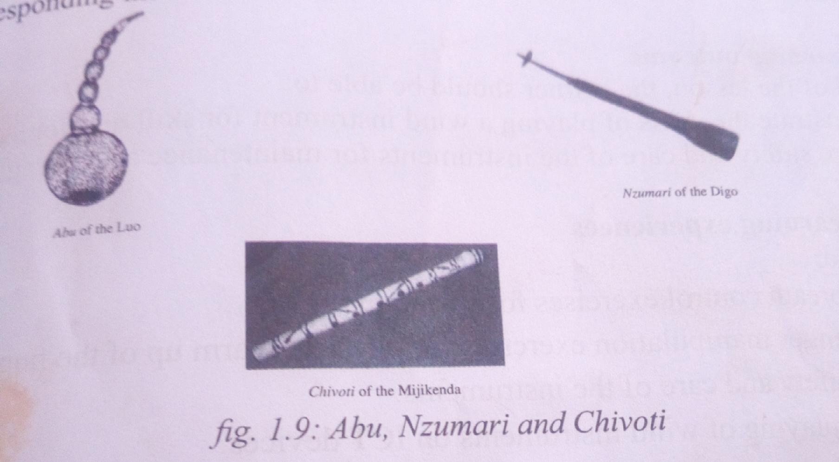

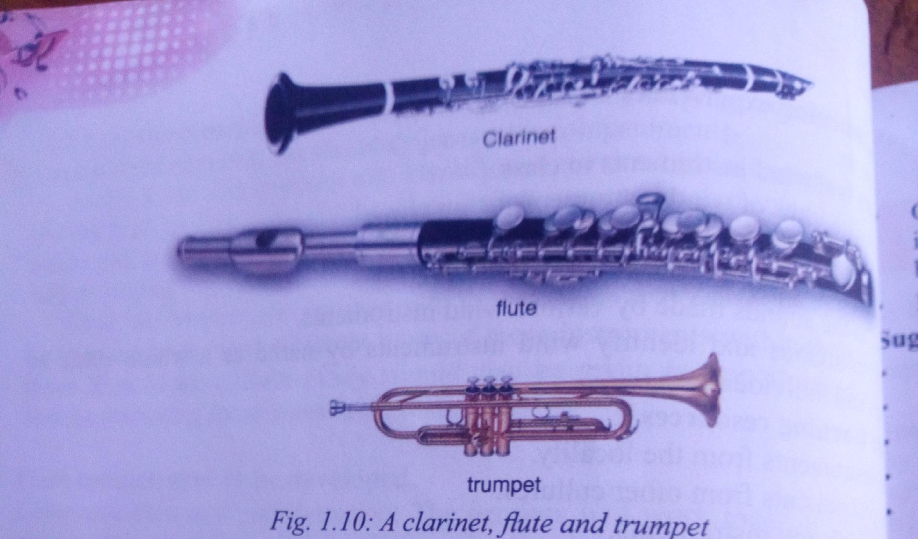

Examples of wind instruments are flute ,reeds, instruments, pipes,horns and whistles.

**Playing of wind instruments**

* Choose the instruments to be played according to the age of the Learners and it’s availability.
* Give every learner and opportunity to play instruments
* Guide the Learners on holding placement of the lips, fingering and breath control

Let Learners practice playing the instrument in groups in pairs and individually.

**Improvising wind instruments.**

Materials needed are;

* Straws
* Reeds
* Cutting tools
* Bottles
* Water
* Plastic bottles
* Papers

Guide Learners to use locally available materials to make simple wind instruments.

Guide Learners to collect most of the materials themselves.

Guide Learners to work in groups.

**Steps for making simple wind instruments.**

1. Biro pen casing or lollipop straw holder can be blown across to produce some musical sounds, varying the rhythm of the sound produces a whistle like musical sound.
2. For reeds plastic pipes or tubes use the cutting tools to cut out a good size,a length of about 6 inches should be sufficient for the Learners little hands.

* Bore out a mouth hole on one end.
* Bore out the finger,holes.
* Test the instruments

**Dance**

Dance is the movement of the body and steps in response to music. This is done as a group or individually. The movement is in a rhythmic way.

Every community has it’s own style of dancing.

People dance for various reasons such as;

* Celebrating a good harvest
* Weddings
* Funerals
* Child birth
* When celebrating victory

Our Kenya dances have specific names that originate from various sources.

Some dances are named from the style of dancing such as kamabega dance from Western Kenya which is connected with the shaking of shoulders .

Other dances are named from the kind of instruments used.Bul dance from the luo is named from the the instruments used( bull drums)

Kithembe is a kamba dance also named after the drum that accompany it.

Other Kenyan dances are ;

Sengenya___ mijikenda

Gonda____ Taita

Muriempe___Meru

Mwomboko___ Kikuyu

**Body movements ( waving, greetings, digging, sweeping)**

* These are body movements that enhance dance
* Dance movements maybe inspired by everyday activities such as waving hello or goodbye , clapping, sweeping, digging and picking up things. These actions can be turned into a dance ,by doing them in rhythms to the music.
* Guide Learners in identifying movement of the body parts that are involved in a dance.
* Discuss with Learners the need to use body movements that enhance respect and moral values.

Guide Learners in or groups to prepare own dances for presentation in class

**Dance performance**

In this section Learners are going to perform dances while observing the basic elements of dance..

The basic elements of dance include space, energy,time and relationship during performances.

**Space** refers to the area surrounding a person in which they are able to move. The body make various patterns such as circles and squares using different body parts by moving through a space.

**Time** refers to the duration taken to excute a movement. It also refers to how long the dance takes

**Force.** Refers to the level energy that the body uses to make a certain movement. Slow and leisurely movements require less energy as compared to fast and agitated movements.

Guide the Learners in presentation a familiar dance as they observe the Basic elements of dance.

**Traditional dances.**

-Learners to learn and perform various dances found in the community.

- Learners to perform various dances performed in different ceremonies. Like in wedding, initiation, ceremonies and in thanks giving ceremonies in the community.

As Learners present dances let them observe the basic elements of dance. They should also observe the use of accomplishment and costumes.

**Creating/ Composing Music**

**Music** is the combination of sounds and rhythms that when they are performed together they are pleasing to the ear.

**Creating/ Composing** is the process of coming up with new music .

Many ideas maybe communicated through compositions.

Examples of these ideas are;

* 1. Messages of patriotism
  2. ICommunication of pertinent and contemporary issues.
  3. Life skills

**Rhythm.** Is a regular or repeated pattern of beats. The beats maybe long or short.

Rhythmic patterns. A rhythmic phrase or idea that appears more than twice and forming a pattern.

Take the learners through the activities of identifying animals that make rhythmic patterns.

Example 1

Show learners a picture of an elephant .

The elephant makes even and slow steps while moving. Guide learners in tapping or clapping the rhythm made by these steps. They could do this while sounding the following counts.

ONE, TWO, ONE,TWO,ONE,TWO,ONE,TWO.

These steady counts make rhythmic patterns . Guide learners in identifying other animals that make rhythmic patterns .

Example 2

A clock makes even and moderate beats. Guide learners to vocalising these beats. They could do this using the following syllables.

The clock ticks tik tok,tik tok,tik tok

These steady counts make rhythmic patterns. Guide learners in identifying other objects that make rhythmic patterns.

The learners through clapping/ tapping rhythms of animal names. They could also vocalise the rhythms at the same time,individuallly or in groups

Example

Za cha riah ze bra. Hip po ka nga roo. Tall gi raffe

**Rhythmic patterns**

Learners to create rhythmic patterns through clapping and tapping.

Guide Learners through the activities of clapping syllables in names. The names include tea, coffee,soda and mango juice.

As the Learners clap or vocalize ,they should be guided to adhere to speech rhythm.

For example, rhythms for karatasi and kawangware are short than those of twiga and miti

In groups,let Learners create own rhythms using body percussions.

**Improvising rhythms**

1. **Rhythm.** A regular or repeated pattern of beats . The beats may be long or short.
2. **Rhythm pattern.** A rhythm is a phrase of ideas that appears more than once and forming a pattern.
3. **Rests.** Moments or sections of silent in a song / musin
4. **Improvisation** It refers to coming up with rhythms and perform using these without prior preparation or rehearsal.

**Rhythmic accompaniment to songs**

**Accompaniment** is instrumentation that supports the main performance. In this case, rhythmic accompaniment is to sing using boby percussion

Take the learner through the activities of creating own rhythms by tapping/ clapping to accompany songs and stories.

Guide Learners to accompany songs with created rhythmic accompaniment.

The accompaniment may be done by clapping/ tapping vocalising or using other body percussions.

**Melody**

Melody is one of the basic elements of music. It is the most recognisable part of music. It is the most recognisable part of music. In this section Learners will learn to recognize variations to melodies and create new text to songs

**Identifying melodic variations**

Variation techniques is one of the commonest ways of developing music and adding flavour.

Composers use this technique to create new sections in the music while still mantaining the feel of the original Melody. The tune changes without making it entirely different.

Sing a familiar song then hum the tune with some variations and let the Learners repeat or imitate the new tone with variations.

**Improvising simple melodic variations**

* Choose one or two of the learners to sing familiar.
* Guide them to make variations as others sing back
* Guide Learners into groups and let each group choose a familiar song to work with some variations.
* Let Learners record the new song with variation in groups.

**Improvising lyrics/text to tunes**

- Guide Learners to sing a familiar song then set other words to the same sound.

- Guide Learners to repeat or imitate the changes

- An example of a familiar tune that could be used is ‘are you sleeping?'

- Set the new words to the tune to create ettiquette song.

Are you sleeping

Are you sleeping

Brother John

Brother John

Morning bells are ringing

Morning bells are ringing

Ding dong dong

Change the words to;

Please and thank you

Please and thank you

Sounds so nice

Sounds so nice

Manners are important

Manners are important

Be polite

Be polite

**Making presentation of own composition.**

* Guide each group to make their presentations, giving a short review of how they made the project and the familiar songs they have used to come up with the new songs.
* After each presentation conduct a discussion where the res of the class can give feedback to the presenters.

**Listening and Responding**

Elements of music

An element is a characteristic part of which something is made .

Elements of music include:

Rhythm refers to the way music moves. It is a combination of long and short sounds which with varying level of accentuation produce strong and weak beats.

Melody. This comprises pitch and rhythm. Pitch is highness or lowness of a sound. A combination of pitch and rhythm produces a flow of pleasant sounds called **melody**

Harmony. This where two or more melodies are sounded simultaneously. The melodies must agree and be pleasant when sounded together.

**Listening and Responding**

* Guide Learners to listen to the music
* Let Learners respond to the music by dancing, clapping or singing along.
* Discuss with Learners how the music makes you feel.
* Give Learners also chance to sing simple melodies observing pitch and rhythm.

**Performance Ettiquette**

* Here Learners are guided on appropriate behavior when watching a performance.
* Guide Learners to practice appropriate audience behavior by sitting quietly, applauding and responding without interrupting performance as they watch others perform.
* Discuss the importance of audience behavior during performances.

**Basic music terminology.**

Discuss with Learners the various elements of music.

Examples

* Loud
* Soft
* Fast
* Slow
* High
* Low

Discuss with Learners the effects of these elements to music.

**Music Appreciation**

* Play music from varied cultures for appreciation
* The music maybe from other communities or from other countries
* Guide Learners to listen to the music carefully
* Discuss the events in which the music is played.

The End

Contact 0718426530

For more notes!