Grade 1 Notes: Hygiene and nutrition

Topic: Healthy practices

Sub strand: healthy habits

1: What are healthy habits?

Healthy habits are things we do to stay healthy.Things we do to stay healthy are; playing, washing hands, brushing teeth and eating healthy foods.We practice healthy habits to prevent us from getting diseases.

**2: which healthy habits prevents illnesses?**

**Illiness is a disease and we get diseases when we don’t practice healthy habits**

**Habits that prevent illnesses are:**

**Washing hands**

**Sleeping well**

**Using the toilet or latrine**

**Doing exercises**

**Eating healthy foods**

**Bathing everyday**

**3: Why do we practice healthy habits.**

**We practice healthy habits to prevent our bodies from getting diseases i.e**

**We wash hands to remove germs,**

**We use the toilet to prevent illnesses,**

**We bathe everyday to keep body clean,**

**We exercise to keep our body fit.**

**4: Doing healthy habits**

Let Learners go out and do healthy habits like running, skipping, playing football etc.

Exercise 1.1

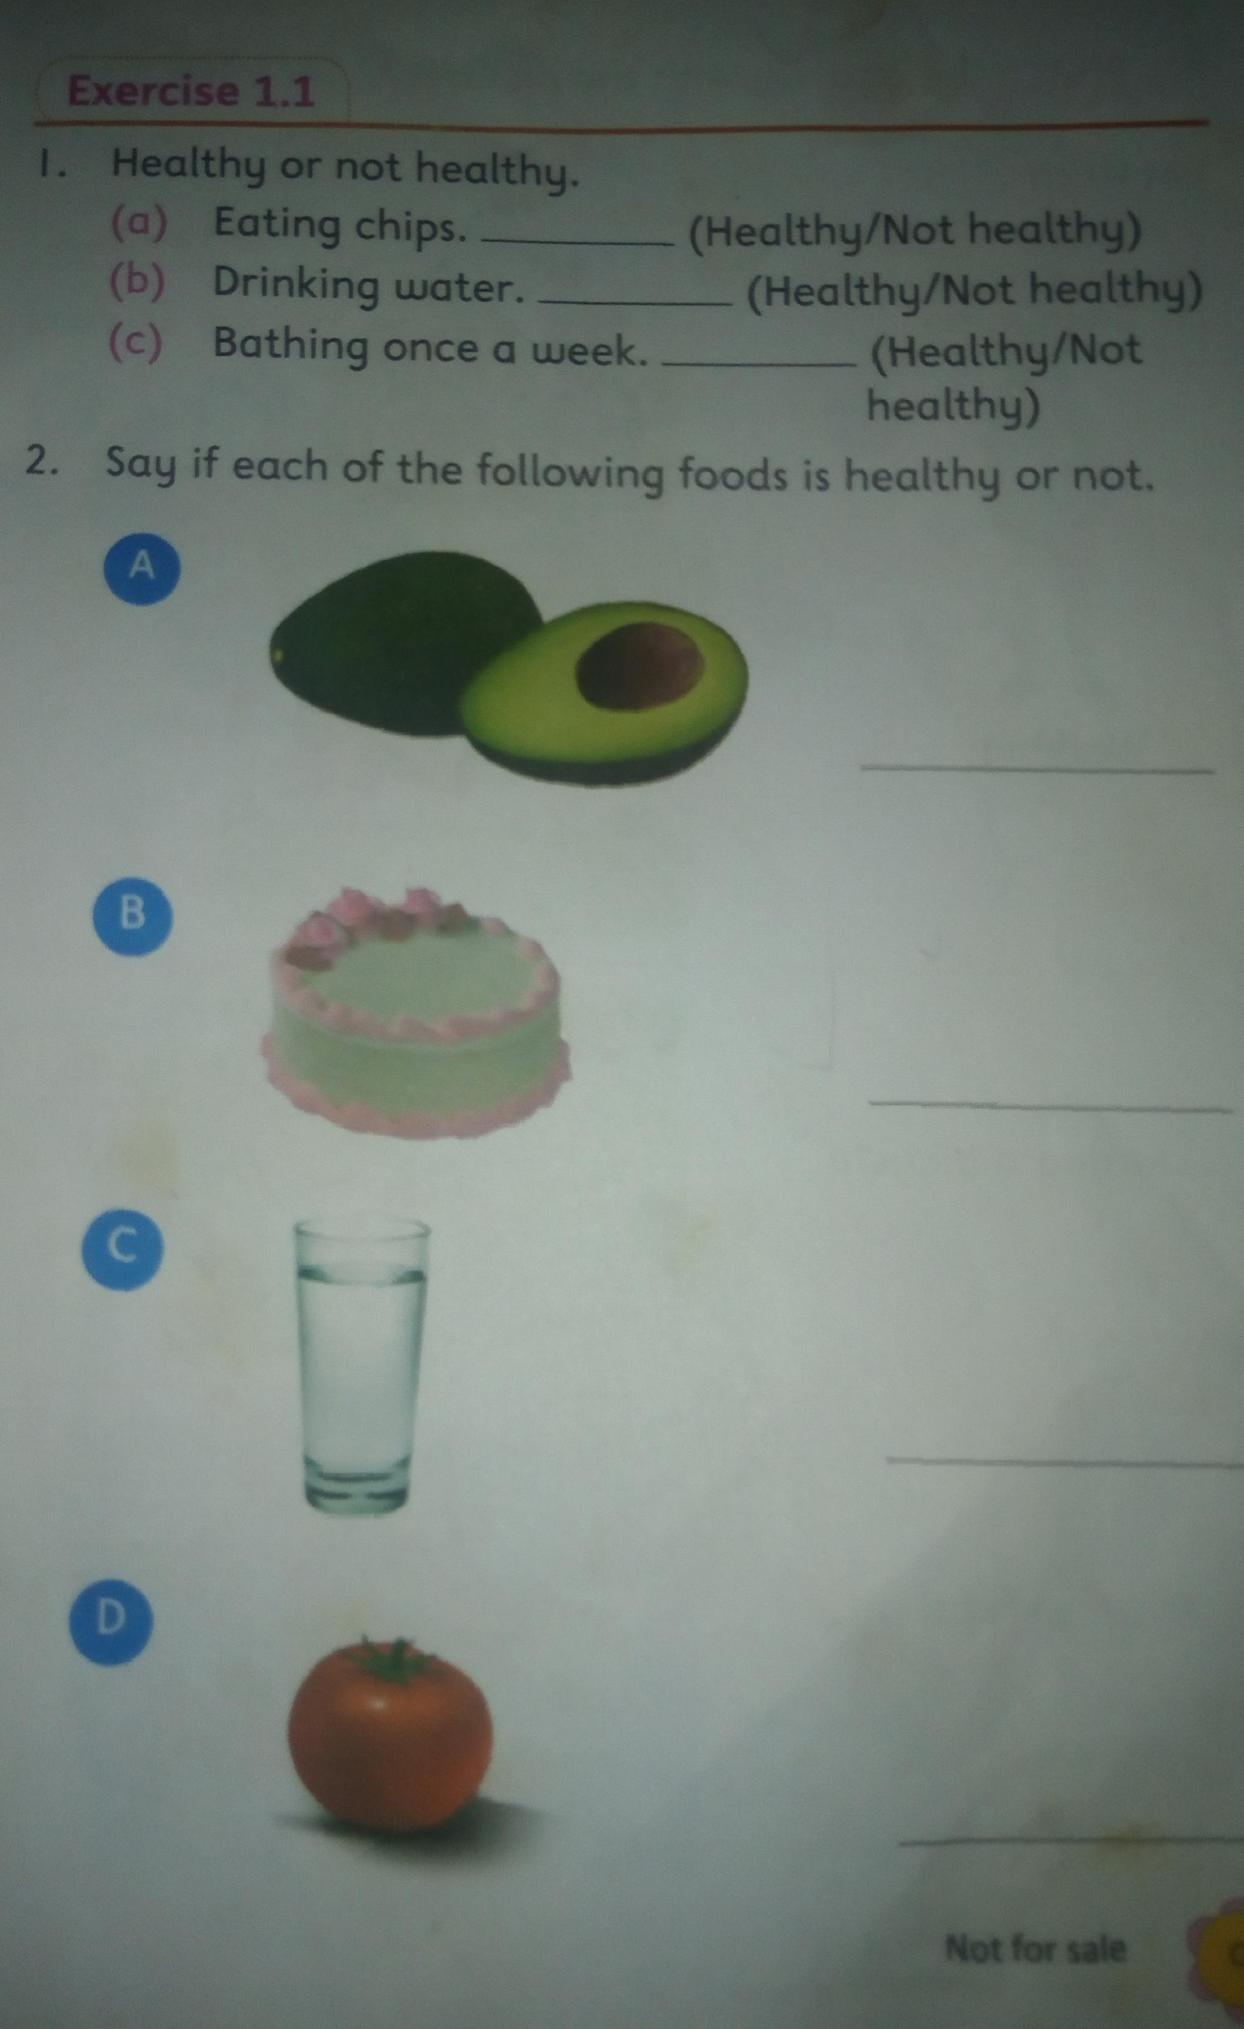

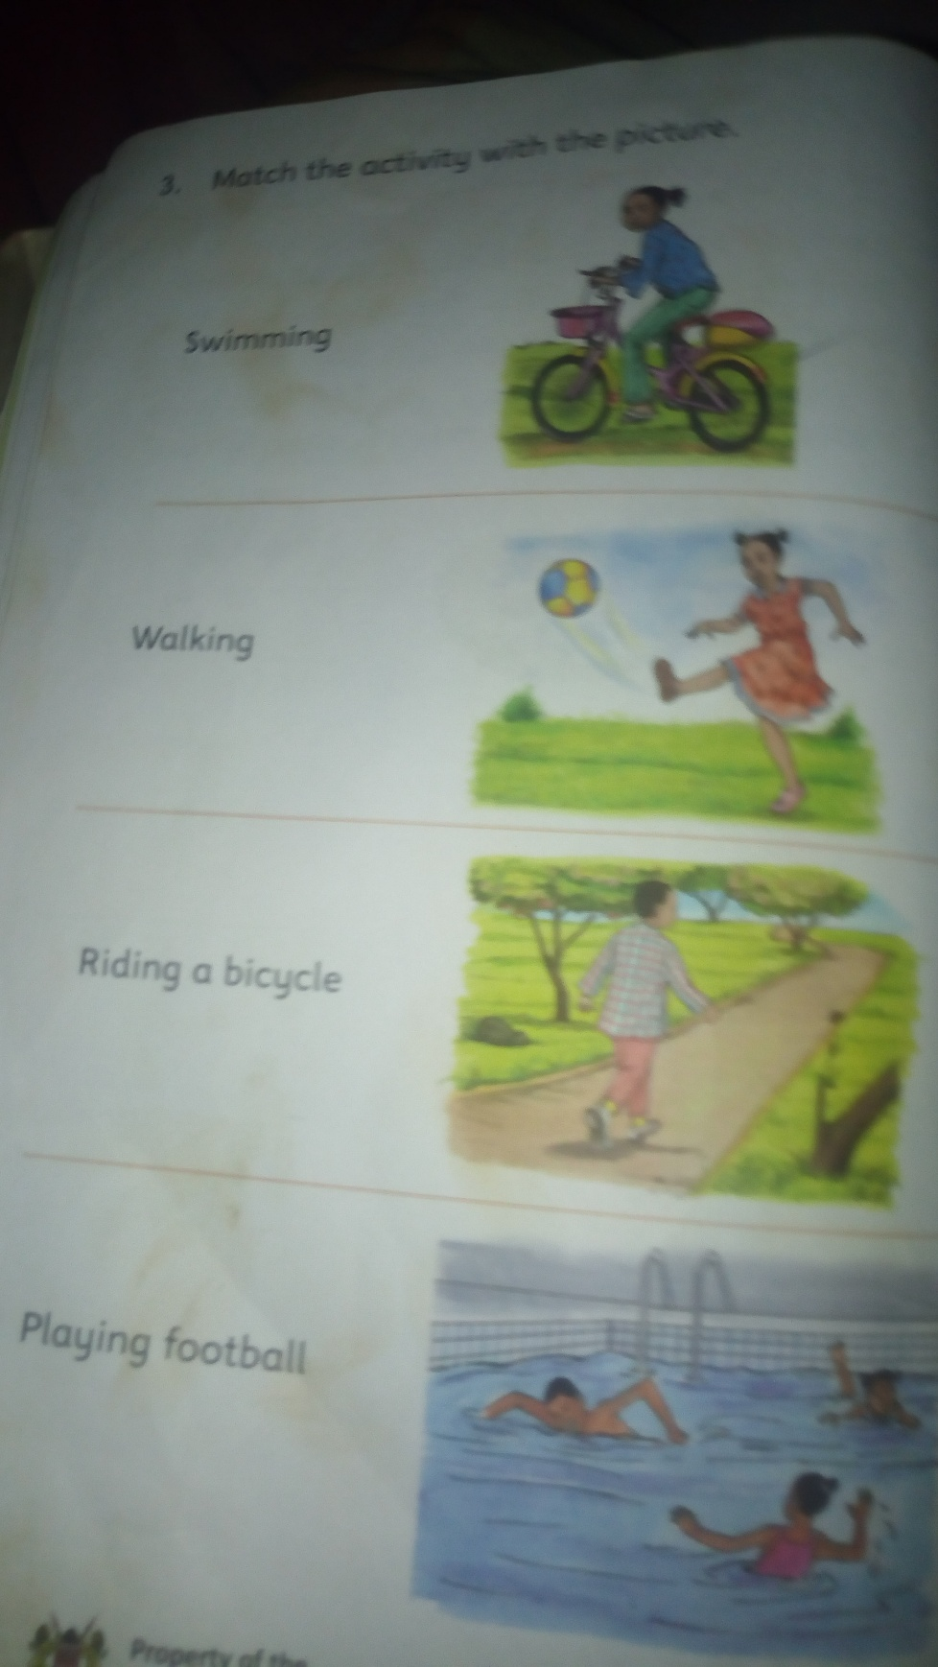

**Care for the teeth**

* **What are milk teeth?**

**We grow two sets of teeth**

**The first set are called milk teeth**

**As babies grow older they loose the milk teeth.The second set of teeth are called permanent teeth**

* **Removing teeth in a clean way**

**How to remove teeth in a clean way**

**1.Wash your hands**

**2.Hold the tooth with a clean cloth**

**3.Remove the tooth**

**4.Put the cloth in a bin**

**5.Gurgle salty water**

**Gurgle is to take water into the mouth,move it round then spit it.**

**Exercise 1.2**

**1.We wash our_____before removing teeth (hands, mouth)**

**2.All children grow milk teeth.(true,not true)**

**3.Teeth that we remove are_____teeth(milk, good)**

**4.We do not go to hospital to remove milk teeth.( Yes,no)**

**Use of medicine**

**Which medicine do you use at home?**

**Some of the medicines we take at home are;**

* **Capsules**
* **Tablets**
* **Ointment cream**
* **Using inhaler**
* **Putting nose drops**
* **Syrup**

**Sick people take medicine to feel better**

**Care when taking medicine**

* **Wash your hands when taking the medicine.**
* **Use clean water to take the medicine**
* **Make sure that you finish the medicine**
* **Do not share the medicine with anyone**
* **Store the medicine in a dry place**
* **Store the medicine away from the baby.**

**Exercise 1.3**

**1.We should take medicine using_____water(clean, sweet)**

**2.Touching medicine with dirty hands is ____(good,bad)**

**3._____is a type of medicine (tablet,table)**

**4.We should always keep medicine in a ____cupboard(closed, open)**

**Topic: Personal Hygiene**

**Care for the parts of the body**

**Parts of the body**

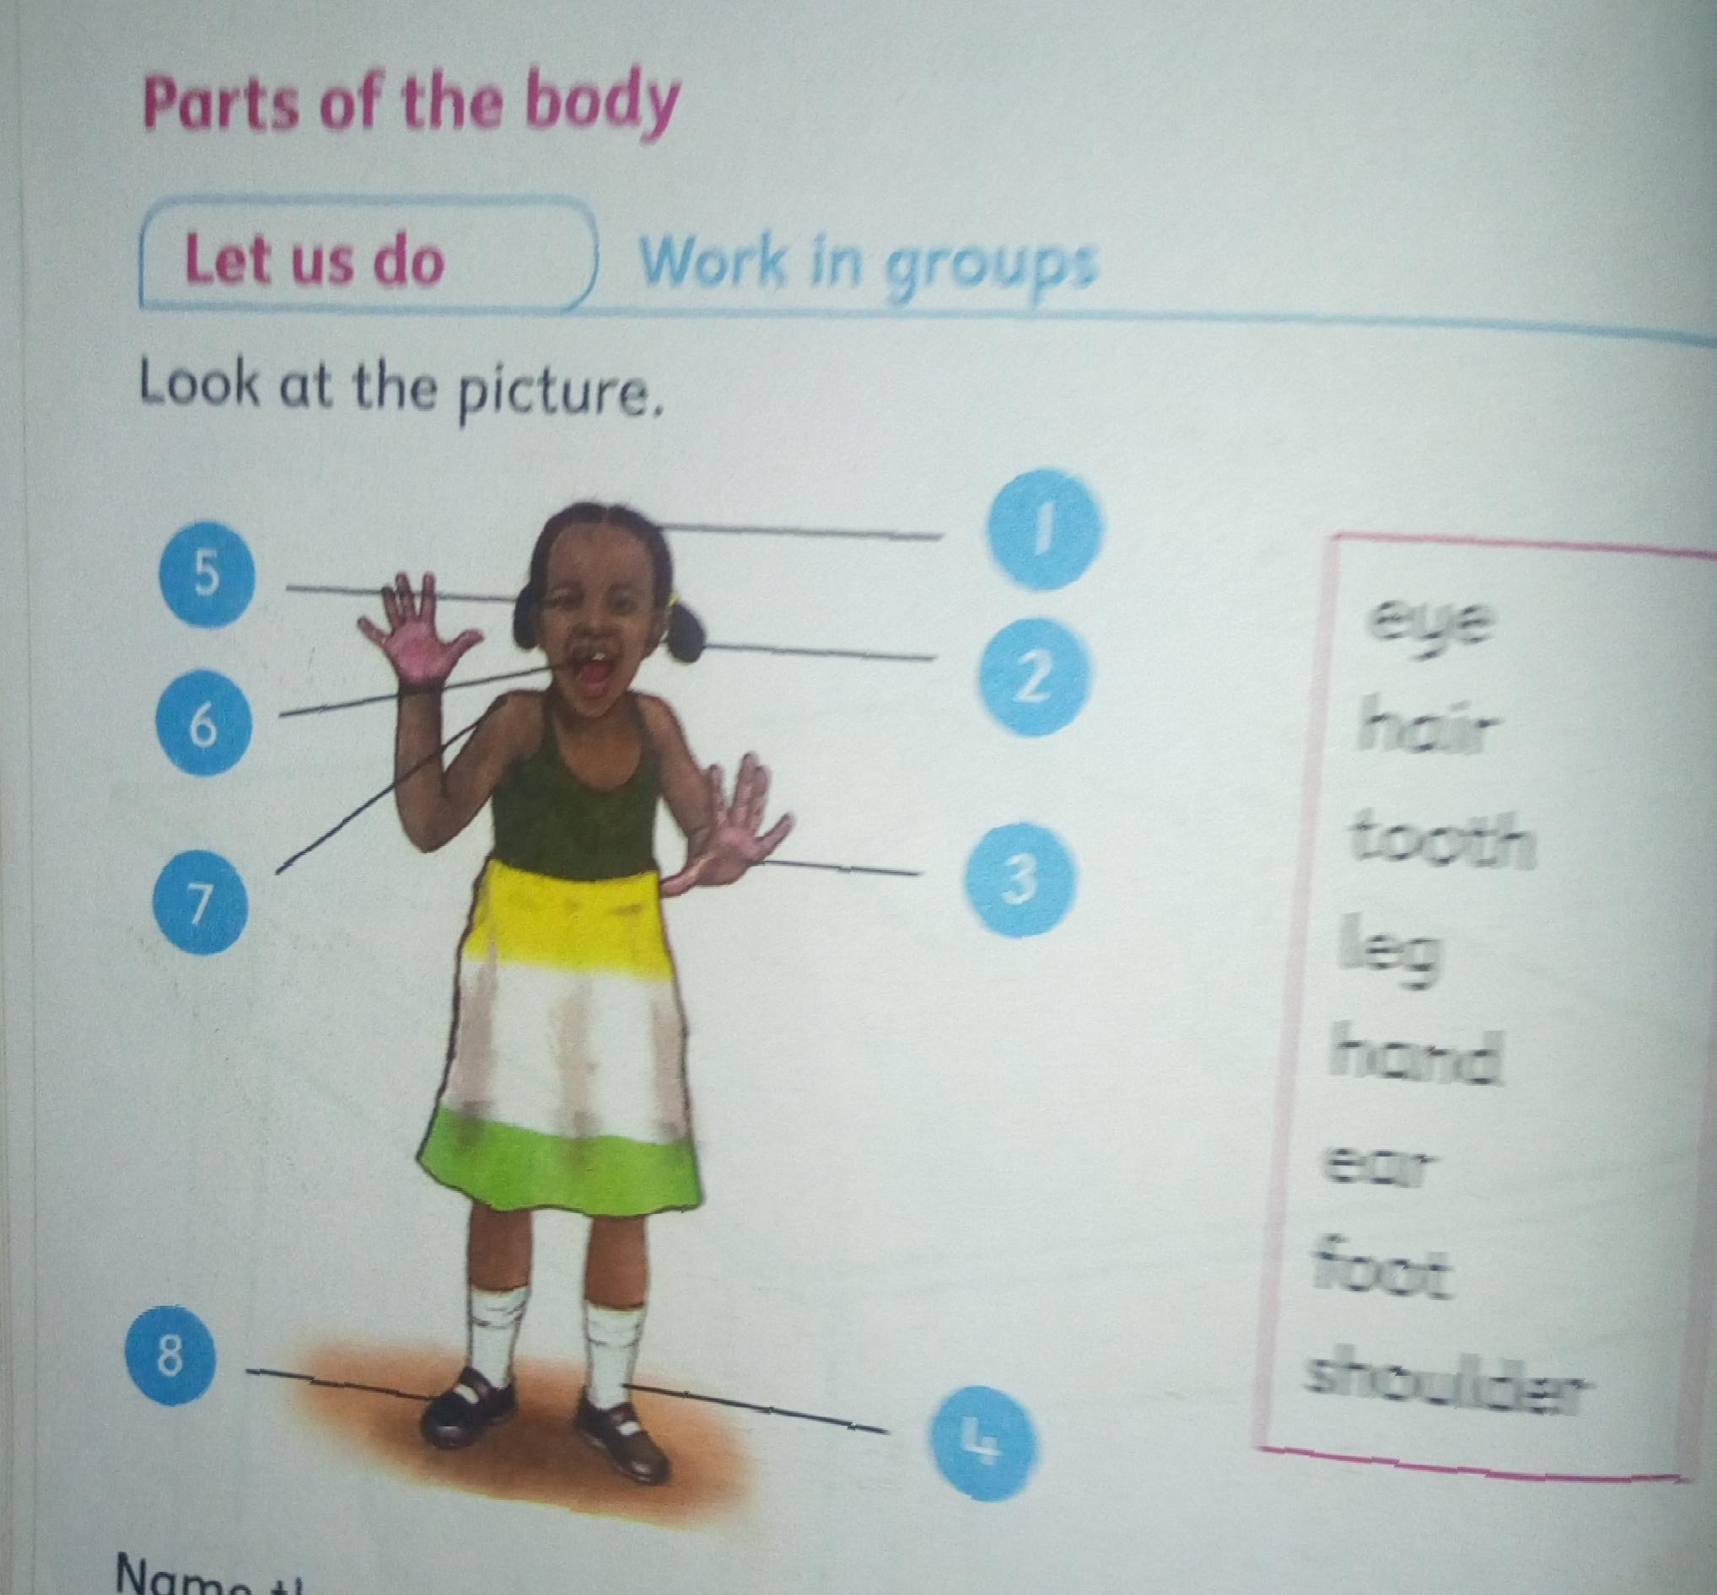

**Things we use to clean the body**

**Things we use to clean the body are;**

* **Water**
* **Soap**
* **Sponge**
* **Towel**
* **Handkerchief**
* **Toothpaste**
* **Toothbrush**
* **Pumice stone.**

**Pumice stone is a soft stone for scrubbing the feet**

**Handkerchief is a small cloth used to clean the nose**

**Cleaning our face**

**1.put water in a basin**

**2.close your eyes**

**3.wet your face**

**4.put soap and rub**

**5.rinse your face**

**6.dry with a towel.**

**Cleaning our teeth**

**1.wet your brush**

**2.put toothpaste**

**3.brush your teeth up and down,front and back**

**4.rinse your mouth**

**We clean our teeth using Colgate, tooth brush/chewed stick, tooth paste/salt, and clean water**

**Clean your teeth at least two times a day**

**Washing our hands**

* **Wet your hands**
* **Put some soap**
* **Rub in between and all around**
* **Rinse your hands**
* **Dry with a towel.**

**We wash our hands after visiting the toilet and before eating**

**Washing our feet**

**To clean my feet;**

* **Wet your feet**
* **Put some soap**
* **Scrub your feet**
* **Rinse the feet**
* **Dry them with a towel**

**Always keep your feet clean and dry**

**Keep your nails short**

**Cleaning our hair,nose and ears**

* **We clean our ears with a soft wet cloth**
* **We use ear bud to remove wax from the ear**
* **We use handkerchief to clean our nose**
* **We use soap and water to wash our hair then we brush it with a hairbrush or comb to make it neat**

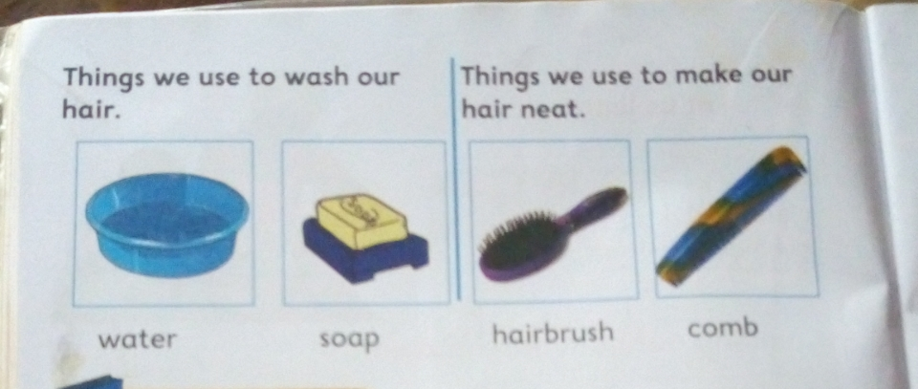

**Washing the hair**

* **Put water in a basin**
* **Wet the hair**
* **Put some soap**
* **Rub then rinse**
* **Dry and comb**

**Let learner’s do an extended activity of washing the doll**

**Exercise 2.1**

**Answer this questions**

**1.We use____and____to clean our hair**

**2.Draw two things you use to clean your teeth**

**3.We use soap,water and ____to wash our face**

**4. Name the parts of the body we clean with these things**

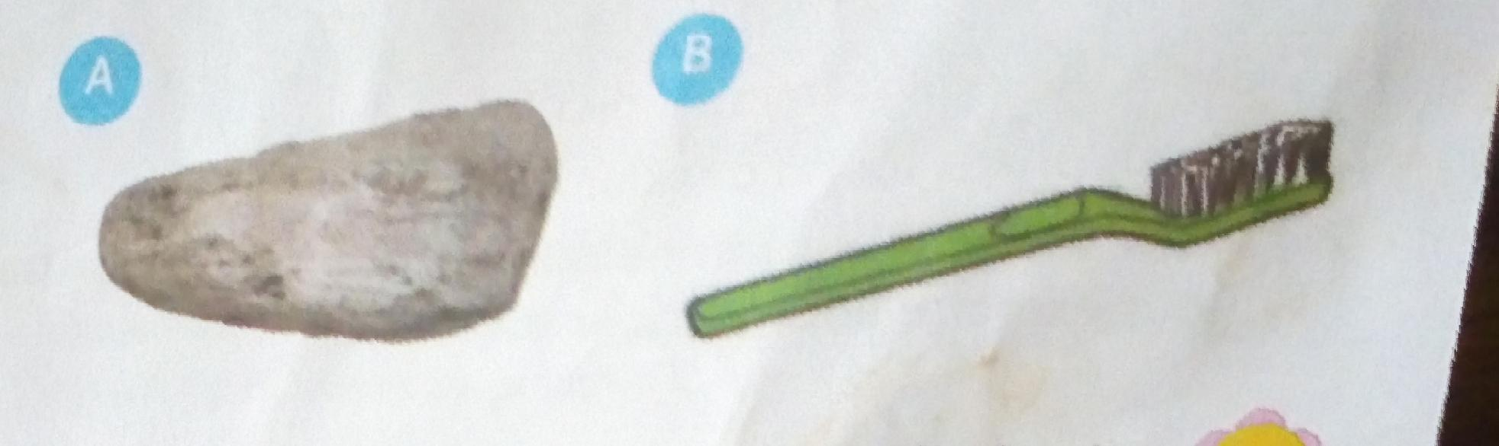

**Use of toilets and latrines**

**Toilets,latrines or urinals**

* **Our homes have a toilet or latrines**
* **Schools also have toilets or latrines**

**Show the toilet, latrine and urinal**

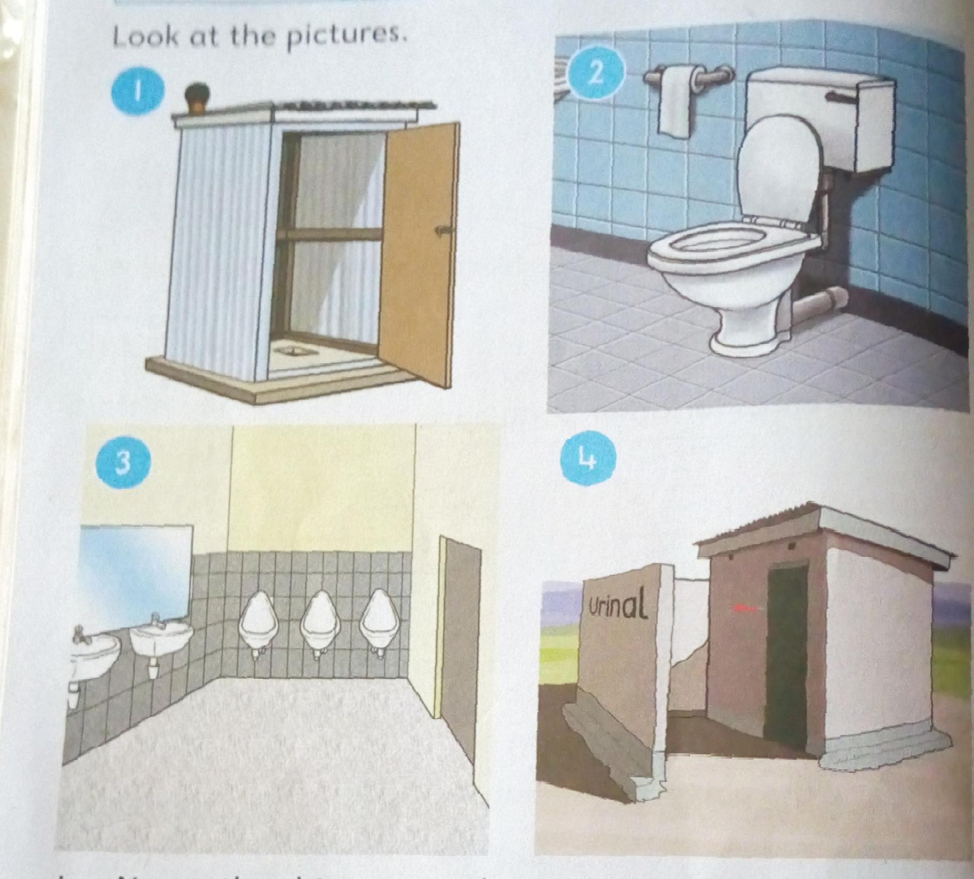

* **Let learners name the things in each picture**
* **Ask them the one that is found at their home**
* **Let them draw the toilet or latrine they use at their home**
* **Note: The latrine is found outside the house**
* **Good use of toilets and latrines prevent illnesses**
* **Going to the bush is not a healthy habit**

Always use the toilet or latrine

**Exercise 2.2______**

**2.After using the toilet,we should_____(knock,flush)**

**Fill in the blank spaces**

**1.Latrine is to outside the house while toilet is to**

**3.Used tissue paper should_____(be used again,be thrown in the latrine)**

**Topic: Foods**

**Sources of food**

**Food at our place**

* **Learners to name the foods they eat**
* **Learners to look at the pictures of foods**
* **Learners to name foods in the pictures**

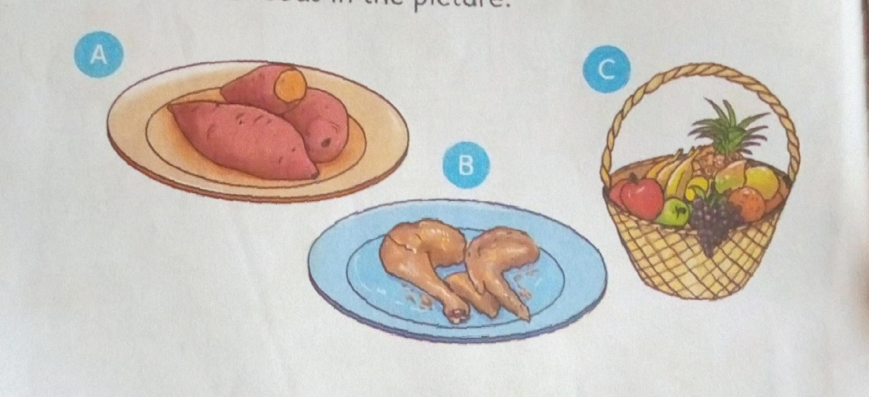

**Activity**

**Learners to draw foods they eat on the table**

**Animal and plant food sources**

**Source is where food come from**

* **Some foods come from plants e.g ugali,sukuma wiki,cabbage, carrots etc**
* **Some foods come from animals e.g milk,meat,eggs,fish etc**

**Exercise 3.1**

**1.Draw and colour**

**(a) One food we get from a**

**(b) One food we get from plants**

**2.We get tomato from______(animals,plants)**

**3.Fish,milk and meat are foods from animals_____(true,not true)**

**Eating habits**

**Food we eat every day**

* **Let Learners name the foods they eat every day**
* **Guide them to draw the foods they eat every day**

**Foods I like or dislike**

* **People like some foods**
* **Some people do not like some other foods**
* **Not all people like the foods we like**

**Note: draw a table and let Learners copy it on their books,let them writfoods they like or not like.**

**Which foods are good for my teeth**

* **The foods that are not good for our teeth are ice cream, biscuits, chocolates,cakes and sweets.**
* **We should avoid eating too much sugary foods.**
* **We should always eat foods that make our teeth strong.**
* **The foods that make our teeth strong are milk,fruits,sugarcane and carrots.**

**Exercise 3.2**

**1.Foods like ____and____ are note good for my teeth.(carrots, biscuits, milk,sweets)**

**2.Draw two foods that you like.**

**3.Draw two foods that are bad for your teeth**

**Using our senses to know food**

**Foods we eat at home and in school**

* **Guide Learners to name the foods they eat at home**
* **Let pupils name that foods they eat at school**

**Common foods at our locality**

**Locality is where we come from.**

* **People come from different localities and eat different foods**
* **Some foods are are eaten in many homes.**
* **Guide Learners to look at the pictures and name foods they eat in their locality**

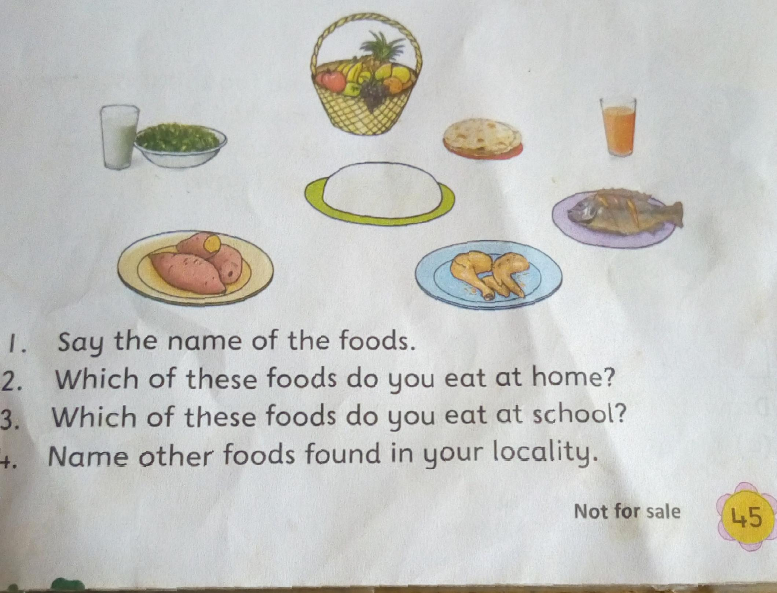

**Senses and food**

**How do we know food?**

**We know different kinds of foods by**

* **Smelling**
* **Tasting**
* **Touching**
* **Seeing**

**Activity**

**Let Learners bring different kind of foods to school**

**In groups let them cover their eyes one at a time.**

**Guide Learners to use hands,nose and tongue to tell the type of foods**

**Exercise 3.3**

**1.Draw and colour two foods you eat at home**

**2.We can know food by it’s colour,taste,smell or_____(touch,ty)**

**3.Foods that taste bitter are not good to our bodies.(yes,no)**

**Cleaning of fruits**

**Fruits at our place**

* **Some fruits come from our place.**
* **Our place is our locality**

**Let Learners look at the pictures of fruits and name fruit in their locality.**

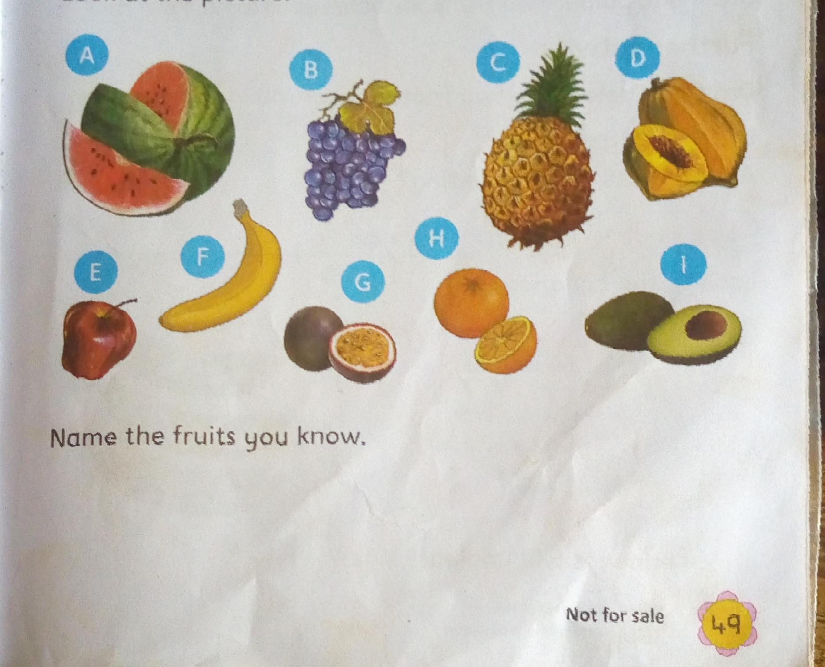

**Learners activity:**

**Draw and colour two fruit found in your locality**

**Choosing fruits**

**Are all fruits good for eating?**

* **We should not eat bad fruits**

**Types of bad fruits are;**

* **TRotten fruits**
* **Dirty fruits**
* **Poisonous fruits**

**When food goes bad we say it’s rotten**

**Show Learners pictures of fruit and let them say which fruits are good and which ones are bad**

**Look at the pictures**

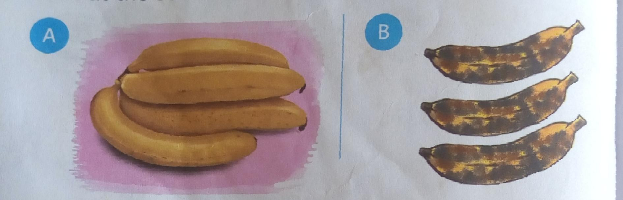

**Which bananas are good for eating?**

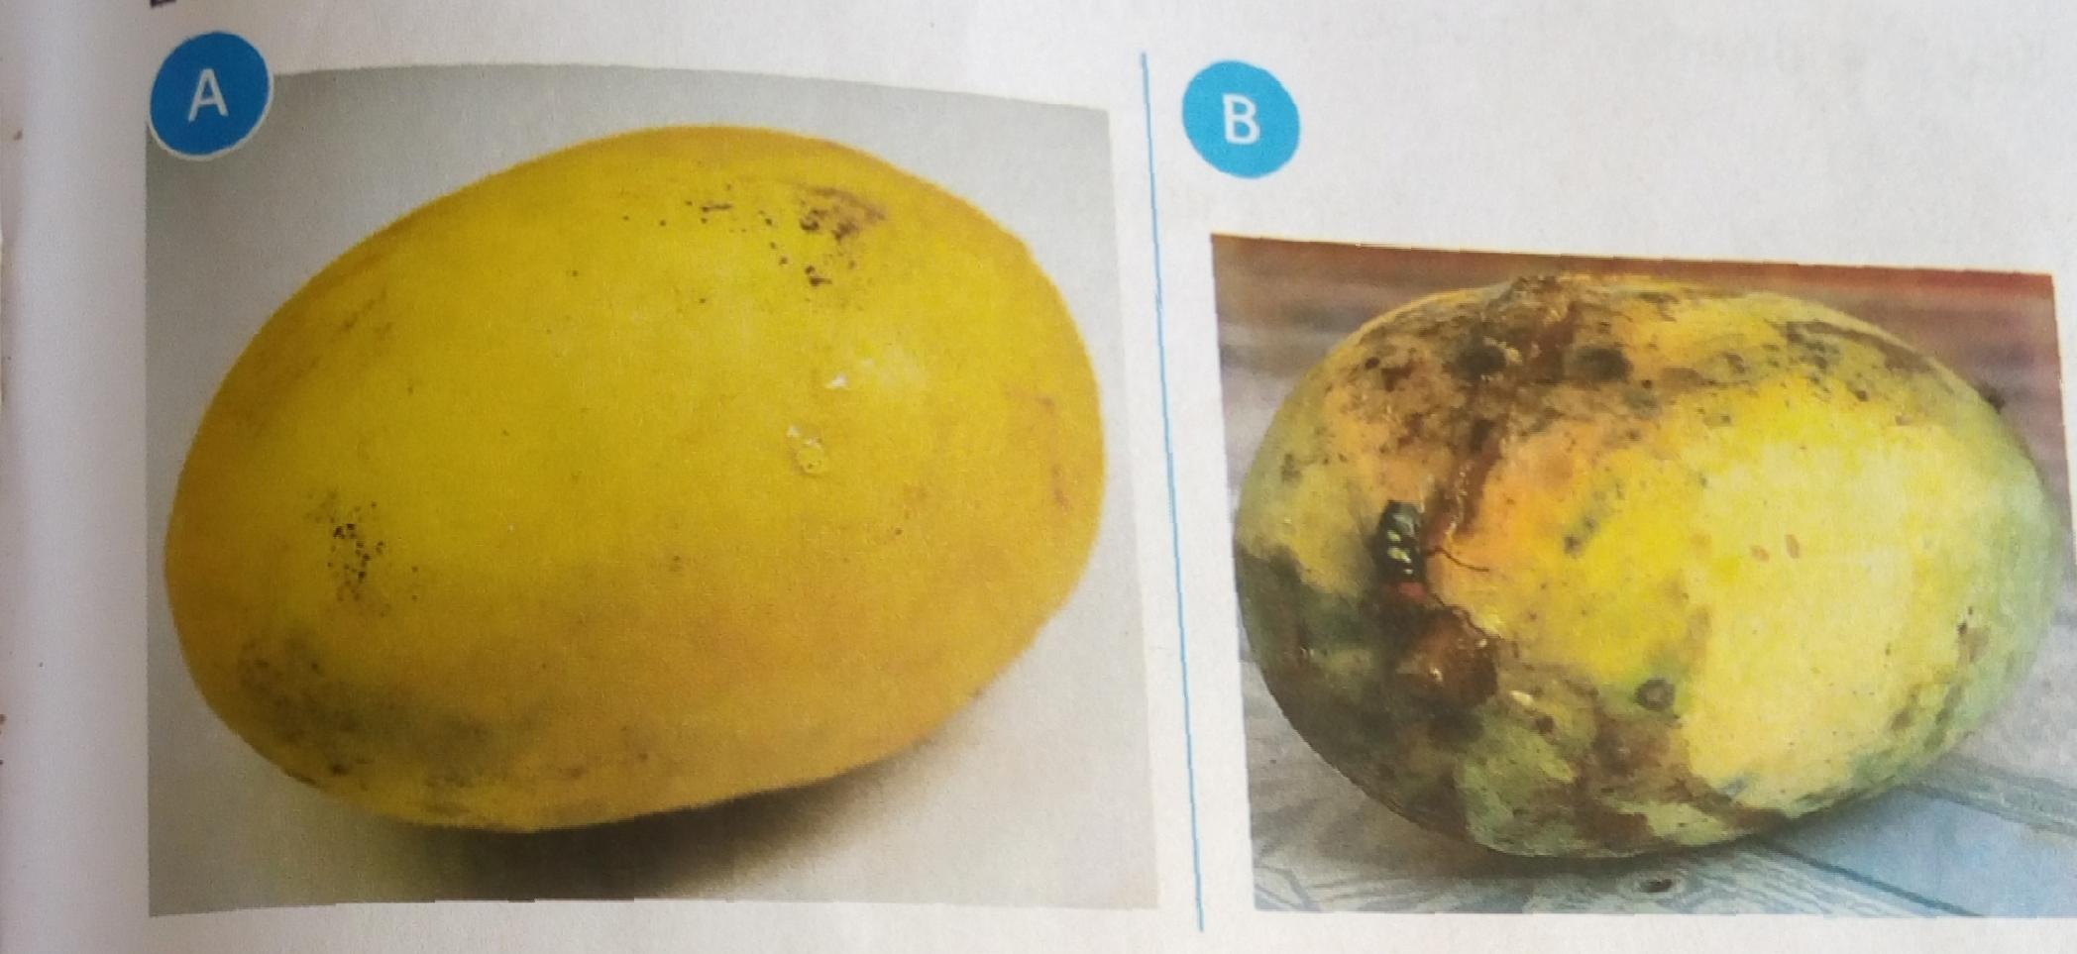

**Which mangoes are good for eating?**

**Washing fruits**

* **Dirty fruits can make us I’ll**
* **Was fruts before eating them**
* **Wash fruits with clean running water**

**Exercise 3.4**

**1.We _____fruits before eating them (wash,bite)**

**2.Which fruit will you eat?A or B? why**

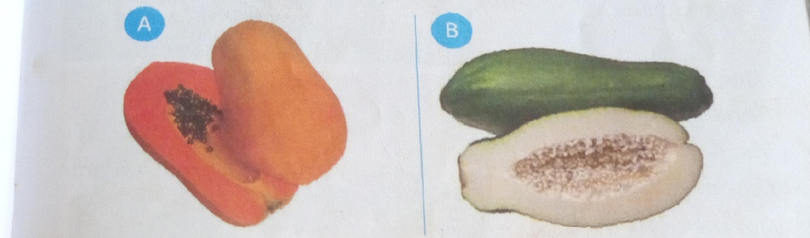**3.Draw two fruits found in your locality**

**Why we eat**

**How many times do you eat in a day?**

* **When you wake up in the morning,you eat breakfast.**
* **Then in the afternoon you eat lunch**
* **In the evening before you go to sleep you eat supper**
* **So we eat three meals a day, breakfast, lunch and supper.**

**Foods we eat at different times**

**Show Learners pictures of foods**

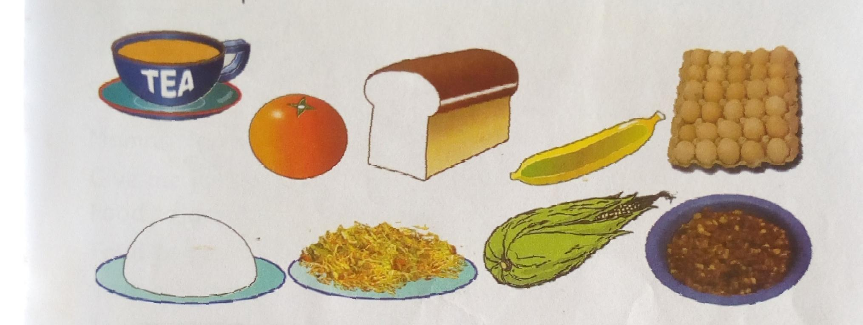

* **Let them show which foods they eat when they wake up**
* **Which foods they eat during the day**
* **Which foods you eat before you go to sleep**

**Why do we eat every day?**

* **We eat every day to get energy**
* **Energy helps us to play,sing,run and jump.**
* **We also eat to grow**
* **We eat to be healthy**

**Exercise 3.5**

**1.Name two activities that you do.**

**2.Say if you need energy to do them.**

**3.We eat to grow and _____ (be healthy, sleep)**

**Good behavior during meal times**

**Meaning of mealtime**

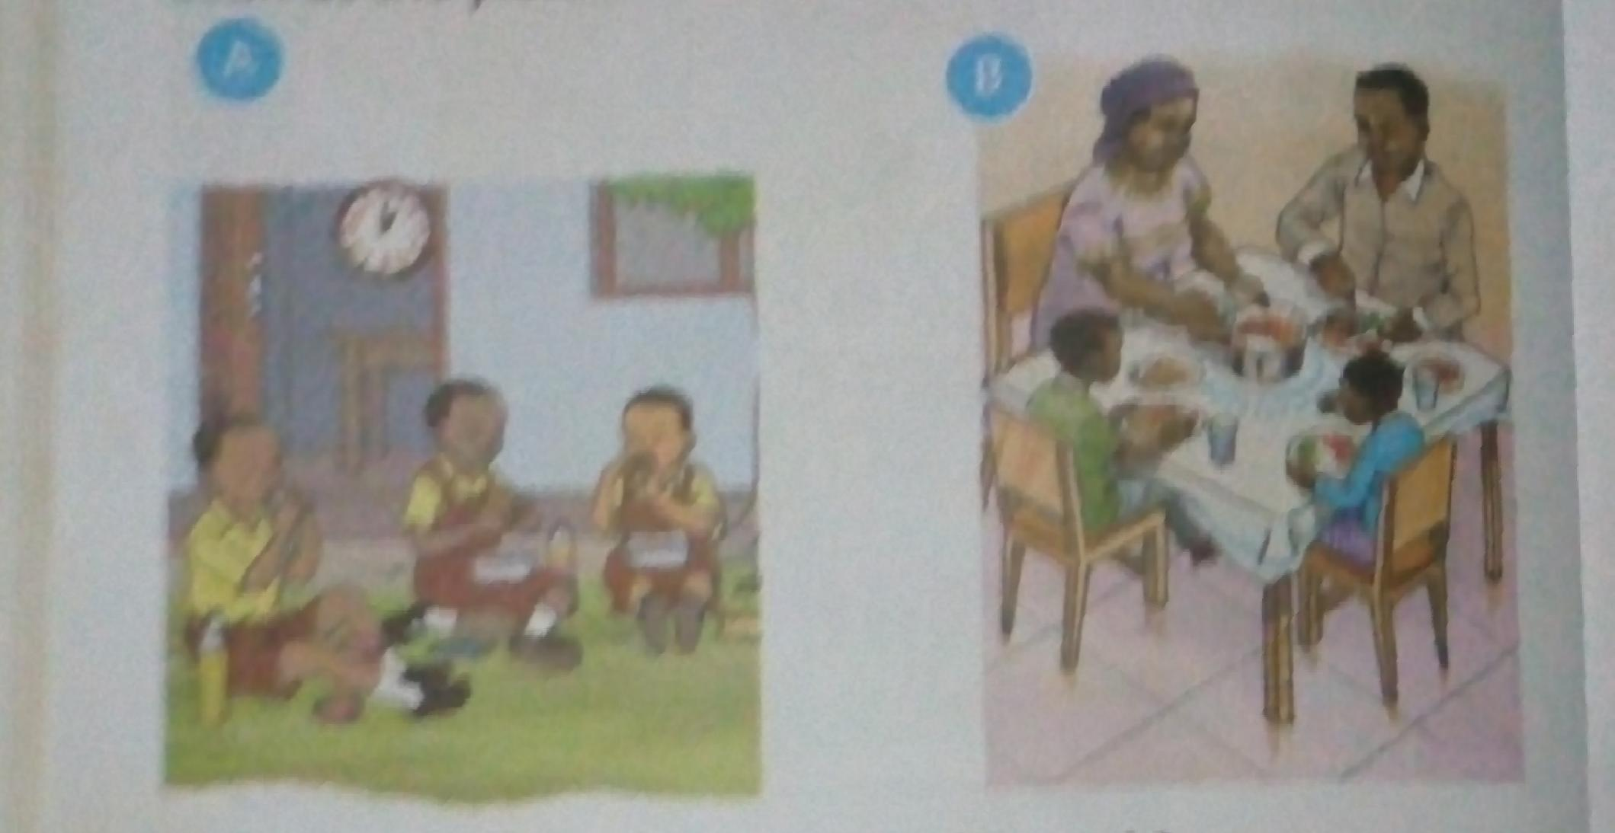**Look at the pictures**

* **The pictures show people eating**
* **The time we eat is called mealtime**

**Good behavior when eating**

**1.Wash your hands before eating**

**2.Serve food that you can finish**

**3.Close your mouth while chewing**

**4.Clear the table after eating**

* **Show Learners this pictures and ask them questions.**

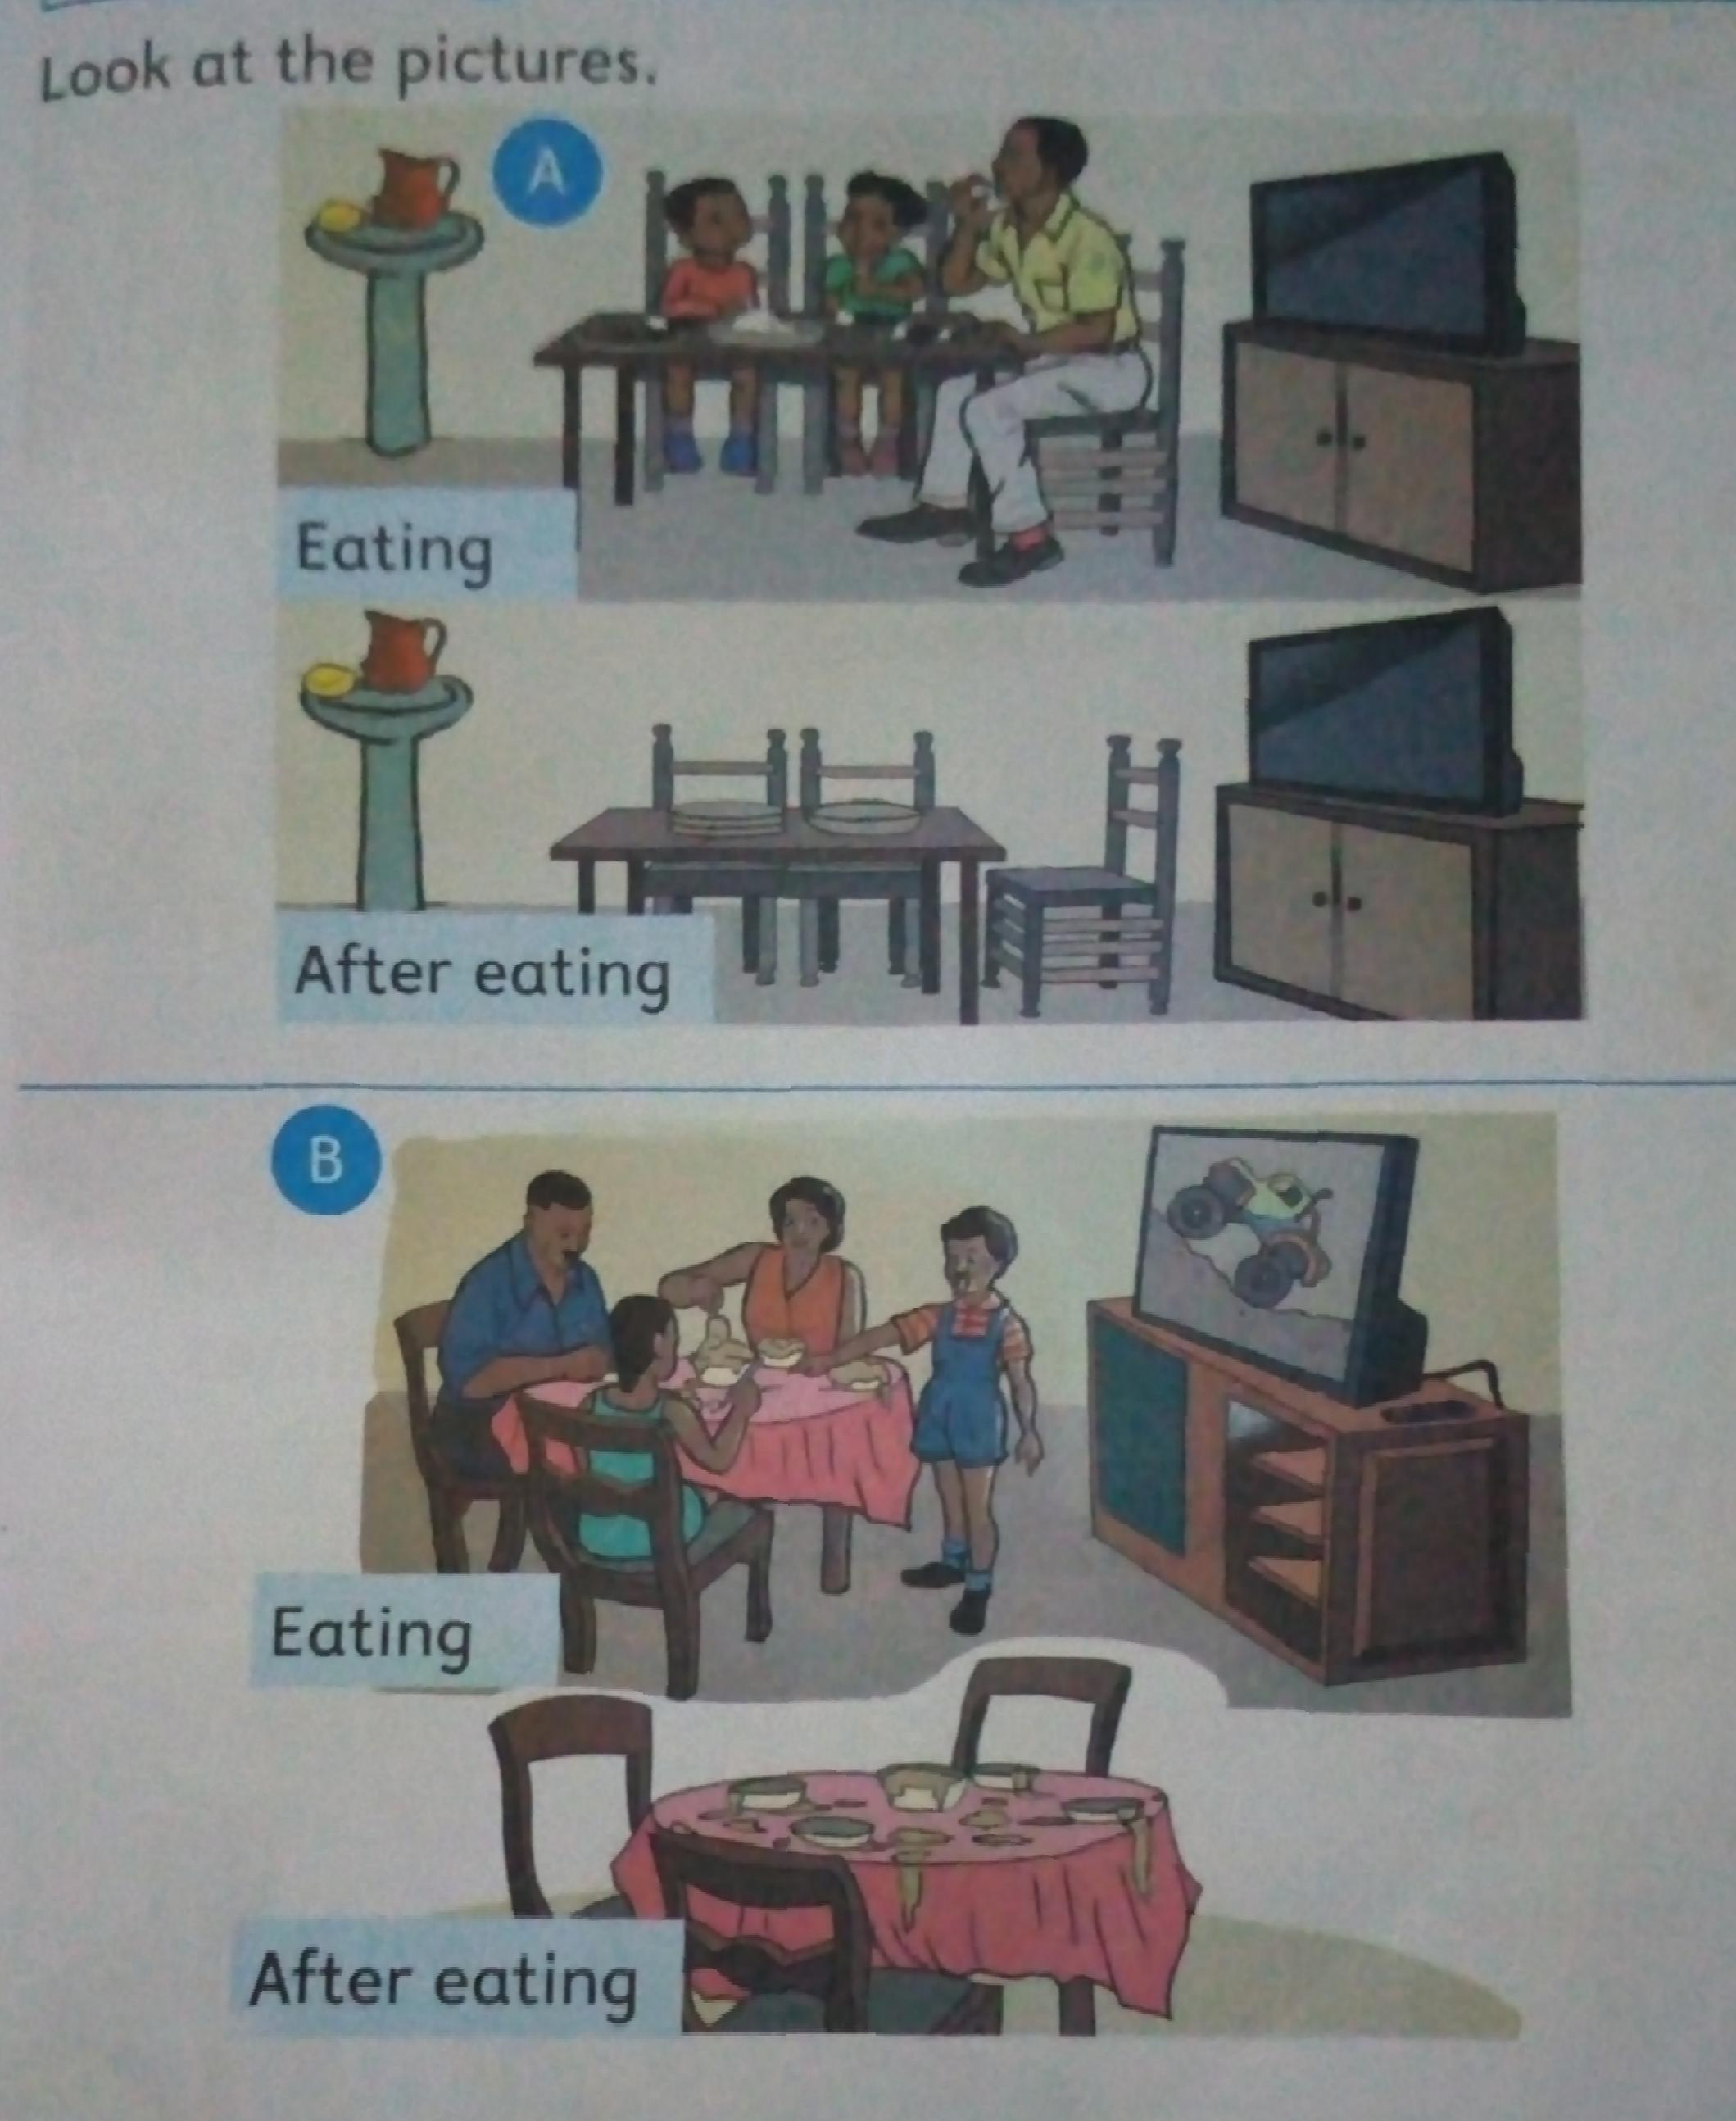

**Which family is showing good behavior during meal times?A or B?**

**Why we show behavior during mealtimes**

* **Bad eating manners can cause choking**
* **Serving a lot of food make other people miss food.**
* **Showing food in your mouth is lack of respect**

**Choking is when food get stuck in the the throat**

**Exercise 3.6**

**1.Peter likes talking while eating.He can____(choke,drown)**

**2.We only wash our hands after eating.____(yes or no)**

**3.Do not _____ food(waste,eat)**

**Buying food**

**Where do we buy food?**

**We buy food from the following places;**

* **Burchery**
* **Kiosk**
* **Restaurant**
* **Hotel**
* **Shop**
* **Open air market**

**Kiosk is a small shop**

**Restaurant is a place where cooked food is sold**

**The food we buy**

**We buy food from different places.**

**1.We buy meat from the butchery**

**2.We get cooked food from a restaurant**

**3.We can buy maize and beans in the open air market**

**\* Let Learners do an exercise of matching pictures on page 67 pupils book grade 1**

**Topic 4: Safety Education**

**Common accidents at home**

**What accidents happen at home?**

**Look at the pictures**

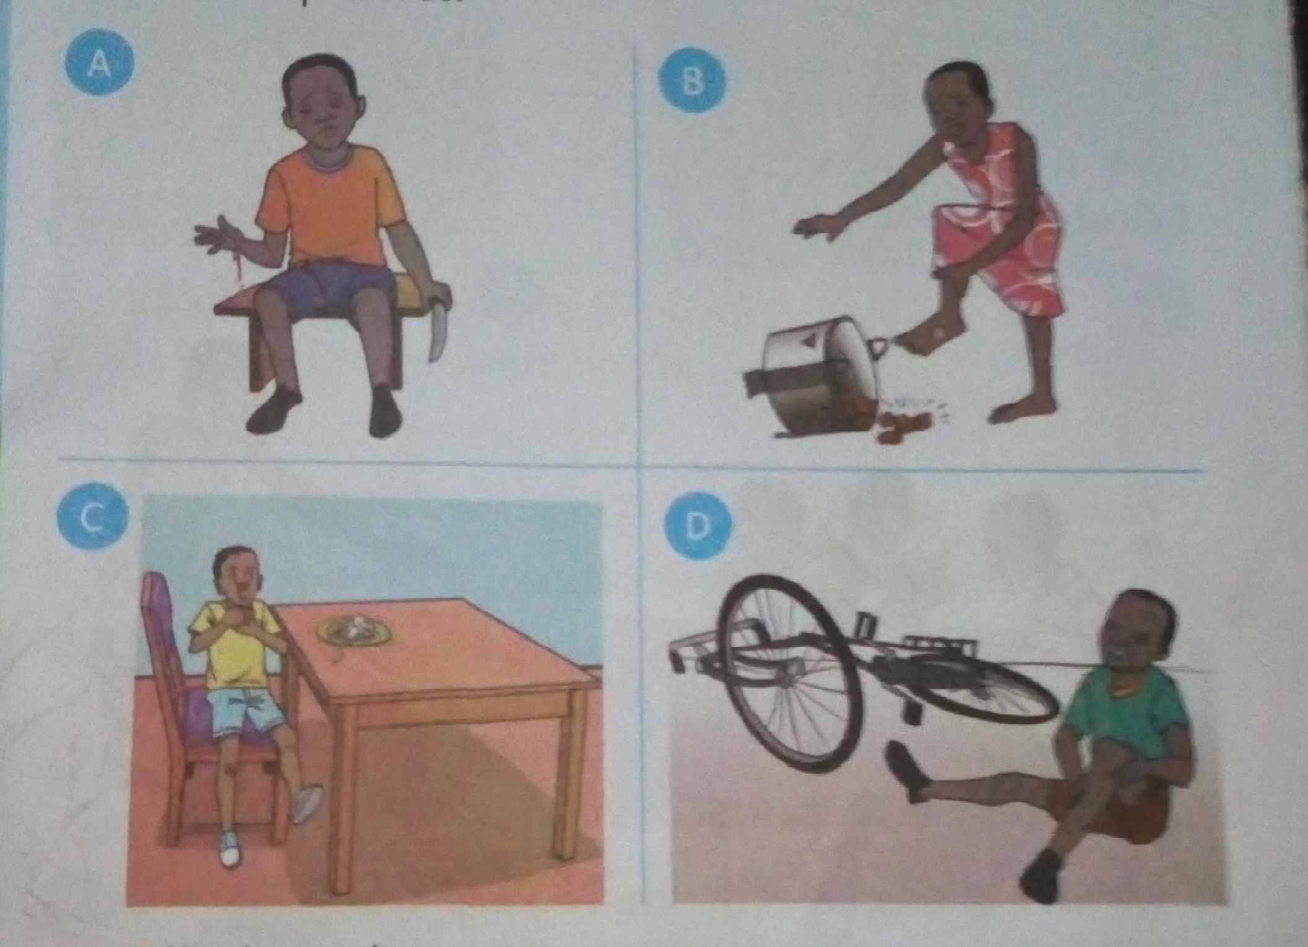

* **The children in the pictures are hurt.**
* **They had an accident**
* **An accident is a bad thing that happens to us like cuts,burns and falls.**
* **Some accidents at home are cuts,burns,fallsand chocking**

**Cuts and burns**

**Look at the pictures**

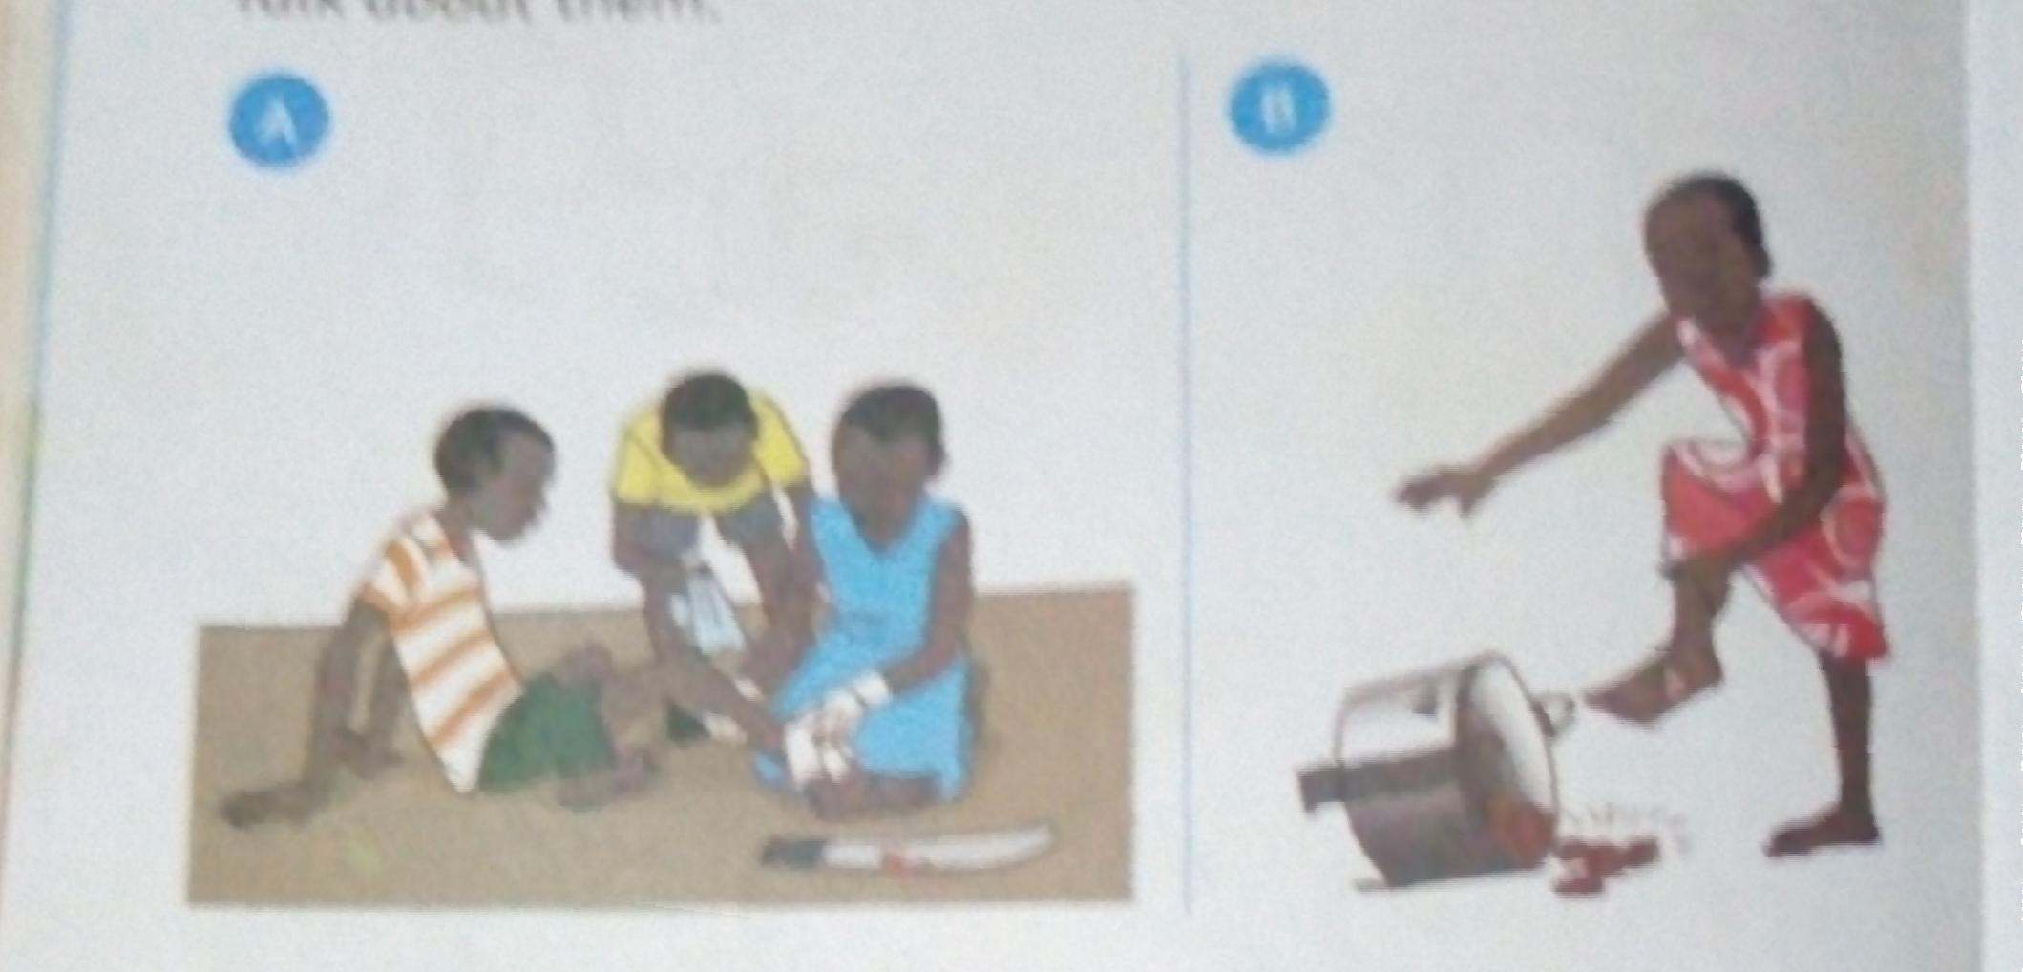

**The boy in picture A has cut his leg and the girl in picture B has a burn.**

**Cuts and burns are common accidents at home.**

**Falls and drowning**

**Ask Learners to look at the pictures**

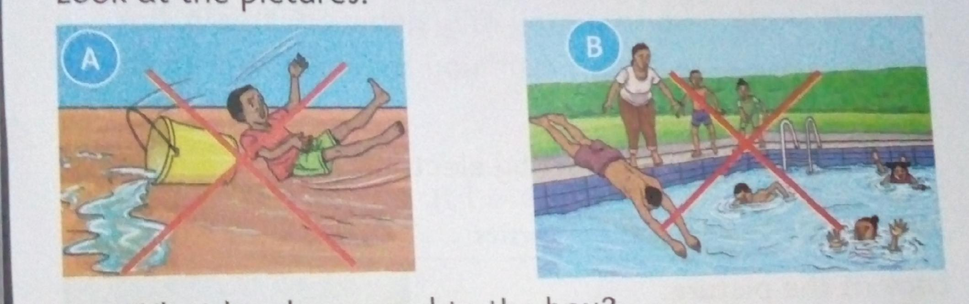

**The boy in picture A has a fall and picture B shows drowning in water**

**Falling and drowning are also common accidents**

**Electric shock, choking and suffocation**

* **When we talk while eating,we can get chocked.**
* **Electric shock is to get hurt by electricity.**
* **Do not touch or put metals in sockets, you can get an electric shock**
* **Do not cover your head with plastic bags, you can suffocate.**
* **To suffocate is when you lack air to breathe**

**Causes of accidents at home**

**Sharp objects**

* **Sharp objects like scissors, old iron sheets and knives can cut us,do not play with them.Always be careful when handling them.**
* **Things that can make us fall are.**

1. **Slippery floors**
2. **Banana peels**
3. **Furniture that is not arranged well**
4. **Rough ground**

**Note: Furniture are things like chairs,beds,tables and desk**

**Slippery is something that can make one slide and fall**

**Sockets and flames**

**Touching a socket is very dangerous ,it can cause a shock**

**Playing with fire is also dangerous,it can cause burns**

**Learners to look at pictures on page 75 pupils book.**

**How can we prevent accidents at home**

* **Wiping water on the floors prevent falls.**
* **Arranging furniture prevents falls**
* **We should put all waste in dustbins**
* **Always hold the knife by the handle**
* **Do not play with sharp objects like iron sheets**
* **Do not play near fire**

**Activity:Ask Learners to make posters of how to prevent accidents in groups.**

**Exercise 4.1**

**1.Name the accidents.**

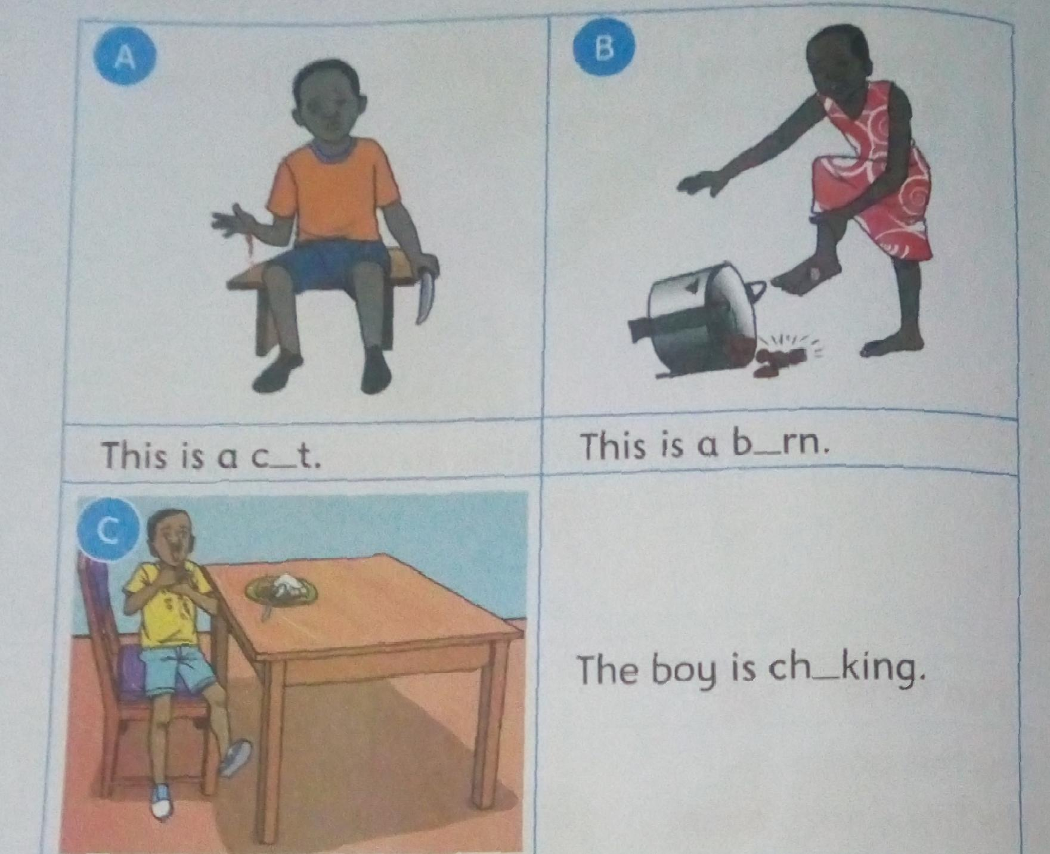

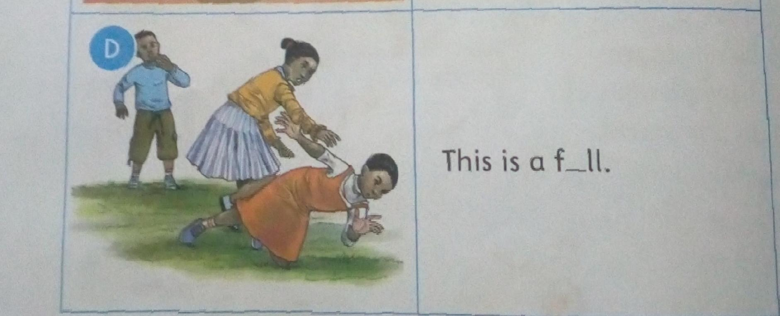

**2. ___can cause accidents in the kitchen.(a knife, blanket)**

**3.We can prevent falls by___(keeping the floor dry,playing with a knife)**

**4.Electricity can cause____(electric shock, drowning)**

**Dangerous chemicals at home**

**Dangerous is a thing that can harrm us**

* **Chemicals are things ilke paraffin,soap and insecticides**

**Which chemicals are dangerous at home?**

**Let Learners look at the pictures of dangerous chemicals at home**

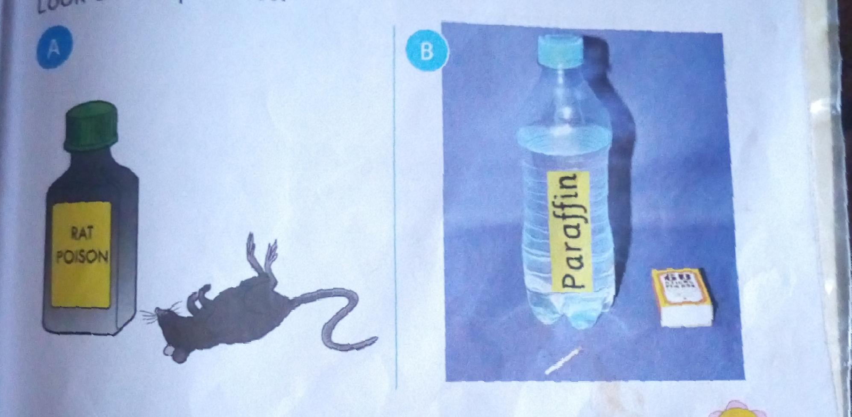

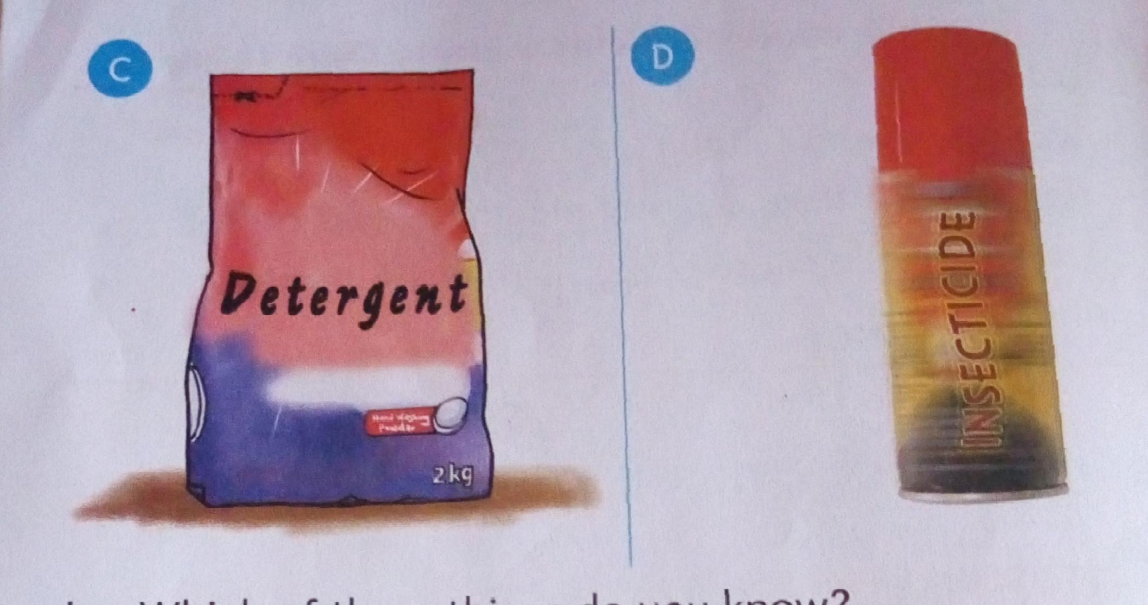

* **Some chemicals can harm us**
* **They are dangerous chemicals**

**What dangers do chemicals at home cause?**

* **Some soaps can damage our skin**
* **Water with soapcanharm our eyes too**
* **We can get ill when we take liquid soap.**
* **Parrafin catches fire easily**
* **Paraffin also harms our skin**
* **Insecticides can harm our bodies as well**
* **Pesticides are also dangerous.**

**Insecticides are chemicals that kill insects like mosquitoes**

**Pesticides kills pest like weevil.**

**Give Learners this exercise on pg 85 pupils book**

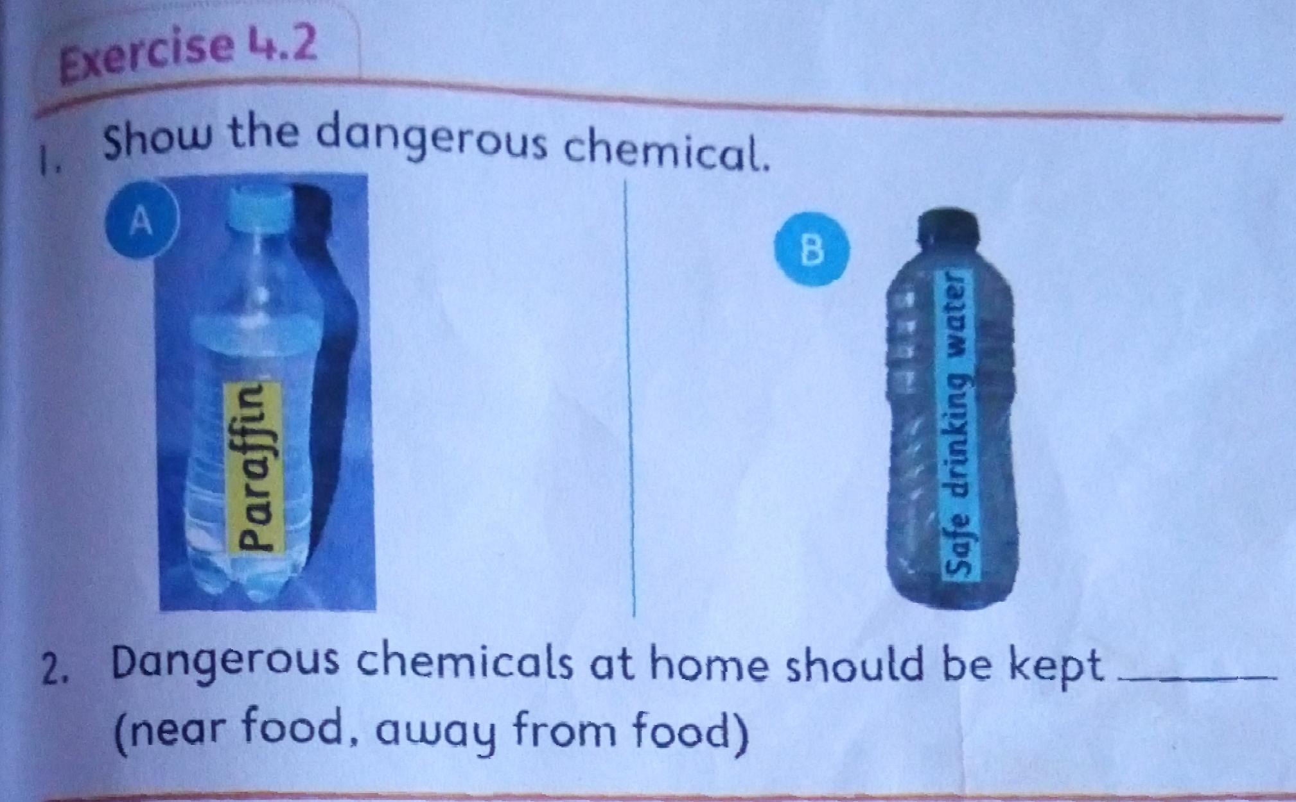

**Simple first aid**

**What is first aid?**

**First aid is the first help given to a hurt person**

**We do first aid for all accidents**

**We do first aid to reduce loss of blood**

**First aid also reduces pain**

**The first aid kit**

**Let Learners look at the first aid kit on pg 89 pupil book**

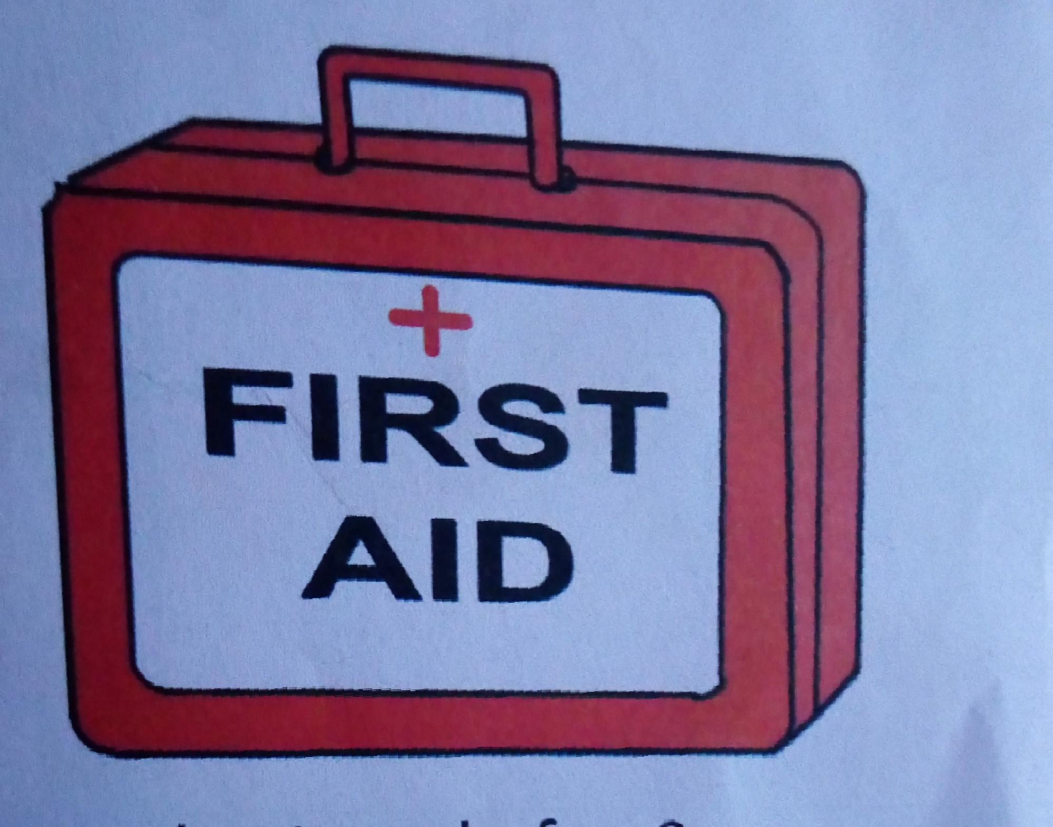

**We keep first aid things in a first aid kit**

**Things found in a first aid kit are;**

* **Bandages**
* **Scissors**
* **Gloves**
* **Cottonwood**
* **Elastoplast**
* **Safety pins**
* **Tweezers**
* **Sterile pad**
* **Show Learners pictures of items found in a first aid kit on pg 90 pupils book**

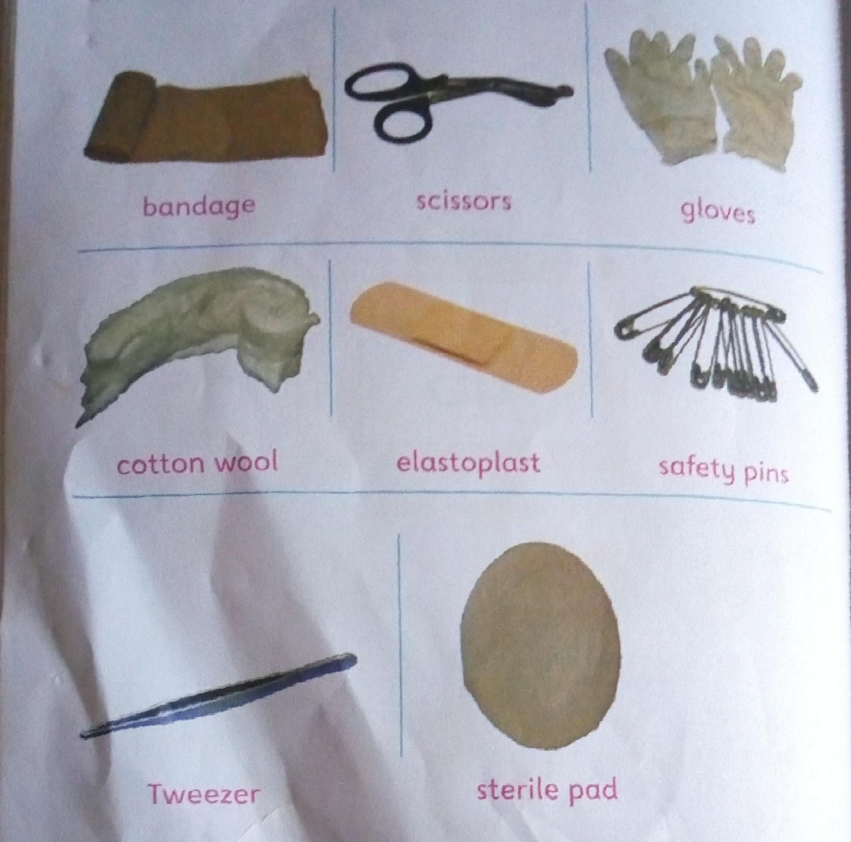

**Activity**

**Let Learners do a hfirst aid activity in groups.**

**Let one pupil in each group act like they have been cuton the leg**

**Let the others do first aid to him/her**

**Observe and give out marks**

**Exercise 4.3**

**1.Your friend has cut herself.What will you do?**

**2. Name the things below.**

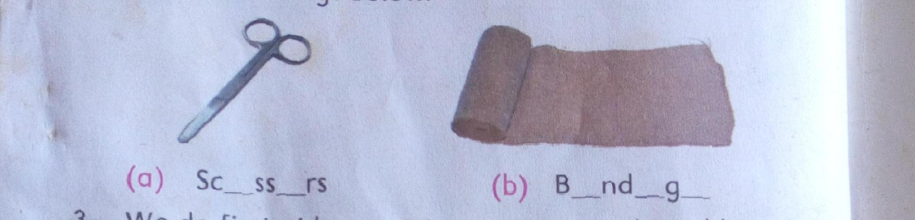**3.We do first aid on a cut to____(stop bleeding,stop crying)**

**4.Things used in first aid are kept in a ____(first aid kit, house)**

**5.____ are not found in a first kit(pins,nails)**