LIVESTOCK PRODUCTION III
(LIVESTOCK REARING PRACTICES)

This topic entails the following:
- Raising young stock
- Milk and milk components
- Milk secretion and milk let-down
- Correct milking techniques
- Marketing of milk and beef.

The following relevant questions and their answers in this topic will greatly motivate and help
the user to comprehend and understand the required concepts and practices:

1. What is “calf crop” in beef production?
2. a) Describe the procedure of hand milking in a dairy cow
b) Explain the practices observed in clean milk production
3. Give two reasons for washing a cow’s udder with warm water before milking
4. Give two roles of uterus in egg formation process
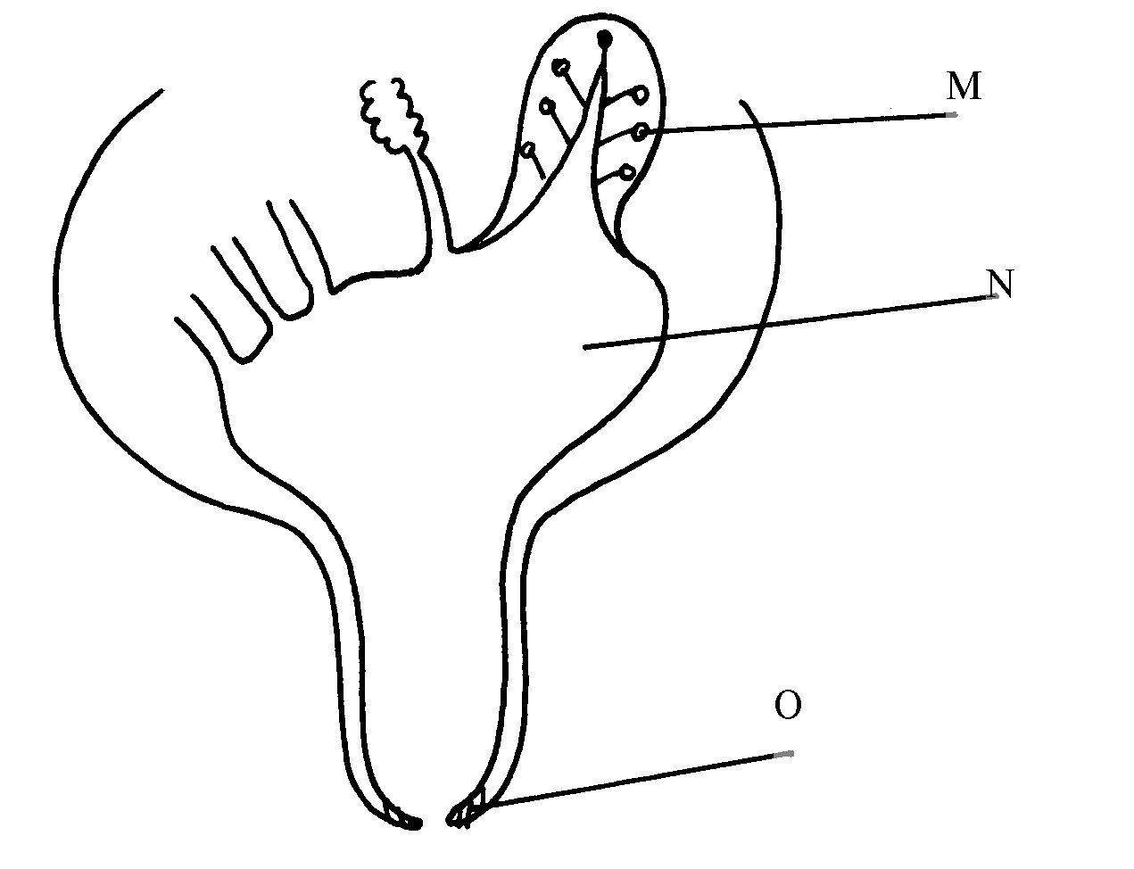
5. The diagram below is a structure of part of a cow’s udder

O

(i) Name the parts labeled M, N, and O on the diagram above
(ii) State the functional difference between the following hormones which influence milk
let-down;
(a) (i) Oxytoxin
(ii) Adrenalin
(b) Mention three qualities of clean milk
6. Give four characteristics of clean milk
7. State three maintenance practices carried out on a milking machine
8. State four reasons for feeding Colostrums to calves immediately after calving
9. Give three ways of stimulating milk let down in a dairy cow
10. a) Describe the operational differences of a disc plough and mould board plough
b) Explain six marketing problems affecting dairy farming in Kenya
c) State four reasons for culling a boar
11. List three advantage of artificial method of calf rearing
12. State three methods that may be used to improve milk production in a breed
of indigenous goats
13. (a) Outline ten physical characteristics between a good layer and a poor layer in a deep
litter house
(b) Describe five factors that influence milk production in a dairy herd
14. a) State two reasons for washing the udder of a cow with warm water before milking.
b) Name the hormone that causes each of the following in dairy cows:.
i) milk letdown.
ii) lactogenesis
15. State four methods of increasing the depth of penetration of a disc harrow.
16. List four farm machines implements that obtain power from P.T.O shaft of a tractor
17. List two tractor drawn implements used for breaking hardpan in a crop field

18. State any three machines which are used for harvesting crops

19. a) describe the daily maintance and servicing of a tractor before use
b) State one function of each of the following parts of a tractor engine.
i) Fly wheel
ii) Ignition coil
iii) Thermostat
iv) Injector
v) Piston

LIVESTOCK PRODUCTION III
(LIVESTOCK REARING PRACTICES)
1. A group of calves kept according to age

2. (a) - Assemble all milking equipments such as buckets, milking can and towels.
- Put animals in milking shed and restrain appropriately.
- Wash udder and teat using warm water mixed with an appropriate sanitizing agent.
- Dry the udder using a towel.
- Use trip cup to test the first few drops of milk for mastitis.
- Carry out milking by squeezing out the milk / teats.
- Strip the udder dry.
- Dip the teats in ant-mastitis solution after milking.
- Apply milking jelly 9milk salve) on the teats.
- Release the cow.
- Weigh and record the milk.
- Strain the milk into the milking can to cover immediately.
-Cool the milk rapidly to a temperature of 4⁰c.
(b) - Keep cow healthy/ free from diseases.
- Wash cow flanks, udder and region around the udder using clean water then dry using clean
towels.
- Milking shed should be clean, wash after every milking and disinfect.
- Clean and sterilize milking utensils.
- Keep milk in a dust free environment.
- Deliver milk to collecting centres.
- Don’t feed cows on feeds which may taint milk a few hours to milking e.g. Mexican marigold, silage, garlic e.t.c.
- Do not expose milk to direct sun.
- Milk should be carried in aluminium container.
Copper and iron containers may cause oxidation of milk fats.

3. Reasons for washing a cow’s udder with warm water
- To remove dirt
- To stimulate milk let down ( ½ mk each = 1mk)

4. two roles of uterus in egg formation process
- Additional of calcium which harden egg shell
- Additional of egg pigmentation (2x ½ =1mk)

5. (a) M – Alveolus N – Gland cistem O – Teat ( ½ x 3= 1½mks)
(ii) Oxytocin – Controls the muscle fibres surrounding alveoli to allow milk secretion
adrenalin – A hormone that relaxes the udder muscles to all milk let down (1x2=2mks)
(b) Free from disease causing organisms
- Has no hair/dirt dust
- Its of high keeping / lasting quality
- Chemical composition is within the expected standards ( ½ x3=1 ½mks)

6. four characteristics of clean milk
- Has normal taste
- Free from physical materials
- Free from pathogens
- Free from foul smell
- It is of high keeping quality
- Is chemical composition is within the expected standards

7. three maintenance practices carried out on a milking machine
- Flushing the tubes under high pressure to deblock it
- Greasing/orling the rotating parts in the pump
- Storing it to dry upside down after through washing

8. four reasons for feeding Colostrums to calves immediately after calving
- Easily digested
- Has high nutritive value
- Contains antibodies which protect the calf from diseases
- Has laxative effect

9.
- Presence of milk man/ milky parlour
- Washing/ massaging udder
- Feeding
- Sounds associated with milking
- Maintain regular milking time
10. a) Differences operational
Disc plough | Mould board plough
Can be used in fields with obstacles | Cannot be used in fields with obstacles
Ploughs/ cuts at varying depths | Ploughs/ cuts at constant depths or confirm depth
Requires less skills to operate | Requires more skills to operate
Works well in sticky soils | Does not work well in sticky soils
Rotates and not easily broken since rolls over obstacles | Easily broken by obstacles
Requires more harrowing | Requires fewer harrowing
Poor furrow slice inversion | Proper furrow slice inversion
Does not require constant replacement of parts | More power to pull
b)
- Poor communication network/ poor infrastructures
- Lack of cooling/ handling facilities/ processing facilities
- Competition with non- dairy products/ cheap imported dairy products
- Prevalence of Zoonotic diseases
- Inefficient/ poor management of marketing society/ dairy boards
- Late/ non- payment by marketing agents/ exploitation by marketing agents/ middle men
- Lack of capital to finance marketing activities
- Price fluctuation due to changes in supply
- Lack of market information
c) Reasons for culling livestock
- Old age
- Poor health
- Low libido/ infertile
- Physical deformities
- Hereditary defects
- To avoid inbreeding

11. three advantage of artificial method of calf rearing
- Accurate records of milk yield may be kept
- It is easy to regulate the amount of milk taken by the calf
- Cows produce milk eve in the absence of the calf
- It is easy to maintain high standard of cleanliness/sanitations
- The farmer is likely to sell more milk hence maximizing profit (1/2x3=1 1/2mks)

12. three methods that may be used to improve milk production in a breed of indigenous goats
- Proper selection/culling
- Proper breeding/upgrading/ cross breeding
- Maintaining good health
- Proper feedings
- Proper milking methods
- Proper housing ( ½ x3=1 ½ mks)

13. a) Physical characteristics between good layer and poor layer
Part/feature | Good | Poor
Comb/wattle | Large warm,wavy | Small, shrunken, dry, scaly pace, cold
Eyes | Bright, orange, alert race | Dark, pace, yellow
Beak | Oval, moist, reddish, active | Yellowish
Vent | Soft, pliable, wide | Round, dry, less active
abdomen | Soft, pliable,wide | Hard, full
Space between keel and petric bone | Wide fits 3-4 fingers | Small fits 1-2 fingers
Temperate | Alert- active | Dull, less active
Moulting | Start late | Start early
Plumage | Dry,rugged, rough | Preened, glossy, smooth
Shanks | Pace | Yellowish
broodiness | rare | common

b) i) - Young animals produce with high butter fat content than older animals
ii) Pregnant, emaculated animals have lower butter fat content than normal animals
iii) early and late stage of lactation has lower butter fat content while middle phase has higher butter fat content
iv) last drawn milk from udder has more butter fat
v) - Different breeds of animals produce milk with different % composition e.g. Jersey produces milk with high butter fat content than fresian
vi) Season of the year
- Fat % increases during cold season of year but decreases during dry season
vii) Animals fed roughages produce milk with high fats, protein and lactase than those fed on
grains
viii) mastitis reduces lactose composition in milk
ix) Certain drugs are known to lower milk composition if animal is under treatment

14. a) - Remove dirt.
- Stimulate milk letdown (2x ½ =1mk)
b) i) Milk letdown – oxytocin
ii) Lacto genesis – Prolactin (2x ½ = 1mk

15. four methods of increasing the depth of penetration of a disc harrow
- Exert more hydraulic force.
- Use fewer discs.
- Increase space between discs.
- Add weights.
Increase cutting angle of discs
16.
- Boom sprayer
- Spray race
- Rotavator
- Maize Sheller
Mowers
17.
- Chisel plough
Sub soiler
18.
- Combine harvester
- Forage harvester
- Potato lifter
Mowers

19. a)
- Oil bath air cleaner – check for oil level and add more if low
- Check for cleanliness in oil bath and wash bowl – replace oil if dirty
- Battery – check for electrolyte level and top up if low
- Fuel – check and fill if low
- Radiation- check for water level and top up with clean water if low
- Check for trash in tins and remove if any
- Fan belt- checks for tension and tighten if loose
- Engine oils – check oil level using a dip stick and add more if level is low
- Tyres- check for tyre pressure and add if low
- Bolts, nuts and pins- check for tightness and tighten if loose
- Grease all the moving parts
- Check for any physical abnormalities and rectify accordingly
- Check sediment bowl and drain if dirty
- Use of right type of oil 15x1=15 mks
b) i) Flywheel – maintain the rotational motion of the crankshaft
ii) Ignition coil – steps up the voltage from the battery
iii) thermostat – controls engine temperature
iv) Injector – Atomises the fuel into very fine spray/ injects fuel into cylinder
v) Piston – compresses air/ fuel mixture in the cylinder/ expels exhaust gases/ transmits power

