Water and hydrogen
1. (a) Aluminium is above hydrogen in the reactivity series of elements
(b) (i) The reaction is too exothermic that alot of heat is produced causing ignition of
hydrogen in presence of oxygen
(ii) K_{(s)} + H₂O_{(g)} KOH_{(aq)} + H_{2(g)}
H_{2(g)} + O_{2(g)} H₂O_{(g)}

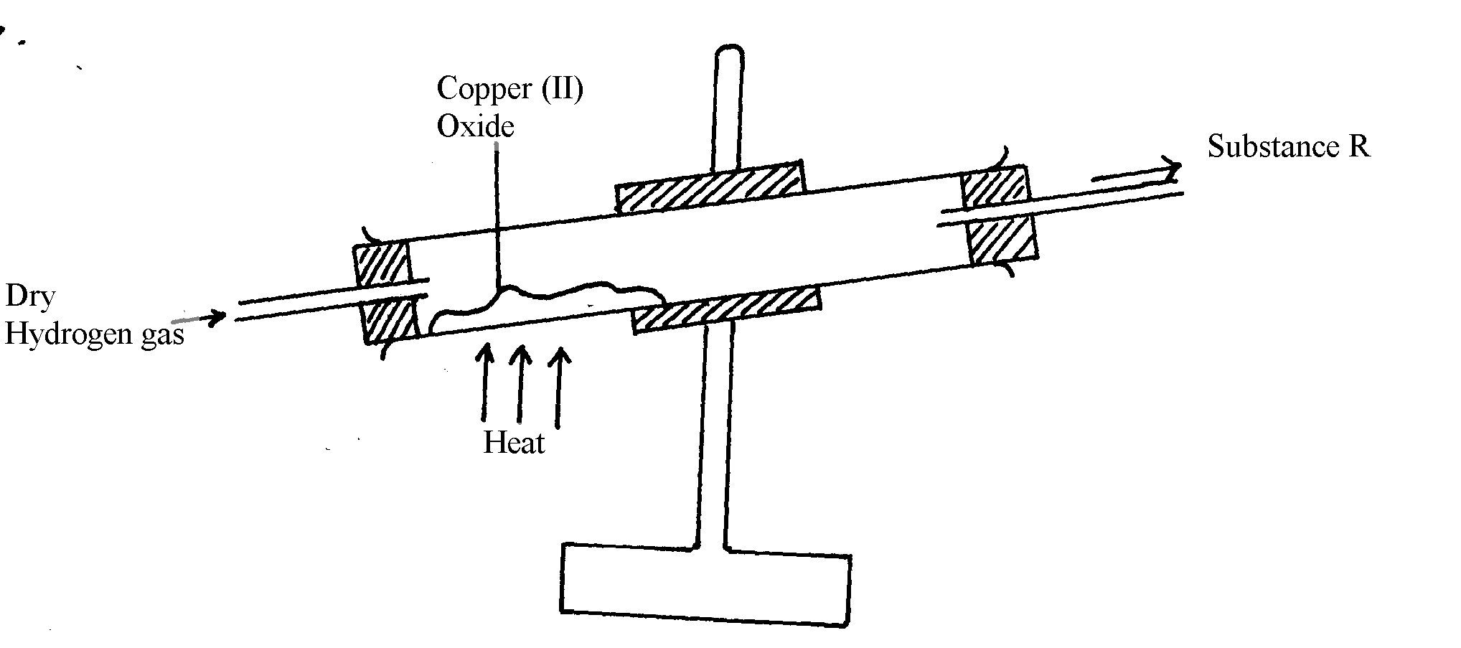
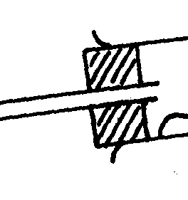
Cold water
Beaker
Substance R
2.

3. a) Calcium chloride
Drying agent

b) 2H_{2(g)} + O_{2(g)} __________ 2H₂O_{(g)}
4. (i) Steam
 1
(ii) Mg_{(s)} + H₂O_{(g)} MgO_{(s)} + H_{2(g)}
(iii) Gas P is passed through the combustion tube before heating is commenced
5. a) 2H_{2(g)} + O_{2(g)} 2H₂O_{(l)} ^{√1}
b) – Turns anhydrous white paper ^{√½} copper (II) sulphate into blue. ^{√½} Or
- Turns anhydrous blue ^{√½} cobalt (II) chloride into pink. ^{√½}
6. a)
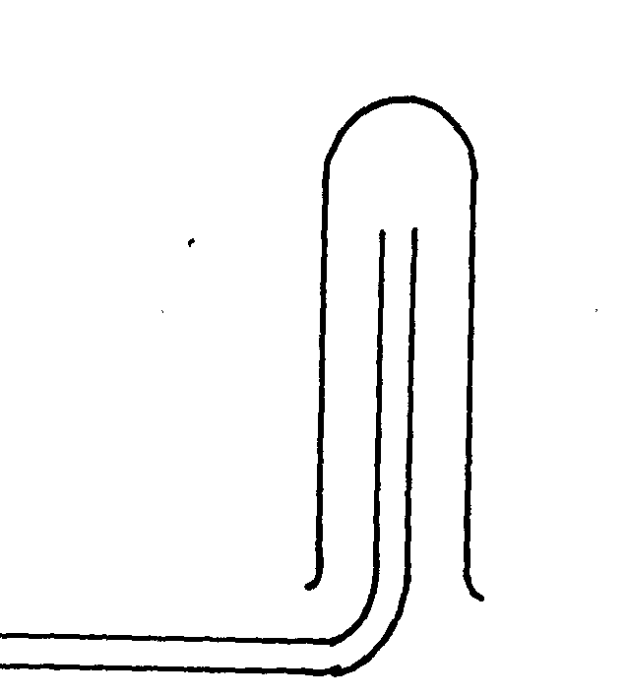
Hydrogen

x
x
x x
x x
•
x
• x
x •
x
•

A
B
B
x
x
x
x
x x
x
x
x x
x x
B

b)reverse steam√1

7. (a) N
(b) 4H₂O_{(g)} + 3Fe_{(s)} Fe3O4_{(s)} + 4H_{2(g)} (Not balanced 0mk)

8. (a)
B.E  ½
S.S  ½
(b) Pb^{2+ (l)} + 2e⁻ Pb_{(s)}
+
-
(c)
1

9. (a) Zn(s) + 2HCl(aq) ZnCl₂(aq) + H₂(g) 1
(b) Concentrated sulphuric (IV) acid or anhydrous calcium chloride. 1
(c) Copper cannot displace hydrogen from its solution. 1
(d) (i) 2H₂(g) + O₂(g) 2H₂O(l) 1
(ii) Before: Pass hydrogen / through the tube before lighting 1 to drive off air.
End: There should be a continuous flow of hydrogen after / putting off the flame
to avoid an explosion. 1

(e) – Filling balloons 1
- Manufacture of margarine.
- Manufacture of ammonia.
- Conversion of coal to synthetic petrol.
(f) Zn (s) + H₂O(g) ZnO(s) + H₂(g) 1
(g) S,½ P,  ½ Q,  ½ R, ½
(h) It adds to unsaturated oils and hardens them. 1
10. a) i) Heating of copper (ii) Oxide to be shown on the diagram
ii) To drive out air because mixture of air and hydrogen is explosive when lit
iii) CuO_{(g)} + H2_{(g)} __________ Cu_{(g)} + H2O_{(g)}
(penalize ½ mark for wrong S.S)
iv) To prevent re-oxidation of hot copper by the atmospheric oxygen
v) Reducing agent
vi) Black copper (ii) Oxide turns to brown showing that copper (ii) Oxide has
been reduced to copper
vii) Zinc is more reactive than hydrogen and therefore cannot be reduced by hydrogen

11. (a) Hydrogen gas

(b) - Calcium react with water forming calcium hydroxide solution
– Calcium hydroxide solution dissociates to produce calcium ion (Ca²+ions) and hydroxide

(OH⁻) ions responsible for basic properties.

