- Trigometric ratios 3

1.
  X⁰ | 0⁰ | 30⁰ | 60⁰ | 90⁰ | 120⁰ | 150⁰ | 180⁰ | 210⁰ | 240⁰ | 270⁰ | 300⁰ | 330⁰
  Cos x | 1.00 | 0.87 | 0.50 | 0 | -0.5 | -0.87 | -1 | -0.87 | -0.5 | 0.5 | 0.7 | 1
  2cos ½ x | 2.00 | 1.93 | 1.73 | 1.41 | 1 | 0.52 | 0.00 | -0.52 | -1 | -1.73 | -1.93 | -2.00
 | 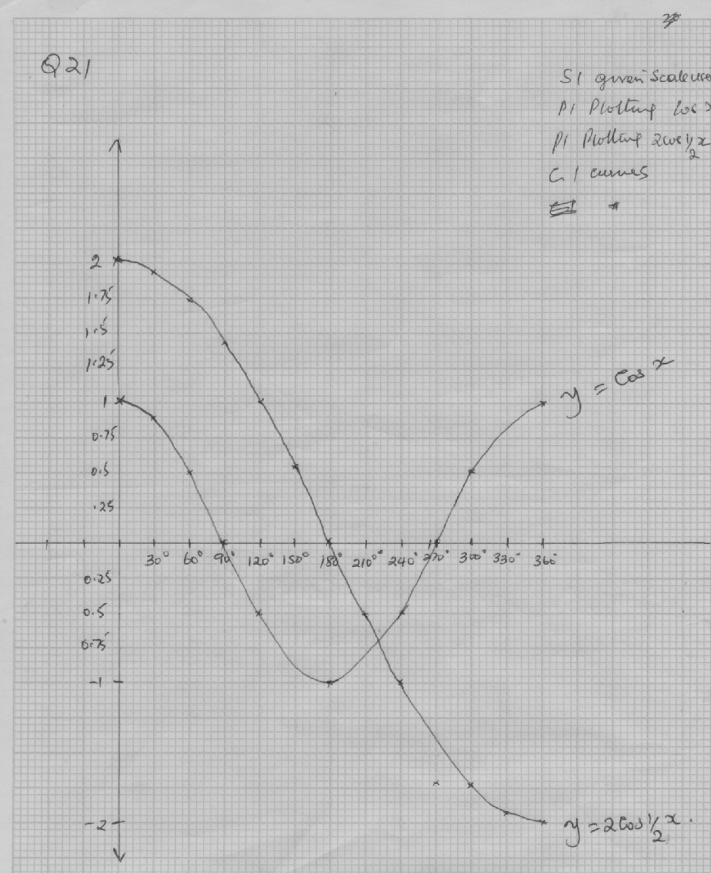  - amplititude = 2 B1  period = 720⁰ B1  - 2cos ½ x = cos x  X = 222⁰ +6⁰ | B1  B1  S1  P1  P1  C1  B1  B1 | All values of cos x  All values of cos ½ x  Given scale used  Plotting cos x  Ploting 2 cos ½ x  Curve smooth continous

1. a)
Xº | -225 | -180 | -135 | -90 | -45 | 0 | 45 | 90 | 135 | 180 | 225
y = sin 2x |  | 0 |  | 0 | 1.0 |  | 1.0 | 0 |  | 0
y = 2cos x |  | -2.0 |  | 0 | 1.4 |  | 1.4 | 0 |  | -2.0
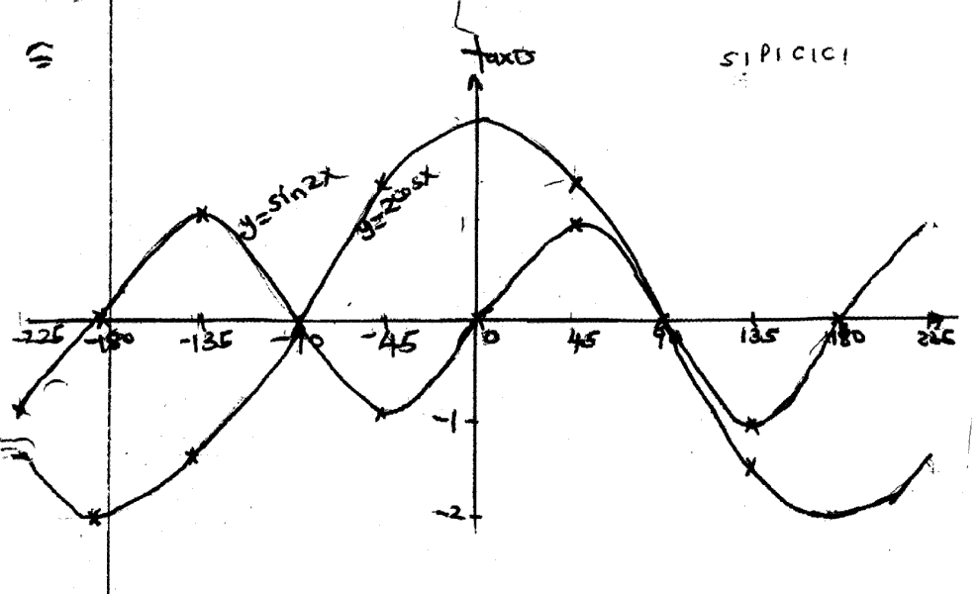
b)

(c) -90º or 90º
(d) (i) Highest point 1 unit
Lowest point - 1.4

2.
© SE- 10 Form 4 Mathematics 121/2 Turn Over

x | 0 | 30 | 60 | 90 | 120 | 150 | 180 | 210
2sin(x+15º) | 0.52 | 1.41 | 1.93 | 1.93 | 1.41 | 0.52 | -0.52 | -1.41
Cos(2x -30º) | 0.87 | 0.87 | 0 | -0.87 | 0.87 | 0 | 0.87 | 0.87

x | 240 | 270 | 300 | 330 | 360
2sin(x+15º) | -1.93 | -1.93 | -1.41 | -0.52 | 0.52
Cos (2x -30º) | 0 | -0.87 | -0.87 | 0 | 0.87
B₁
B₁
B₁

(i) Amplitudes:, y = 2 sin ( x + 15)
= 2units
B₁
y = cos (2x – 30)
B₁
=1unit

12º, 159º

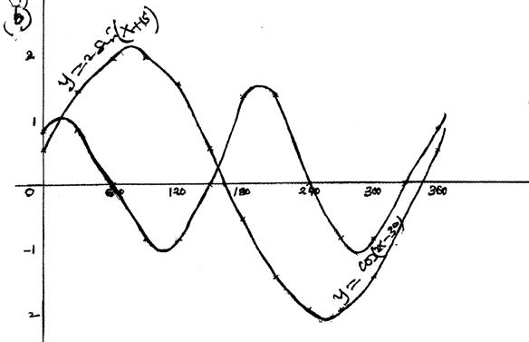
60
120
180
240
300
360
-2
-1
0
1
2
y =2sin(x + 15)
y =cos(2x - 30)
C₁
P₁
C₁

S₁

3. Determine the
A¹
C¹
4√2
i) Altitude of the frustrum
5cm
5cm
Solution
A¹C¹ = √ 4² + 4² = √32 = 4√2
C
AC = √10² + 10²
A
X
M
3√2
4√2
3√2
= √200
= 10√2
AM + XM = 10√2 - 4√2
= 6√2
AM = ^{6√2}/₂ = 3√2
Height = AM =√ 5² – (3√ 2)² = √25 – 18
= √7 = 2.646
∴ the altitude of the frustrum = 2.646 cm
A¹
C¹
ii) Angle between AC and the base ABCD
5cm
5cm
√7
AX = 3√2 + 4√2 = 7√2
Tan ø = ^{CX}/_{AX} = ^{√7}/ _{7√2} = ^{2.646}/_{9.898}
θ
C
= 0.2673
7√2
A
X
θ = tan ⁻¹0.2673
= 14.96°
Y
iii) Volume of pyramid = ¹/₃ bh
AC = 10 √ 2
h
A1C1= 4 √ 2
C¹
A¹
L.S.F = 10:4
√7
∴ h + 2.646 = 10
C
A
h 4
4(h + 2.646) = 10h
4h + 10.584 = 10h
6h = 10.584
h = 1.764
H = h + 2.646
= 1.764 + 2.646 = 4.410
Vf = (¹/₃ x 10 x 10 x 4.41) – (¹/₃ x 4 x 4 x 1.76)
= ^{441.0}/₃ - ^{28.224}/₃
= ^{413.776}/₃
= 137.592cm³

4. (a) table completed

(b)

(c) (i) 3 P1 – plotting

S1- scale

C1 – smooth curve
(ii) 180º
(iii) Line y = 1 drawn
x = 4.5º or 72.8^{o –} 107.2º - 175.4º

5. (^{A}/_{B})² = p + 33q
q – 3P
A²q – 3A²P = BP + 3Bq
Aq² – 3Bq = BP + 3A²P
2(A² – 3B) = BP + 3A²P
Q = BP + 3A²P
A² – 3B

6.

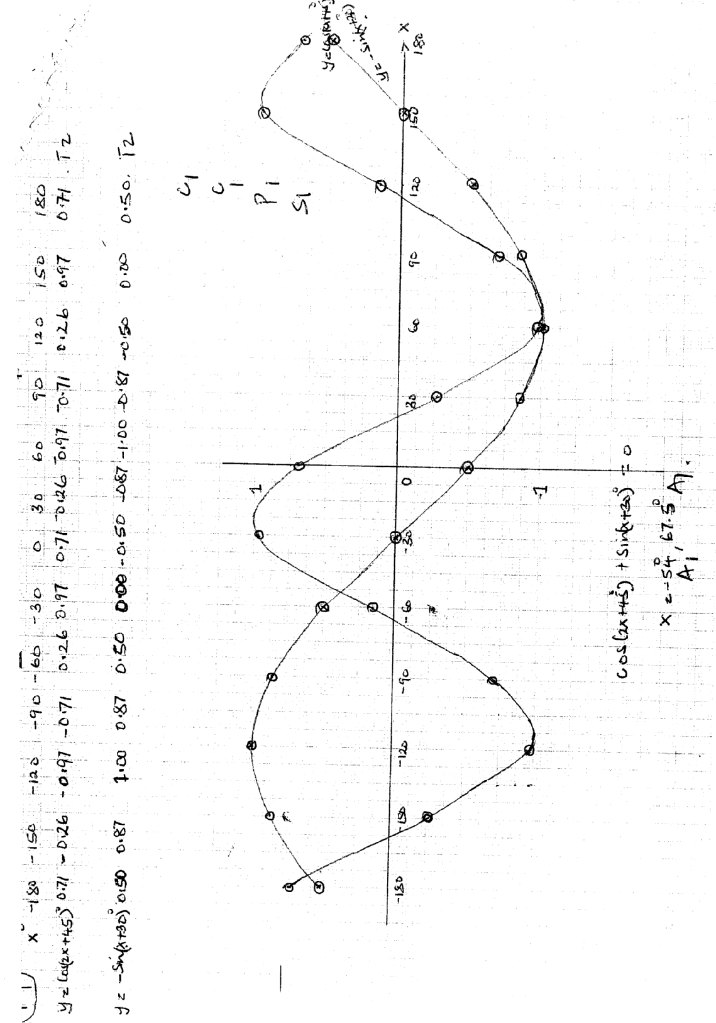

7. 7. √3 x ½
2
1 x 1
√3 √2
√3 x √6
4 1
√18
4
3 √2
4
8. a)
x | 0 | 30 | 60 | 90 | 120 | 150 | 180 | 210 | 240 | 270 | 300 | 330 | 360
3sinx |  | 1.5 |  |  | 2.6 | 1.5 |  |  |  |  | -2.6 |  | 0
2cos x | 2 |  |  | 0 | -1.0 |  |  | -1.7 |  | 0

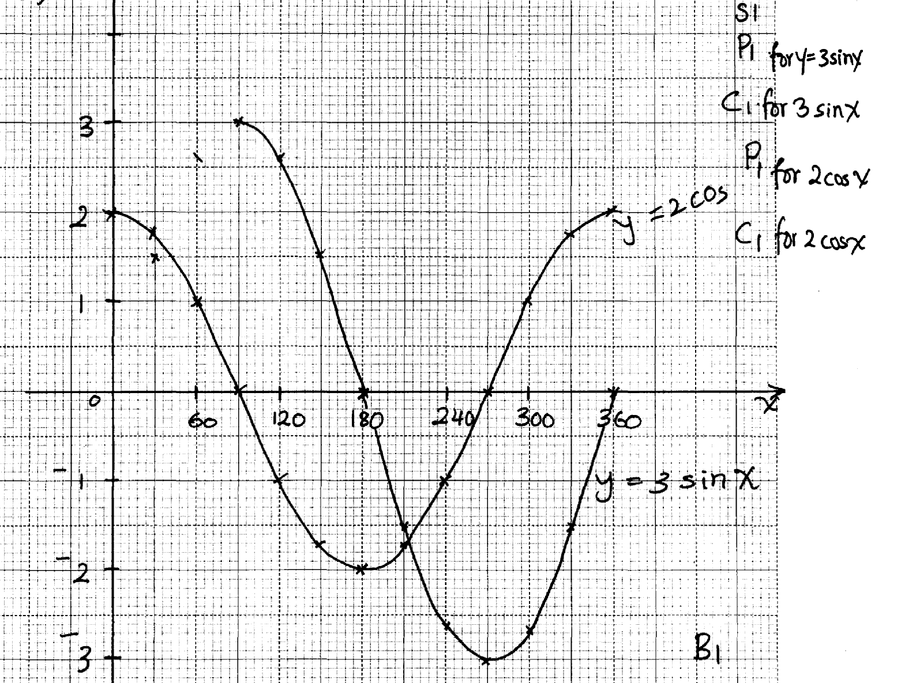

(c) (i) Amplitude =3
(ii) x = 36º
x = 216º
(iii) 33º ≤ x ≤ 213º

9.
x | 0 | 90 | 180 | 270 | 360 | 450 | 540 | 630 | 720 | 810
sin ½x | 0 | 0.71 | 1 | 0.71 | 0 | -0.71 | -1 | -0.71 | 0 | 0.71
3Sin (½x + 60) | 2.6 | 2.9 | 1.5 | -0.78 | -2.6 | 2.9 | -1.5 | 0.78 | 2.6 | 2.9

10.
x | 0º | 30º | 60º | 90º | 120º | 150º | 180º
2 sin x | 0 | 1 | 1.73 | 2 | 1.73 | 1.00 | 0
1-Cos X | 1 | 0.13 | 0.50 | 1 | 0.06 | 1.87 | 2

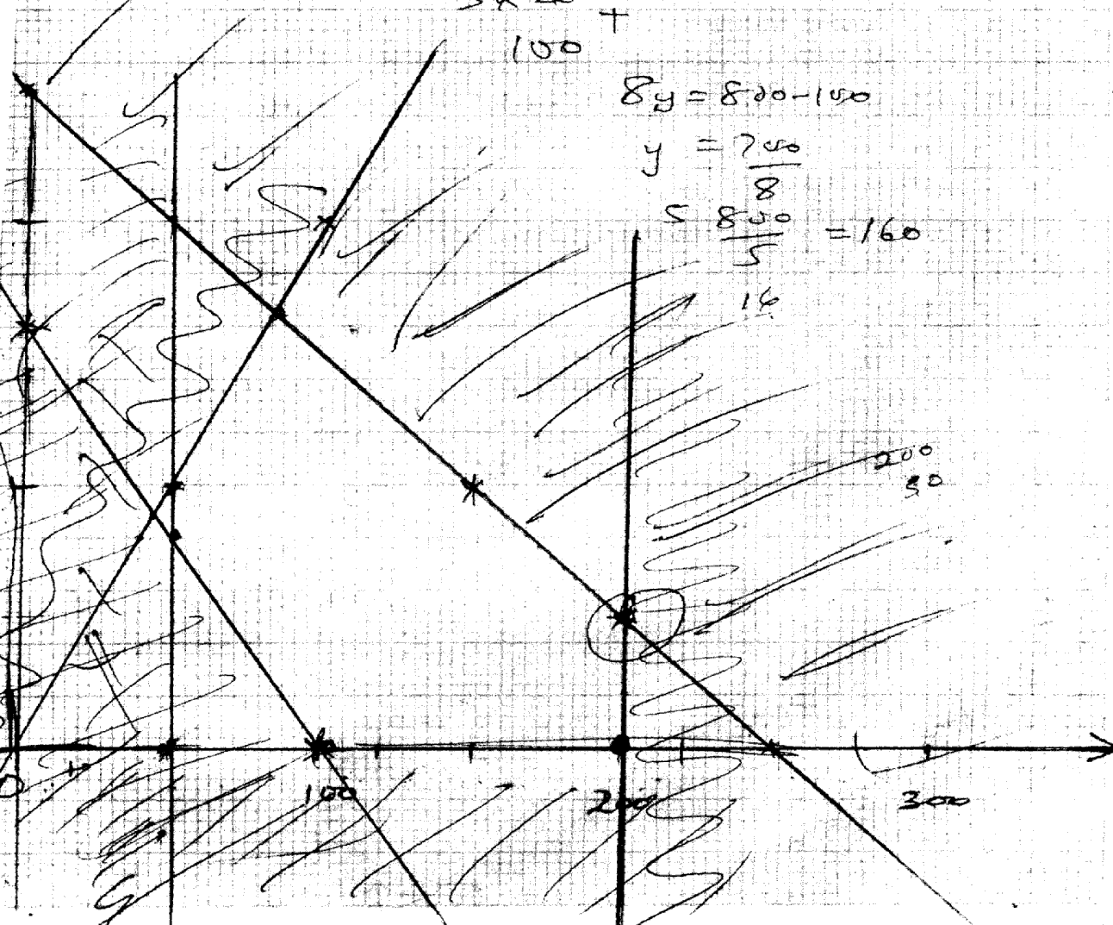

11. Sin (x + 30) = 0.5
x + 30 = 30º
x = 0
0, 180, 360

12. (c)10sin x = ⁻¹/₅₀ + 5
Y = ⁻¹/₅₀ + 5
X | 0 | 50
y | 5 | 4
X₁ = 28º ±1
X₂ = 70º ±1

12.

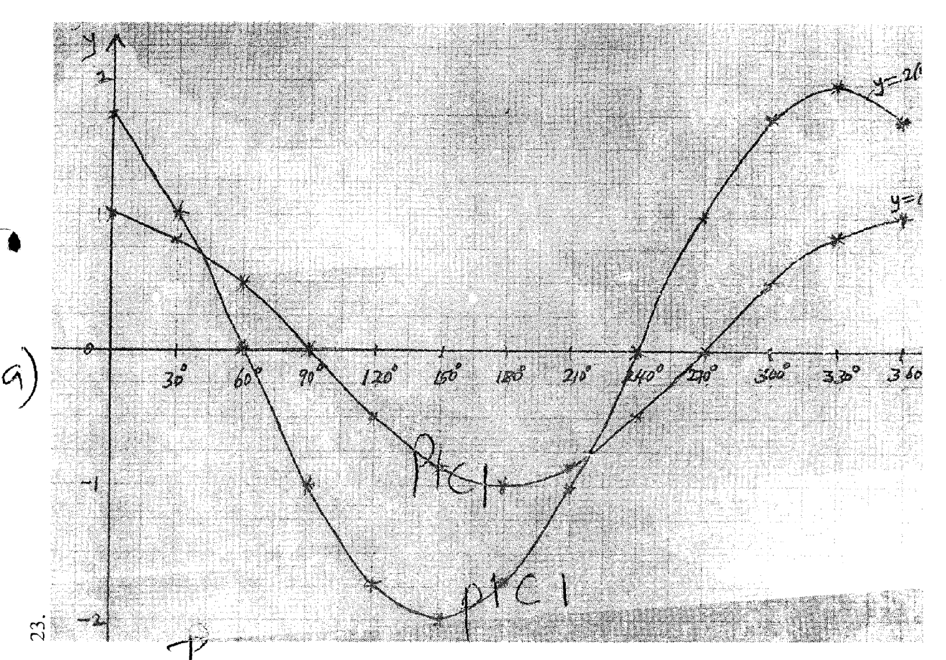

b) i) amplitude = 1
ii) Period = 360°
iii) 45°, 219°

13. 2θ + 10 = 210º, 330º, 570º, 690º
2θ = 200, 320, 560, 680
= 100º, 160º, 280º, 340º
= 5π^{c} , 8π^{c}, 14π^{c} ,17π^{c}
90 9 9 9

14. 4sin 2x+4cos x-5 = 0
4(1-cos2X) + 4 cosx -5= 0
4cos2x – 4 cosx + 1=0
4cos2x – 2cosx – 2cos x +1 =0
(2cos x – 1)2 = 0
X = 60°, 300°

15.
x | 15º | 60º | 150º | 165º
4 Cos 2x | 3.46 |  |  | 3.46
2Sin (2x + 30º) |  | 1.00 | -1.00

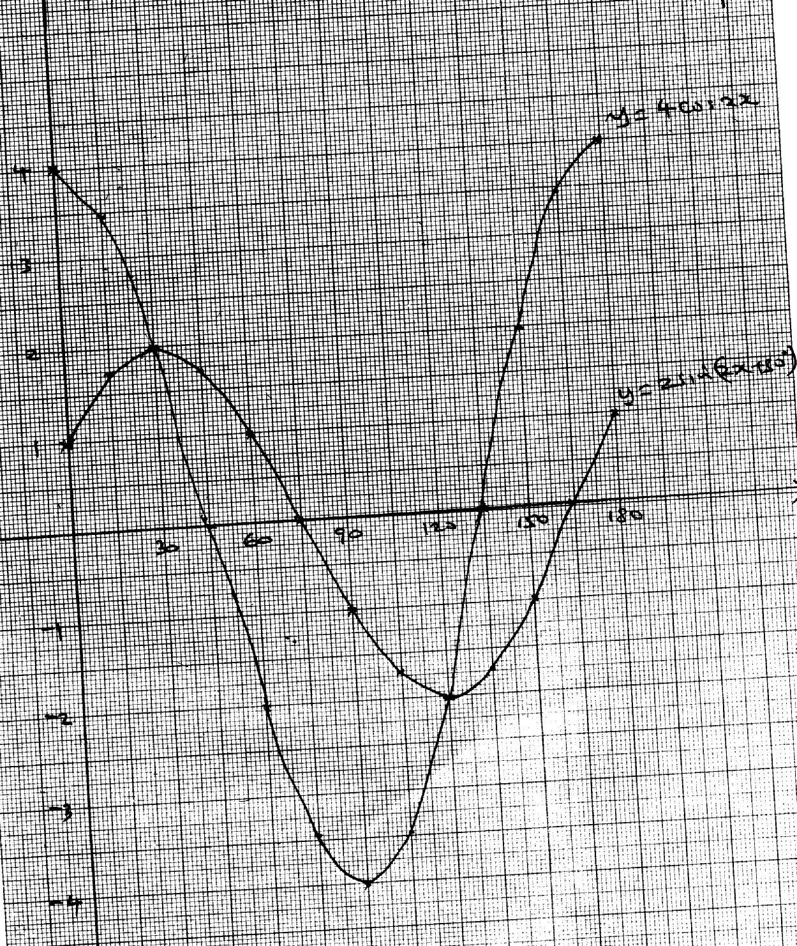
(b) graph

(c)(i) Amplitude = 4
(ii) period = 180º

(d) x = 30º, 120º

