Thin lenses

1. Use a ray diagram to show how short sightedness in a human eye can be corrected.

Thin lenses
1. The figure below shows how rays from a distant and near objects are focused inside a human
eye with a certain defect
Retina

Name the defect and state two causes of the defect
2. (a) The figure below shows an object O placed in front of an objective lens L_{o} whose focal
length f_{o} is less than f_{e}, the focal length of the eyepiece L_{e}. Complete using ray construction
how the arrangement would produce a compound microscope
L_{o} (objective lens)
L_{e} (eye piece)
F_{e}
F_{o}
F_{e}
2F_{o}
F_{o}
0

(b) A nail is placed 25cm from the objective lens of focal length 15cm. On the other side of the
objective lens another converging lens of focal length 30cm is placed as the eyepiece. The
distance between the two lenses is 52.5cm
Find: (i) the position of the first image
(ii) the position of the final image from the eye piece lens

3. (a) The figure below shows a set-up consisting of a mounted lens, L₁, a screen S, a metre
rule and a candle
Candle
L
Metre rule
S

(i) Describe how the set-up can be used to determine the focal length, f of the lens.
(ii) Explain why the set-up would not work if the lens was replaced with a diverging lens
1
u
1
v
(b) The graph in the diagram in figure below shows the relationship between and
for a converging lens where u and V are the object and image distances respectively.
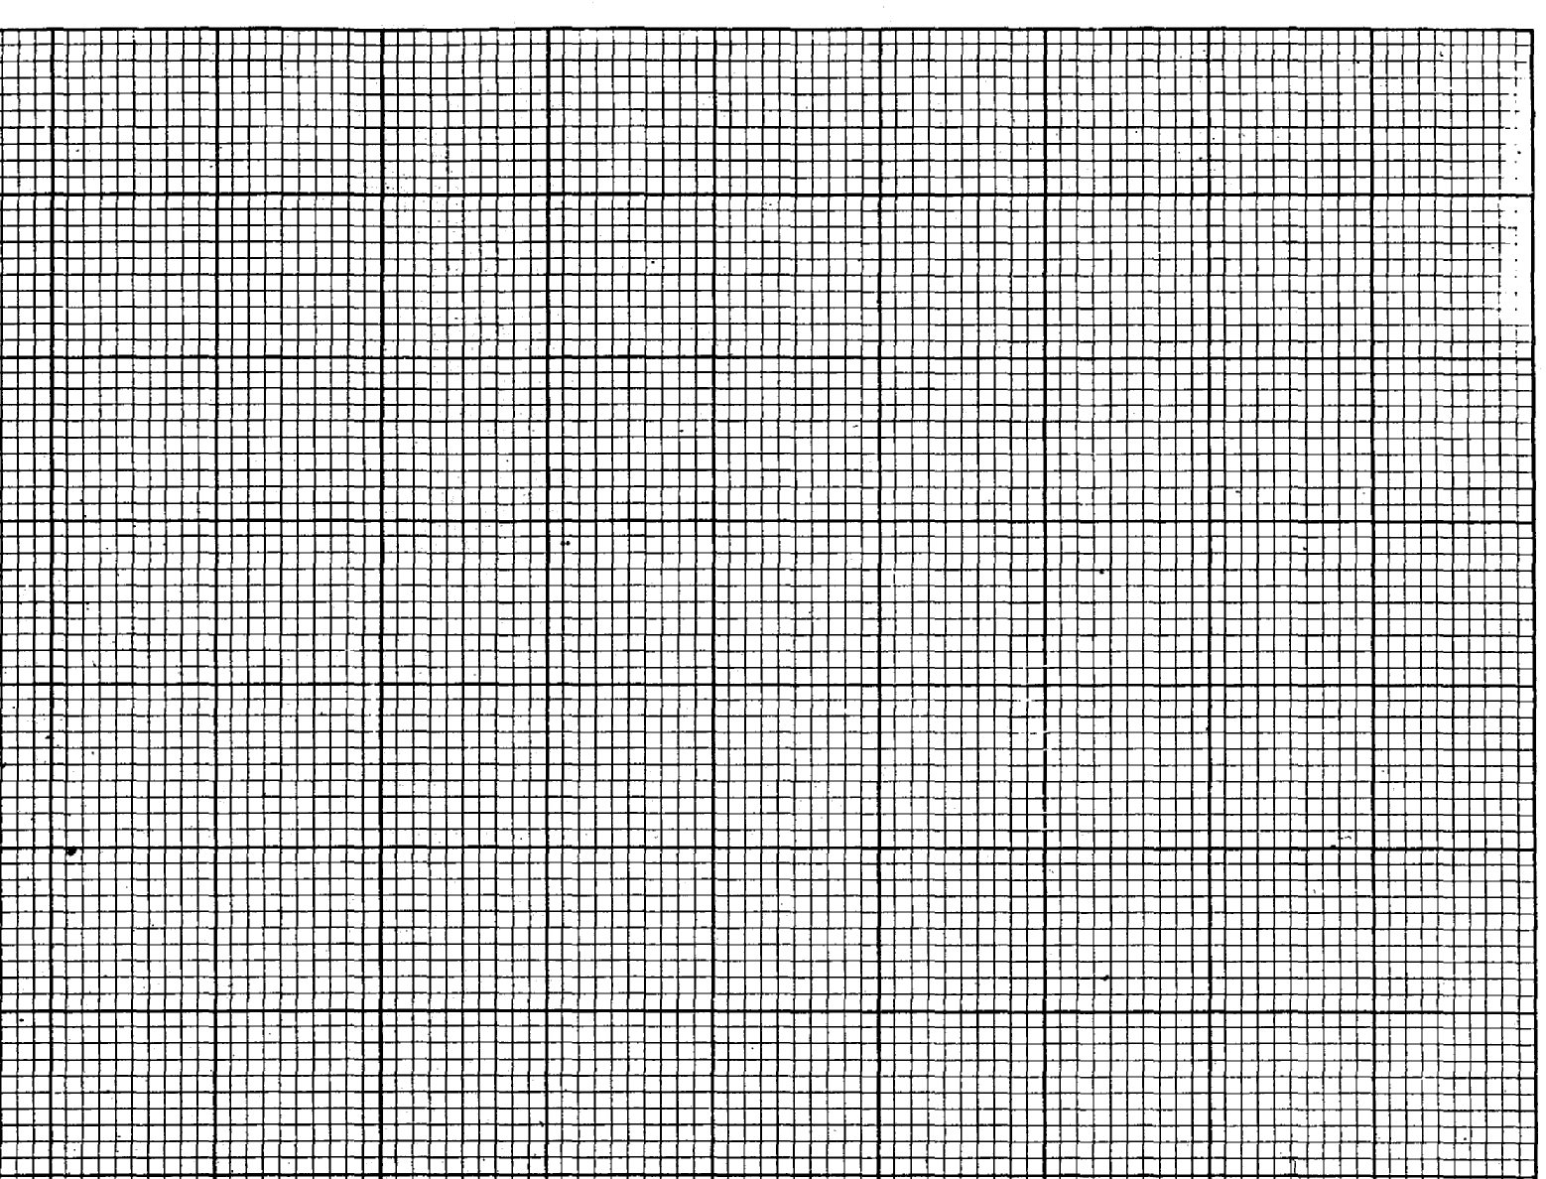
From the graph, determine the focal length f of the lens (5mks)
2
0
1
1
2
3
¹/_{v} x (10⁻³ cm⁻¹)
¹/_{u} x (10⁻³ cm⁻¹)

(c) An object placed 15cm from a convex lens forms an image twice the size of the object.
Determine the focal length of the lens
4. The graph below represents a graph of stopping potential V_{s} , V against frequency f, Hz

Stopping potential, V_{s} (V)

1.0
X
0.8
0.6
X

0.4
X
0.2
X
0

1
2
3
4
5
6
7
Frequency, F(Hz)
X10¹⁴

(a) Use the graph to determine:
(i) The threshold frequency of the metal
(ii) Plank’s constant
(iii) Work function of the metal

(b) Figure 8 below shows a mercury vapour lamp, which emits ultraviolet light held over a
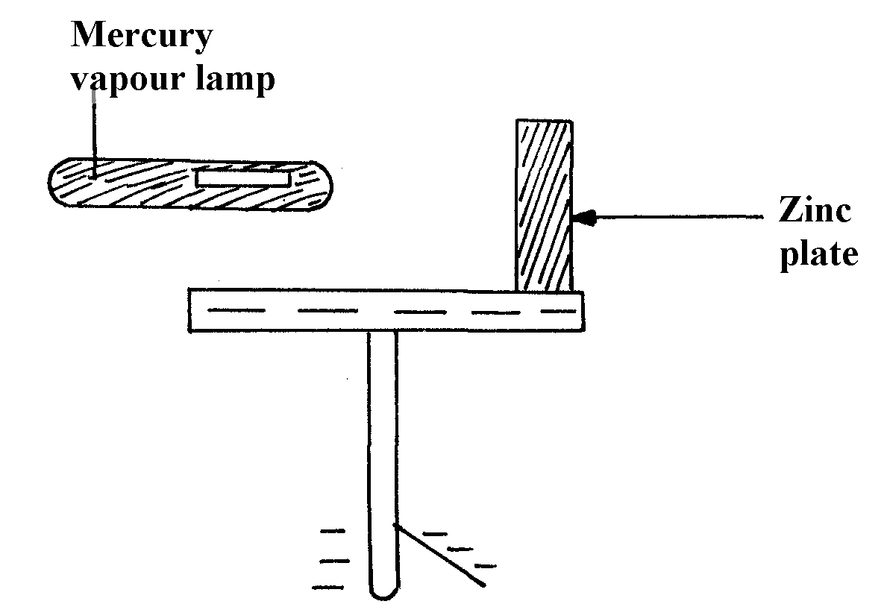
negatively charged electroscope:

figure 8

(i) What happens to the leaf after the lamp is switched on?
(ii) Explain why it happens
(iii) If the experiment is repeated with equally bright red light held the same distance from the
plate in place of the mercury vapour lamp, what effect would this have on the leaf?
Give a reason
(iv) What does photoelectric effect suggest about the nature of light?

5. (a) Describe briefly a simple method of estimating the focal length of a convex lens.
(b) Define linear magnification of a lens.
(c) In an experiment to determine the focal length of a converging lens, the following reading
were obtained

Image distance V cm | 14.3 | 16.0 | 17.7 | 21.0 | 31.0
Magnification m | 0.4 | 0.60 | 0.80 | 1.10 | 2.10
(i) Plot a graph of m against V.
(ii) From the graph determine the focal length of the lens.
(d) Which eye defect is corrected by a diverging lens? Show using a diagram how this is achieved

6. a) Describe with the aid of a labeled diagram an experiment to determine the focal length of the
lens when provided with the following;
- An illuminated object screen
- A convex lens
- A lens holder
- A plane mirror
- A meter rule
b) A small vertical object is placed 28cm in front of a convex lens of focal length 12cm. In the
space below, draw a ray diagram to locate the image and find its magnification.
(use a scale: 1cm represents 4cm)
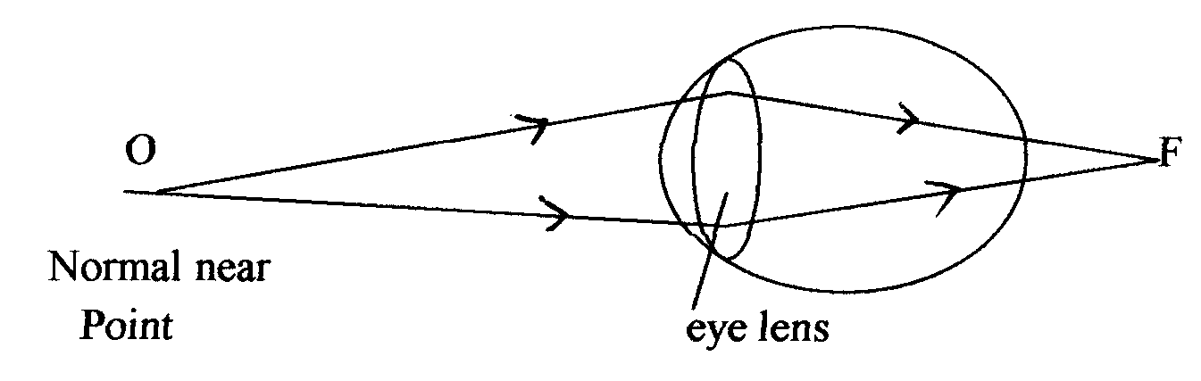
c) The figure below shows a human eye with a certain defect

i) Name the defect
ii) On the same diagram, sketch the appropriate lens to correct the defect and sketch rays
to show the effect of the lens

7. An object of height 10cm is placed in front of a diverging lens of focal length 25 cm and at a distance of 20 cm from the lens. Calculate the height of the image formed

8. (a) The figure below shows an object, O, placed in front of an objective lens L_{o} whose focal
length, ƒ_{o} is less than the focal length of the eye piece lens; L_{e} Complete using ray
construction how the arrangement would produce a compound. Microscope
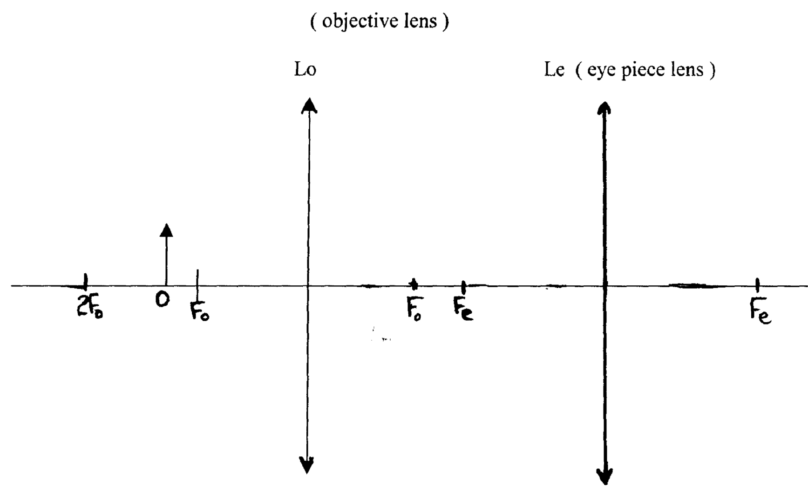

(b) A thin converging lens of focal length 30cm is used to form a real image on a screen 90cm
from the lens, Determine :-
(i) The object distance
(ii) The magnification

9. Figure 2 shows an object O placed in front of a concave ion with principal foci F and F¹.
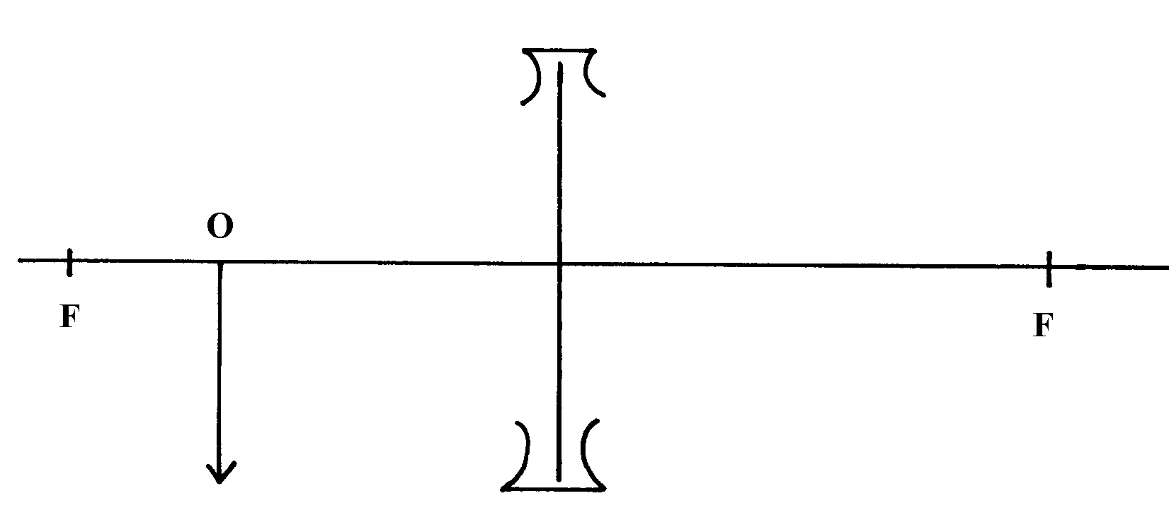
Construct a ray diagram to locate the position of the image

F¹

Fig 2

10. Use a ray diagram to show how short sightedness in a human eye can be corrected.

11. a) An object is placed 15 centimeters in front of a diverging lens of focal length 20 cm. Use
a ray diagram to determine the image distance and its magnification.
b) A nuclide F has a half life of 5 hours. What percentage of the original number of atoms of the
isotope would have decayed after 30 hours? c) A current of 1.5A flows through a conductor in 5 seconds. Determine the number of
electrons that pass through the conductor (charge on an electron = 1.6 x 10⁻¹⁹ C)

12. Calculate the wavelength of the KBC f.m radio waves transmitted at a frequency of 95.6
mega Hertz

Thin lenses
1. Short –sightedness or myopia
cause- the eye-ball is too long for the relaxed focal length

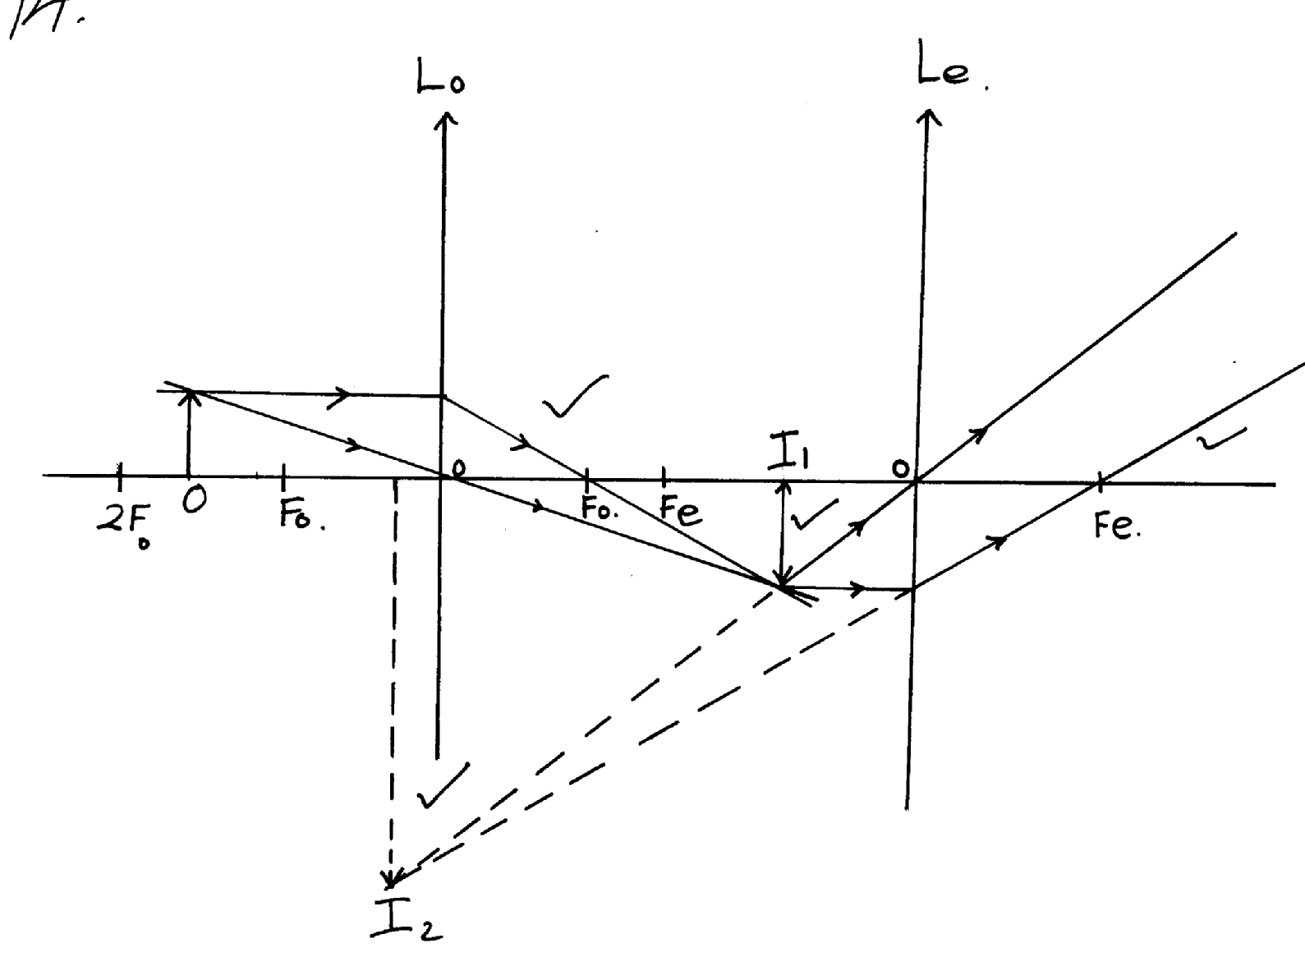
2.

)

b) i) ^{I}/_{F} = ^{I}/_{U} + ^{I}/_{V}√
¹/₁₅ = ¹/₂₅ + ^{I}/_{V}√
V = 37.5cm√
ii) U = 52.5 – 37.5
= 15cm√
^{I}/_{F} = ^{I}/_{U} + ^{I}/_{V}
^{I}/_{V} = ¹/₃₀ - ¹/₁₅
= -30cm √
3. (a) (i) - Candle placed at a distance u, from the lens and the position of the screen is adjusted
until a sharp image is formed/obtained
- The distance, V, between the lens and screen is measured
- The procedure is repeated to get other values of V and u
- For each set of u and v the value of f is determined using the formula
(ii) The image would be virtual and cannot be formed on the screen
(b) Extrapolate both sides of the graph and read-off
1 and 1 = 0.25 = ¼
u v
1 = 1 = f = 4 or
f u
1 =1 =f= 4
f v

(c) M = ^{u}_{/v} = 2
V = 2
15
v = 30cm
1 = 1 + 30 f = 10cm
f 15 30
4. (a) (i) X – Intercept = 4.5 x 10¹⁴Hz
1
(ii) Slope = h – h = e x slope
e
1
= e x 6.6 – 0)V
(6-4.5) x 10¹⁴ ^{s-1}
= 1.610⁻¹⁹ x 4 x 10-15
1
= 6.4 x 10⁻³⁴Js
(iii) W₀ =hf₀
1
1
= 6.4 x 10-34 Js x 4.5 x 1014s-1
= 2.88 x 10-¹⁹J
1
1
1
(b) (i) The leaf falls Collapses
(ii) The electrons are repelled causing the leaf potential to decrease
1
(iii) NO effect on the leaf. Light emitted by red light doesn’t have enough energy to cause
photoelectric effect.
1
1
(iv) Light is a wave, it carries energy in small packets (protons).

5. (a) This distance is the focal length
1
1
(b) Linear magnification is the ratio of image height to the object height or image distance
to object distance
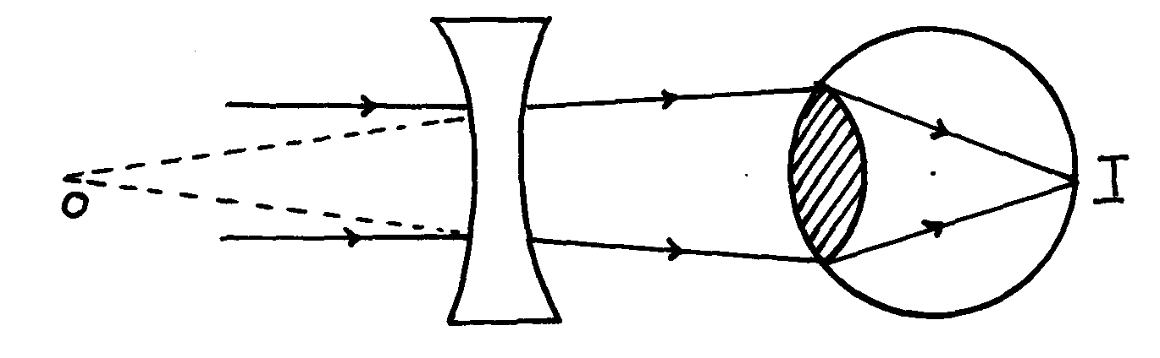
Eye defect – short sightedness (myopia)

1
1
arrows object
6. a) By adjusting the lens’ position obtain a sharp image on the screen as shown above.
- d = f

b) ν = 5.5 X4 = 22cm
μ = 7X4 = 28 cm
Μ = ν = 22 = 0.7857
μ 28
c) i)Long sightedness
ii)

7. f = -25cm, u= 20cm
1 = 1 + 1
f u v
-1 = 1 + 1
25 20 v

v = -20 -25 = -11.1cm
250
11.1 = h

20 10
h = 5.56cm


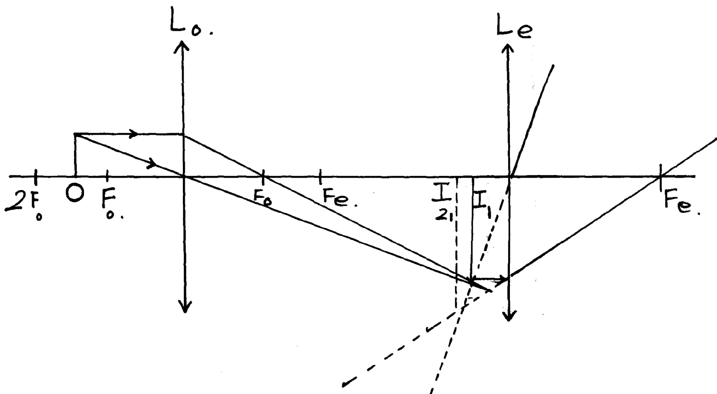
8. (a)






b (i) f = 30cm, v = 90cm
F_{e}


1+ 1 = 1
u v f


1 = 1 – 1 = 1 – 1
u f v 30 90
- Rays using lens L_{o}
Rays using Lens L_{e}
Position of imagerge I₁
Position image I ₂
= 2
90


u = 45cm


(ii) m = v
u


= 90
45


= 2

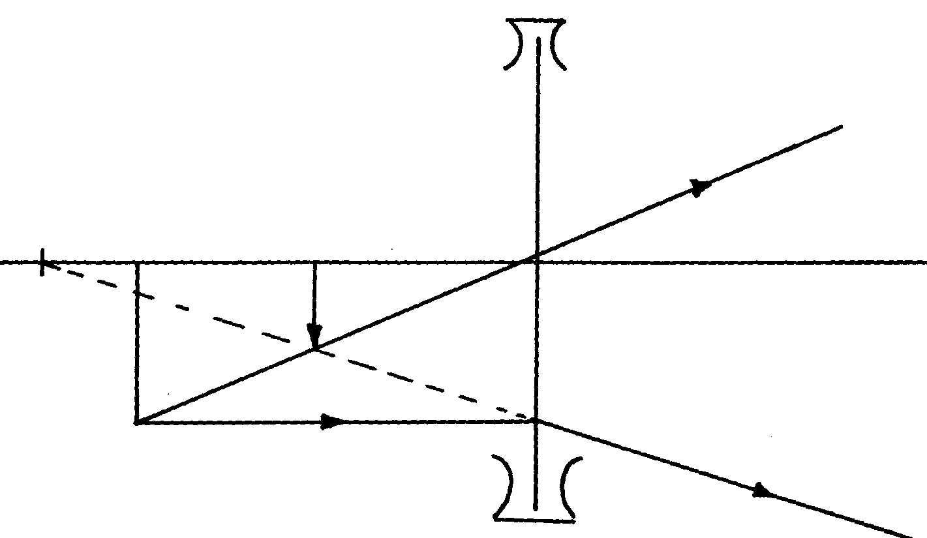
9.

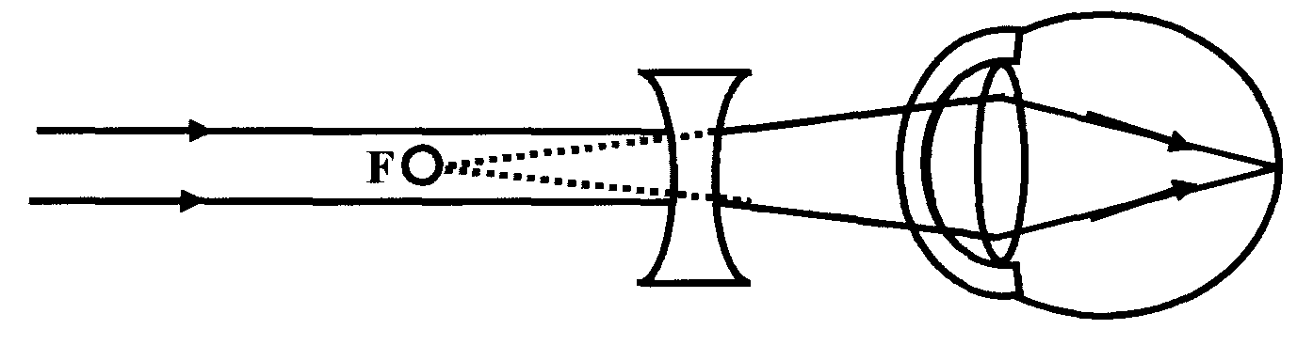
10.

