Structure of the atom and the periodic table

1. Na₂CO₃ + 2HNO₃ ____ 2NaNO_{3 (L)} + CO_{(q)} + H₂O_{(C)}
Mole ration 1 : 2
a) Moles of HNO₃ in 20cm³ = 20/1000 x 0.25
= 0.005 moles

b) Moles of Na₂CO₃ in 25cm³ = ½ of 0.005 moles
= 0.0025

c) If 25cm³ = 0.0025 moles
in 250cm³ = ?
250 x 0.0025
25
= 0.025 moles

RFM of Na₂CO₃ = 106
I mole of Na₂CO₃ = 106g
0.025 moles = ?
0.025 x 106
1
= 2.65g of Na₂CO₃
2. (a) A= 2.8.1
B= 2.1

(b) B
Strong attraction of the outermost energy level electron to the nucleus make it difficult
to remove This is due to smaller atomic radius compared to A
Or - Outermost electrons are closer to the nucleus hence higher force of attraction
3. R.A.M = (62.93 x 69.09) + (64.93 x 3091)
100
= 4347.834 + 2006.99
100
= 63.5482
≈ 63.5
4. (a) R.A.M = (33 x 2) + (30 x 1)
 1
3
 1
99 = 33
3
(b) Number of electrons of C = 57-31 = 26
Number of electrons of B is the same as for C = No. of Protons
B = 26 protons
 ½
5. 69.09 x 62.93 + 30.91 x 64.93 1
100 100
43.4783 + 20.0698 1
= 63.548 ≃ 63.55 1
6. 63 x + 65 (100 – x) = 63.55
100
63x + 6500 – 65x = 6355
2x = 6355 – 6500
2x = -145
X = 72.5
% abundance of ⁶³ M = 72.5%
⁶⁵ M = 27.5%
7. a) Valency of G is 3
b) G is a group 3 element
8. a) i) 11 protons
ii) 16 protons
b) Formula of compound = T2Z
Mass number of T = 11+ 12 = 23
Mass number of 2 = 16+16 = 32
Formula Mass of T2Z = ( 23x2) + 32 = 78
c) – When molten
- When in aqueous solution
9. Silicon (iv) Oxide has giant atomic structure with strong covalent bond holding the atom
together. These require a lot of energy to break, hence it has high melting point. Carbon (IV) Oxide has simple molecular structure with weakVan Der Waals forces holding the molecules together which require little energy to break, hence sublimes at low temperature and is a gas at room temperature and pressure
10. O₂ 2.8 O 2.6
The oxide ions has 2 extra electrons that causes greater electron repulsion than in oxygen atom
11. To separate samples of CUO and charcoal in test tubes, dilute mineral acid is added with
shakingCuO black dissolves to form blue solution√ ½
Charcoal does not dissolve in dilute mineral acids
12. (90 x 8) + 10Q = 28.3 (½mk)
100
100 x 2520 + 10Q = 28.3 x 100
100
2520 + 10Q = 2830 (½mk)
10Q = 2830 – 2520
10Q = 310
Q = 31
Electron arrangement of X = 284 (½mk)
Atomic No. = 14 ( ½mk)
No. neutrons = 31 – 14 = 17 (½mk)
13. L₃ has delocalised electrons while the others has less
14. (a) Is a constant temperature at which a solid changed to a liquid/ A point at which a solid
changes to a liquid which a solid changes to a liquid without change in temperature.
15. (a) P ^{√ ½} and S ^{√ ½} √
They have the same atomic numbers. √ Both must be there to score 3
(b) 4 (7, -3) √

16. a) B√ ½ - its ion has a stronger nuclear charge than that of A√ 1
b) D√ ½ - has the weakest nuclear charge as compared to the other non- metals √ 1
17. (a) CA 1

(b) (i) E 1
(ii) B 1

(c) Period 3, ½ Group 2,  ½

(d) (i) The atomic radius of F is greater than that of C1 because F has more energy levels.
(ii) The atomic radius D is smaller than that of C 1 because of increased positive charge
in the nucleus which attracts the electrons more. 1

(e) (i) Electrovalent bond ½
(ii) Covalent bond ½

(f) (i) 4C + O₂ 2C₂O 1
G + O₂ GO₂ 1
(ii) C₂O is basic while 1
GO₂ is acidic. 1

18. (a) B – ammonia gas 1
C - nitrogen (II) oxide (NO) 1
E – water 1
F – unreacted gases 1

(b) The mixture of ammonia and air is passed through heated/ catalyst where ammonia (II) is
oxidized to nitrogen (II) oxide. 1

(c) Gases are cooled and air passed through heated/ catalyst where ammonia is further
oxidized to nitrogen(IV) oxide. 1

(d) Fractional distillation, ½
Water with a lower boiling point ½ than nitric (V) acid, distills left leaving the
concentrates acid.

19. (a) (i) C
 1
(ii) D or E
 1
(iii) F
(iv) D or E
 1
(v) A
(vi) D
 1
 ½
(b) Atomic radius of Y is smaller than that of X. The effective nuclear charger in Y is greater
 ½
than in X hence outer electrons strongly pulled to the centre reducing the radius.

(b) (i)
 ½
 ½
(ii) Period – 3 Group – IV
 1
(c) (i) On the grid (period 2 Group 7)
(ii) Halogen
 1
 1
(iii) – Used in hospitals with patients with breathing difficulties
- Used by mountain climbers and deep sea divers
 1
(iv) Basic

20. A (i) P – ionic configuration - 2
- Formula of oxide – PO
Q – Atomic number – 20
R- Atomic number – 19
T – Ionic configuration – 2.8.8
Formula of oxide – TO2
(ii) R – Has the largest atom with one outer electron hence easily loses it.
(iii) S – is the smallest atom of a non-metal with a deficit of only one electron hence
-
easily gains.
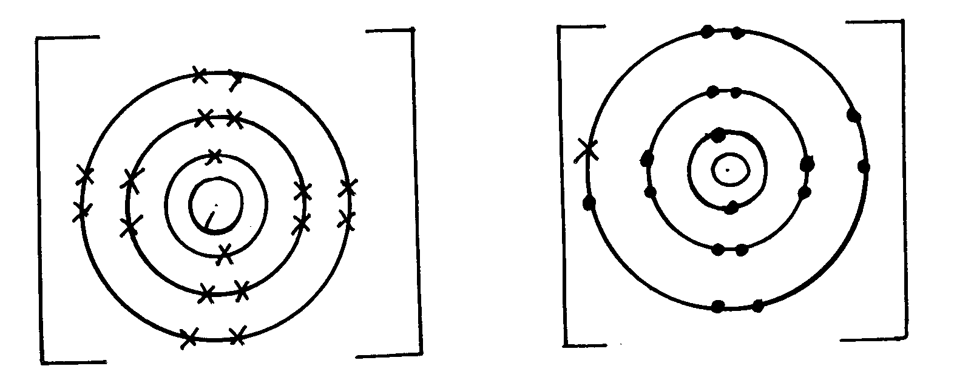
(iv)
2⁺

2

Q ²⁺
2Cl⁻

(v) T is insoluble – It has a molecular structure/non-metal
(B)(i) It is coated with an un reactive layer of aluminium oxide which prevents it form reacting.
(ii) Valency – The number of electrons an atom gains or loses during a reaction.
Oxidation number – The resultant charge of an atom has after gaining or loosing electrons.

21. a) +3 + P = (-2x3)= 0
+3+P – 6 = 0
P = +3√
b) Mg- its oxidation state increases from Zero to +2 √ 1 mark
22. a) Group 1 – Because √½ it has 1 electron in its outermost energy level.
Group 7 – It requires √½ 1 electron to fill its outermost energy level.
b) Alkaline earth metals √1
c) PV₂ √1
d) Q has higher√½ m.p than J. Q has a giant metallic structure and strong metallic bonds. √½
While J has molecular structure and Vander
Waals forces which are easy to break. √½
e) R. √1
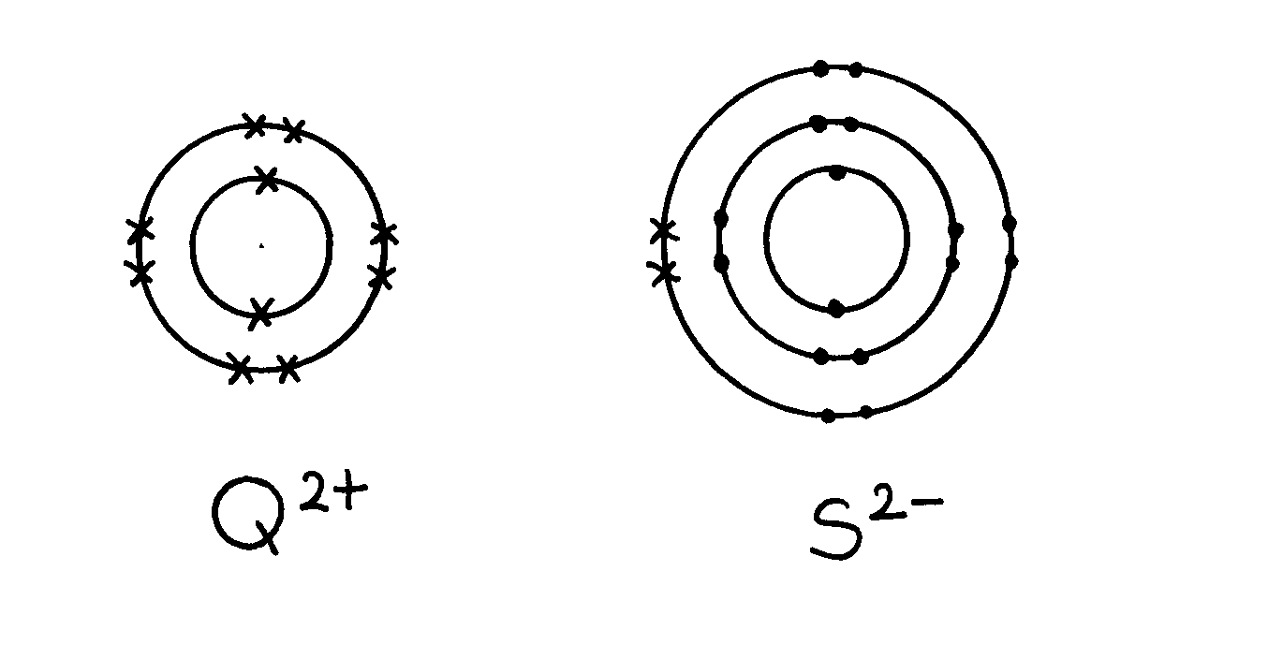
f) T(s) + O₂(g) TO₂(g) √1

g)

h) – Filling electric light bulb √1 accept any other correct one.

23. (a) (i) X Rj: If actual symbols are given.

(ii) Q. Rj. Actual symbols.
Explanation: It looses the outermost energy level most readily.

(iii) Halogens

(iv) I). Moving across a period there is increased nuclear charge.
II). Going down a group the energy levels increase in number.

(v) V- Explanation It has a complete outermost energy level/ Has a stable octet.

(vi) Z₂R Rej. Interchange of letters, RZ₂.
24. a) i) I S√ 1- It readily gain one electron on ionization√1
II Q - It readily give out one electron on ionization√1

ii) Alkali metals√1
iii) WS₃√1
iv) Bond - covalent√ ½
Structure – Giant atomic structure√ ½
v) It is stable. Cant remove nor add electrons on its outermost energy level
vi) T has a smaller radius than Q because it has fewer energy levels than Q
- The melting point increases from A to C this is due to increase in number delocalized electron
hence increase in the strength of metallic bond.
D forms a giant structure with strong covalent bonds. Hence high melting.
It exhibits allstrophy ie may exist as two different form in the same state.
C2 (SO₄)₃
Noble gases or inert
Used in filament bubls
Used to produce an inert atmosphere in high temperature inetallurgical processes e.g welding.
C is amphoteric oxide
F acidic it is non –metal oxide.

Ethene
^{H} ^{H}
C= C
_{H} _{H}
Acidified potassium Manganate VI abromine water it from a colourless solution

CH₂CH₂ + H₂ CH₃CH₃
Nickel catalyst

26. a) 2 : 8
b) W₂O₃
27. i) Delocalized electrons
ii) Mobile ions
iii) Mobile ions

28. - Sodium has a larger raius than aluminium
- Aluminium has more protons than sodium hence a more effective nuclear charge
than sodium
29. a) 2.5
b) Q Group 1 ½, Period 4 ½
R Group 2 ½, Period 3 ½
30. Ethanol contains molecules 1 which are not1 responsible for electrical conductivity. (2 mks)
31. a (i) Q
(ii) R
32. (a) K and N because they have the same number of electrons on their outermost energy level


(b) L₂O₇
(c) L₁ because it has 7 electrons on the outermost energy level or reacts by gaining electrons
or the ionic radius is larger than the atomic radius (½mk)

33. a) Formula; J₅G₂ √1
b) E form ironic structures due to ionic bonding in its oxide. While G form molecular
structure due to covalent bonding in it oxide

