FORM TWO , GEOGRAPHY HOLIDAY ASSIGNMENT
TERM THREE, 2013.
4. STATISTICAL METHODS

1. Study the table below and answer questions that follow:-

CROP | 1978 | 1979 | 1980 | 1981 | 1982
COFFEE  TEA  PYRETHRUM  MAIZE | 1000  750  300  500 | 990  700  250  450 | 870  650  350  550 | 830  700  400  600 | 840  600  450  350

(a) (i) Using 1cm to represent 500 tons, draw a compound bar graph to represent the data.
(ii) Give two disadvantages of using the method to represent statistical data.
2. The table below shows leading import crops by value (Kshs. Million). Use is to answer
questions a – c

 | CROP
Year | Un milled wheat | Maize | Rice | Wheat flour
2000 | 6,989 | 4,664 | 1,968 | 180
2001 | 7,515 | 3,342 | 2,619 | 639
2002 | 5,577 | 229 | 2,104 | 237
2003 | 6,099 | 1,417 | 2,981 | 168
2004 | 6,754 | 4,647 | 3,659 | 200
(a) (i) Using a scale of 1cm represents 100,000 , draw a comparative bar graph to represent
the data in the table above
(ii) Give three advantages of suing comparative bar graphs
(b) Explain three reasons why Kenya is a producer of the commodities shown in the table
above yet she imports the same

3. The table below shows milk production in ‘000 units in selected Districts
District | 1982 | 1992 | 2002
Trans nzoia | 24 | 26 | 40
Kiambu | 23 | 25 | 31
Meru | 25 | 27 | 32
Bungoma | 12 | 14 | 20
a) i) Using a vertical scale of 1 centimeter to represent 10,000 units, draw a compound
bar graph to represent the above given data

5. The table below shows four principal crops produced in Kenya in the years 2000 and 2001.
Uncovered
Use it to answer questions.
CROP AMOUNT IN METRIC TONS
YEAR | 2000 | 2001
Wheat  Maize  Coffee  Tea | 70,000  200,000  98,000  240,000 | 13,000  370,000  55,000  295,00
(a) (i) Using a radius of 5 cm, draw a pie chart to represent crop production in the year 2000.
(ii) State two advantages of using pie charts.
(b) Calculate the percentage increase in wheat production between the years 2000 and 2001.

6. Study the data given and use it to draw a pie chart showing mineral production in Kenya;

Mineral | Amount (000 tonnes)
Gold | 26
Flouspar | 14
Soda ash | 32
Zink | 28

(a) Using a radius of 5cm, draw a pie chart to represent the above data
(b) List three advantages of using a pie chart in representing data
12. FORESTRY

1. (a) Give three reasons for over-exploitation of hardwoods in Africa.
(b) State four measures taken to conserve forests in Kenya.
(c) (i) Name two major lumbering maritime provinces in Eastern Canada.
(ii) Explain the factors that have favoured forestry in Canada.
(d) Explain three differences between softwoods in Kenya and Canada.

2. (a) (i) What is agro-forestry?
(ii) State four reasons why agro-forestry is being encouraged.
3. (a) (i) Distinguish between pure and mixed forests
(ii) Show how natural forests differ from planted forests in Kenya
(c) (i) State three measures that are being taken in Kenya to conserve forests
(ii) Explain three factors favouring the exploitation of softwoods in Canada
4. (a) Define agro forestry
(b) Outline four benefits of agro forestry
(c) Explain how the following factors influence growth of forests;
(i) Altitude
(ii) Aspect
(d) Explain three measures being undertaken to conserve forests in Kenya
(e) Give four consequences of forest depletion in Kenya
5. (a) (i) Distinguish between indigenous and exotic forest
(ii) Explain four ways in which natural forests differ from planted forests
(b) Explain three factors that influence the distribution of forests in Kenya
(c) State three measure that are being taken to conserve forests

6. (a) (i) What is forestry?
(ii) Explain three factors that favour the growth of natural forests on the Kenya highlands
(b) Explain five problems hindering the exploitation of tropical hardwood forests
(c) (i) Explain three measures that the government of Kenya is taking to conserve forests
in the country
(ii) State three factors that have led to the reduction of the area under forest in Mau forest
7. (a) (i) Distinguish between forestry and forest
(ii) Discuss the influence of the following factors on the destruction of natural forests
a) Climate
b) Human activities
c) Topography
8. (a) Explain three measures which have been taken to manage forests in Kenya
(b) Give the differences between the soft wood forests in Kenya and
Canada, under the following headings:
(i) Species
(ii) Problems
(iii) Marketing
(d) Your class intends to carry out a field study on the erotic trees of the Kenya highlands:-
(i) Name two types of tree species they are likely to observe
(ii) Identify three methods you will use to record the data in the field
9. (a) Define the term agro-forestry
(b) Name three topical hardwoods found in Kenya
(c) Name one indigenous soft wood found in Kenya
RIVERS AND GLACIATION
1. a) i) What is a river?
ii) Distinguish between a river confluence and a river tributary
b) Describe how a river erodes its channel by the following processes
i) Hydraulic action
ii) Abrasion
2. a) Describe the process of a river capture
b)State five characteristics of a flood plain
3. (a) Define the term river capture
(b) The diagram below shows a river capture, name the features marked X, Y, Z
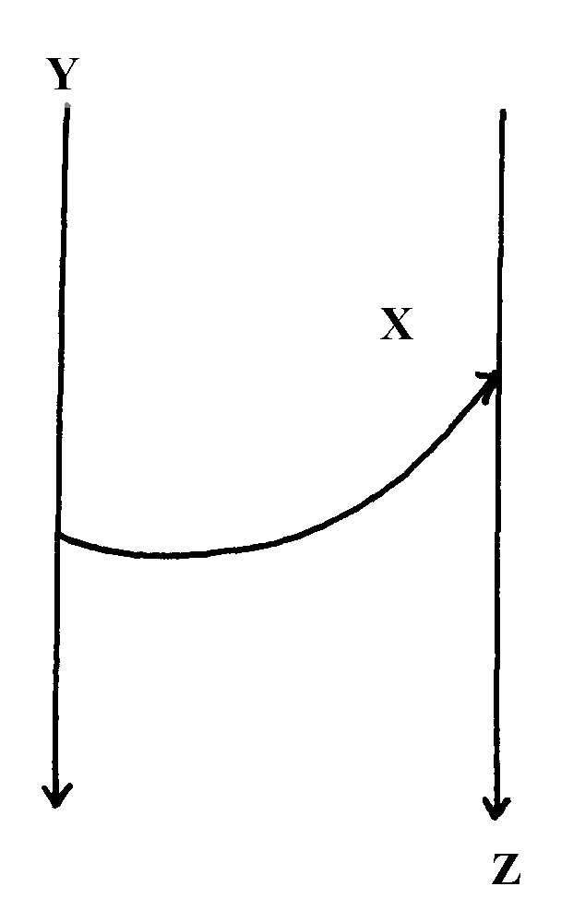

4. (a) Differentiate between accordant and discordant drainage systems
(b) State three factors that facilitate formation of deltas

5. (a) (i)Name two ways in which ice moves
(ii) State two factors which facilitate the movement of ice
(b) Identify two erosional features in glaciated lowlands
(c) Describe how the following features are formed:
(i) Outwash plain
(ii) Moraine-dammed lake
(d) Explain four ways in which a glaciated landscape is of significance to human activities
6. (a) State four factors which may cause a waterfall to form
(b) (i) Describe how river braids are formed
(ii) Name three features resulting form river rejuvenation
(c) Describe how a river capture occurs
(d) Give two reasons as to why Lake Naivasha is a fresh water lake

7. (a (i) Outline two factors that influence the development of drainage patterns. (2 marks)

(ii) Outline five characteristics of a river in its youthful stage. (5 marks)

(b) Describe the following processes of river erosion:

(i) attrition; (2 marks)

(ii) corrasion. (4 marks)

(c) Explain three negative effects of rivers to the human environment.

(d) Your class is planning to carry out a field study of a river in its old stage.
(3 marks)
(i) State three reasons why it would be necessary to pre-visit the area of study.
(3 marks)
8.(a) | Explain the following processes of weathering:
 | (i) hydration; | (2 marks)
 | (ii) oxidation; | (2 marks)
 | (iii) frost action. | (3 marks)
(b) | Describe how an exfoliation dome is formed. | (6 marks)
(c) | Explain three physical factors that enhance movement of materials along a slope due to gravity. | (6 marks)
(d) | (i) Give two processes of rapid mass movement. | (2 marks)
 | (ii) State four indicators of occurrence of soil creep in an area. | (4 marks)
9. (a) (i) What is an ice sheet? (2mks)
(ii) Give two reasons why there are no ice sheets in Kenya (2mks)
(iii) Explain three factors that influence the movement of the ice from the place where it has accumulated (6mks)

(b) Describe how an arête is formed (4mks)

- The diagram below shows types of moraines in a valley glacier


    - Name the type of moraines marked S, T and V (3mks)
    - Explain four positive effects of glaciation in lowland areas. (8mks)
10. (a) (i) What is the difference between weathering and mass wasting?
(ii) Apart from plants, give three other factors that influence the rate of
weathering
(iii) Explain two ways in which plants cause weathering (4mks)
(b) (i) List two types of mass wasting other than soil creep (2mks)
(ii) Explain three factors that cause soil creep. (6mks)
(c) Explain four effects of mass wasting on the environment. (8mks)

8. a) i) Name two sources of rivers. (2mks)

ii) The diagram below shows the three stages of the long profile of a
river.
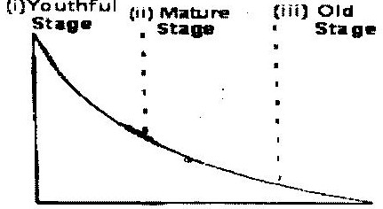

Give two features formed by the rivers in each of the three stages.
(6mks)

98. (a) Describe plucking as a process in glacial erosion. (4 marks)
(b) Explain three conditions that lead to glacial deposition. (6 marks)
(c) The diagram below shows features resulting from glacial deposition on a lowland area.
Direction of movement of ice
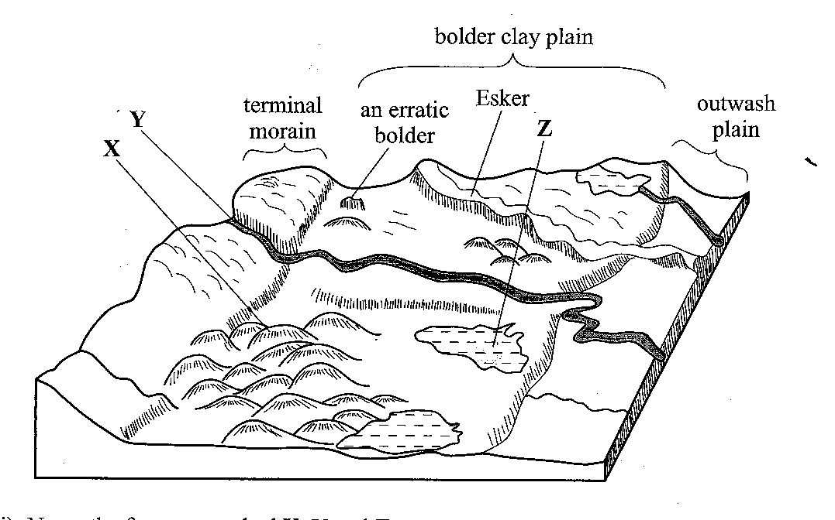

- Name the features marked X, Y and Z. (3 marks)
- Describe how terminal moraine is formed. (4 marks)
(d) Explain four positive effects of glaciation in lowland areas. (8 marks)
10. (a) Differentiate between river rejuvenation and river capture. (2 marks)
(b) Give three features resulting from;
(i) river rejuvenation; (3 marks)
(ii) river capture. (3 marks)
(c) Explain the four ways through which a river transports its load. (8 marks)
(d) You are planning to carry out a field study on the lower course of a river.
(i) Give three reasons why you would require a route map. . (3 marks)
(ii) State three characteristics of a river at the old stage that you are likely to observe during the field study.(3 marks)
(iii) Give three follow-up activities you would be involved in after the field study. (3 marks)

MERRY XMASS AND HAPPY NEW YEAR 2014.

