14. SOILS
1. a) - Soil profile is the vertical arrangement of various soils in layer showing the
sequence of horizons from the surface to the parent materials
- Soil catena is the sequence of different soils on a slope from the top of the
hill to the valley Bottom
.

b) - platy/plate soil structure
- crumb soil structure
- prismatic soil structure
- blocky/block soil structure
- granular soil structure
- columnar soil structure
c i) - Controlling overgrazing
- Avoiding bush fires
- Controlling tree cutting
- Practicing appropriate methods of cultivation e.g. planting cover crops, irrigation,
mulching, terracing, contour farming
c ii) - Leaves & branches reduce the force of rain drops which would otherwise loosen
and remove soil particles
- Rate of infiltration of rain water into the soil is increased by vegetation cover thus reducing surface run off
- Tree roots which penetrate the soil help to carry surface moisture into the ground. This allows the moisture to gradually percolate deeply
- Tree roots bind the soil particles together and therefore the soil can not be easily carried away
- Trees break the force of the wind at the ground and reduces the transportation of soil by wind

2. a i) Soil is the top layer of loose or unconsolidated rock material overlying crustal rocks
and on which the plants grow
Or - Is an accumulation of rock particles minerals, organic matter, water and air found on
the surface of the earth
a ii) ) Soil catena : This is the arrangement of soil on a mountain slope from the top of the
valley bottom while soil profile is the vertical arrangement of various soils in layer
from surface to bed rock
.b i) - - Climate
-Seasonal variation of rainfall can cause accumulated concentration of salt in the soil
- Rainfall provides water which make it possible for rocks to disintegrate to form soil
- Rainfall also affect the rate at which some soil forming processes can occur (leaching)
- High temperatures increase the rate of weathering by accelerating the raise of bacterial activities which generates some of the organic matter in the soil
- Wind, ice, water erode, transport and deposit soil particles in other areas leading to the formation of new soils
- Living organisms
- Living organisms add organic matter to the soil
- Areas with thick vegetation lead to the formation of fertile humus laden soils which is quite useful in aeration
- Bacteria help to decompose organic matter
- Bacteria fixes nitrogen into root nodules of plants thus enriching the soil
- Human activities can change the nature of the soil through grazing cultivation, use of fertilizers e.t.c.
b ii) - Type of parent
- Amount of organic matter
- Chemical composition i.e. minerals
- Drainage of the soil or amount of water in the soil

3. a) Relief
Slope influences the type of soil in that on steep slopes the soils that develop are thin, on gentle slopes the soils are deep and fertile. This is because the rates of erosion and weathering are quite rapid on steep slopes than gentle slopes
Drainage
- The amount of moisture in the soil is determined by the slope. Steep slopes have
well drained but thin soils
- Hill top has well drained and mature soils
- Valley bottoms develop soils that are poorly drained
Mass wasting and surface run off
This leads to development of fertile soils at the valley bottom because the top soil
removed and deposited there
Leaching
This is the movement or washing of soil minerals from one layer to another which will also affect the type of soil developing

b i) the vertical arrangement of soil in layers from the top the bedrock
b ii)
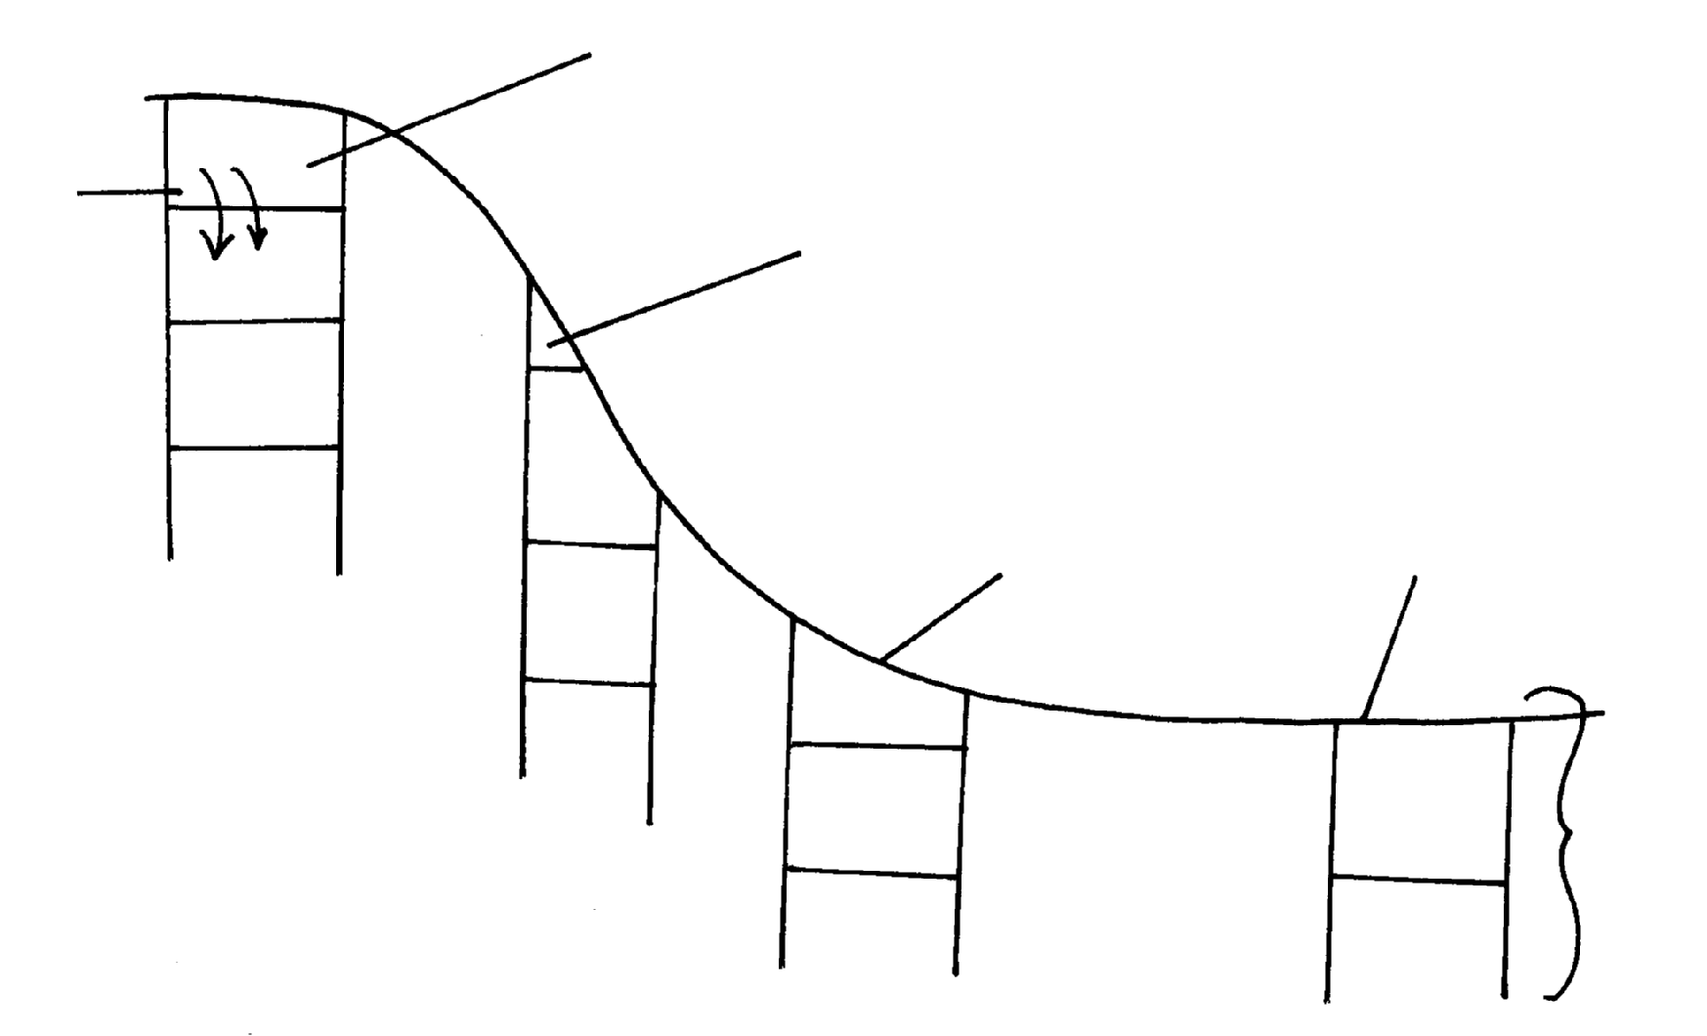
A
Leaching
½
B
C
D
Deep soils. Well formed horizons ½
Steep slope with thin horizon A’ coz of soil erosion ½
Deep soil support cultivation and settlement ½
Valley bottom ½
A and B very wide, soils are greg and water logged½
D
C
B
B
C
A
A
B

b iii) elluviation calcification
illuviation gleization
leaching ferrilisation
lateralization
humification
b iv)- Excess irrigation
- Over stocking

4. a i) Soil is a thin layer of natural material on the earth’s surface that supports plant
and animal life
ii) - Inorganic matter
- Organic matter
- Soil water
- Soil air
- Soil organisms
. b i) - Parent rock
- Topography
- Climate
- Time
b ii) - Dense vegetation vital for fertile soils
- Micro-organisms like fungi fix nitrogen to the soil
- Micro- organisms aerate the soil hence improve porosity
- Activities of man i.e. grazing, use of fertilizers, construction
c i) - Soil air – gases that are available within spaces that separate soil grains
- Soil texture- size of individual soil grains
c ii) - High amount of rainfall promote chemical weathering of acid parent rock materials

- Long cold withers and short mild summers in temperate climates reduce bacterial activity
- Weathering of parent rock materials releases iron, aluminum, silica and organic acids
- Strong acid conditions enhance leaching of bases especially calcium along with iron and aluminum
- Silica that is less soluble is left back with the top layers and staining the soil beneath
- ash- grey
c iii) - Develop mostly through calufication
- Have dark surface horizons
- Rich in calcium
- Have deep top layers of about I meter thick

5 .a)
Bare rock (1mk)
Heath & moorland (1mk)
Bamboo forest (1mk)
Savanna vegetation (1mk)
1000
2000
3000
4000
5000

b i) - Soil catena is the sequence of different soils on a slope
b ii)
Humus
Top soil
Sub soil
Partially weathered rock
Parent rock

a iii) - The soils are light in colour
- They are saline
- They are sandy/ strong
- They are loose in texture
- They are thin
- They have low moisture content
b) - The type of parent rock
- The amount of organic matter/ humus
- The chemical composition/ the degree of iron oxide/ minerals
- The amount of water in the soil/ drainage of soil
c) - During the wet season, mineral salts in the top layer of the soil dissolve rain water
- The dissolved minerals percolate seep downwards from the top soil to the sub soil
- The dissolved minerals are deposited further downwards to the lower layer
- Insoluble minerals such as iron and aluminum are left on the up layers to form a crust
of late rite soils
d i) - Burning destroys micro- organisms which are essential for formation of humus which
binds the oil particles together
- Burning destroys vegetable matter that protects the soil against erosion
- Burning destroys the nitrogen fixing bacteria making the soil less fertile
- Burning loosens the soil making it susceptible to erosion/ leaching which drains away soluble mineral nutrients
d ii) - This increases the aridity of the soil/ changes the PH of the soil
- The acidity destroys the micro- organisms in the soil/ bacteria/ fungi which could
have helped in the formation of humus
d iii) - Monoculture leas to exhaustion of certain minerals from the soil making it infertile
leading to its erosion
- Monoculture leads to loosening of soils particulars there by encouraging soil erosion

6. (a) i) - Tundra soils
- Podzols
- Chernozens
- Proure soils
- Chestrut soils
- Red Desert soils
a ii) - In warm to hot humid regions silica and other bases dissolve in water are
leached/percolate when it rains seep downwards from the top soil
- This leaves iron and aluminium oxides which are insoluble on upper soil horizons.
- This forms soils on upper soils on the upper soil horizons rich in iron and alluminiumoxides called lateritic soils
a iii) - They are young/of recent origin
- They are immature
- They are insufficiently affected by soil forming processes
- Characteristics depend on their origin
b i) - High rainfall can lead to water logging and formation of acidic soils
- Heavy rainfall also results into surface run off that may lead to sol erosion run-off that may lead to soil erosion
- Too much rain can alter the soil structure by causing crumb soil to form blocky or columnar structure
- Heavy rainfall can led to leaching of nutrients from top soil to lower soil horizons depriving the top soil of some nutrients
- Low rainfall leads to loose soils easily blown away by the wind
- Excessive drought leads to accumulation of salts in the top soil leading to salination
b ii) - Soil is baked to make building and construction materials like bricks, tiles/whitewash
- Soils are used in making pottery/ceramics/sculptures and used by people
- Some soils contain minerals like apatite which is mined and used to make phosphatic
fertilizers
- Some soils are medicinal
- Some soils are food to animals and people
7 a i) soil catena is the horizontal arrangement of soil on a mountain slope while a soil
profile is the vertical arrangement of soil particles in layers or horizons
. a ii) -leaching
-eluviations
-uluviation
-organic accumulation
-cheluviation
-precipitation
-organic sorting

b i) - seasonal rainfall in temperature and rainfall facilitating the rate of weathering
-the rate at which organic matter decompose rise in to increase in temperature and rainfall while dry areas are devoid of vegetation covers
b ii) - micro-organism cause both plants and animals to decay into humus .humus are
added o the upper layers of the soil
-living organisms act on decaying organic matter through humification to form humus.
This humus consolidate forming rich soils.
b iii)- soils formed on steep slopes generally fails to develop or mature because most of the
rain water runs of along the surface ,this accelerate erosion which comes away the top layers of soil
-on rolling and gentle slopes maximum soil development is likely to occur. This is because the rate of soil erosion is matched by the rate of soil formation due to good drainage
c i) soil degeneration is the decline in the usefulness of soil resulting from either soil
mismanagement or environment causes
c ii) -plant roots which penetrate the soil help to carry surface moisture into the soil
-vegetation helps to bind soil particles together
-plant cover breaks the force of wind and therefore reduces the transportation of soil particles
-decayed vegetation matter provide humus which binds the soil particles together
-the leaf cove helps to reduce the force of rain drops which would loosen and remove soil
particles
-the rate of infiltration of rain water into the soil is increased by vegetation cover thus reducing
surface run offs
c iii) -crop rotation
-contour ploughing
-strip cropping
-inter cropping
-bush fallowing
-mixed cropping

8. a i) -this is the sequence or arrangement of different soils down a slope
8. a ii) -the relief/slope/steepness of the land
-the drainage of the area
-the transportation of the soil debris
-the teaching process
8. b) -the production topsoil is lost foe ever and his lowers the agricultural production of the land
-the soil left behind after erosion is thin and cannot hold plants firmly in the ground.
-continued loss of soil through erosion destroys vegetation cover turning the area into
semi- arid/desert.
-soil erosion causes water reservoirs to be filled up by silt adding extra cost of dredging.
-sediments which are carried into rivers/lakes/oceans may contain industrial effluents
which kill aquatic life.
-gullies as a result of erosion expose water onto the surface leads to lowering of the
water table
8. c) -develop best in areas which are cool and sufficiently wet
-soluble soil constituents are moved downwards
-it leads to severe absence of bases throughout the soil profile resulting to low PH and
an accumulation of hydrogen clays
-there is an accumulation of acid organic matter in horizon a leading to intense teaching
of bases and clays
-iron and humus are deposited in horizon B

9. a) - Living organisms.
- Organic matter.
- Soil minerals.
- Soil matter.
- Soil air.
b i) - Climate influence type & rate of weathering.
- High rainfall influence leaching process runoffs resulting from high rainfall increases
rate of erosion.
- It influence rate of decomposition
b ii) - Influence soil profile.
- Parent material influence soil structure.
- It influences soil colour.
- It influences mineral composition.
- It influences soil texture.
c i) - Over cultivation exhausts the soil fertility.
- Monoculture exhausts soil minerals.
- Clearance of land for agriculture interrupts nutrient cycling.
- Application of fertilizer changes the P.H.
- Construct of roads, mining, quarrying destroy soil structure.
-Application of fertilizers change soil PH
c ii) A-TOP SOIL
B- SUB-SOIL
C- PARTLY WEATHERED ROCK
D -PARENT ROCK

10. a) - A lake is an accumulation of water in a wide hollow or depression
. b) - By erosion
- By earth movements/ volcanic activity
- By deposition
- By human activity
- By falling meteorites
- By mass movements e.g. land slides
- Weathering by solution
11. a i) Soil is the upper most surface layer of unconsolidated material which lies on the
surface of the earth and in which plants grow/ soil is an accumulation of rock particles
or minerals, organic matter, water and air found on the surface of the earth
. b i) - Seasonal variation of rainfall can cause accumulation/ concentration of salts in soil
- Rainfall provide water which make it possible for rocks to decay/ disintegrate to form soil
- Rainfall can affect the rate at which some soil forming processes can occur (leaching)
- High temperatures increase the rate of weathering/ accelerate the rate of bacterial activities
which generates some of the organic matter in the soil
- Water, ice and winds erode, transport and deposit soil particles in other areas leading to the formation of new soils (for example loess)
b ii) - Valley bottoms/ gentle slope encourage the formation of deep and fertile soils due to
deposition/ accumulation of minerals
- Steep slopes encourage erosion of the top layer of soil thus slowing down formation of soil/ have thin soils
- Flat plains/ flood plains are saturated with water therefore slows down soil forming processes
- Slopes influence arrangement/ sequence of soil/ soil catena
- Some slopes are more exposed to the sun/ rain which influence weathering of parent rocks/ soil formation (aspect)
c i) - Humus helps to improve soil porosity by aerating the soil
- It improves the moisture – retention capacity of the soil
- Humus provides essential minerals to the soil
- It improves the soil texture
c ii)- They are thin and shallow
- They are sandy or stony
- They lack humus or have low organic matter content
- They are generally saline
- They are coarse- textured and quite porous
- They are alkaline because of high content
- They have low moisture content
. d i) - This occurs on gentle slopes which are bare
- When heavy rain falls, water spreads over a large area
- As water moves, it removes the top layer of soil evenly over the area
. d ii) - It occurs on steep slopes
- Rain water cuts deep grooves/ channels/ rills on the slopes
- The channels are widened and deepened to form gullies, through which soils are carried away
. d iii) - Soils are sources of valuable minerals
- Soils are used raw materials for pottery/ ceramics/ tiles/ bricks
- Soils are used for agriculture
- Some soils are mixed with herbs and sold for medicinal purposes e.g. clay/ sold directly for
food
12. a) - It is a careful management/protection of soil against erosion and exhaustion
. b) - Ploughing along the contour
- Controls grazing
- Stripping cropping

