SOIL FERTILITY II (IN ORGANIC FERTILIZERS)

This topic entails the following;
- Essentials elements required by cops
- Classification of essential elements
- Role o micro-nutrients
- Deficiency symptoms of macro-nutrients and micro-nutrients.
- Identification and classification of fertilizers.
- Soil sampling and testing methods of fertilizer application.
- Effect of soil acidity/alkalinity air crops
- Fertilizer rate calculations

The following relevant questions and their answers in this topic will greatly help and motivate the user to comprehend and understand the required concepts and practices:

1. State four advantages of applying lime in clay soil
2. a) Give the form in which the following elements are absorbed by crops
i) Sulphur
ii) Nitrogen
iii) Carbon
iv) Magnesium
b) List three effects of nitrogen to plants
3. Mr. Malombe of Shinyalu village prepared to top dress 10 hectares of nappier grass using
sulphate of ammonia (21%N). Sulphate of ammonia is applied at rate of 150kg per hectare.
Calculate
a) The quantity of sulphate ammonia fertilizer the farmer will need for 10 hectares
b) The number of 50kg bags of fertilizer he will purchase
4. Give two disadvantages of using farmyard manure
5. State four factors which influence the stage at which the crops are harvested
6. A form four student was given a sample of a fertilizer with the following characteristics:
(i) Grey in colour
(ii) It is granular
(iii) Causes no corrosion
(iv) It is highly hygroscopic
(v) It is neutral
(a) Identify the fertilizer
(b) At what stage of growth of maize should it be applied?
(c) Calculate the amount of K₂O contained in 400kg of a compound fertilizer 25:10:5
7. State two pieces of information that soil sample should have before being taken to the laboratory
for testing
8. A compound fertilizer bag has the labels 20-20-0. What do the figures stand for?
9. Give four functions of sulphur in crops
10. State four advantages of lining as a measure of soil improvement
11. State two methods of increasing soil PH
12. (a) State three factors that determine the amount of inorganic fertilizers needed to be applied
to crops
(b) What are the necessary precautions observed when carrying out soil sampling?
13. List three functions of nitrogen in crops
14. (a) Distinguish between fertilizer grade and fertilizer ratio
(b) List four elements whose deficiency results into chlorosis in plants
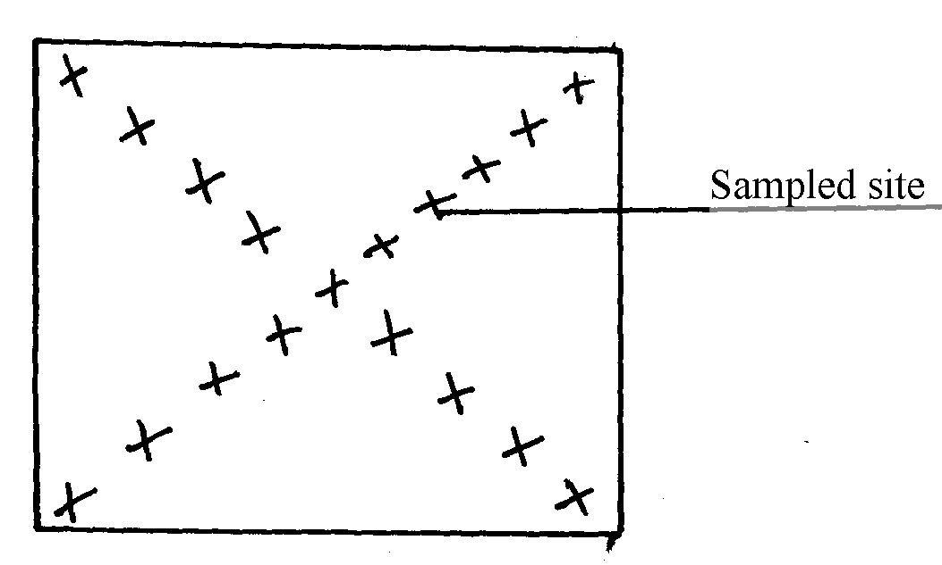
15. The diagram below shows a method of soil sampling

(a) Name the method illustrated in the diagram
(b) State three precautions taken when collecting the soil for testing using the above method
(c) Give four reasons why soil from the farm is tested
16. A farmer was advised to apply compound fertilizer 20-20-10 on an orchard measuring
20m X 10m at the rate of 80kg/ha. Calculate the amount of fertilizer the farmer would require
for the orchard. (Show your working)
17. a) A compound of fertilizer has a fertilizer grade of 25:10:5.calculate the a mount
of phosphorus fore sent in 400kg of this fertilizer
b) The diagram below illustrate methods of collecting soil sample from a field

2
X
X
X
X
X
X
X
X
X
X
X
X
X
1
X
X
X
3
4
5
8
7
6
10
9

i) Identify the methods illustrated 1-
ii) xx
iii) State three importance of carrying out soil sampling and testing
18. (a) What is an incomplete compound fertilizer?
(b) State four reasons why a maize crop continued showing deficiency of potassium despite
applications recommended amount of potassic fertilizer

19. The diagram below shows a soil sampling method.
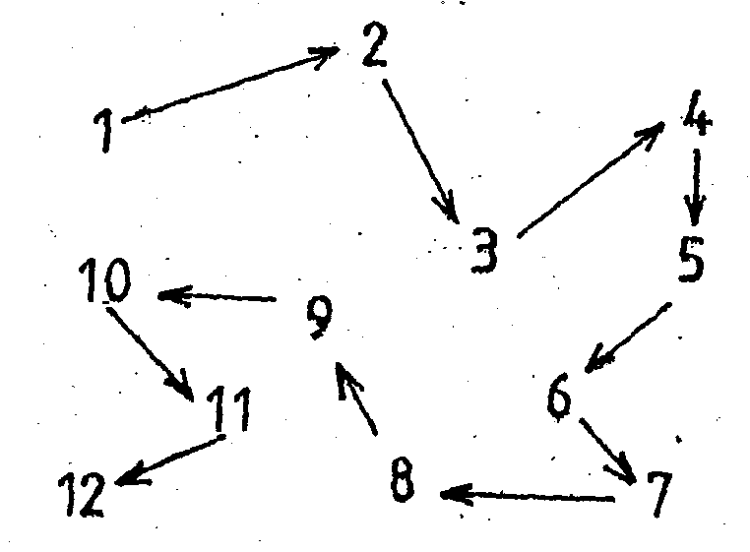

(a) Identify the method illustrated above
(b) Name any two spots in a farm that should be avoided during sampling
(c) Describe the steps followed while carrying out the exercise in (a) above

SOIL FERTILITY II (IN ORGANIC FERTILIZERS)

1. four advantages of applying lime in clay soil
- Lower soil acidity
- Increase calcium content
- Hastens decomposition of organic matter
- Improve soil structure/ improve drainage
- Facilitates availability and absorption of nitrogen and phosphorous
- Improve legume nodulation and nitrogen fixation
Increase multiplication of micro- organisms
2. a) i) Sulphur- SO₄²⁻,SO₂
ii) Nitrogen-NO₃⁻,NH₄
iii) Carbon-CO₂
iv) Magnesium-mg²⁺
b) three effects of nitrogen to plants (1 1/2mks)
- delayed maturity
- excessive succulence
- excessive vegetative growth
- weak stems
- lodging
3. a) The quality of sulphate ammonia fertilizer the farmer will need for 10 hectares (1mk)
100kg SA supplies 21kg N
1ha requires 150kg SA
10ha requires (150x10) kg SA
= 1500kg SA in 10ha
b) The number of 50kg bags of fertilizer he will purchase (1mk)
50kg fill 1 bag
- 1 x 1500=30bags (1)
50
4. two disadvantages of using farm yard manure
- It’s bulky hence difficult to apply by one laborer.
- It may spread weeds.
- It may spread diseases.
- It releases nutrients slowly.
5. four factors which influence the stage at which the crops are harvested.
- Purpose of the crop / maturity.
- Moisture content.
- Concentration of certain chemicals.
- Water condition.
- Market demand.
6. a) - Calcium Ammonium Nitrate CAN.
b)- Knee high
- 30 – 45 cm height.
c) Calculate the amount of K₂O contained in 400 kg of a compound fertilizer 25 : 10 : 5.
5 kg of K₂O is in 100 kg of 25 : 10: 5
∴ 400 kg of compound fertilizer
400 x 5 = 20 kg of K₂O
100
7. Two pieces of information that soil sample should have before being taken to the laboratory
for testing are:-
- Name of the farmer
- Address of the farmer
- The type of test to be carried out
- Date of sampling
8. A compound fertilizer bag has the labels 20-20-10. What do the figures stand for
- 20 – 20% Nitrogen (N)
- 20 – 20% Phosphorous Pentoxide (P₂O₅)
- 0- 0% Potassium Oxide (K₂O)
9. Four functions of sulphur in crops are:-
- Amino acids/protein synthesis
- Formulating enzymes and hormones
- Increase oil content and hormones
- Needed for formation of chlorophyll
Needed in carbohydrate metabolism
10. - Improves soil PH hence microbial activities
- Allows wide production of different crop varieties
- Improves soil aeration
- Improves drainage
Improves soil structure
11. -Liming
- use of alkaline fertilizer (2 ½ = 1mk)

12. a) -Type of crop
- Fertilizer characters
- Type of soil
- Environmental condition ( ½ x3=1 ½ mks)
b) - Avoid unique sites e.g. compost, along fence
- Remove all vegetation parts
- Mix the samples thoroughly
Make as many samples as possible
13. three functions of nitrogen in crops (1 1//2mks)
- Protein synthesis/formation
- Forms part of chlorophyll molecule
- Encourages vegetative growth
- Regulate availability of phosphorus and potassium in plant
- Increase to size of grains and protein content increases
14. Fertilizer ratio is the proportion of various nutrients in a fertilizer grade is the percentage of
nutrients in a fertilizer;
(b)- Nitrogen
- Calcium
- Potassium
- Magnesium
- Sulphur

15. (a) Diagonal/transverse method; (1x1=1mk)
(b) – Avoid contamination/use sterilized container;
- Avoid sampling soil from unusual sites e,g ant hills
- Avoid mixing top soil with sub-soil; (3x1=3mks)
(c) – To determine the nutrient status of te soil;
- To determine the soil PH/type of fertilizer to add to the soil/lime to add to the soil;
- To determine the type of crop to grow;
- May help in diagnosing low crop yield/mineral deficiency;
16. Area – 10x20 =200m² (1mk)
100,000m² require 80kgs of 20-20-10
200m² will require
200 x 80
10,000
═ 1.6kgs (1mk)
17. a) A compound of fertilizer has a fertilizer grade of 25:10:5.calculate the a mount
of phosphorus fore sent in 400kg of this fertilizer
N:P:K
25:10:5
If 10kg P₂O₅√1 = 100kg NPK
? = 400kg NPK√1
= 400 x 10
100
= 40kg P₂O₅√1 (3 steps x 1=3mks)
b) i) - zigzag method
ii) xx –traverse/diagonal
iii) State three importance of carrying out soil sampling and testing
- determine the type of crop to grow
- determine the type of fertilizer to be used
- determine type of nutrients in the soil (3x1=3mks)
18. (a) Lacks one of the major fertilizer NPK elements
(b) – The soils could be very acidic
- Too much rainfall.
19. (a) Random/zigzag soil sampling
(b) – old manure heaps
- Ant hills
-Dead furors
-Fence lines
-Cattle bomas
(c) - Clear vegetation
- Mark points using pegs
Collect top soil and sap soil n different paper bag.
- Dry the soil and mix thoroughly
- Sent dispatch to laboratory for fasting

