**312/1GEOGRAPHY MARKING SCHEME**

**1.** (a) - Physical environment

- Social / human environment

(b) - During construction of roads, bridges, dams, an engineer needs to understand the nature /

type of rocks in order to give a firm foundation.

- Geography deals with relief, this knowledge will help a civil engineer when constructing

roads.

**2.** (a) - Centrifugal force

- Centripetal force

- Gravitational force

(b) - Through mining

- Through examining igneous activities (magma)

- Through studying seismic waves (Earthquakes)

**3.** (a) - Presence of fossils.

- Presence of deposits from rivers / ocean waters etc

(b) - Proportion of silica.

- Proportion of basic oxides.

- Variation of proportion of silica and basic oxides in basic rocks varies between 45% and

55%.

**4.** (a) -**Weathering** is the mechanical breakdown or chemical decay of rocks insitu, as a result of their exposure at or near the earth’s surface.

(b) - High rainfall facilitates chemical reactions.

- High humidity facilitates rapid chemical weathering of rocks.

- High temperature and high humidity facilitate the decay of the plant litter which produces organic acid that cause chemical reaction.

**5.** (a) (i) Temperature range = 240 – 220c

= 20c

(ii) Annual rainfall = 17421mm

(b) - Rainfall occurs throughout the year.

- Rainfall has two maxima ie. November and April.

- Highest rainfall occurs just after the equinox.

- The temperatures are high throughout the year.

- There is small range of temperature.

- The highest rainfall occurs when the temperatures are high.

**6.** (a) (i) 1 cm represents 0.5 km/ ½ km

(ii) Borehole

(b) (i) – Scattered trees

- Scrub

(ii) - The area covered by the map has presence of hills e.g. Kyoomi, Kitui hills.

- Presence of steep slopes.

- Gentle slopes to the south eastern part of the map.

- Many valleys

- The area is rocky especially in grid square 0382 with evidence of out crop rock.

- The area has rugged landscape with irregular undulating landscape due to irregular contours.

- The highest point on the map is 1530 m above sea level evidenced by trigonometrical station in grid 9264.

(c) (i) - Health service evidenced by health centres.

- Administration centres evidenced by chiefs centre.

- Education centre evidenced by schools.

(ii) 14.5 km

+0.1

(d) (i)

**10cm**

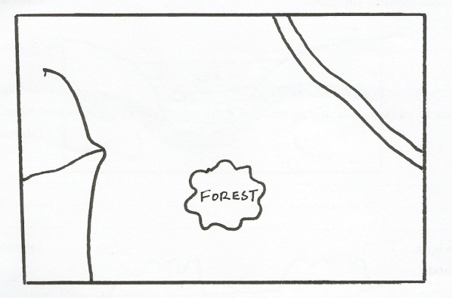

**River**

**Road**

**8cm**

iii) 1:100,000

(e) (i) – dendritic drainage pattern

- parallel

- trellis

(ii)

* Vast area to be covered
* Steep slopes / rocky areas
* Crossing or river valleys
* Unfavourable weather (hot)

**7.** (a) (i) **Folding** is the process of crystal distortion which causes the rocks to bend upwards or

downwards.

(ii) - Tectonic forces

(b) (i) X - Atlas Mountains

Y - Andes

Z - Rockies

(ii) - Presence of extensive depression known as geosyncline.

- Rivers from the surrounding highlands deposit their sediments in the geosyncline.

- The weight and pressure of the sediments causes the floor of the geosynclines to subside.

- The continents are pulled towards the geosynclines by the sagging motion of the

geosyncline.

- This movement triggers off convectional currents or compressional forces in the

continental rocks.

- This causes the continents to begin moving slowly towards the geosyncline.

- Deposited materials are folded upwards to form mountains.

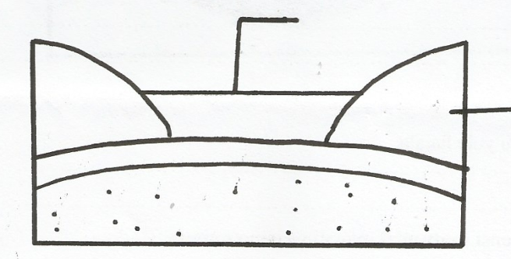

**Sediment**

**Geosynclines**

**Sial**

**Sea**

**Mantle**

**Sial**

**Sial**

**Sea**

**Geosynclines**

**Eroded continent**

**Convection current**

**Continental land mass**

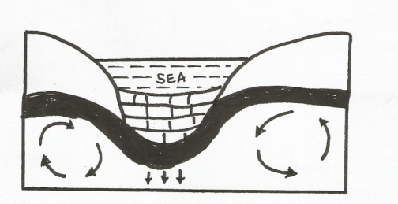

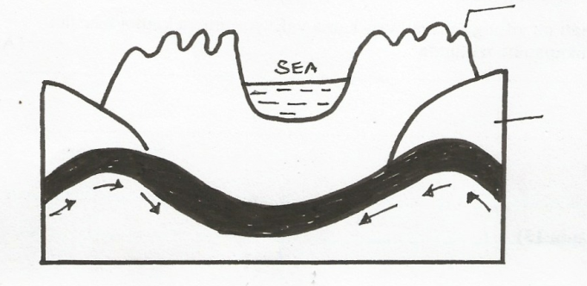

**Sial**

**Sial**

**Mantle**

**Mantle**

**Mountain**

(c) (i) - Gives ample time to each activity.

- Reduces time wastage as the researcher works, within the allocated time.

- It provides a basis for evaluating the fieldwork exercise.

- It enables one to remain within the scope of the topic.

(ii) - Discussion of the findings.

- Individuals /groups presenting their reports

- Drawing maps and diagrams.

- Labeling features.

- Putting data into groups.

(d) - Some fold mountains are snow capped which attract tourists who earn the country

foreign exchange.

- Mountain slopes especially on the windward side support growth of forest which

provide timber.

- Some fold mountains act as water catchment areas, hence provide water for

domestic and industrial use.

**8.** (a) (i) **A river tributary** is a small river which flows into a bigger one while **a river confluence** is the point at which a tributary joins the main river.

(ii) - **Hydraulic action**

-Water hits against the banks of the river channel.

- The water is forced into the cracks on the riverbank.

- Some air in the cracks is trapped and compressed.

-The compressed air develops high pressure which widens the cracks.

- As the water retreats, pressure in the cracks is suddenly released.

- Repeated compression and widening of the cracks eventually shatters the rocks.

- As water retreats, it carries away the loose particles.

- The force of moving water and the eddying effect sweep away loose materials in the river channel.

**Corrasion**

- The load carried by the river is used as a tool to scour the bed and sides.

- Some of the load is hurled by the water against the banks while the heavier one is

dragged along the river bed.

- The load chips off the rock on the bank and floor.

- Eddy currents rotate rock particles in hollows on the river bed and widen the

hollows into particles.

(b) (i) - **Volume of water** – a large volume of water increases the ability of the river to erode

by corrasion, hydraulic action.

- **Gradient of the river channel**. The steeper the gradient, the higher the water

velocity.

- **Nature of the bed rock** – If the rock over which the river is flowing has little resistance to erosion, it can easily be eroded.

- **Amount of Load-** If a river is carrying a large load and is flowing at high velocity,

it will be more effective in eroding the channel.

(ii) - Levees make the channel narrower hence a slight increase in volume of water may

cause flooding.

- Levees block tributaries resulting in the formation of different tributaries which

extend the area under flooding on the plain.

- The river channel is elevated above the general level of the flood plain. This makes

the flood waters to rush farther along the plain.

(c) (i) N – Radial

P – Parallel

Q – Fault – guided.

(ii) - Two rivers flow adjacent to each other and are separated by a common divide.

- One of the rivers has more erosive power due to its bigger volume of water and may be flowing a less resistant rock.

- The stronger rivers erode both vertically and laterally, faster than the weaker one.

- Its valley becomes deeper and wider and so it flows at a lower level.

- The stronger river extends its valley backwards by head ward erosion.

- It eventually joins the valley of the weaker ones.

- The head waters of the weaker river start flowing into the valley of the stronger

river, so the weaker river is captured by the stronger river.

**9.** (a) (i) **Karst Scenery -**  is any rugged landscape whose surface rocks are limestone or

dolomite and which has been acted on carbonation by rain and river water to produce features typical of limestone surfaces.

(ii) X – Clint

Y – Grike

(b) (i) -Water percolates through the rocks of the roof of a limestone cave

- This water, which is a solution of sodium bicarbonate, drips slowly from the roof of

the cave to the floor.

- The water spreads out and begins to evaporate.

- Tiny crystals of sodium carbonate are deposited on the floor.

- Each drop which falls on the floor spreads out and evaporates.

- More crystals form on top of the previous one.

- the accumulation of the crystals builds a structure upwards called a stalagmite.

(ii) - The surface rock and the rock beneath the surface should be thick limestone,

dolomite or chalk.

- The rock should be hard and well jointed.

- The climate should be warm or hot.

- Rainfall should be moderate to high.

- The water table in the rocks should be deep below the surface.

(c) (i) - Observation

- Administering questionnaires

- Oral interview

- Taking photographs

(ii) - Rugged terrain hampers movement.

- High temperature.

(d) - The surface and underground features in limestone areas are tourist attraction

earning the country foreign exchange.

- Blocks of limestone rocks area used for building houses.

- Limestone is a raw material for the manufacture of cement.

- The limestone landscape discourages settlements because its rugged nature and

scarcity of surface water.

**10.** (a) (i) **Parent material** is the rock debris from which soil forms whereas **bed rock** is the mass of rock which underlies the soil.

(ii) - Loamy

- Clay

- Silt

- Sandy

- Gravel

(b) (i) **Parent rock**

- Parent rock helps to form soil, some parents rock weather faster than others, hence this affect the rate of weathering.

- Mineral composition of the parent rock determines the mineral component of the resultant soils.

- aren’t rock determines the texture of the resultant soil.

**Topography**

- Relief determines the exposure of slopes to the sun, this exposure to sun, cause

differences in temperature affecting soil types.

- Gentle slopes develop mature soil.

- Steep slopes, erosion is greater resulting in immature thin soils.

**Living Organisms**

- Break down rocks through burrowing ploughing and root penetration.

- Influence chemical composition of soil by adding or removing organic acids and

minerals.

-Burrowing by animals or ploughing by people improves aeration.

(ii) - Relief

- Drainage

- Transport of soil debris.

- Leaching

(c) (i) - Overgrazing

- Heavy rainfall

(ii) - They are thin and shallow.

- They lack humus and have low organic matter content.

- They are generally saline.

- They are coarse – textured.

- They are alkaline because of high lime content.

- They have low moisture content.

(iii) - Preserving the existing forests

- Forestation and growth of soil binding plants.

- Controlling the cultivation of water catchment areas and river banks.