**312/1**

**GEOGRAPHY**

**PAPER 1**

**MARKING SCHEME**

**a)**

1. **Force of gravity** – attracts objects on the earth’s surface and materials within the earth towards the centre of the earth hence making the earth appear round
2. **Centripetal force –** Pulls the North Pole and the South Pole towards each other thus flattening the area at the poles.
3. Centrifugal force – Causes bulging at the equator due to variation in rotation towards the equator

(3x1) =3

**b) Importances of weather forecasting**

1. helps farmers to plan their calendar of activities
2. Assists in the choice of clothing
3. Important in determining suitable housing
4. Important when exploiting fishing habitats
5. Helps in setting time for air and sea travels
6. Helps when setting sporting activities 3x1 =3marks

**2.**

**a) Factors determining the size of a lake**

* The area of the depression in which the lake is formed
* Rate of sedimentation
* Different ways in which the lake is lost
* Percolation through rocks and uses by man
* Water inflow from rainfall, rivers and underground water

2x1 =2marks

**b) Formation of Caldera Lake**

* Magma flows through a vent and lava accumulates around the vent, a funnel shaped hollow at the volcanic vent is formed leading to the formation of a crater.
* Subsequent volcanic eruptions in the crater blows off its top and enlarges the hollow/ subsidence of the volcanic summit causes a large basin called a caldera.
* Water from rainfall/melt water occupies the depression leading to formation of a caldera lake.

**3.**

**a) Soil profile and soil cantena**

* Soil cantena is the horizontal arrangement of different soils down a slope.
* Soil profile is the vertical arrangement of soil horizons from the surface to the bedrock

1x2 =2

**b) Factors which increase the process of leaching in tropical soils**

* High solubility of minerals in the soil
* High amount of rainfall received
* Gentle / flat topography
* High rate of evaporation in a humid climate. 3x1=3marks

**4.**

**a) Mass wasting and mass movement**

* Mass wasting is the movement of weathered materials down a slope by gravitational influence.
* Mass movement is the movement of weathered materials down slope after they have been lubricated by rain water.

1x2 =2 marks

**b) Chemical weathering processes**

* Oxidation
* Carbonation
* Hydration
* Hydrolysis
* Solution 3x1 =3 marks

**5.**

**a) 2 types of waves**

* Constructive waves
* Destructive waves

2x1 =2 marks

**b) X** - Backwash

**Y** – Swash 2x1= 2 marks

**SECTION B:**

**6.**

**a) i) 4 figure grid reference of court house at Ndooa**

0964 2x1=2marks

**ii.** **Altitude of the highest area**

1530m 2x1 =2marks

**iii.** **Types of natural vegetation**

* Scrub
* Scattered trees 2x1 =2marks

**b) i) Distance of all weather road bound surface (C94) from the junction**

5.6 km + 0.1 2x1 =2marks

**ii) Bearing of air photo principal point grid square 9575 from dam 9078**

**c)** **Rectangle of area enclosed by E 90 - 99 and N 62 – 69**

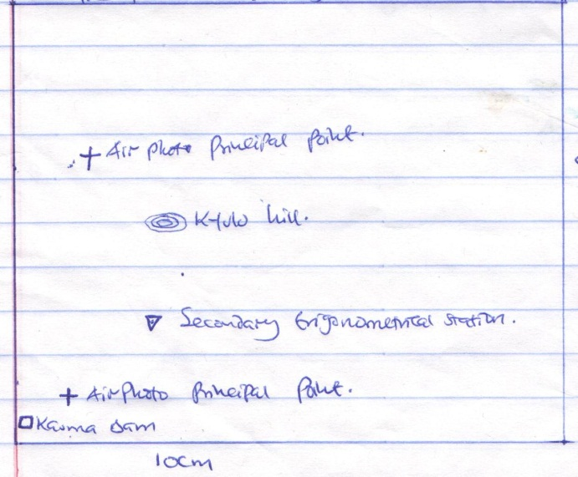

*Kauma dam*

*Air photo principal point*

*Air photo principal point*

*Secondary trigonometrical station*

*Kyulu hill*

**8cm**

**10cm**

*Rectangle 1 x1 = 1mk*

*Features 4 x 1= 4 mks*

*5marks*

**d) Functions of Ndooa Town**

1. Trading centre – presence of shop
2. Administration centre-presence of chiefs office and D.Os office
3. Communication and Transport centre-presence of roads and post office
4. Education centre-presence of schools
5. Health centre-Presence of a health centre at grid reference 0764 *any* 3x2 =6marks

**e) Drainage of the area covered by the map**

* The area is well-drained and has many permanent rivers.
* The main rivers draining the area is R. Ikoo and R. Mui
* The area has disappearing rivers on grid reference 0667
* Most of the rivers form dendritic drainage pattern
* The area has artificial drainage features such as mboni dam, kauma dam, itoloni dam; and boreholes such as in grid reference 0769. *Any* 4x1=4mks

**7.**

**a) i) Definition of tsunami**

Huge sea waves that occur when volcanoes erupt in sea bed or when earthquakes occur in the sea 1x2= 2mks

**ii)** **P**-Epiculture

**Q**- Seismic focus

**R**- Surface wave 3x1= 3mks

**b) i) Types of waves**

Primary waves

* Causes rock particles to vibrate in a push and pull manner.
* Passes through liquids, gases, and solids
* They are the fastest vibrations recorded first

*Direction of propagation*

Secondary waves

* Causes rock particles to vibrate at a right angle to the direction of the movement of the waves.
* Only pass through solids
* Recorded after primary waves.

*Direction of propagation*

C:\Users\Main\AppData\Local\Microsoft\Windows\Temporary Internet Files\Content.Word\002.jpg

Longitudinal waves

* Are destructive
* Causes surface rocks to shake making buildings to collapse
* Particles move either in elliptical manner or in a horizontal manner and at right angles to the surface of the wave.

*Love waves*

*Relalygh waves*

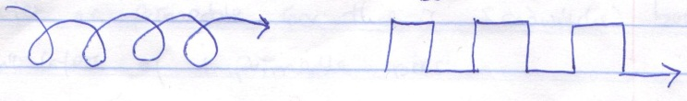 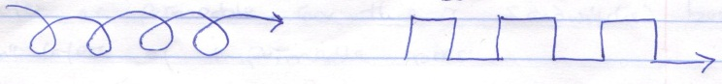

Diagram 1x1= 1

Explanation 2x1=2mks 3x3= 9mks

**ii) Proofs that the crust is in constant movement**

* Sea floor spreading
* Formation of transform fault
* Formation of fold mountains
* Formation of land forms

*(State 1x1, explanation* 1x1=4x2=8mks)

**c) Ways in which the earth’s crust is affected by earthquakes.**

* Causes landslides
* Causes volcanic eruption
* Causes faulting 3x1= 3mks

**8.**

**a) i) Definition of artesian basin**

Is a sauce-shaped depression which consists of a layer of permeable rock that is sandwiched between two layers of impermeable rocks. 1x2=2mks

**ii) Factors influencing the development of karst scenery**

* Hard and well-jointed rock
* Surface rock and the rock beneath should be limestone, chalk or dolomite
* Water table should be deep below the surface
* The region should receive moderate to high rainfall to facilitate solution 4x1=4mks

**b) i) Underground features in Karst scenery.**

* Caves and caverns
* Limestone pillar
* Stalactites
* Stalagmites 4x1=4mks

**ii) Formation of polje**

* Formed when several uvalas collapses leading to a depression
* The depression is broadened by water action through solution
* May be filled with water to form a temporary lake.
* The very large elongated steep-sided depression is called a polje 3x1=3mks

**Formation of a doline**

* Several small holes emerge in karst scenery
* Water starts acting on the points of intersection of joints on the surface
* The points of intersection are widened as solution process continues until the rock is completely dissolved.
* A continuous rounded or elliptical depression called a doline is formed 3x1=3mks

**c) i) Sources of ground water**

* Melt water
* Lake/sea water
* Rain water
* Magmatic water 3x1=3mks

**ii) Significances of features in karst scenery (human activities)**

* Some features such as grikes and clints are beautiful to look hence attract tourists bringing/earning foreign exchange
* Limestone rocks are used in building and construction
* Limestone is a raw material for cement manufacturing
* Limestone landscape is rugged hence discourage settlement
* Limestone areas/regions are used for grazing sheep as the soil is thin and dry. 3x2=6mks

**9.**

**a) i) Physical factors influencing vegetation distribution in Kenya**

* Rainfall- areas that receive high rainfall support dense forests while areas that receive low and unreliable rainfall have grass/scrubs
* Temperature- Forests in cooler areas have fewer species with those in warm areas have more species.
* Altitude/relief- Vegetation varies with height as relief influences soils and climate
* Soil types – Different soil types support different plants e.g. light coastal deep sandy soils support mainly palms.
* Aspects – areas on leeward slopes of mountains have different vegetation types than those of the windward slopes because they receive different amounts of rainfall.
* Drainage – water logged areas support swampy vegetation such as mudflats at the coast support the mangrove forests. 3x2=6mks

**ii) Major vegetation zones in Kenya.**

Forest vegetation

Savannah vegetation

Arid and semi-arid vegetation

Health and moorland

**b) i) Characteristics of tropical rainforests**

* Trees have broad leaves to protect them from collapsing during intense insolation and high temperatures.
* Trees have distinct canopies, top layer, middle layer and bottom layer.
* Trees are at different stages of development due to the absence of seasons
* The forests are evergreen because the trees shed their leaves at different times throughout the year.
* Trees have straight and smooth trunks and grow to great heights in their attempt to compete for sunshine
* There is little or no undergrowth because no sunlight reaches the ground.
* The trees have thick buttress roots to anchor them firmly on the ground because they usually grow to enormous sizes.
* They contain a wide variety of plant species which are close together in mixed stands.
* Most trees are hardwoods and take a long time to mature 3x2=6mks

**ii) Problems experienced during the exploitation of tropical rainforests**

* Hot and humid conditions making lumbering activities uncomfortable
* Trees appear in mixed stands and grow closely together making it difficult to exploit.
* The thick buttress roots make it difficult to cut the trees.
* Dangerous wild animals pose a threat to lumbers
* Construction and maintenance of roads in the tropical humid conditions is expensive 3x1=3mks

**c) i) Field study on vegetation on Mt.Kenya Objectives of the study**

* To identify the plant species on Mt.Kenya
* To determine the relationship between altitude and vegetation
* To investigate the influence of aspect on vegetation
* To find out how the plants have adapted to their physical conditions 3x1=3mks

**ii) Methods of recording data**

* Field sketching
* Mapping
* Photographing
* Note taking 3x1=3mks

**iii) Uses of mountain vegetation**

* The forests are habitats for wild animals
* The forests provide timber and building materials
* Grasslands at lower altitudes of mountains in the tropics are used for grazing animals
* In temperature regions, pastoralists use the alpine meadows as summer pastures 2x1=2mks

**10.**

**a)** **Types of faults**

* Normal fault
* Reversed fault
* Shear fault
* Thrust fault
* Anticlinal fault 3x1=3mks

**b) i) Features resulting from faulting other than the Rift valley**

* Fault block
* Fault scarp/escarpment
* Block mountain/horst
* Tilt block
* Fault steps 3x1=3mks

**ii) Formation of the Rift valley by tensional forces**

* A section of the earth’s crust is subjected to forces of tension

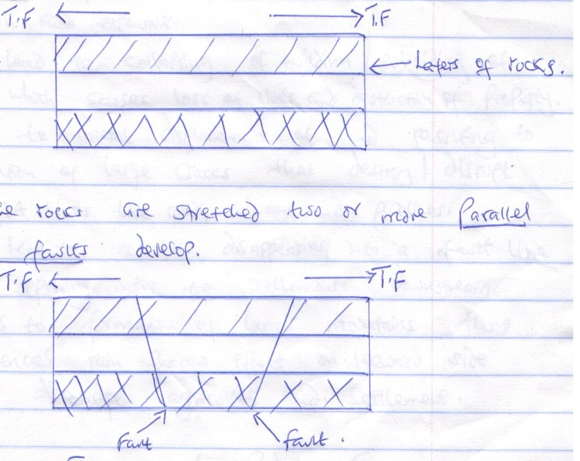

*Layers of rocks*

* As the rocks are stretched two or more parallel normal faults develop

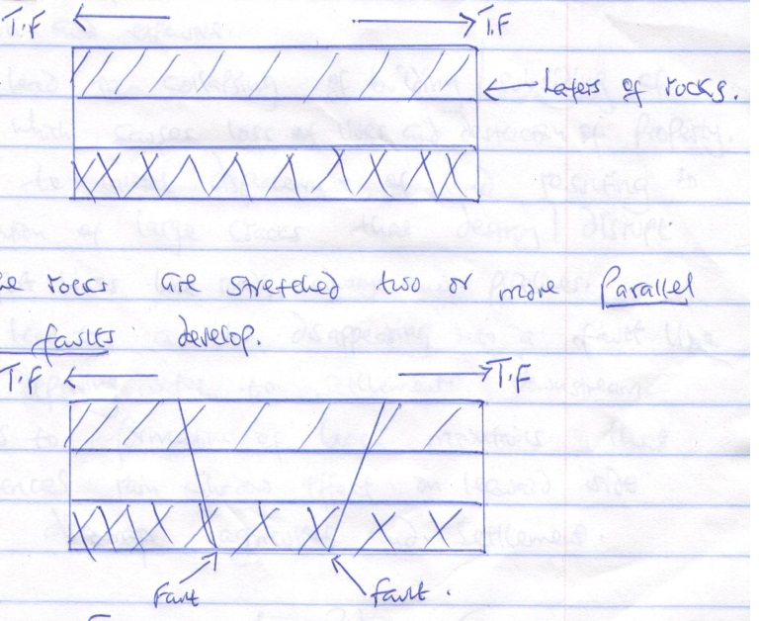

*Fault*

*Fault*

**NB:** T.F- Tensional Forces

* The sideblocks move away from each other/sideway.
* The middle block sinks/subsides
* The top part of the middle block forms the floor of the rift valley/the sunken middle block forms a depression called the Rift valley

*Fault scarp*

*Fault scarp*

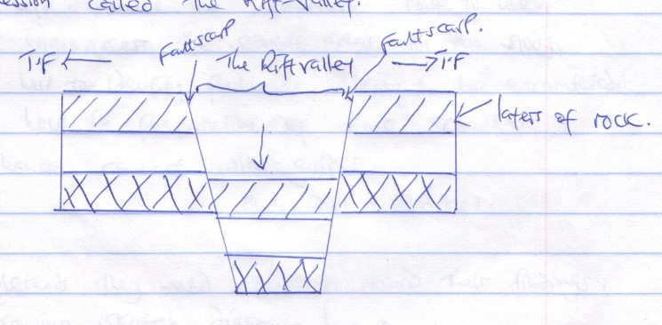

*The Rift Valley*

*T.F*

*Layers of rock*

**c)** **Negative effects of faulting**

* Leads to formation of fault scarps that make construction of transport lines like roads and railways difficult and expensive.
* May lead to collapsing of building/subsiding of land which causes loss of lives and destruction of property
* Leads to lateral displacement of land resulting to formation of large cracks that destroy/disrupt transport lines like roads, railways and pipelines
* May lead to a river disappearing into a fault line hence depriving water to settlements downstream.
* Leads to formation of block mountains that experiences rain shadow effect on leeward side which discourage agriculture and settlement *any* 3x2=6mks

**d) i) Reasons for carrying out a reconnaissance**

* It will help to decide appropriate methods of data collection
* Help to identify appropriate equipment to be used
* Will help determine the appropriate route to use
* Will help to assess the suitable areas for the study
* Will help to identify problems likely to be encountered
* Will help in preparation of time schedules
* Enhance contact with guides. *Any* 3x1=3mks

**ii) Methods they would use to record their findings**

* Drawing sketch diagrams/maps
* Taking photographs/filming
* Writing notes 3x1=3mks