NAME ____________________________________ INDEX NO. _______________

SCHOOL ____________________________________ SIGNATURE _______________ DATE _______________

**312/2**

**GEOGRAPHY**

**PAPER 2**

**TIME: 2¾ HOURS**

**SET 8**

**FORM 4**

312/2

GEOGRAPHY

PAPER 2

TIME: 2¾ HOURS

**INSTRUCTIONS TO CANDIDATES**

* This paper has **two** sections: **A** and **B.**
* Answer **all** the questions in section **A**.
* Answer question **6** and any other **two** questions from Section **B**.
* All answers **must** be written in the answer booklet provided.
* Candidates should answer the questions in English.
* This paper consists of **4** printed pages.
* Candidates should check the question paper to ascertain that all pages are printed as indicated and that no questions are missing.

**SECTION A**

***Answer ALL questions in this section***

1. a) Name **two** products from beef farms in Argentina. (2 marks)

b) Identify **three** functional zones of an urban centre. (3 marks)

1. a) Name **two** types of wheat grown in Canada. (2 marks)

b) Give **three** reasons why Canadian prairies are important wheat producing areas. (3 marks)

1. a) What is a multi-purpose project? (2 marks)

b) Name **three** benefits of the seven folk’s scheme. (3 marks)

1. a) Give **two** tourists attraction found in the Kenya’s inland. (2 marks)

b) Suggest **three** reasons why Kenyans should be encouraged to use biomass energy. (3 marks)

1. Study the map of East Africa below and answer the questions that follow.

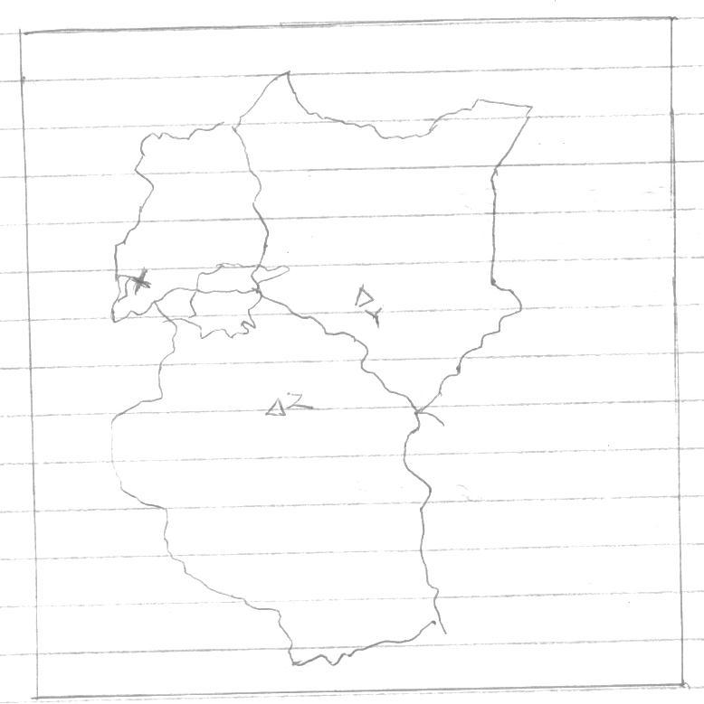

1. Name the minerals mined at places marked Y, X and Z. (3 marks)
2. State **two** problems facing mining industry in East Africa. (2 marks)

**SECTION B**

***Answer question 6 and any other TWO questions from this section.***

1. a) The table below shows the production of various horticultural crops in Kenya between 2008

and 2010 in 000’s tonnes

| **Crop** | **2008** | **2009** | **2010** |
| --- | --- | --- | --- |
| Cabbages | 380 | 340 | 320 |
| Tomatoes | 340 | 360 | 360 |
| Onions | 360 | 320 | 340 |
| Oranges | 400 | 380 | 380 |

1. Using a scale of 1cm to represent 50,000 tonnes, draw a comparative bar graph to present

the data above. (6 marks)

ii) Name the crop that has the highest production within the period. (1 mark)

b) State **four** factors that favour the growth of cocoa in Ghana. (4 marks)

c) Outline the stages involved in processing of cocoa from harvesting to the time it is ready

for export. (8 marks)

d) Explain **three** importance of cocoa to the economy of Ghana. (6 marks)

7 a) What is water transport? (2 marks)

b) Give **three** reasons why Kenyan rivers are not suitable transport routes. (3 marks)

c) State **three** merits of using containerization as a means of transport. (3 marks)

Below is a sketch map of the Great Lake and the St. Lawrence Seaway.

Use it to answer question (d) and (e).

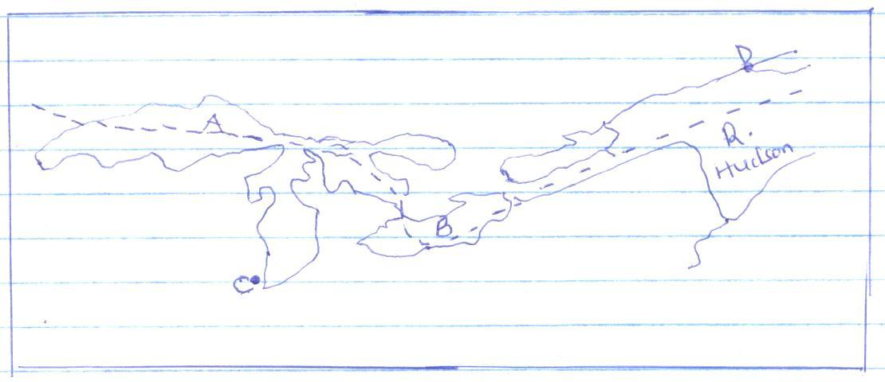

d) i) Name the lakes marked A and B. (2 marks)

ii) The parts marked C and D. (2 marks)

e) Explain **three** benefits of St. Lawrence Seaway and the economy of the USA. (6 marks)

f) Name **two** towns in Kenya which are served by the Kenya pipeline. (2 marks)

g) State the role of transport and communication in Africa. (5 marks)

8. a) Name **three** species of hardwood grown in Kenya. (3 marks)

b) State **five** factors that favour the development of softwood in Kenya. (5 marks)

c) State **five** factors that determine the location of pulp and paper industry. (5 marks)

d) Explain **three** reasons why there has been decline in the areas under forest on the

slopes of Mt. Kenya. (6 marks)

e) Explain **three** measures which the Kenyan government has taken to manage the existing

forests and their resources. (6 marks)

9. a) Define the following terms as used in trade.

1. Quota (2 marks)
2. Balance of payment (2 marks)

b) Explain **four** factors that inhibit trade between Kenya and her neighbours. (8 marks)

c) State **five** problems developing countries face in international trade. (5 marks)

d) Explain **four** measures Kenya has taken to reduce her unfavourable balance of trade. (8 marks)

10 a) Name **two** agricultural non-food processing industries in Kenya. (2 marks)

b) Explain how the following factors influence the location and development of industries.

1. Availability of raw materials (2 marks)
2. Labour (2 marks)
3. Government policy (2 marks)

c) State **four** measures that a government may take to attract industries to an area. (4 marks)

d) Outline any four significances of cottage industries in India. (4 marks)

e) Form IV students of Mwitika Secondary School intends to carry out a field study on an

industry in the local environment.

1. How will they prepare for the study? (2 marks)
2. Give three reasons why it would be necessary to carry out a pre-visit. (3 marks)
3. State four methods they would use to present their data. (4 marks)

**312/2**

**GEOGRAPHY**

**PAPER 2**

**MARKING SCHEME**

**a)** - Beef/meat

* Hides/skin
* Horns
* Hooves

**b)** Industrial zone

Central business District

Residential zone 1x3=3mks

**a)** Winter

Spring wheat

Short season growing strain

**b)**  **-** Extensive flat land for large scale mechanization

* fertile chenozerms soils
* warm summers which dries the crop
* at least 120 frost free days
* light rains that fall during the growing season
* large market both home and abroad
* extensive storage facilities (silos)
* Efficient transport like railways.

**a)** Is a river project designed to serve more than one purpose like Kariba, Seven folks

**b)** **-** Generates Hydro-electric power

* Provides water for irrigation
* Provides fishing grounds
* Provides water for domestic and industrial use
* It is a tourist attraction

**a)** **-** national parks, game reserves and sanctuaries

* varied people’s culture
* historical and pre-historical site
* hot springs, geysers and fumaroles
* mountains, scarps, waterfalls, craters
* lakes, Rift valley scenery

**b)** **-** Biomass is a clean source of energy

* Its cheap since it uses waste products
* Available everywhere in the world
* Its renewable

**5.**

**a)** **Y** –Flouspar

**X** - Copper

**Z**- Diamond

**b) -** Small quantities of mineral deposits

* Inadequate funds to purchase mining equipment
* Poor/low technological know-how
* Remoteness of the areas with mineral deposits
* Poor infrastructures

**6.**

**a) i.**

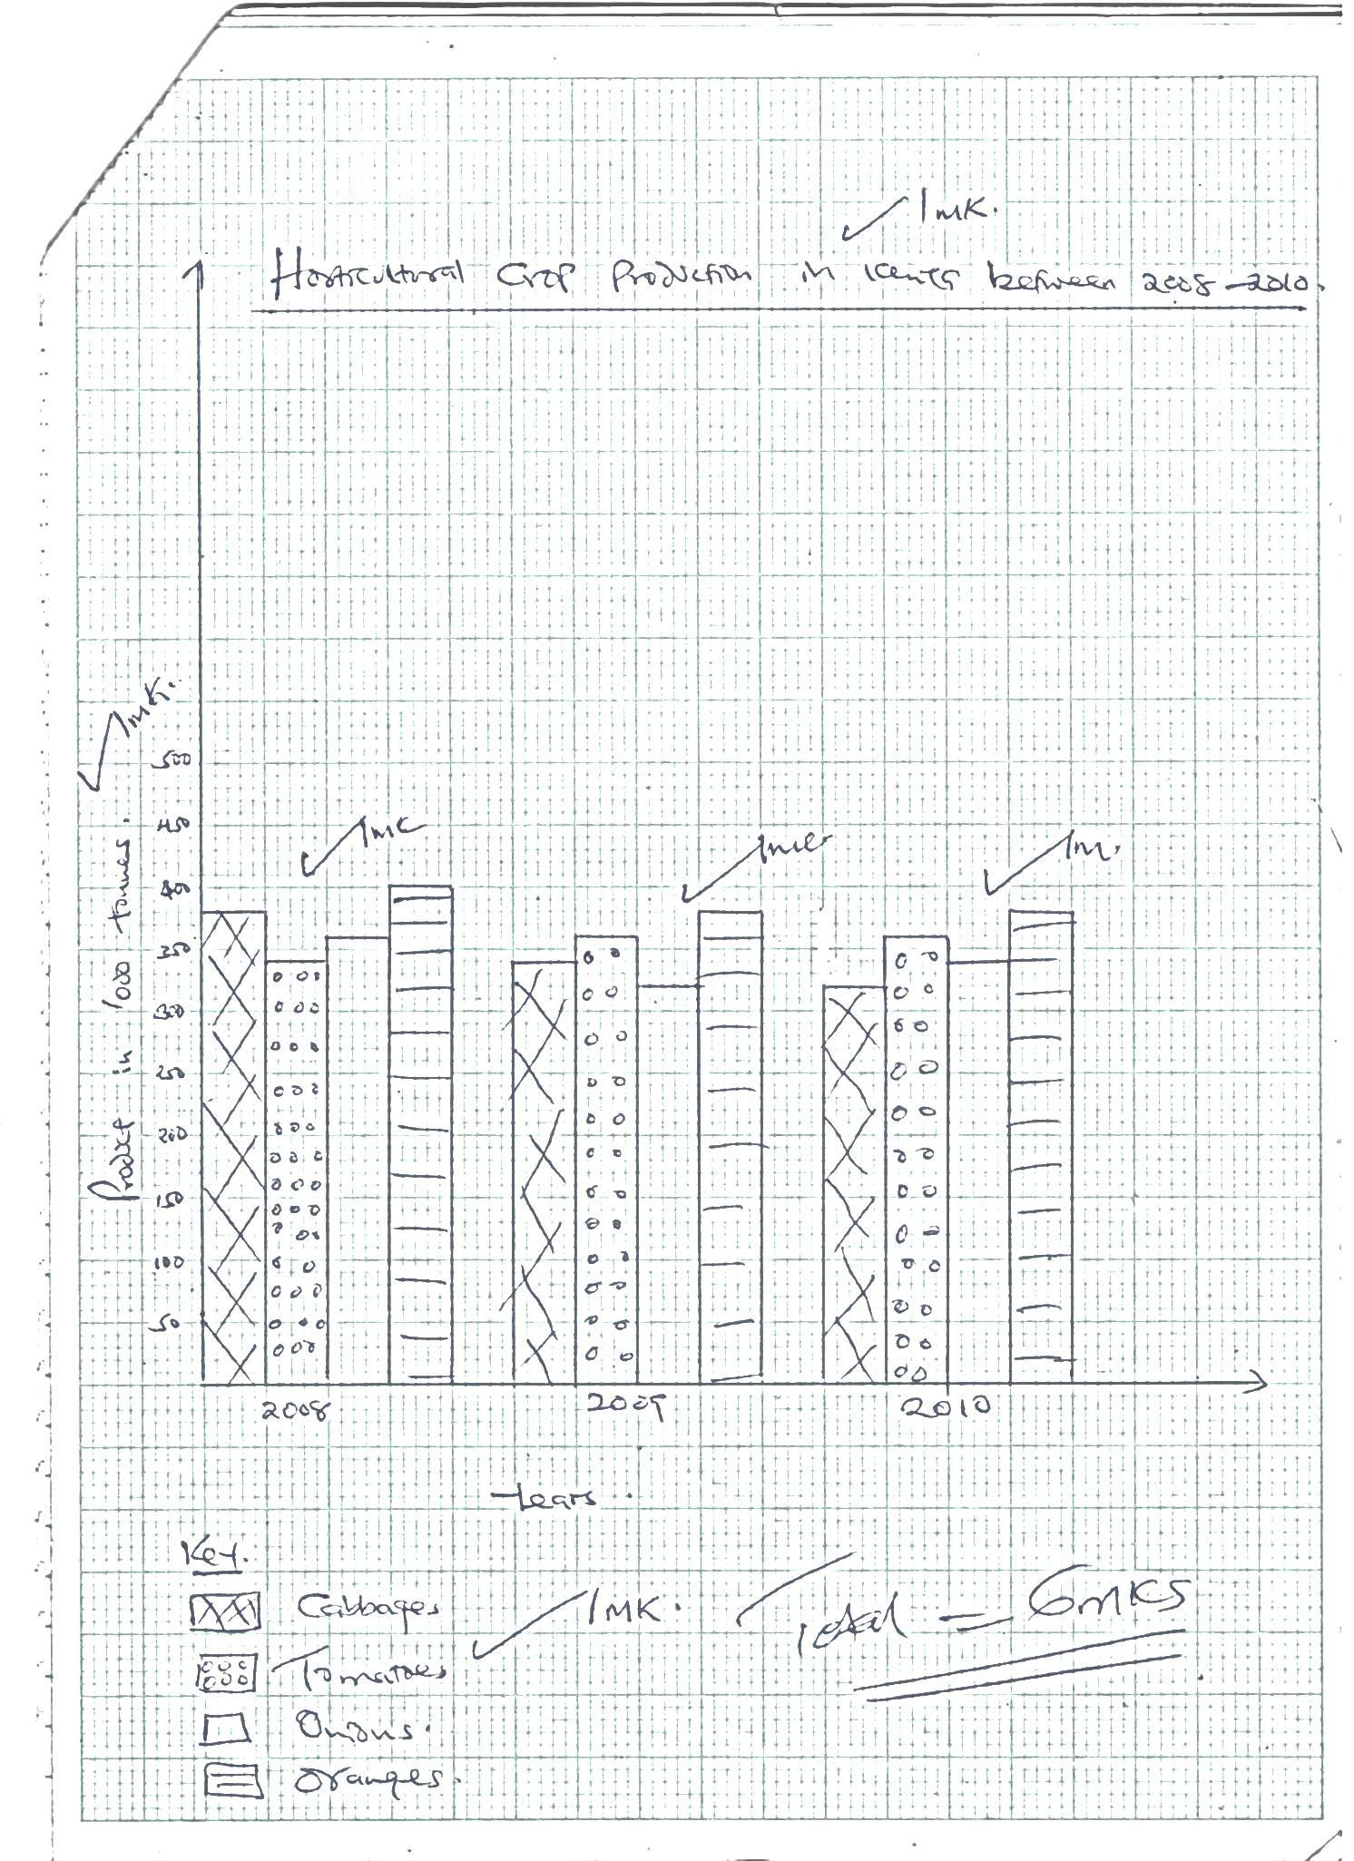

ii. Oranges 1x1=1mk

**b)** **Factors favouring growth of cocoa**

* High temperatures throughout the year with a mean of 210c
* High annual rainfall evenly evenly distributed between 1300-1500mm
* High relative humidity
* Deep well-drained soils rich in iron and potassium/volcanic soils
* Require shelter from strong winds
* Does well in gentle slope below 750m above sea level
* It is labour intensive

**c) Stages involved in processing of cocoa**

* Pods are harvested using long sharp knife
* Pods are split open with a sharp knife and beans are scooped out by hand
* Beans are put in heaps on mats and covered with banana leaves
* Beans are allowed to ferment for 5-6 days during which the juicy pulp drains away
* Fermented beans are washed and cleaned
* Beans are spread on tables covered with mats and turned frequently as they are left to dry under the hot sun.
* Dry beans are put in sacks and sent to the harvest buying centre.
* At the centre the dry beans are weighed and graded ready for export. 8x1=8mks

**d) Importance’s of cocoa to the economy of Ghana**

* Earns the country 60% of its foreign exchange currencies i.e it’s the leading export commodity.
* Revenues obtained has been ploughed back to improve other sectors of the economy such as transport, infrastructure and other social amenities.
* Offers employment opportunities to many people in the fields and in the processing plants.
* Improvement of the living standards of the farmers through the income obtained from the direct sale of the crop. 3x2=6mks

**7.**

**a)** Is the movement of goods and passengers over waterways (2mks)

**b)**

* Most rivers are shallow due to silting rapids
* Rivers have waterfalls and rapids
* Some are short and narrow
* Some have floating vegetation
* Most of them are seasonal with little volume of water
* Most rivers are infested with crocodiles
* Some rivers pass through region of low economics value

**c)** Guards against destruction of goods make loading and offloading easy saves time for loading and unloading containers are sealed at the point of origin minimizing cases of theft.

Increased degree of security and safety makes the cost of insuring containerized goods cheaper.

Specialized containers have been developed for specialized commodities.

**d) i**. **A**– L.Superior

**B** - L. Erie

**ii.** **C** - Chicago

**D** – Quebec

**e)**

* Development of urban centres and ports e.g. Toronto
* Led to production of H.E.P both domestic and industrial
* Provides cheap mode of transport for people and goods.
* Has promoted industrial development by offering cheap transport for raw materials and finished goods.

1. Nairobi Kisumu

Mombasa

1. **Role of transport and communication in Africa**
   * Facilitated the exploitation of natural resources which provide raw materials for industries.
   * Boosted trade through transportation of trade items
   * Expansion and establishment of industries due to availability of raw materials.
   * Enhances labour force and expertise to be imported from any place in the world.
   * Promoted international understanding by encouraging cultural, economic and social interactions
   * Makes provision of essential social services easy and ensures implementation of government policies.
   * Offer employment opportunities to many people
   * Leads to opening up of rural and remote areas hence leading to their development 3x2=6mks

**8.**

**a)** **-** Meru oak

* Mvule
* Muringa
* Elgon teak 3x1=3mks

**b)** **-** Cool climate enabling trees to grow

* Highland receive high amount of rainfall
* Deep well drained soils favour forest growth
* Ruggid highland discourage settlement and agricultural activities leaving forestry as the only alternative.
* Windward slopes of mountain which receive high rains 5x1=5mks

**c)** **-** Availability of water

* Areas with abundant supply of labour
* Areas with Hydro-electric power
* Availability of softwood as raw material
* Adequate funds/capital 5x1=5mks

**d) Reasons why there is decline in the areas under forest on the slopes of Mt. Kenya**

* Forests are being cleared to pave way for human settlement and agriculture
* Over exploitation of forests due to high demand for products such as pulp and paper and timber for furniture making.
* Illegal logging/unlicensed people for charcoal and other timber products
* Forest fires caused by hunters and honey gatherers consume larger hectares of trees.
* Pests and diseases are a major problem affecting forests with exotic trees e.g. Aphids mainly affect cypress trees
* Prolonged droughts have led to the shrinking of forests and retarded the rate of regeneration of forest cover. 3x2=6mks

**e) Measures which the Kenyan government has taken to manage existing forests and their resources**

* Vigorous campaigns against indiscriminate cutting down of trees.
* Creation of forest reserves which protect natural forest from extinction
* Encouragement of afforestation and reafforestation practices
* Establishment of Nyayo tea zones to act as buffers
* Enacting laws which encourage forest dependent industries to establish their own forests or pay levies for forest conservation.
* Educating and encouraging farmers to practice agroforestry
* Employment of forest wardens to protect forests.
* Encouraging participatory of NGO’s in management of forests e.g. UNEP.
* Establishment of the ministry of natural resources and environment which protect forests. 3x2=6mks

**9.**

**a)** **i.** **Quota-** An allocated specific amount of commodity to be imported into or exported out of a country within a given period of time. 1x2=2mks

**ii. Balance of payment**- Difference in value between both the visible and invisible imports and exports of a country 1x2=2mks

**b)**  **-** Most of her neighbours produce similar goods mainly agricultural based or mineral oriented primary products

* Kenya patterns of trade still follows the line of flow established by her former colonizer Britain being mainly a supplier of raw materials, the developing countries provides the manufactured goods that Kenya requires so they can form better trading partners.
* Transport and communication network between Kenya and some of its neighbours is not well developed. This hinders inter-territorial trade
* Some of her neighbours also control trade through allocation of quotas and through tarrifs. 4x2=8mks

**c)** - The prices of the primary products they export are low and unstable

* They face problems of inadequate capital
* They produce almost similar goods and so face a problem of competition and inadequate market
* Political problems between many of these developing countries discourages investors from investing in these countries
* Many of them still maintain historical links with their former colonial masters and following the earlier establishment links.
* Inadequate means of transport and communication also hinders trade
* Most of these countries have a high specialization index in agricultural products which are prone to adverse weather conditions and price instability.
* Political strife common in many of the developing countries of Africa is a major hindrance to international trade. 5x1=5mks

**d)** **-** Government imposes tariffs on imported goods so as to discourage importation of non- essential goods and luxury goods

* Kenya has established the export processing zones and encouraged foreign investors to set-up industries which increases the volume of exports
* She (kenya) signed the international trade government which increases her trade thus a wider market
* The government encourages production of high quality goods which are competitive in the world market.
* The government has created the ministry of trade and industry to oversee matters relating to trade in the country.
* The government organizes trade fairs to enable the business community advertise their products and this helps to widen the markets for the products 4x2=8mks

**10.**

**a)** **-** Sisal processing – leather tanning

* Textile manufacturing –Tobacco processing
* Soap manufacturing –Pyrethrum processing – saw milling 2x1=2mks

**b) i)** Constant supply of raw materials is important in the establishment of any industry.

Industries which use heavy and bulky materials are located near the source of raw materials. Perishable raw materials may also require that industries are located at the source e.g. fishing, milk processing 1x2=2mks

**ii.** Labour- Labour intensive industries are located in areas where there is dense population providing cheap semi-skilled labour while industries that required specialized personnel can import labour. 1x2=2mks

**iii.** Government may encourage decentralization of industries for equitable development in the country. Some industries may be set up in particular places for political reasons. 1x2=2mks

**c)** **-** Provide cheap land

* Improving transport network in the area
* Reduction of tax for industries establishment in that area.
* Provision of water, electricity in the area.
* Industrial planning which identifies that area for industrialization.
* Provision of capital to the potential investors in the area. 4x1=4mks

**d)** **-** Creation of employment

* Utilization of local resources
* Earning of foreign exchange
* Production of relatively cheap goods
* Reduces rural-urban migration 4x1=4mks

**e) i) -** Seek permission from relevant authorities

* Assemble the required tools and equipment
* Grouping of students
* Reading relevant secondary materials 2x1=2mks

1. **-** To get contact with the industry owners and familiarize themselves

* Help identify the methods to be used to collect data
* Enable them prepare working schedule
* Know the routes to be followed
* Identify some possible problems likely to be experienced 3x1=3mks

**iii)**

* Preparing a written report
* Displaying photographs
* Drawing maps
* Tabulation
* Drawing sketches and diagrams. 4x1=4mks