***Kenya Certificate of Secondary Education (K.C.S.E)***

**312/2**

**GEOGRAPHY**

**PAPER 2**

**MARKING SCHEME**

**SECTION A**

**a) Physical conditions for cultivation of sugarcane**

* high temperatures between 21°c – 27°c
* abundant rainfall at least 1270mm or maximum of 2000P.a and well distributed
* deep fertile and well drained soils
* gently sloping land
* dry season for harvesting

(2 x 1 = 2 mks)

**b) Uses of by-products of sugarcane**

* fodders
* manure
* fuel biogas
* molasses for browning

(*Any* 2 x 1 = 2 mks)

**a) What is a cottage industry**

* It’s a small scale industry which uses local raw materials and requires little capital to start and operate **(2mks)**

**b) Reasons the government of Kenya encourages Jua Kali Industries (3mks)**

* it requires little capital investment
* requires no skills or little skills
* Jua Kali industries produce cheap goods
* Jua Kali industries make use of locally available raw materials
* Jua Kali industries create employment opportunities
* It saves on foreign exchange
* It encourages innovations
* Helps to decentralize industries, reducing rural-urban migration

(*Any* 3 x 1 = 3 mks)

**a) Benefits of rapid urbanization experienced in Kenya**

* encourages national unity
* leads to development of roads and communication network
* increases demand for Agricultural products hence expanding agriculture

(3 x 1 = 3 mks)

**b) Functions of Eldoret Town**

* agricultural collection centre
* an industrial centre
* a residential centre
* recreation and cultural centre
* financial and trade centre

(*Any* 3 x 1 = 3 mks)

**a) Oil producing countries in Africa**

* Nigeria
* Algeria
* Libya
* South Africa
* Niger

(*Any* 2 x 1 = 2 mks)

**b) Effects of land dereliction**

* Waste of agricultural land
* Waste of industrial land
* Ugliness / loss of aesthetic (beauty) value
* Health and accidental hazards

(*Any* 3 x 1 = 3 mks)

**a) Indigenous softwood tree species planted in Kenya**

* cedar - cypress
* pine - podo

(2 x 1 = 2 mks)

**b) Characteristics of planted trees**

* trees are grown in rows/lines
* trees are of the same species / pure stands
* trees are of the same size
* no undergrowth
* mostly softwood trees

(*Any* 3 x 1 = 3 mks)

**SECTION B**

**a) i)** Total for 2009 = 50.1

Total for 2010 = 59.41

Total for 2011 = 68.05

Total for 2012 = 76.16

2009 r2 = 50.1

r =

r = 7.078 ✓½

2010 r2 = 59.41

r =

r = 7.078✓½

2011 r2 = 68.05

r =

r = 8.249 ✓½

2012 r2 = 76.16

r =

r = 8.727 ✓½

Scale for radii: 1cm represents 2 units of the square root ✓½

1. radius for 2009: ✓½

= 3.5 cm

1. radius for 2010: ✓½

= 3.9 cm

1. radius for 2011: ✓½

= 4.1 cm

1. radius for 2012: ✓½

= 4.4 cm

**Proportional circles representing coffee export in million tones in three countries** ✓½

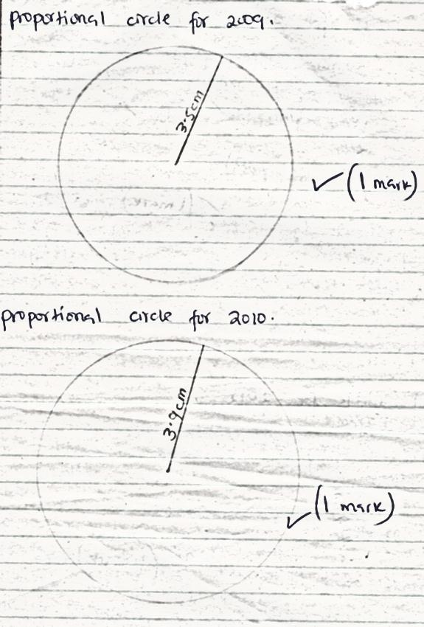

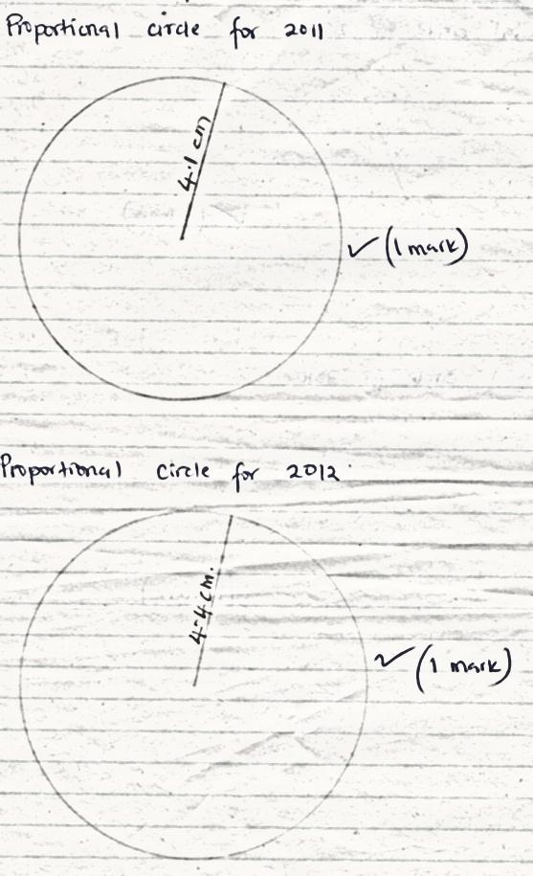

**ii) Advantages of proportional circles**

* Give clear comparison of total value of exports
* They give good visual impression

(*Any* 1 x 1 = 1mk)

**Disadvantage of proportional circles**

* They are tedious and time consuming to construct
* Difficult to establish the actual total values for the period
* Its hard to obtain a suitable scale if the variations in values is too big

(*Any* 1 x 1 = 1mk)

**b) i) Factors inhibiting trade between Kenya and her neighbours**

* Most of her neighbours produce similar goods, mainly agriculture based
* Transport and communication network between Kenya and her neighbours is not well developed
* Some of her neighbours also control trade through allocation of quota and through tariffs
* There is insecurity between Kenya and her neighbours. Some traders are attacked by thugs who steal their goods or take away the money earned.

(*Any* 3 x 2 = 6mks)

**ii) Problems that developing countries face in international trade**

* The price of the primary products they export are low and unstable
* They face a problem of inadequate capital. The value of manufactured goods they import is higher than the value of their export
* They produce almost similar goods hence competition and inadequate market
* Political problems between many of these developing countries discourages investors from investing in these countries inadequate
* Inadequate means of transport also hinder trade
* Most of these countries have a high specialization index in Agricultural products which are affected by adverse weather conditions and price instability
* Political strike common in many of the developing countries of Africa is a major hindrance to international trade.

(*Any* 4 x 1 = 4mks)

**c) Measures Kenya has taken to reduce her unfavourable balance of trade**

* Imposing tariffs on imported goods so as to discourage importation of non-essential and luxury goods
* Kenya has signed international trade agreement on COMESA which will increase her trade
* Kenya has established the export processing Zone (EPZ) and encouraged foreign investors to set up industries.
* The government encourages production of high quality manufactured and agricultural goods for export in order to fetch higher prices and earn higher income
* The government has created the ministry of trade and industry to oversee matters relating to trade in the country
* Encouraging the development of Jua Kali industries which don’t require importation of heavy machinery.

(*Any* 4 x 1 = 4mks)

**a) i) Eco-tourism**

Is an environment friendly tourism whereby a tourist enjoys watching what nature has provided for enjoyment, while at the same time protecting what nature has provided. (2mks)

**ii) Problems experienced by Kenyan government when conserving wildlife**

* Poaching/illegal killing of wildlife reduce their number or may cause extinction of various species
* Insects, pests and diseases cause deterioration of wildlife
* Bush fires started by arsonists burn down the vegetation which is a habitat of the animals. Some animals are forced to migrate to safer areas
* Frequent droughts cause loss of animals through starvations
* Rapid human population growth leads to the encroachment into game parks and reserves
* Inadequate capital limits the government efforts to conserve game parks
* Pollution from the tourists who visit game parks and throw away litter cans, bottles and plastic papers carelessly. Effluents from factories also cause pollution.

(*Any* 4 x 2 = 8mks)

**b) Reason for encouraging domestic tourism in Kenya**

* To utilize facilities such as hotels during low tourist season
* To facilitate interaction between different communities thus enhance national unity
* Enables people to understand and appreciate the need to conserve wildlife
* Enables people to understand features available in the country in order to appreciate them.
* Helps to encourage circulation of money within the country

(*Any* 3 x 2 = 6mks)

**c) Tourist attractions in Kenya inland**

* National parks / game reserves/ sanctuaries
* Landscape of varied landforms
* Historical sites
* Varied culture
* Hot springs, geysers and fumaroles

(*Any* 4 x 1 = 4mks)

**d) Reasons why Switzerland gets more tourists than Kenya**

* Switzerland is located in central Europe thus easy accessibility
* Switzerland is a peaceful country which

encourages tourists

* It has well developed transport network
* In Switzerland the hotel industry is well advanced
* Switzerland has well and more efficient marketing system.

(*Any* 5 x 1 = 5mks)

**a) i) Difference between transport and communication**

* Transport is the activity of moving people and commodities from place to another while communication is the process of relaying information from one person to another.(2mks)

ii) **Advantages of road transport**

* It is cheaper over short-distance
* It is the most flexible- can be constructed to reach the remotest parts
* Faster to use than water and railway
* Easy and relatively cheap to construct and maintain
* Many different types of vehicles can use roads
* Roads can be constructed in stages while they are still being used

(*Any* 4 x 1 = 4mks)

**b) Factors hindering river transport in Africa**

* Many rivers have rapids and waterfalls which hinder the movement of vessels
* Some rivers in Africa have floating vegetation that makes it difficult for vessel to move through them
* Many rivers in Africa are either too short, too shallow or too narrow making navigation on them difficult
* Rivers are also affected by siltation reducing the required depth for vessel to move
* Some of the rivers are infested by crocodiles and hippos that disrupt navigation
* Some of the rivers contain huge rocks and boulders on their beds which disrupt navigation
* Other rivers flow through areas of low economic value like deserts.

(*Any* 4 x 2 = 8mks)

**c) Problems facing communication**

* Inadequate capital to install communication equipments
* Inefficient communication system
* Language barriers due to diverse ethnic backgrounds
* Vandalism/ theft of communication equipments
* Destruction of communication facilities in some African countries due to civil wars

(*Any* 3 x 1 = 3mks)

**d) Why it is difficult to transport goods from Mombasa to Lagos through Trans-African Highway**

* Parts of the highway are impassable during wet seasons
* There is civil wars and banditry in the region
* There are political differences and hostilities between the countries along the highway
* Tariffs charged at borders points increase transportation costs
* Transportation is difficult because of long distance involved and the long time it would take to cover them(*Any* 4 x 2 = 8mks)

**a) i) Census**

Is the physical counting of people living in each household (2mks)

**ii) Primary source of population data**

* sample surveys
* national census
* registration of birth/death/ marriage/ migrations

(*Any* 2 x 1 = 2mks)

**b) Factors contributing to rapid population growth in Kenya**

* early marriages hence long periods before menopause
* polygamous marriages lead to many children
* failure to use birth control measures
* decline in infant mortality due to improved health care
* search for male child
* improved nutritional habits hence increased fertility
* pre-marital sex among the youth/ weakening of traditional moral values

(*Any* 4 x 1 = 4mks)

**c) Positive effects of rapid population growth**

* It leads to high number of human labour force hence cheap labour and reduced cost of production
* Leads to maximum utilization of available resources as all the resources are exploited thus improving the economy of country
* Leads to increased demand for goods and services since high population provides market for locally produced goods hence increased production
* Leads to increase and improved infrastructure as government builds more schools, roads, health facilities etc to cater for the increased population
* Technological/ innovation – population increase forces people to think of ways to cater for themselves out of the limited resources.

(*Any* 3 x 2 = 6mks)

**d) How population in Kenya differs from that of Sweden**

* The population of Kenya has a large number of young people below 20 years while Sweden has an ageing population
* Kenya population has a lower life expectancy while Sweden has a high life expectancy
* In Kenya birth-rate is high while in Sweden is low
* The fertility rate in Kenya is high while in Sweden is low
* The death rate of Kenya is high while in Sweden is low
* A high percentage of Kenyan population lives in rural areas whereas in Sweden more people live in urban centres.

(*Any* 3 x 2 = 6mks)

**e) i) Preparations student made for the study**

* Conducting a pre-visit to the area of study
* Seeking permission from relevant authorities
* Gather relevant equipment for the study
* Prepare a work schedule
* Hold discussions in class about the study

(3 x 1 = 3mks)

**ii) Methods they would use to record information**

* Taking notes
* Tape recording
* Take photographs
* Tabulating the findings

(2 x 1 = 2mks)

a) i) **A forest** – is a continuous and extensive land covered with a closed stand of tall trees, usually of commercial vales (1mk)

ii) **Forestry** – Is the science of developing or cultivating forests (1mk)

**b) i) Indigenous hardwood trees species in Kenya**

* Meru oak
* Elgon Olive
* Elgon Teak
* Campher
* Mvuli
* Mangrove

(3 x 1 = 3mks)

**ii) Conditions that favour growth of forests**

* High rainfall that is well distributed throughout the year
* Fertile, deep and well drained soils
* High temperature throughout the year
* Absence of pests and diseases that may affect growth
* Less or no interference of trees by man

(4 x 1 = 4mks)

**c) i) Factors favouring development of softwood forests in Canada**

* The ruggedness of the landscape and thin soils don’t favour agriculture therefore most of the mountain slopes are under forests
* Low temperatures experienced discourage settlement and other forms of land use leaving forestry as the alternative
* High precipitation throughout the year has promoted forest growth
* Canada has a low population density, so there is more land available for forestry
* There is ready market in Canada and the neighbouring U.S.A for the forest product

(4 x 2 = 8mks)

**d) i) Activities engaged in during collection of data**

* Observation
* Interviewing forest officers
* Taking photographs
* Administering questionnaires

(3 x 1 = 3mks)

**ii) Follow up activities (3mks**)

* Discussing the findings with other students
* Interpreting and analysing the information collected
* Re-labeling samples with clean labels
* Writing the report
* Developing photographs

(3 x 1 = 3mks)

**iii) Problems students were likely to encounter**

* Attack from wild-animals like snakes
* Impassable paths within the forests
* Adverse weather e.g. heavy rain
* Lack of resource persons to help with identification of some tree-species.

(2 x 1 = 2mks)