***Kenya Certificate of Secondary Education (K.C.S.E)***

**312/2**

**GEOGRAPHY**

**PAPER 2**

**MARKING SCHEME**

**SECTION A**

**a) Reasons why Northern Kenya is sparsely population**

* Low rainfall/ its dry
* Thin/poor soils unsuitable for agriculture
* Scanty vegetation to support livestock
* Inadequate surface water supply
* Rugged terrain unsuitable for settlement
* Insecurity
* Inaccessibility/remoteness (*Any* 3x1=3mks)

**b) Types of information obtainable from population pyramid**

* Size of population
* Population by age
* Composition by sex
* Dependent ratio
* Sex ratio/ proportion of male to female
* Different age cohorts/ age groups (*Any* 2x1=2mks)

a**) Reasons why paper milling industries are located near rivers**

* The industries need large amount of water for cleaning
* The industries uses water for cooling machines
* The industries dispose off their waste material through water
* Water provide a cheap means of transport
* Some industries are located near large rivers that they may provide H.E.P.
* Water is used as a raw material
* Some industries use water to the bank the logs (*Any* 2x1=2mks)

**b) Industries that use agricultural non-food products as raw materials**

* Tobacco processing
* Paper Making
* Pyrethrum processing
* Clue making industry
* Textile industry/ plant fibre processing.
* foot wear making
* Saw milling
* Rubber based industries
* Leather tanning
* Non-edible oil processing (*Any* 2x1=2mks)

**a) Ports through which minerals are exported in E. Africa**

* Mombasa
* Dar-es-salaam (*Any* 2x1=2mks)

b) **Ways of reclaiming derelict land**

* Planting of trees
* Creating a park to attract tourists
* Introducing aquaculture
* Refilling the holes
* Landscaping for settlement or farming (*Any* 3x1=3mks)

**a) What is biogas?**

Biogas is a combustible gas comprising of methane and carbon dioxide gas which is generated by fermentation of biomass (1x2=2mks)

**b) State three advantages of Uranium as a source of energy**

* generates large amount of energy/ has high calorific value
* the power is free from pollution
* it is a reliable source of energy due to its long lasting supply. (3x1=3mks)

**a) Cattle breeds kept by nomadic pastoralists**

* Boran
* Zebu (*Any* 2x1=2mks)

b) **Why nomadic pastoralists keep large herds of animals**

* Animals are kept as a sign of wealth prestige/ social status
* For Use to pay dowry
* Source of food – milk/ meat/ blood
* Source of income when sold
* Form of insurance against natural calamities / diseases/drought. (*Any* 3x1=3mks)

**a) Comparative bar graph representing Kenya’s imports and export in tones in 1987** ✓1

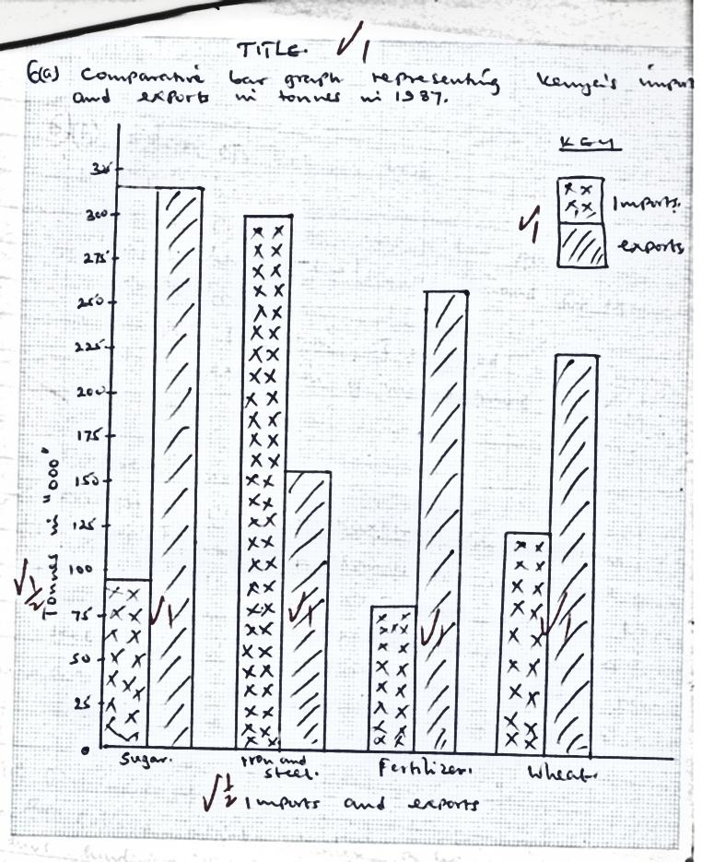

Total 8 marks

**b) Effects on external trade**

1. **population**

* Kenya’s population has a low purchasing power/inadequate capital hence a low/limited demand for external goods which limits trade.
* Kenyan’s population is engaged in primary production hence exportation of manufactured goods is limited (*Any* 2x1=2mks)

1. **Foreign investment**

* Foreign companies/ multinational companies have huge capital to exploit natural resources to manufacture goods. The goods are then exported hence promote external trade
* Foreign companies/ multinational companies use advanced technology in the exploitation of natural resources which are used as a raw material to manufacture good for external trade

(*Any* 2x1=2mks)

1. **Government policy**

* The policies might involve a ban on exportation of goods thus hindering the external trade since no type of restricted/banned goods are exported
* The government reduce duty on important raw materials to manufacture goods for export e.g. E.P.Z (*Any* 2x1=2mks)

**c) Measures to reduce unfavourable balance of trade**

* Developing other sources of energy to reduce importation of fuels
* Establishment of import substitution industries to reduce import of commodities
* Encourage use of local technology e.g. Jua Kali which does not require import of heavy machinery
* Restrict imports of luxury items through taxation
* Encourage the assembly of machine locally since import of parts is cheaper
* Encourage the exportation of locally manufactured goods
* Increase invisible trade e.g. tourism insurance banking etc.

(*Any* 3 x 2 = 6 marks)

**d) Ways in which Kenya would benefit from renewed East Africa co-operations**

* Improved transport and communication skills between Kenya and other member states facilitate faster movement of goods and passenger
* Kenya’s volume of trade will increase because of the expanded trading area.
* Easy movement of people across the borders enables more tourists to visit Kenya.
* Expanded market will attract more foreign investors hence promote industrialization
* There will be creation of many employment opportunities
* Exportation of goods will increase earning from foreign exchange
* There will be exchange of research findings/ training which will help in economic development
* There will be mutual political understanding between Kenya and her neighbours.
* There will be improved negotiating powers in the international arena

(*Any* 5x1=5mks)

**a) i) Containerization**

* is the use of large rectangular metal boxes to carry cargo (2mks)

**ii) Benefits of Kenya from international airports**

* Encourages growth of tourism industry to resort centres parks and reserves
* Promotes horticultural sector because the product are perishable and needs to be transported very fast
* Promotes international trade
* Promotes international co-operation with over- seas countries
* It earns foreign exchange from tourism and landing fee fuel
* Facilitates emergency service in case of disaster terrorist attacks
* Creates employment opportunities e.g. Pilots, cabin crew etc
* Promotes exchange of ideas and information within a short time. (*Any* 3x2=6mks)

**b) i) efforts to improve communication**

* Liberalization of postal services e.g. courier G4S security etc
* Liberalization of many radio and TV stations e.g. Royal media, standards group, Nation Media Group Etc
* Introduction of mobile phones e.g. Safaricom, Airtel, Orange, YU etc
* Liberalization of press-there is more freedom of press
* Expansion of telephone facilities (Telcom Kenya, Optic Fibre, Seacom) (*Any* 2x2=4mks)

**ii) Problems associated with internet**

-Addictive

* It does not limit dessimination of information according to age
* Some people are not computer literate so they are unable to use the service
* The use of the service is quite expensive curtailing those who have inadequate money
* It is mainly found in urban areas discriminating those in rural areas
* Sometimes the service gets jammed up leading to failure or very low speed
* The services are sometimes unreliable or unavailable.

(*Any* 4x1=4mks)

**c) i) Advantages of using pipeline**

* Constant supply since the flow is continuous
* Reliable and convenient especially for oil which is highly unflamable
* Low operating costs
* Complements oil transportation using tankers
* Free of pollution
* Flexibility
* No congestion (*Any* 3x1=3mks)

**ii) Problems posed by relief and drainage in construction of transport network**

* Steep slopes cause transport lines to follow long routes since cutting through steep gradient is expensive
* Succession of plateau levels creates problems of building roads and railway from one level to the next.
* Flat low lying desert lands encourage formation of sand dunes which cover transport lines.
* Steep cliffs bordering the sea make it difficult to construct harbours
* Coral reefs and sand bars make it difficult to construct harbours

(*Any* 3x1=3mks)

**Drainage**

* Marshy/ swampy areas have to be filled in or drained to obtain a hard surface
* Too many rivers make construction of transport lines expensive because of the many bridges
* Some river mouths are narrow and shallow making them unfit for habour construction
* Steep river gradient/ meanders make some sections of river unnavigable

(*Any* 3x1=3mks)

**a) Physical conditions favouring sugarcane farming**

* well drained fertile soils / black cotton soils
* gently sloping undulating landscapes
* high rainfall / 1000-1500 mm well distributed throughout the year
* moderate to high temperature of between 20oc – 28oc
* long period of sunlight

(*Any* 3x1=3mks)

**b) Cultivation of sugarcane to harvesting**

* The land is cleared from its natural vegetation
* It is ploughed using tractors
* Harrowing is done to loosen the large lumps of soils
* Shallow furrows are dug at intervals of 1.2m to 1.8m apart
* Cutting seed canes are planted in furrows. Top dressing/nitrogen fertilizers are applied
* Weeding is done regularly
* After 18 months cane is ready for harvesting
* The cane is harvested using pangas
* The harvested cane is loaded into lorries for transportation

(*Any* 6x1=6mks)

**c) Problems facing sugarcane farming in Kenya**

* Accidental fires destroy cane resulting to heavy loses to farmers
* Flooding of market by cheap imported sugar results to unfair competition causing delayed payments
* delays in harvesting reduces quality and tonnage of the cane reducing farmers earning
* Clossure of some factories has deprived farmers a source of income
* poor roads in some areas leads to delayed delivery thus lowering the quality
* high cost of farm inputs reduces the farmers profit margin
* mismanagement of factories and cooperatives leads to delayed payments thus discouraging the farmers (*Any* 5x2=10mks)

**d) i) Stages of sugar processing –**

* Weighing of the cane
* Chopping of the cane
* Boiling
* Bleaching
* Crushing
* Drying
* Packing
* Clarifying
* Filtering
* Grading (*Any* 4x1=4mks)

**ii) By-product of sugarcane they identified**

* Molasses
* Bagasse
* Wax
* Filter cake/filter mud
* Aconitic acid (*Any* 2x1=2mks)

**a) i) eco-tourism**

Eco-tourism refers to tourism which emphasis on the conservation of the environment by tourists and local community while enjoying the benefits of it at the same time

(1x2=2mks)

**ii) Why the government encourages domestic tourism**

* to make citizens aware of their environment
* for people to be able to appreciate their cultural heritage
* citizens make sure use of tourists hotels during the low season
* to enhance national unity through the interaction of different communities
* to increase money in circulation in country
* it may enhance the need to preserve the environment

(*Any* 5 x 1 = 5marks)

**b) Suitability of following factors to wildlife**

**i) Forest**

* they are major sources of rivers, water for game
* they offer good habitat and food for wild animals
* high rainfall leads to Forest growth e.g. Aberdares, Mt. Kenya

**ii) Savanna woodland /grass land**

* has the greatest concentration of game since they are open and good hunting ground
* has a lot of grass for herbivorous animals e.g buffaloes
* birds are also common since there are pests and other insects to prey on.

**c)**

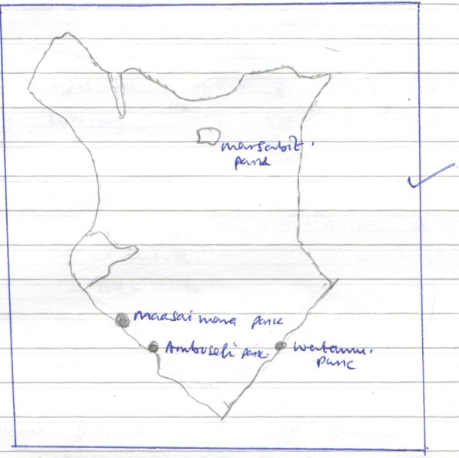

Margin (1mk)

*Locating each* (1 mk)

*Total* (4 mks)

**d) Explain negative implications of tourism**

* moral decay among the youth e.g. prostitution, school dropouts, drug abuse
* animals destroy crops and prey on animals
* spread of animals diseases to livestock
* expatriates may be employed leading to taking money abroad
* Government may invest heavily on improvement of infrastructure at the expense of other sectors. (*Any* 3x2=6mks)

**e) Compare tourism in Kenya and Switzerland under following**

**i) Coastal beaches**

Kenya has coastal beaches while Switzerland has lake beaches

(1x2=2mks)

**ii) Relief**

* Kenya has magnificent Rift Valley and snowcapped mountains while Switzerland has glaciated sceneries (1x2=2mks)

**a) i) A forest**

* A forest refers to a group of trees growing together and usually covering a large tract of land. (1x2=2mks)

**ii) Factors influencing the distribution of natural forests**

* climate
* altitude
* soils
* topography
* human activities (2x1=2mks)

**b) i) Problems facing forestry in Kenya**

* illegal cutting down of trees
* prolonged droughts leading to drying of trees
* over exploitation of forest
* rapid population increase which has led to people encroaching on forest land
* frequent advances of forest fires which destroy large part of forest
* pest and diseases which destroy trees
* poor forest management practices e.g poor harvesting techniques
* degazettment of forests by the government has led to reduction of forest cover

(*Any* 3x1=3mks)

**ii) Efforts by Kenyan government to manage and conserve forest**

* people are being encouraged to establish tree nurseries from where seedlings can be gotten for plating
* Certain forests have been gazetted as forest reserves in order to protect them’.
* Forest guards have been employed to guard forest from destruction
* Various afforestation and re-afforestation programmes have been started.
* Cutting practices are being improved through rotational felling of trees.
* The public is being educated on the importance of forests through the mass media.
* Research is being carried out to establish the suitability of soil and the effects of pests and diseases on forests
* Laws have been enacted to govern management of forests
* The practice of agro-forestry is being encouraged.
* Forests processing industries are being encouraged to reduce waste through recycling the wastes (*Any* 4x2=8mks)

**c) i) Characteristics of coniferous forests**

* The trees are light in weight
* The trees are tall
* The tree occur in pure stands
* The trees are evergreen
* The trees have a conical shape
* The trees have thick barks
* The trees have hard needle shaped leaves which help reduce evapotranspiration during summer. (*Any* 3x1=3mks)

**ii) Species of trees in tropical hard wood forests**

* Mahogany
* Iroko
* Sapele
* Meru oak
* Iron wood
* Rose wood
* Ebony
* Elgon olive (2x1=2mks)

**d) Importance of forests and forests products**

* Forest provide habitat for wild animals
* Forests are water catchment areas
* Trees are sold to earn income
* Trees are a raw material for industries e.g. paper industries
* Forests provide firewood and charcoal
* Some trees species from forests provide fodder
* Forests aid in the regulation of climate
* Forests are genetic store houses
* Forests serve as education and research centres
* Forests provide fruits and dyes
* They provide wood that is used in the building industry.

(Any 4 x 1 = 4 marks)