**GEOGRAPHY P2**

**MARKING SCHEME**

1. a) **Name two tree species of high commercial value in a coniferous forest. (2mks)**

* pine
* spruce
* Fir

**(any 2x1 = mks)**

**b) State three characteristics of Tropical hardwood forests which hinder exploitation**

* Trees are closely set / packed making it difficult to cut and penetrate into the forest
* -Trees have large massive/heavy trunks which make it hard to cut and haul
* Different / many species within a unit area
* trees take long to mature ( 65 – 100 years )
* large buttress roots make it difficult to cut the trees

(**any 3x1 = (3mks)**

1. **State two factors that influence exploitation of minerals**

* Quality of the ore
* Size of the mineral deposit
* Value of the mineral
* Transport costs
* Availability of capital
* Availability of skilled personnel labour
* Demand for the mineral
* Political influence / climate
* Methods of extraction
* Level of technology

Any 2x1 = (2mks)

**b) Describe how soda ash is extracted from Lake Magadi**

* Mined using a **bucket√ dredger** floating on the lake water.
* Dredger **digs√ out** trona from the lake bed upto 3m deep.
* Inside the dredger trona is **crushed√ into smaller pieces** and **mixed√ with** solution from the lake called Lake liquor.
* The trona and the solution is pumped into the factory through a pipeline for processing

(**max 3mks)**

1. **a) i) Distinguish between population distribution and population density**

– Population distribution refers to the way people are spread out on the land while population density is the average√√ number of persons per square kilometers.

**(1mk) marks as a whole**

**ii)What is dependency ratio?**

This is the proportion of the population that is not involved in productive activities to t he one that is OR

The ratio of the population that is dependent on the population that is working

**(1mk)**

**b) state three reasons for reduced fertility rate in Kenya**

* Late marriages / more girls attending school
* Modern career opportunities limit fertility rate / maternity leaves.
* Use of birth control measures lowering number of children a woman get.
* Urbanization leading to people opting to smaller families.
* Increase in the number of women opting to remain single. **( Max 3 mks )**

**4. a) Name two dairy cattle breeds reared in Kenya**

- Ashyire

- Guernsey

- Jersey

- Friesian

- Sahiwal **(2x1 = 2 mks)**

**b) State three differences between beef farming in Argentina and Kenya.**

|  |  |
| --- | --- |
| **Argentina** | **Kenya** |
| * Has more beef processing plants | * Has few processing plants |
| * Beef products are exported | * None of the beef products is exported / most consumed locally |
| * Animals have enough pasture | * Pasture may be scarce in the dry season |
| * Animals mainly transported by rail | * Animals mainly transported by road |
| * Exotic breeds mainly reared | * Both exotic and locally indigenous breeds are reared |
| * Corn is used to fatten the beef cattle | * Animals mainly rely on natural pastures |

**Any 3 complete comparison x 1 = 3mks**

**5.a) Give two advantages of wood as a source of fuel**

* available nearly throughout the world
* there are no maintenance costs
* -cheap source of energy
* -ashes can be used for other purposes e.g plastering traditional houses

**Any 2x1 = 2mks)**

**b) State three conditions necessary for the formation of oil**

* -presence of sedimentary rocks
* -Presence of organic remains fossils
* presence of non-porous rocks overlying the porous rocks
* presence of porous rocks to trap the oil
* presence of pressure to compress the organic matter  **(Any 3x1 = 3mks)**

6.a. i)

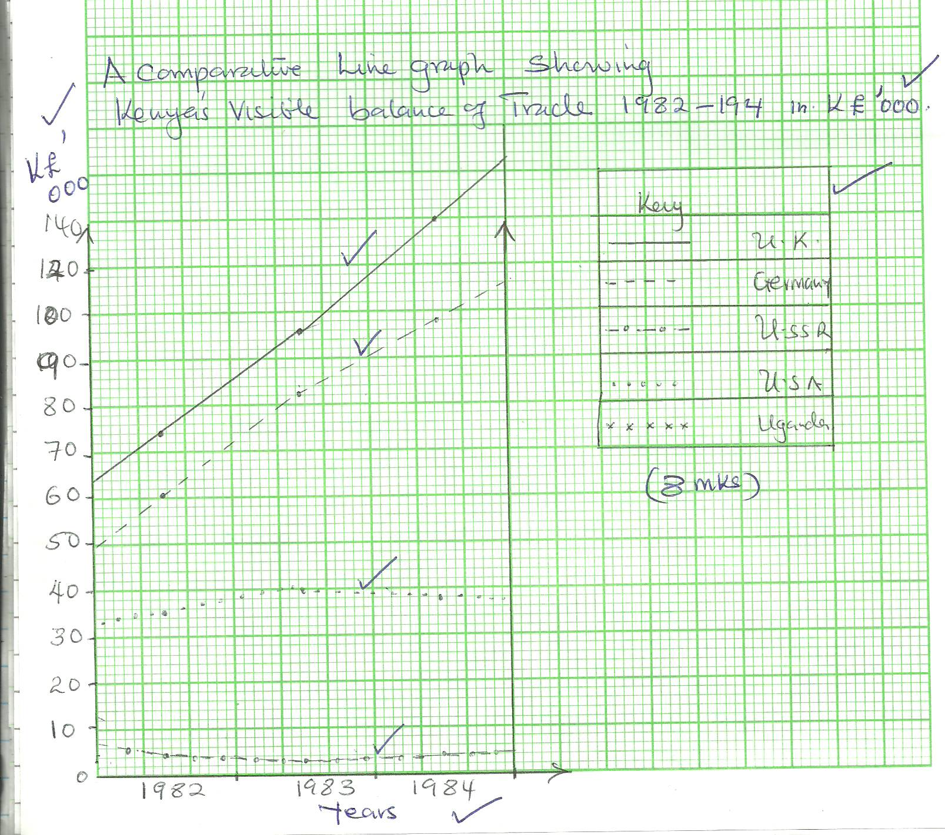

**ii) plotting small values is difficult where the range is large**

- The total amount of each variable in the group cannot be known at a glance

- Locating the position for the point is difficult (3mks)

**b. i) Balance of trade is the difference in value between the visible imports and visible exports of a county. (2mks)**

ii) Calculating the balance of trade. (2mks)

Exports 347,000

Imports 400,300

* + 53,300
  + 53,300,000

c. i) **Major imports** : - Motor Vehicles

- Machinery

- Electronics

- Petroleum

**Major exports:**

* Horticulture
* Tea/coffee
* Soda ash / fluorspar/ cement

**i) Kenya has an unfavourable balance of trade.**

-Kenya exports mainly agricultural raw materials which are of law value and imports manufactured goods which are of high value.

- The agricultural raw materials face not only stiff competition from other counties / but also the quota system in the world market which leads to reduced sales and less earnings.

-The minerals and other goods such as curio are of low quality hence generate little earnings.

**d) Measures to achieve a favourable balance of trade**

* Development of other sources of energy to reduce on the importation of fuels
* Establishment of import – substitute industries to reduce imports of commodities
* Restriction on importation of luxury items through high taxation to save the county foreign exchange
* Diversifying agro-exports such as horticulture that has a large market and earns more
* Increasing invisible exports such as tourism, shipping and insurance that is not vulnerable to weather adversities.

**7. a) i)Wheat growing areas in Canada**

- Alberta; Saskatchewan; Mamtoba

**ii) Physical factors – Kenya**

- Gently sloping/fairly level – allows proper drainage and mechanization

- Volcanic soils which are well drained – provide proper anchorage for wheat stalks

- Moderate r/fall – between 305mm – 1015mm sufficient for growing wheat

- Warm dry sunny spell which enhances ripening and harvesting of wheat

- Warm temperatures ranging from 15oC to 20oC – this facilitates maturity of wheat (for at least 3 months)

- High altitudes of 1500 mm – 2900 mm

**b) i) Comparison Wheat Kenya Vs Canada.**

- Cultivation – small scale farmers doing it manually / mechanized while in Canada all the work is mechanized.

- Kenya small scale Canada large scale.

ii) Harvesting – in Kenya both manual (small farmers) and mechanized while in Canada all work mechanized.

iii) Marketing – in Kenya all the wheat is consumed locally while in Canada – consumed locally and the bulk exported.

**b. i) Human and economic problems in Canada.**

- Monoculture has led to soil exhaustion – low yields

- Over production of wheat – too much surplus and low income.

- Fluctuation of market prices, affects the farmers income and it makes it difficult to plan ahead.

**c. i) Human / economic problems in Canada**

- Fluctuation of market prices for wheat exports affects the farmers income and makes it difficult to plan ahead.

- Overproduction of wheat

- Monoculture has led to soil exhaustion, resulting in low yields

**8. a i) Countries found in NW pacific fishing ground**

- Japan - Malaysia

- China - Indonesia

ii) **Explain four physical factors that favour fishing in the above fishing ground.**

* Numerous Islands provide good breeding ground for fish hence fishing.
* Extensive continental shelf are shallow providing light for the growth of Plankton which food for fish.
* Cool temperature arising from the meeting of cold Kamchatka and the warm Kurosiwo providing conditions for Plankton survival.
* Japan is generally mountainous which does not favour Agriculture making fishing the only economic activity. **(4x2 = 8 mks)**

**b) Describe the following methods of fishing**

**i) Drifting** **(4mks)**

- The net is vertically hanging in water

- They are fitted with floats on the upper edge and weights below and placed a few meters below the water and pulled by powerful boats called drifters

* When fish swim into the net they are entangled by their gills and cannot get out of the net.
* Once enough fish are caught the net is hauled onto the boat and fish is removed.

**Any 4 x 1 = ( 4mks)**

1. **Purse seine ( 4mks)**

* The purse seine net is laid in a circle to enclose a school of fish.
* At the bottom of the net are rings through which passes a rope
* One end of the rope is attached to a boat and the other part is pulled by another boat around a school as fish.
* When the circle is completed the rope is pulled to close the net forming a bow- like shape hence trapping fish.
* The net is them hauled to the shore and fish is removed.

**4 x 1 == ( 4mks)**

C. Compare fishing in Kenya and Japan under the following sub-headings:

**i) Fishing ground.**  **(2mks)**

- Japan main fishing ground is marine while Kenya’s is mainly mainland.√√

**ii) Climate.**  (2mks)

Kenya’s climate is warm discouraging growth of planktons and variety of fish species therefore fishing is not elaborate while Japan’s climate is cool favouring Planktons hence intensive fishing.√√

**d. State 3 significance of fishing to the economy of Kenya. (3mks)**

- Export of fish earn foreign exchange used to develop the economy.√

- Fish creates employment opportunities which earns income that improves their standard of living.

- Fishing wastes produce raw materials to produce Lubricants, fertilizer and cosmetics.

-Fishing is a source of government revenue through taxation which is invested in other sectors.

- Fishing is a sport that attracts tourists thus generate foreign exchange for the country.

- Fishing stimulates and promote establishment of industries e.g ship building repair and net making. **Any 3 x 1 ( 3mks)**