*312/2 GEOGRAPHY PAPER 2 MARKING SCHEME*

**1. a) State two ways in which minerals occur.** **(2 marks)**

* Minerals may occur in beds and seams
* Minerals may occur as weathered products
* Minerals may occur in alluvial or placer deposits
* Minerals may occur in veins and lodes
* Minerals may occur as evaporates **(Any2 x 1 = 2mks)**

**b) Describe panning as a method of mining.** **(3 marks)**

* The method involves digging out the sand/gravel which contains mineral particles and mixed with water from the river in a shallow pan. The mixture is then whirled such that the lighter particles of sand/gravel are pushed on the sides of the pass white the heavier mineral particles are at the bottom of the pan which are easily removal by hand as the waited mineral.

**2. (a) Name two indigenous softwood tree species found in Kenya. (2 marks)**

* + - African pencil/cedar/juniper
    - Podo **(Any 2 x 1 =2mks)**

**(b) State three factors that favour the development of softwood forests in Canada. (3 marks)**

* Cool/cold climate suitable coniferous forest.
* High rainfall/1,000 to 2,000mm.
* Thin permafrost soil spares the land for the forest.
* Rugged and steep landscape is suitable for growth of coniferous forest/discourage agriculture.
* High local and international demand for softwood products.
* Availability of land due to low population density. **(Any 3 x 1 = 3mks)**

**3. a) Define international trade. (2 marks)**

International trade is the exchange of goods and services between different countries **(2mks)**

**b) Name three major imports from Europe to Kenya. (3 marks)**

-Machinery

-Capital equipment

-Pharmaceutical products/ medicine

-Fertilizers

-Automobiles **(Any 3 x 1 = 3mks)**

**4. a) Define eco-tourism. (2marks)**

Eco-tourism refers to visiting places of interest for recreational purposes while taking care of animals and plants and their habitats. **(2mks)**

**b) Three factors which have made Switzerland a major tourist destination.**

* Warm sunny summers allow for swimming and sun-bathing/cold winters encourage winter sports.
* Varied scenery.
* Central position of Switzerland within Europe.
* Political neutrality of Switzerland.
* Diversity of languages spoken in Switzerland.
* Developed transport network to tourist sites.
* Advanced training in the tourist industry/package tours.
* Availability of health resorts/spas.
* Inherent hospitality of the Swiss.
* Developed financial institutions for easy transactions.
* Switzerland is the headquarters for some international agencies. **(Any 3 x 1 = 3mks)**

**5. Factors influencing nucleated settlement pattern.**

* Farming – irrigation farming e.g. MweaTebere.
* Limitations of site, lack of space for expansion.
* Presence of water sources e.g. Oasis in desert.
* Exploitation of natural resources e.g. mining.
* A prime area for defence / cluster together for strength.
* Government policy – settlement schemes.
* Ownership of land in small plots.
* Presence of an industrial plan.
* Security leading to cluster in a more secure area. **(5 x 1 = (5mks)**

**6. Study the photograph below and use it to answer question (a)**

**(a)(i) Name the type of photograph shown above (1 mark)**

-Ground general view

**(ii) What time of the day was the photograph taken if the camera was held facing south? (1 mark)**

-Evening

**(iii) Draw a rectangle measuring 16cm by 9cm to represent the area of the photograph. On it sketch and label the main features shown on the photograph. (5 marks)**

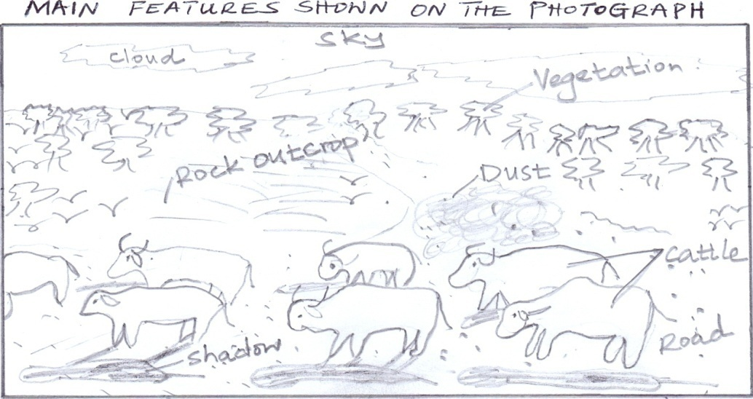

**(iv) Describe the landscape of the area represented by the photograph. (3 marks)** -The land rises from the foreground towards the background

-The area covered with vegetation is slightly raised.

-The area in the background has bare rock surfaces/rock outcrops.

-The area in the foreground is gently sloping.

**b)i) Identify two counties in the Rift Valley where ranching is practiced. (2 marks)**

-Kajiado

-Laikipia

-Nakuru

**ii) Name one exotic breed of beef cattle reared in Kenya (1 mark)**

-Aberdeen Angus

-Hereford

-Galloway

-Charoleus

-Shorthorn

-Sahiwal

**c) State four physical factors which favour beef farming in Argentina. (4 marks)**

-Availability of water for cattle supplied using wind pumps

-Warm and wet climate/maritime climate make it possible for grazing throughout the year.

-Gently sloping landscape for easy movement of animals

-Moderate temperatures /10 - 24°C/ cool winters and warm summers ensure continuous growth of pasture.

-Fertile loose soils support growth of pasture.

**d) Explain four benefits of beef farming to the economy of Argentina. (8 marks)**

-Beef is exported to earn foreign exchange which is used to develop other sectors of the economy.

-Beef farming has led to growth of towns e.g. Buenos Aires leading to urbanization in the country.

-Beef farming has resulted in development of roads/railway lines thus increase accessibility.

-Beef farming is a source of income to farmers which has improved their living standards.

-Beef farming provides raw materials used in industries thus promoting industrialization.

-Beef farming increases employment opportunities hence improve the living standards of citizens.

**7. (a) State two advantages of written communication. (2 marks)**

-Effective in disseminating information.

-For marketing/advertisement.

-For entertainment.

-To educate citizens on government policies.

-For certification/reference.

-Can be used as official document.

**(b) Use the outline map of East Africa provided to answer questions (i) and (ii).**

**(i) Name the towns marked W and X. (2 marks)**

W-Nanyuki

X-Kasese

**(ii) Name the railway lines marked Y and Z. (2 marks)**

Y-Konza *–* Magadi

Z-Kisumu *–* Butere

**I(i) State *two* ways in which Kenya would benefit from the construction of the Standard gauge railway. (2 marks)** -Employment

-Faster mode of transport.

-Efficient transport.

-Increase trade between East African countries.

-Handle bulky goods with ease.

-Development of towns/port

**(ii) Explain three factors that hinder development of River transport in Africa. (6 marks)**

-Seasonality of many rivers i.e. fluctuating river regime.

-Presence of rapids and waterfalls along the course of the river.

-Many rivers are either too short, shallow and too swift/narrow.

-Siltation at the river mouths hinders port development.

-Most rivers pass through unproductive areas hence it’suneconomical to develop river transport.

-Presence of floating vegetation and dense vegetation along the river banks making it impossible to navigate through.

-Differences in political ideologies of countries through which rivers pass which calls for negotiations.

**(d) The map below shows the Great Lakes and St. Lawrence Seaway. Use it to answer question (i) and (ii).**

**(i) Name the canals marked J and K. (2 marks)**

E-Trent canal

F-New York State Barge canal

**(ii) Name the towns marked M, N and P. (3 marks)**

M-Duluth

N-Detroit

P-Buffalo

**(e) Explain three measures that were taken to solve the challenges that faced navigation along the Great Lakes and St. Lawrence Seaway. (6 marks)**

-Construction of canals to avoid waterfalls and rapids.

-Deepening/dredging of the canals and channels to accommodate larger ships.

-Blasting of the rocky islands.

-Use of ice breakers during winter when water is frozen.

-Locks were constructed along the seaway to regulate the flow of water as well as the movement of vessels.

-Installation of radars and for lights on ships.

**8.a i) Countries found in NW pacific fishing ground**

* Japan - Malaysia
* China - Indonesia

**ii) Explain four physical factors that favour fishing in the above fishing ground.**

* Numerous Islands provide good breeding ground for fish hence fishing.
* Extensive continental shelf is shallow providing light for the growth of Plankton which food for fish.
* Cool temperature arising from the meeting of cold Kamchatka and the warm Kurosiwo providing conditions for Plankton survival.
* Japan is generally mountainous which does not favour Agriculture making fishing the only economic activity.

**b) Describe the following methods of fishing**

**i) Drifting (4mks)**

* The net is vertically hanging in water
* They are fitted with floats on the upper edge and weights below and placed a few meters below the water and pulled by powerful boats called drifters
* When fish swim into the net they are entangled by their gills and cannot get out of the net.
* Once enough fish are caught the net is hauled onto the boat and fish is removed.

**Any 4 x 1 = (4mks)**

**ii) Purse seine (4mks)**

* The purse seine net is laid in a circle to enclose a school of fish.
* At the bottom of the net are rings through which passes a rope
* One end of the rope is attached to a boat and the other part is pulled by another boat around a school as fish.
* When the circle is completed the rope is pulled to close the net forming a bow- like shape hence trapping fish.
* The net is them hauled to the shore and fish is removed. (**4 x 1 = 4mks)**

**C) Compare fishing in Kenya and Japan under the following sub-headings:**

**i) Fishing ground.**  **(2mks)**

* Japan’s main fishing ground is marine while Kenya’s is mainly mainland.

**ii) Climate.**  **(2mks)**

* Kenya’s climate is warm discouraging growth of planktons and variety of fish species therefore fishing is not elaborate while Japan’s climate is cool favouring Planktons hence intensive fishing.

**d) State 3 significance of fishing to the economy of Kenya. (3mks)**

* Export of fish earns foreign exchange used to develop the economy.
* Fish creates employment opportunities. Income earned improves their standard of living.
* Fishing wastes produce raw materials to produce Lubricants, fertilizer and cosmetics.
* Fishing is a source of government revenue through taxation which is invested in other sectors.
* Fishing is a sport that attracts tourists thus generates foreign exchange for the country.
* Fishing stimulates and promote establishment of industries e.g. ship building repair and net making. **Any 3 x 1 ( 3mks)**

**9a) State three physical conditions that favour large scale sugarcane farming in Kenya**

- Well drained fertile soils.

- Gently, sloping, undulating landscape.

- High rainfall of 1000mm - 1500mm per year which is well distributed throughout the year.

- Moderate to high temperature ranging of 20oC - 28oC.

- Long periods of sunlight. (**Any 3 x 1 = 3 marks)**

**b) Describe the cultivation of sugarcane in the Lake region of Kenya from the preparation of land to the harvesting stage.**

- The land is cleared to its natural vegetation.

- It is ploughed using either tractors or oxen-drawn plough.

- Hallowing is done to loosen the large humps of soil.

- Shallow furrows are dug at intervals of 1.2m to 1.8 metres apart.

- Cuttings/seed cane is planted in the furrows and then top dressing is applied.

- Weeding is done regularly.

- Herbicides are applied.

- After 18 months are cane is ready.

- The cane is cut/harvested using pangas.

- The harvested cane is loaded onto lorries for transportation to the factory.

(**Any 6 x 1 = 6 marks)**

**c) i) Give five problems facing sugarcane farming in Kenya. (5 marks)**

- Pests such as termites and white grab and diseases such as stunting diseases attack the plants and lowers yields leading to low income for the farmers.

- Accidental fires destroy the cane resulting into heavy losses to the farmers.

- Flooding of the market by cheap imported sugar results in unfair competition thus causing delay in payment to the farmers.

- Delay in harvesting reduces the quality and tonnage of the cane thus reducing the farmers earning.

- Closure of some factories such as Mumias had deprived the farmers of their income.

- Poor roads in some areas leads to delayed delivery of the cane to the factory lowering the quality and subsequently profit to the farmers.

- Prolonged droughts in some areas destroy crops leading to heavy losses.

- High cost of farm inputs reduces the farmer’s profit margin.

- Mismanagement of factories and cooperatives lead to delayed payments thus discouraging farmers.  **(Any 5 x 1 = 5marks)**

**ii) Explain three reasons why Kenya import sugar yet she is a producer of the same commodity. (5marks)**

- Hoarding of the commodity creates an artificial shortage.

- Country’s production is lower than the demand.

- Cane sugar is more expensive than beet sugar hence the importation.

- Pests and diseases lower production causing a shortage.

- Mismanagement of the industry and eventual closure delays harvesting hence a drop in quality and quantity.

- Crop failure due to drought cause severe shortage.

**d) Your class visited a sugar factory for a field study on sugar processing.**

**i) Outline four stages of sugar processing that the class may have observed. (4 marks)**

- Weighing of the cane, Chopping of the cane, Crushing of the cane, Boiling, Filtering, Grading, Drying, Weighing of sugar, Packing/bagging, Crystallization, Bleaching.  **(Any 4 x 1 = 4 marks)**

**i) Name two by products of sugar the class may have identified during the study. (2 marks)**

- Molasses.

- Bagasse.

- Wax.

- Filter mud.

**10.(a) i) Apart from water and air pollution, name two other types of pollution. (2 marks)**

- Land pollution/soil. Ground

- Noise pollution/sound

- Thermal pollution

- Radiation **Any 2x1=2mks**

**ii) Give three ways through which water is polluted. (3 marks)**

- Discharge of industrial waste/oil spillage/radioactive waste into water bodies

- Disposal of agriculture chemicals into rivers/lakes by rain water

- Discharge of raw sewage into water bodies abuse of water bodies by human bodies

- Natural causes e.g. soil erosion/terrestrial gas. **Any 3x1=3mks**

**iii) Explain three effects of air pollution on the environment. (6 marks)**

-Gases emitted from some factories contain substances which corrode roofs of houses and mental structures.

-Some, gases from factories contain substances which dissolve in water to form acid which make plants maim or kill animals.

-Inhalation for smoke and soot particles which are poisonous substances can lead to poor health/death/plants leave turn yellow.

-Gases/excess carbon dioxide rises the temperature affecting the climate of the affected areas/depletion of O-Zone layer.

-Smoke/dust/smog reduces visibility which may lead to motor accidents

-Dust particles that settle on leaves inhibit photosynthesis. **Any 3x2=6mks**

**b)(i) Explain three factors that lead to frequent flooding in the lake region of Kenya.**

-Most of the land is low lying which causes the rain water of spread over a wide area.

-The adjacent highlands receive torrential rainfall which releases large volumes of water resulting to rivers overflowing their banks.

-Silt has filled the river beds making hem shallow thus spilling their water over banks

-The rivers are at their old stage, thus they have wide flood plains which allow water to spread over large areas.

-The area has black cotton soil which is non-porous and when soaks up allow water to flow and spread on the surface.

-The heavy rainfall received in the area is discharged into Lake Victoria making its level o rise thus flooding the adjacent lowlands. **Any 3x2=6mks**

**ii)** Dams have been constructed across the rivers to check their velocity thus reducing the incident of flooding.

- Several dykes have been constructed/artificial levees to restrict the rivers within their channels/diverting channels have been constructed in the flood plains and water sued for irrigation thus reducing the effect of the excess water.

**c) i)** - Observing

-Reading from secondary sources.

-Taking measurements. **2 × 1 = 2 marks**

**ii)**

* will identify the effects of winds.
* will be able to identify methods of controlling effects of wind.
* They will learn the causes of wind hazards. **3 × 1 = 3 marks**