NAME: ………………………………………………………CLASS:……………………………

INDEX NO:………………………

312/2
GEOGRAPHY
PAPER 2
TIME: 2 ¾ HOURS

SET 2
FORM 4
Kenya Certificate of Secondary Education (K.C.S.E)

INSTRUCTIONS:

- The paper comprises of 2 sections A and B.
- Attempt all question in section A.
- In section B, answer question 6 and chose any other two.
- Use separate answer sheets for section A and each question in section B.

This paper consists of 4 printed pages. Candidates should check the question paper to ensure that all pages are printed as indicated and no questions are missing.
SECTION A
Answer ALL the questions in this section.
- a) Give two ways in which minerals occur in the earth crust. (2 marks)
b) State three effects of mining to the environment. (3 marks)
- a) State two advantages of alluvium as a source of energy. (2 marks)
b) Give three factors that hinder expansion of geothermal power in Kenya. (3 marks)
- a) Give two primary sources of population data. (2 marks)
b) State three reasons why government of Kenya carries out census. (3 marks)
- a) Name two non-food industries in Thika town. (2 marks)
b) State three characteristics of cottage industry in India. (3 marks)
- a) Give three physical conditions that favour maize cultivation in Trans Nzoia district in Kenya.
(3 marks)
b) State two problems facing maize farming in Kenya. (2 marks)
SECTION B
Answer question 6 and any other TWO questions from this section.
- Study the data in the table below and answer the questions that follow.
CROP\YEAR | 2000 | 2001 | 2002 | 2003 | 2004
Tea | 35 | 37 | 38 | 40 | 42
Coffee | 31 | 33 | 33 | 31 | 35
Sugarcane | 20 | 28 | 30 | 26 | 31

CROP PRODUCED IN KENYA IN “000” TONNES
i) Draw a comparative line graph to present the above data. (7 marks)
ii) State two advantages of using a comparative line graph to present statistical data. (2 marks)
b) (i) State three physical factors that favor sugarcane growing in Kenya. (3 marks)
ii) Describe how sugarcane is processed. (5 marks)
iii) State two uses of molasses. (2 marks)
iv) Explain three reasons why Kenya imports sugar yet she is a producer of the same commodity.
(6 marks)
- a) Explain how the following factors influence the distribution of wildlife.
i) Climate (2 marks)
ii) Vegetation (2 marks)
b) The map below shows national parks, game reserves and sanctuaries in East Africa.
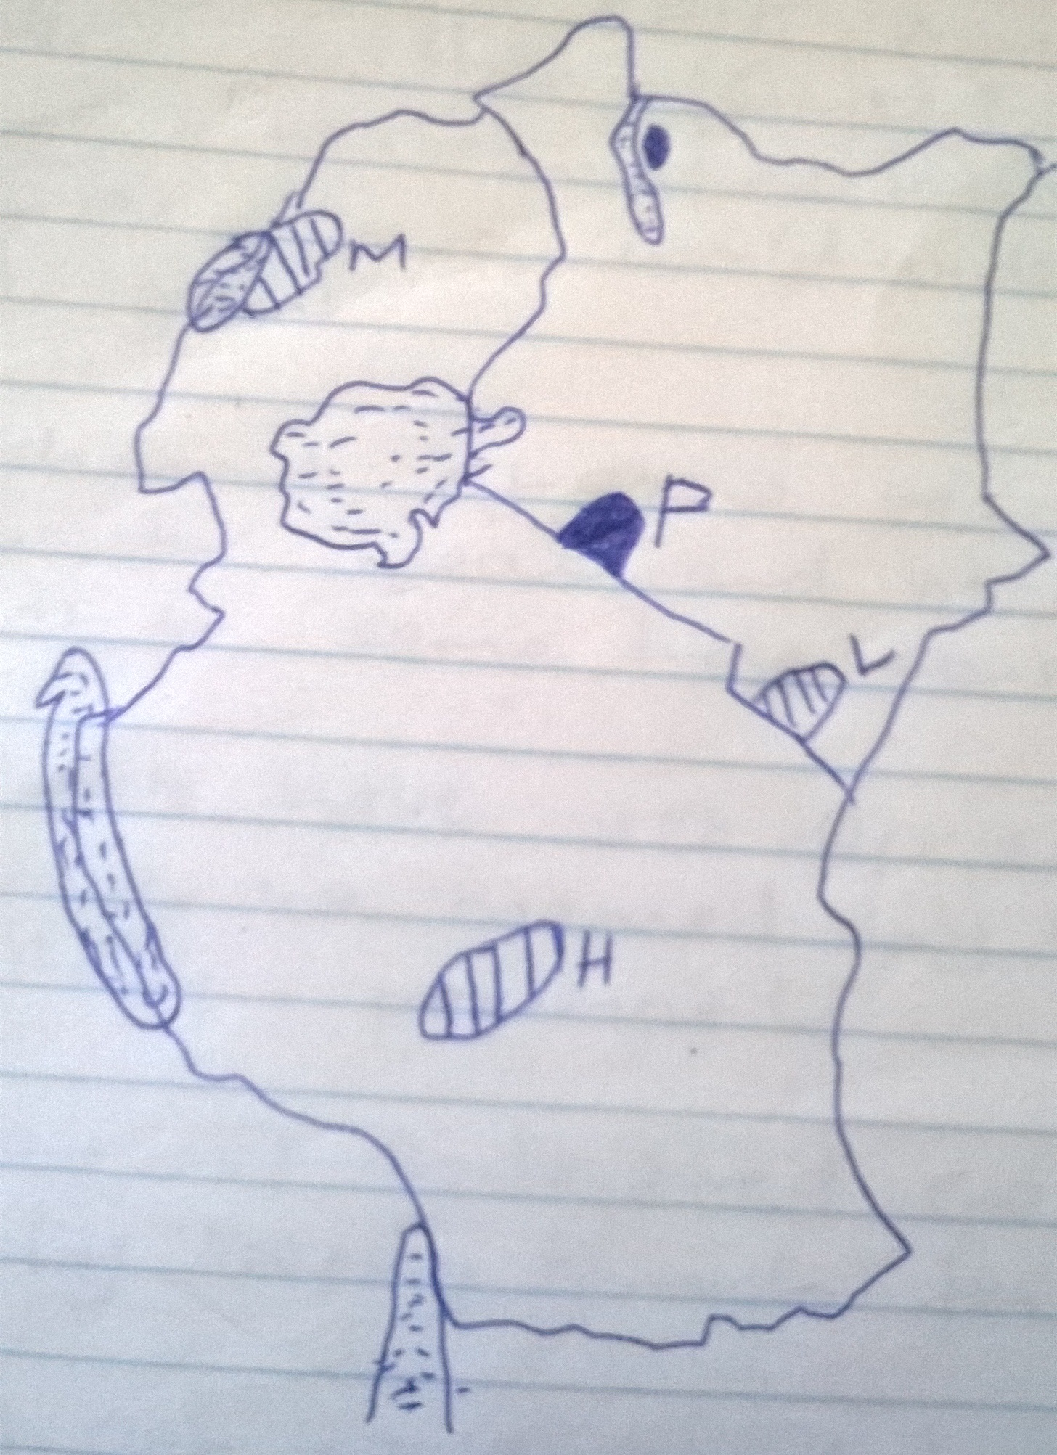
(i) Name the national parks marked. (3 marks)
L
H
M
(ii) Name the game reserve marked. (1 mark)
P
(iii) State three problems facing wildlife in East Africa. (3 marks))
(iv) Explain four measures undertaken by the governments of East Africa to conserve wildlife.
(4 marks)
c) (i) What is ecotourism. (2 marks)
(ii) State four reasons why the government of Kenya encourages domestic tourism. (4 marks)
(iii) Give four ways in which tourism in Kenya differs with that of Switzerland. (4 marks)
8. a) (i) What is forestry. (2 marks)
(ii) Explain how the following factors influence the distribution and types of natural forests.
-Aspect (2 marks)
-Human activities. (2 marks)
b) (i) Give three differences between natural forest and planted forest. (3 marks)
(ii) State three characteristics of coniferous forests. (3 marks)
(iii) Explain three problems that hinder exploitation of forest reserve in Africa. (6 marks)
c) (i) Give four problems facing forestry in Kenya. (3 marks)
(ii) State three measures which have been taken to manage forest in Kenya. (3 marks)
9. a) (i) Distinguish between transport and communication. (2 marks)
(ii) List any two main telecommunications links. (2 marks)
(iii) State three effects of the development of telecommunication. (3 marks)
b) (i) Give three reasons why road transport is used more than air transport in East Africa. (3 marks)
(ii) Name two international airports in Kenya. (2 marks)
(iii) Explain four problems facing railway transport in Africa. (8 marks)
(iv) State five reasons why there is limited use of river transport in Africa. (5 marks)
10. a) (i) Distinguish between internal trade and regional trade. (2 marks)
(ii) Name two invisible exports from Kenya. (2 marks)
b) (i) State four benefits of foreign trade in Kenya. (4 marks)
(ii) What is the meaning of unfavourable balance of trade? (2 marks)
(iii) Give three measures which Kenya may take in order to correct unfavorable balance of trade.
(3 marks)
c) (i) Name two members of COMESA apart from Kenya. (2 marks)
(ii) State four objectives of COMESA. (4 marks)
(iii) Explain four economic benefits of COMESA to its member countries. (8 marks)

312/2 GEOGRAPHY PAPER 2 MARKING SCHEME
SECTION A: ANSWER ALL QUESTIONS
- a) Give two ways in which minerals occur in the earth crust.
- Beds and seams.
- Hodes and veins.
- As alluvial deposits.
- As weather products.
2x1=2mks
b) State three effects of mining to the environment.
    - It leads to hand dereliction.
    - It causes pollution e.g. land water.
    - It destroys the bio-diversity.
    - It lowers water table.
    - It causes soil erosion.
3x1=3mks
- a) State two advantages of alluvium as a source of energy.
- Produce a lot of heat and steam to run heavy machines.
- It can be easily transported.
- It has longer lifetime compared to coal and natural gas.
2x1=2mks
b) Give three factors that hinder expansion of geothermal power in Kenya.
- Inadequate capital for investment.
- Inadequate skilled personnel.
- The country has limited suitable sites.
- Inadequate technology.
3x1=3mks
- a) Give two primary sources of population data
- Registration of persons i.e. birth and death.
- National –the sample survey.
- Population census data.
- Statistical abstracts.
2x1=2mks
b) State three reasons why government of Kenya carries out census.
- It helps the government in planning for social amenities e.g. schools, hospitals.
- To provide employment opportunities.
- Make decision on division of new administrative area.
- It shows the trend of mortality and fertility. 3x1=3mks
- a) Name two non-food industries in Thika town.
    - Textile.
    - Tobacco.
    - Sisal fibre making.
    - Leather tanning industry.
2x1=2mks
b) State three characteristics of cottage industry in India.
- Industries are owned by individual families or groups.
- Use local available raw materials.
- Little capital investment is required.
- Labour is provided by individuals or members of the family.
- Industry is labour intensive.
3x1=3mks
- a) Give three physical conditions that favour maize cultivation in Trans Nzoia district in Kenya.
- Moderate to high rainfall.
- Deep well drained soils.
- Gently sloping land.
- Moderate to high temperature.
- Sunny / dry season for ripening.
3x1=3mks
b) State two problems facing maize farming in Kenya.
- High cost of farm input.
- Unpredictable climate condition.
- Pest and diseases.
- Poor storage facilities.
- Weeds e.g. striga weed which complete with crops for nutrient.
2x1=2mks

SECTION B
6. Study the data in the table below and answer the questions that follow.

CROP PRODUCED IN KENYA IN “000” TONNES
- Draw comparative line graph to present the above data. (7 marks)
A COMPARATIVE LINE GRAPH SHOWING CROPS PRODUCED IN KENYA IN ‘000 TONNES
X-Axis Scale: 2cm rep. 1 year.
Y-axis: 1cm rep. 5000 tonnes.

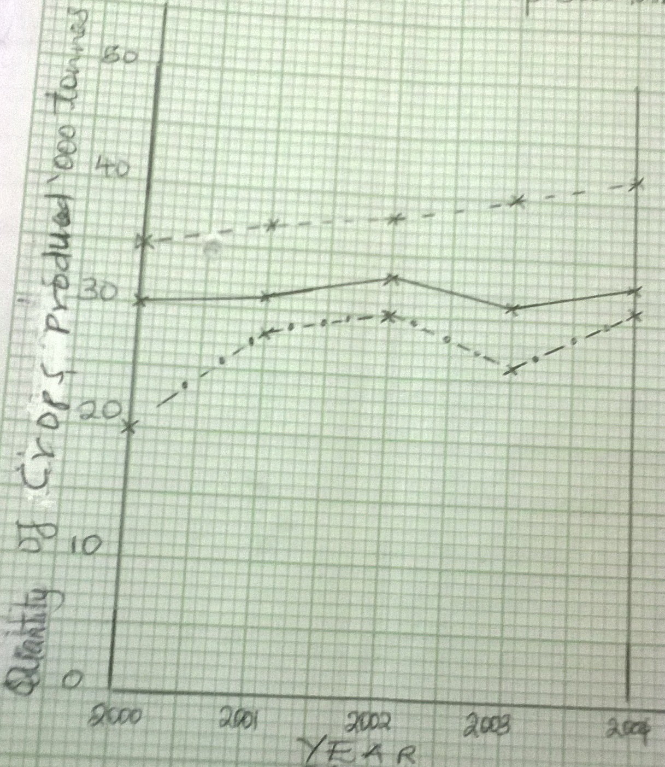

- State two advantages of using a comparative line graph to present statistical data.
- Its easy to read and interpret
- Its easy to draw
- Used for comparison purposes
- It saves time as several graphs are drawn on the same graph
2x1=2mks
b) (i) State three physical factors that favour sugarcane growing in Kenya.
- The land should be gently sloping to facilitate mechanization.
- High temperatures throughout the year.
- Deep well drained soils.
- A warm \ sunny dry season which enables the cane to ripen.
- High rainfall throughout the year.
3x1=3mks
(ii) Describe how sugarcane is processed.
- At the factory, the cane is weighed, washed then crushed.
- The juice is boiled for water to evaporate.
- It is then stirred in tanks to allow formation of crystals.
- The crystals are then separated from molasses for white sugar.
- Bleaching agent is added
- The sugar is dried, graded and refined
- This is followed by weighing and packing ready for the market
5x1=5mks
- State two uses if molasses
- Molasses are used to make rum
- They are incorporated in livestock feeds
- Molasses are used in the distilling of industrial alcohol
2x1=2mks
- Explain three reasons why Kenya imports sugar yet she is a producer of the same commodity. (6 mks)
- Hoarding of the commodity creates temporary shortage
- Country’s production outstrips the demand
- Cane sugar is more expensive than beet sugar hence the importation
- Pests and diseases lower production causing a shortage
- Mismanagement of the industry and eventual closure delays harvesting hence a drop in quality and quantity
- Crop failure due to frost or drought causes severe shortages
6x1=6mks
7. a) Explain how the following factors influence the distribution of wildlife.
- Climate (2 mks)
- Climatic elements like temperatures and rainfall influence the distribution of plant and animal species e.g. where there is high rainfall a variety of plant species grow and a variety of animals like baboons, elephants are found
- Vegetation (2 mks)
- Different types of vegetation are habitats for different animals eg natural forests are habitats for elephants, buffaloes etc savannah grasslands hosts a large variety of herbivores
b.) The map below shows national parks, game reserves and sanctuaries in East Africa.
(i) Name the national parks marked.
L-Tsavo East
H-Ruaha
M-Murchison Falls
3x1=3mks
(ii)Name the game reserve marked. (1mk)
P-Maasai Mara
(iii) State three problems facing wildlife in East Africa.
- Bush and forest fires especially during the dry season destroy natural habitat of wildlife
- Overgrazing leading to the destruction of habitats by grazers leading to soil erosion
- Adverse climatic conditions e.g. severe drought leads to destruction of habitats forcing animals to migrate while some die
- Human activities like illegal game hunting for commercial purposes
- Pests and diseases e.g. FIV threaten to reduce wildlife
- Inadequate capital to carry out conservation of wildlife
3x1=3mks
(iv) Explain three measures undertaken by the governments of East Africa to conserve wildlife.
- Imposing a ban on game hunting and being signatories on a worldwide ban on trace in wild game
- Establishment of game ranches to exploit wildlife for meat and other products while at the same time conserving it
- Governments have set-up anti-poaching units which are manned by well trained paramilitary personnel
- Protection of endangered species eg black rhino by keeping them in fenced off areas
- Involving non-governmental organizations and international agencies like world wildlife fund etc to support the conservation of wildlife and conduct public awareness programmes.
c. (i) what is ecotourism. (2 mks)
- This is a form of tourism which aims at caring and preserving nature
(ii) State four reasons why the government of Kenya encourages domestic tourism.
- To earn the government revenue which could be used to develop other sectors of the economy
- To create more employment opportunities for many Kenyans thus raise their standards of living
- To enable people to appreciate their cultural heritage
- To encourage peaceful co-existence among different ethnic communities in Kenya
- To expose Kenyans to a wider variety of recreational activities
- To facilitate circulation of money within the country
4x1=4mks
(iii) Give four ways in which tourism in Kenya differs with that of Switzerland. (4 mks)
KENYA | SWITZERLAND
Climate is warm throughout the year | Experiences warm summers and cold winters
Has landscape with a variety of physical features e.g. Rift valley, Lakes | The main physical feature is the Alps Mt
Rich in a variety of tropical flora and fauna | Lacks similar wildlife
Has abundance of marine life | Lacks marine life reserves
Rich in traditional culture due to different ethnic communities | Lacks variety of culture
Has sunny beaches which are ideal for sunbathing | Has no beaches since it a landlocked country
8. a) (i) What is forestry. (2 mks)
- This is the science of developing and managing forest including cultivating them.

(ii) Explain how the following factors influence the distribution and types of natural forests.
-Aspect (2 mks)
- The windward slopes of mountains are wetter than the leeward slope hence have denser forests.
- In high latitude areas, the south facing of the northern hemisphere and the north facing slope of the southern hemisphere and exposed the sun hence are warmer than the slope facing the poles. The warm slopes have more luxuriant forests.
-Human activities. (2 mks)
- Human beings clear large tracks of forests to create room for settlement and cultivation hence reduce the land under forest cover.
- When man carries out afforestation and agroforestry they increase the acreage of the land under forest
b) (i) Give three differences between natural forest and planted forest. 3x1=3mks
NATURAL FOREST | PLANTED FOREST
Trees are of mixed species. | Trees are of one species.
Trees grow haphazardly. | Trees are planted in rows.
Comprises of indigenous trees. | Comprises of exotic trees.
Thick undergrowth. | Less undergrowth.
Trees are mainly hardwood. | Trees are mainly softwood.

(ii) State three characteristics of coniferous forests.
- The trees are softwood and light in weight.
- The tree species occur in pure stands.
- There is no undergrowth in these forests.
- The trees have needle-like leaves.
- The trees have straight trunks.
- The trees have shallow roots.
- The trees have thick barks with a lot of resin which protect them from frost.
- The trees crown are cone-shaped
3x1=3mks
(iii) Explain three problems that hinder exploitation of forest reserve in Africa. (6 marks)
- The hot humid climate encourages pests and diseases which are dangerous to both men and the trees
- Limited local market due to low purchasing power
- Low technology to harvest logs from forests
- Poor transport network connecting the forest and market
- The forest form habitat for dangerous wild animals which make the exploitation insecure
- The humid climate makes working conditions unfavorable
6x1=6mks

c.(i) Give four problems facing forestry in Kenya.
- Outbreak of pests and diseases which destroy large quantities of valuable trees
- Outbreak of forest fires which destroy large tracks of forest
- Wild animals damage a lot of forest plants eg grazers
- High population among communities living adjacent to forest has led people to encroach on forest land
- Over-exploitation of forest through activities like charcoal burning, logging etc
- Some forests have been turned into game reserves while some parts of forest have been converted into public utility
4x1=4mks
(ii) State three measures which have been taken to manage forest in Kenya.
- Public campaigns on the importance of forest are always being conducted
- Research is being carried out on soils suitable for different species
- Alternative sources of energy are being encouraged eg water, oil etc
- Introduction and promotion of energy saving jikos
- Creation of forest reserves
- The government has established training and research institutions
3x1=3mks
9. a (i) Distinguish between transport and communication. (2 marks)
- Transport is the physical carriage and movement of goods and people from one place to another whereas communication is the process of transmitting or exchanging information between persons
(ii) List any two main telecommunications links.
- Telex services
- Telephone services
- Telegraphic services
- Paging services
2x1=2mks
(iii) State three effects of the development of telecommunication.
- Telecommunication has enhanced unity in different parts of different countries
- It has led to the very quick dissemination of ideas and information
- Telecommunications have lessened the isolation of remote regions which have inadequate roads
- Advancement in telecommunications has increased the ability to warn people in case of disaster
- It has promoted international trade by transmitting news on various commodities produced in certain regions and their prices
3x1=3mks

b(i) Give three reasons why road transport is used more than air transport in East Africa.
- Motor vehicles are cheaper to buy an maintain than aircrafts
- Road transport is more flexible than air transport
- Construction of roads is cheaper than that of airports
- Fare/freight charges are lower than that of air transport
- Skills required to operate an aircraft are higher and rare than those required to operate motor vehicles
3x1=3mks
(ii) Name two international airports in Kenya.
- Jomo Kenyatta Airport
- Moi International Airport
- Eldoret International Airport
2x1=2mks
(iii) Explain four problems facing railway transport in Africa.
- Vandalism/uprooting of the railway line causes great loss and delays in transportation
- Construction of railways requires large amounts of capital that most countries lack
- African countries use different railway gauges which make it difficult to have an integrated railway transport system
- Tropical storms waters at times wash away vital sectors of the railway lines
- Stiff competition from other means of transport
- High maintenance costs
4x2=8mks
(iv) State five reasons why there is limited use of river transport in Africa.
- Some rivers have rapids/waterfalls/cataracts hence are not navigable
- Some rivers are seasonal
- Some have thick floating vegetation
- Inadequate capital to develop waterways
- Some rivers are too short
- Some are difficult to navigate due to siltation especially at the mouth
- Some rivers have narrow channels unsuitable for sailing vessels
5x1=5mks
10. a)(i) Distinguish between internal trade and regional trade. (2 marks)
- Internal trade is the buying and selling of goods within a country while regional trade is the exchange of goods and services that is carried out by countries within the same geographical region
(ii) Name two invisible exports from Kenya.
- Interest and dividend on foreign investment
- Payment of transport services from Uganda, Tanzania for using Mombasa port
- Remittance/money from Kenyans working abroad
- Payment for financial services carried out on behalf of foreigners
2x1=2mks
b) (i) State four benefits of foreign trade in Kenya.
- The surplus goods produced and exported earn Kenya foreign exchange
- It enables Kenya to dispose of her surplus commodities
- It has stimulated industrial growth due to increased demand for goods locally and abroad
- Earns the government revenue through taxes and duties which can be used to develop other sectors of the economy
- It leads to supply of goods in times of calamities
- It enables Kenya to import goods that she does not have
- It brings about specialization in production of various goods
4x1=4mks
(ii) What is the meaning of unfavorable balance of trade? (2 marks)
- This refers to a situation where the value of exports exceeds the value of imports into a country
(iii) Give three measures which Kenya may take in order to correct unfavorable balance of trade.
- Establishment of import substitution industries to reduce importation of goods
- Development of other sources of energy in order to conserve oil eg HEP
- Establishment of export processing zones
- Finding new market for exports in order to export more goods
- Increasing invisible trade eg tourism, insurance
- Diversifying exports both in agriculture and manufacturing to promote export earning
3x1=3mks
c) (i) Name two members of COMESA apart from Kenya
- Egypt
- Sudan
- Eritrea
- Ethiopia
- Rwanda
- Zambia
- Angola
- Tanzania
2x1=2mks
(ii) State four objectives of COMESA.
- To foster good relations, peace, political stability and high standards of living for member states
- To establish a free trade area
- To promote social and economic integration
- To act as a showcase of a building bloc towards the eventual establishment of the African Economic community
4x1=4mks

(iii) Explain four economic benefits of COMESA to its member countries.
- The volume of trade has increased due to availability of wider market
- More transport facilities have been constructed to link the member states
- It has encouraged specialization in the different member countries
- The removal of trade barriers has extended the market for the finished products
- Creation of employment opportunities for people in the various member states
- The transfer of technology
4x2=8mks

