NAME: ………………………………………………………CLASS:……………………………

INDEX NO:……………………………….

312/2
GEOGRAPHY
PAPER 2
TIME: 2 ¾ HOURS

SET 1
FORM 4

Instructions to Candidates
a) This paper has two Sections: A and B.
b) Answer all the questions in Section A.
c) Answer Questions 6 and any other two questions from section B.
d) All answers must be written in the answer booklet provided.
e) This paper consists of 4 printed pages.
f) Candidates should check the question paper to ascertain that all the pages are printed as indicated and that no questions are missing.
g) Candidates should answer the questions in English.

This paper consists of 5 printed pages. Candidates should check the question paper to ensure that all pages are printed as indicated and no questions are missing.

SECTION A
Answer all questions in this section
1. a) State two factors that influence the development of Nucleated settlement. (2 marks)
b) Outline three characteristics of the central business district.
2. a) What is fish farming? (2 marks)
b) List down three physical factors that favour fishing in North West pacific. (3 marks)
3. a) Give three negative effects of open cast mining on environment (3 marks)
b) Name two methods of placer mining. (2 marks)
4. The diagram below shows the demographic transition of a given region. Use it to answer
the questions that follow.
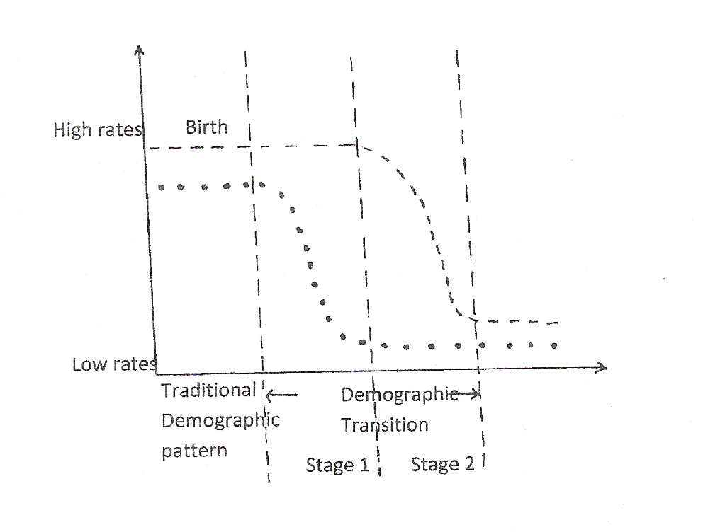

a) Give two characteristics of stage 1. (2 marks)
b) State three reasons for the high death rates in the traditional stage. (3 marks)
5. (a) Give two renewable sources of energy. (2 marks)
(b) State three measures that are being taken to manage and conserve energy in Kenya, (3 marks)

SECTION B
Answer question 6 and any other two questions from this section.
6. a) The table shows the number of household structures in selected towns in Kenya in 2010. Use it to answer the questions which follow.
Towns | Permanent | Temporal
Kisumu  Nairobi  Nakuru  Kitale  Moyale | 1371  4026  1558  1427  191 | 1394  3907  1764  1501  195

- Taking a vertical scale of 1cm to representing 300 households, draw a
comparative bar graph to represent the data above. (6 marks)
ii) State two merits of the above method. (2 marks) b) Explain four problems Mombasa as a town experiences as it grows. (8 marks)
c) Compare the ports of Mombasa and Rotterdam under
i) Climate (2 marks)
ii) Size of the ports. (2 marks)
iii) Transport links to the interior. (2 marks)
d) Why is North Eastern Kenya sparsely settled. (3 marks)
7. (i) Give three reasons why the government of Kenya is encouraging the use of
Motorcycle and "Tuk-Tuk" as modes of road transport. (5 marks)
(ii) State two problems created by the introduction of the modes of transport on
(a)(i) above

8. a) Define the term ecotourism. (2 marks)
b) i) Explain four steps taken to promote ecotourism in Kenya. (8 marks)
ii) State four roles played by Kenya Tourism board in the tourist industry. (4 marks)
c) Using the map of Switzerland below, answer the questions that follow.
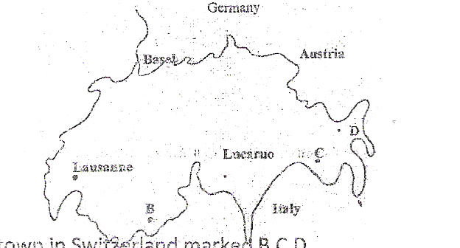

i) Name the tourist resort town In Switzerland marked B,C,D. (3 marks)
ii) Explain four factors which make Switzerland receive more tourists than Kenya.
(8 marks)
9 . a) i) Distinguish between bilateral and multilateral trade (2 marks)
(ii) State any four factory that influence trade. (4 marks}
b) Explain the following terms
(i) Balance of trade (2 marks)
ii) Invisible trade (2 marks)
d) State any four ways in which Kenya is trying to enhance its external trade. (4 marks)
10. a) Name two exotic beef cattle breeds in Kenya. (2 marks)
b) State three steps taken by the Kenya government to improve beef farming. (3 marks)
c) State three problems facing beef farming in Kenya. (3 marks)
d) i) Explain three physical conditions that favour beef farming in Argentina. (6 marks)
ii) Using map outline of the great lakes and the St. Lawrence Sea Way provided below
answer question b(i) – b(iv) (4 marks)
Name
(i) Town marked A
ii) Lake marked B
iii) Canal marked C
iv) River marked D
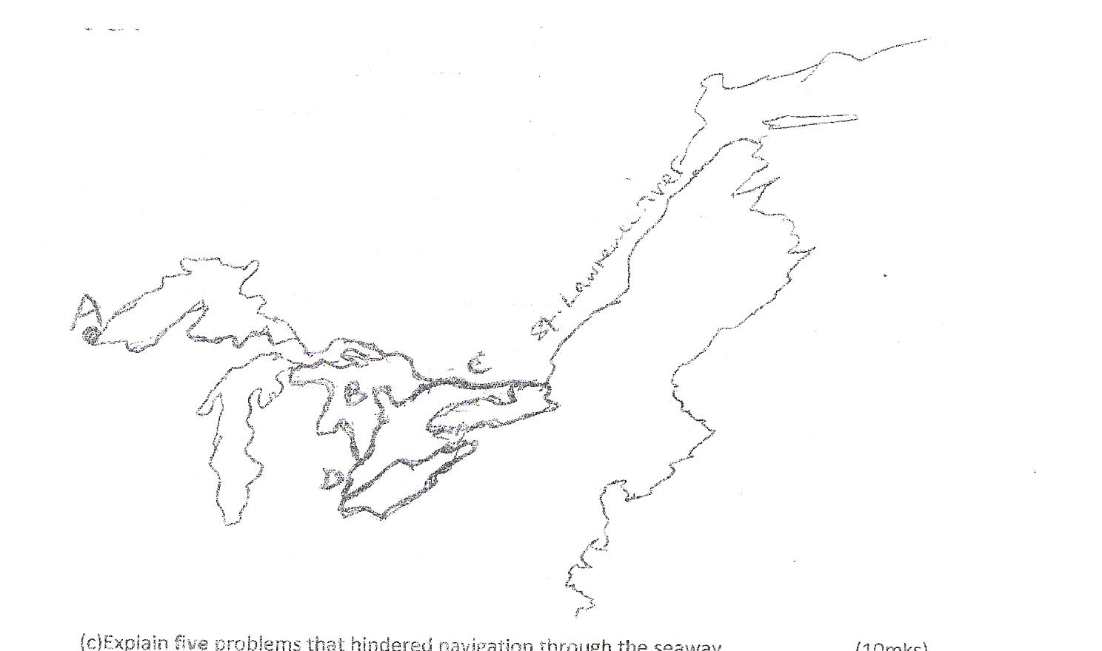

c) Explain five problems that hindered navigation through the seaway. (10 marks)
d) Students from a school carried out a field work along Nakuru –Nairobi Highway to
study the traffic flow.
i) State three methods they are likely to have used to collect data. (3 marks)
ii) Give three methods that they could use to present the data collected. (3 marks)
iii) Explain two ways in which beef farming contribute to the economy of Argentina. (4 marks)
e) Form four students in your school carried out a field study on beef farming in Narok
District
i) State three objectives for their study (3 marks)
ii) Give four follow up activities they carried out (4 marks)

312/2 GEOGRAPHY PAPER 2 MARKING SCHEME
SECTION A
1. a) Factors influencing the development of nucleated settlement
- Availability of water
- Presence of facilities such as schools, dispensary.
- Presence of an industrial plant
- Mining activity
- Scarcity of land
- Security concerns.
(3x1 = 3mks)
b) Characteristics of Central Business District.
- Easily accessible
- Has high concentration of tallest buildings
- Has high rental value
- Has wide streets
- High concentration of business activities
(3x1=3mks)
2. a) - Fish farming is the rearing offish in ponds and dams (2 mks)
b) Physical factors that favour fishing I North West Pacific
- The convergence of the cold oya siwo current and the warm kuro siwo
- The broad continental shelf along the coastline
- The indented coastline with several islands
- The mountainous landscape hinders agriculture (3x1=3 mks)
3. a) Negative effects of open casts mining on environment
- The land is left with gaping quarries which are ugly
- Agricultural land is wasted or reduced.
- Dust produced pollute the environment / health hazard
- Land for settlement is reduced -;
- Water pool from breeding grounds for disease causing organisms
- Interferes with the natural vegetation
(3x1=3mks)

b) Methods of places mining/ alluvial mining
- Panning mining
- Dredging mining
- Hydraulic mining
(2x1=2mks)
4.a) Characteristics of stage 1
- High birth rates - Declining death rates.
- High population growth rate.
(2x1=2mks)
b) Reasons for the high death rates in the traditional stage.
- Inadequate medical care.
- Rampant / wide spread diseases.
- Malnutrition / inadequate food supply.
- Frequent wars.
(3x1=3mks)
5. (a) Two renewable sources of energy
- Water
- wind
- Solar/sun -Biomass-Wood
b) Measures that being taken to manage and conserve energy in Kenya
- Encouraging people to use alternative sources of*energy other than oil e.g. biomass,
solar wind
- Development of wood fuel programme through afforestation and reafforestation
- People are being encouraged in the rural areas
- Creating awareness eg through the media on the importance of conserving energy
- Encouraging /improving of public transport to encourage people to use it
- Proper planning /maintenance and repair of roads to reduce fuel consumption
- Proper management of the existing forests through banning of logging, training of
foresters, selective tree cutting to ensure sustainable use of forests.
- The government is making efforts to harness /develop other forms of energy
eg wind, geothermal (3 x 1 = 3mks)

SECTION B
6(a)(i) GRAPH (10x¹_{/2}=5mks)
- Attractive to the eyes/clear visual impression
- Easy to compare values at a glance
- Easy to draw/construct ( 2x1=2marks
b) Problems experienced by Mombasa as it grows
- Serious traffic congestion during rush hours leading to loss of time as one goe
to work
- There is a rapid growth of population which leads to acute shortage of housing/slums
- There are heaps of uncollected garbage posing health hazards
- There is large population which is unemployed encouraging the increase
in crimes/immoral practices, parking boys/beggars
- Pollution of water, air and sound
- Poor sewerage system in some parts of the town causing health hazards
(4x2=8marks)
(c)(i)Climate
- Both towns are free from fog and mist conditions
(1x2=2mks)
(ii)Size of the ports
- Mombasa is the largest part in East Africa but lacks space for expansion while
Rotterdam has expanded greatly (1x2=2mks)
(iii)Transport links to the interior
- Mombasa is linked to the interior by the Kenya Uganda Railway while Rotterdam is
served by waterways, roads, railway lines to other towns (1x2mks)
d) Why North Eastern Kenya is sparsely settled.
- There are harsh climatic conditions such as high temperatures and low rainfall
- The soils are thin and infertile discouraging agricultural activities
- Insecurity from banditry attacks scare people from settling (3x1=3marks)
7. (a)(i) Reasons why the government of Kenya is encouraging the use of Motor cycle
and "Tuk-Tuk" as modes of road transport
- Motorcycles are convenient to use as they can do door to door services
- Motorcycles are fast
- Motorcycles and tuk-tuk have provided job opportunities to many Kenyan,
thus improve the standards of living
- Has made movement within the urban centre convenient. (1x3 = 3mks)

(ii) Problems created by the introduction of the modes of transport on (a)(i) above
- Rates of roads accidents have increased due to lack of proper driving training
and ignorance/abuse of traffic rules by the motor cyclists.
- Rate of insecurity has gone up - criminal activities like shooting passengers
robberies.
- Congestion of urban centers, especially the C.B.D by Tuk-Tuk and Motorcycles
- Unhealthy competition with other modes of transport like Taxis, Boda-boda
- Encourage immorality
(2x1=2mks)
(b)
Town marked A...... Duluth (1mark)
Town marked B.......L. Huron (1 mark)
Canal marked C......Trent canal (1 mark)
River marked D…..R. Detroit (1 mark)
Problems that hindered navigation through the seaway
• Presence of rapids and waterfalls e.g Sault Marie rapids/Niagara falls
• Existence of bottleneck/arrow sections due to silting
• Differences in water levels between t he lakes
• Existence of rocky islands section in the St.. Lawrence river
• Freezing of the waterways in winter.
• Frequent fog and mist in certain months
• Shallow sections due to silting - (2x5 = 10 mks)
(d)
(i) Methods they are likely to have used to collect data :
• Counting
• Observation
• Photographing/filming/video taking
• Interviewing
• Administering a questionnaire (3x1= 3mks)
(ii) Methods that they could use to present the data collected
• Tabulation
• Drawing flow-charts/pie charts
• Displaying photograph (3x1=3mks)

8. a) Tourism aimed at using the earnings and knowledge gained to conserve the environment (2mks)
(b)(i) -Creating awareness among the local communities to understand and appreciate the
environment
-Restoring the damaged environment in Bamburi nature trail
-Warning tourists at place entry against the danger of throwing cigarettes remains which
Cause fire and littering place with garbage
-Sharing of benefits accrued from tourism with the local communities ie. Building schools,
Hospitals. etc
- High lightning ecotourists' activities i.e. Bird watching, landscape painting, moving on
Marked traits etc to conserve the environment. (4x2=8mks)
(ii) Advertising/publicizing of Kenya's/tourist facilitates locally and internationally
- To advice the ministry of tourism on ways to improve tourist sites
- Licenses and controls the operations of tour and hotel operations to ensure they
give quality services
- Owns some of the hotels e.g. Hilton Hotels
- Co-ordinates with Kenya tourist police to ensure tourist safety (3x1=3mks)
(c) i) A - Lausanne
B- Zermatt
C - St. Moritz
D- Davos (4x1=4mks)
ii) -Switzerland is located in central Europe making it easily accessible to tourists from Europe
while Kenya is far from Europe
-Peaceful atmospheric/political neutrality in Switzerland encourages tourists, while in Kenya
there are at times cases of insecurity i.e. Terrorists attack, political unrest in 2007 etc .
-Switzerland has better developed transport and communication network i.e. Roads, rail,
cable cars which are used to transport tourists to various parts of the country, while in
Kenya the railway, network road network is developed and maintained.
-Switzerland has many unexpected agencies located in the country and international Red
cross organization, United Nations high commission for references, hence many
conferences are held there, While in Kenya there is only the United Nations environmental
programme.
-Switzerland encourages packages tours which lowers the rate charged for tourists' facilities
hence encouraging more visitors while in Kenya package tours are poorly developed.
-Switzerland mounts more effective promotion campaigns through print, electronic media
and participating in trade fairs, while in Kenya this is poorly done. (4x2=8mks)
9 a) i) Bilateful is trade between two countries while multilateral is trade between many countries,
more than two. (2mks)
ii) Factors that influence trade.
- Availability of capital
- Availability of goods.
- Security
- Demand for goods
- Availability of transport.
- Existence of trading blocs. (4x1=4mks)
b) i) Trading Blocs in Africa.
- The common market for Eastern and Southern Africa (COMESA)
- The East African co-operation (EAC).
- Southern African Development community. (SADC)
- Economic Community of West Africa. (ECOWAS) (3xl=3mks)
ii) Benefits of trading blocks.
- They create a large market for goods to be bought and sold.
- They help to create harmony and co-operation among the member states.
- Reduction of tariffs makes the goods cheaper to the people in the regions. The expanded
market for goods has promoted industrial development as the demand for goods increases.
- Inter-state trade has encouraged the development of transport and communications.
- The trade between the countries has created job opportunities which have led to a high
standard of living.
- Trade in the region has stimulated agricultural development. Has reduced the reliance of
countries in Africa on goods and services from other parts of the world.
- They have made it easier for goods to be readily available to the people of the regions.
(4x2=8mks)
c) i) Balance of Trade
- This is the difference in value between a country's visible exports and import. (2mks)
ii) Invisible Trade
- Trade in intangible products i.e services. (2mks)
d) Ways in which Kenya is trying to enhance its external trade.
- Advertisement of export goods.
- Improving its infrastructure e.g roads. Encouraging foreign investors.
- Lowering taxes levied on trade goods.
- Encouraging sale of processed goods. (4x1= 4mks)

10. (a) Exotic beef cattle breeds in Kenya
-Aberdeen Angus
-Hereford
-Short horn
-Sahiwal (2x1=2mks)
(b) Steps taken by the Kenyan government to improve beef farming
- Establishing the priority orders by creating awareness among the leaders
- Identifying methods of approach that include related industries and department of Agriculture
- Organizing forums to educate the farmers on strategies to improve their systems of livestock
farming
- Investigating the prevailing market situations and make appropriate recommendations
- Identifying possible financial institutions to the farmers such as Agricultural Finance
Corporation (AFC), banks and advice the farmers accordingly
- Creating ranching schemes in the Arid and Semi Arid Areas (ASAL) to improve livestock
farming among the pastoral communities
- Providing dipping equipment and facilities
- Providing extensions officers to give the farmers the necessary advice
- Decontrolling the price of meet products resulting in a variety of prices offered to beef farmers
- Improve water supply by building dams and reservoirs
- Teaching and encourages farmers to adopt modern methods of rearing and breeding beef
cattle
- Introduction of pedigree British Cattle in some suitable districts or cross-breeding them with
indigenous breeds
- Funding research in animal diseases control and management, educational programmes and
drug supply
(c) 3 problems facing beef farming in Kenya
- Unreliable and inadequate rainfall in some months of the year leading to inadequate pasture
- High temperatures in most parts of Kenya which makes it hard to raise cattle of high quality
- The pastrol tribes care for quantity rather than quality, the large herds of poor animas are
steadily ruining pastureland
- The hard ancient rocks that underlie Kenya produce poor soils prone to erosion. Natural grass
is poor and not good for quality animals
- The Kenya environment encourages the spread of nagana and rinderpest which are
disastrous diseases to animals (3x1=3mks)

(d) (i) Physical conditions that favour beef farming in Argentina
- Well distributed rainfall throughout the year with an annual total of about 1000mm favours
the growth of good pasture for the animals.
- The sub-tropical temperatures with summer temperatures rising above 240c and lower
winter temperatures of about 10°c favour the growth of grass throughout the year.
- The area is flat and low rising gently westwards from the cliffs at the coast which provides
goods natural grazing landscape with good pastures.
- Fertile soils are washed from the foot hills of Andes by rains and rivers eastwards to the dry
areas which forms loess that are fertile that gives rise to good naturals pastures.
- The pampas enjoys the advantage of receiving on shore most winds from the north that
makes the areas receives very high rainfall. (3x2=6mks)
(ii) Ways in which beef farming contributes to the economy of Argentina
- Beef industry has provided employment in various sectors e.g the stockmen in ranches
- There has been improvement in infrastructure from the coast to the interior to enable farmers
transport cattle from interior to the coastal urban centers
- The exported beef earns a lot of foreign exchange for the government of Argentina
- The by-products such as hides, horns and hooves are used as raw materials for other industries like shoe-making (2x2=4mks)
(e) i) Objectives for the study
- To find out the type of beef cattle kept
- To find out where the farmers sell his or her livestock hides etc
- To find out the significance of beef products to the local area (3x1=3mks)
(ii) Follow up activities include:-
Displaying the filled in questionnaires
Displaying the photographs taken Giving a lecture on beef farms
Group discussion
Drawing proper sketches - well labeled
(4x1=4mks)

