- Representation of data
1. The height of 36 students in a class was recorded to the nearest centimeters as follows.
148 159 163 158 166 155 155 179 158 155 171 172 156 161 160 165 157 165 175 173 172 178 159 168 160 167 147 168 172 157 165 154 170 157 162 173
(a) Make a grouped table with 145.5 as lower class limit and class width of 5. (4mks)
2. Below is a histogram, draw.
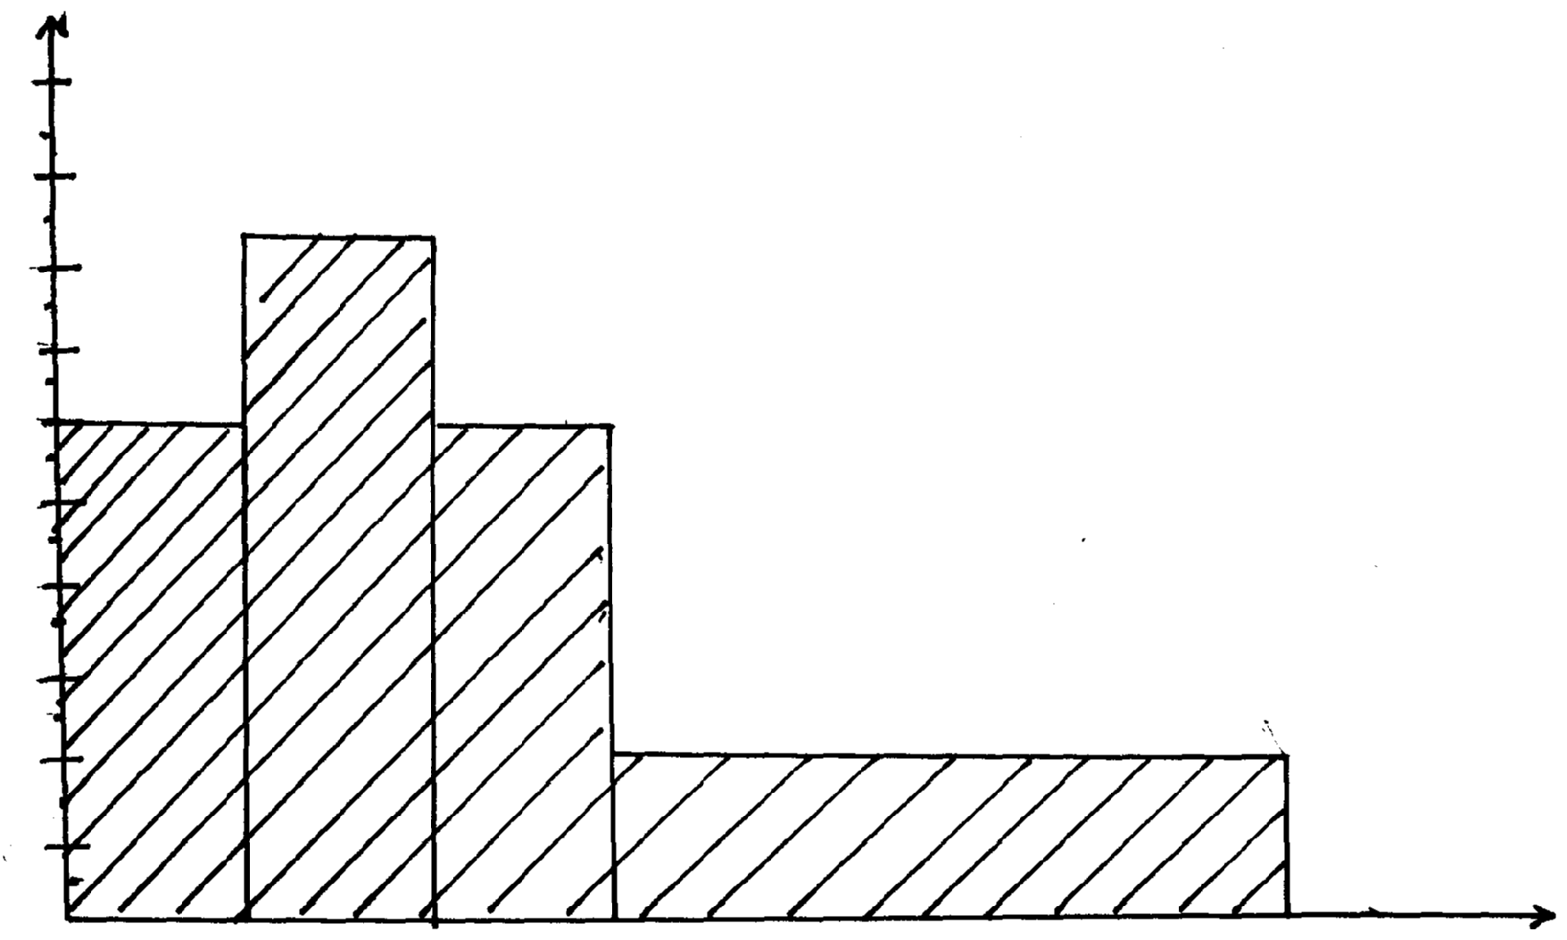
Frequency density
4.5
1.0
1.5
2.0
2.5
3.0
3.5
4.0
5.0
0.5

11.5
23.5
Length
17.5
15.5
13.5

Use the histogram above to complete the frequency table below:

Length | Frequency
11.5 ≤ x ≤13.5
13.5 ≤ x ≤15.5
15.5 ≤ x ≤ 17.5
17.5 ≤ x ≤23.5

3. Wambui spent her salary as follows:
Food | 40%
Transport | 10%
Education | 20%
Clothing | 20%
Rent | 10%

Draw a pie chart to represent the above information

4. The examination marks in a mathematics test for 60 students were as follows;-

60 | 54 |  | 34 | 83 | 52 |  | 74 |  | 61 | 27 | 65 | 22
70 | 71 |  | 47 | 60 | 63 |  | 59 |  | 58 | 46 | 39 | 35
69 | 42 |  | 53 | 74 | 92 |  | 27 |  | 39 | 41 | 49 | 54
25 | 51 |  | 71 | 59 | 68 |  | 73 |  | 90 | 88 | 93 | 85
46 | 82 |  | 58 | 85 | 61 |  | 69 |  | 24 | 40 | 88 | 34
30 | 26 |  | 17 | 15 | 80 |  | 90 |  | 65 | 55 | 69 | 89
Class |  | Tally |  |  |  | Frequency |  | Upper class limit
10-29
30-39
40-69
70-74
75-89
90-99
From the table;
(a) State the modal class
(b) On the grid provided , draw a histogram to represent the above information
5. The marks scored by 200 from 4 students of a school were recorded as in the table below.
Marks | 41 – 50 | 51 – 55 | 56 – 65 | 66 – 70 | 71 – 85
Frequency | 21 | 62 | 55 | 50 | 12

- On the graph paper provided, draw a histogram to represent this information.
- On the same diagram, construct a frequency polygon.
- Use your histogram to estimate the modal mark.

6. The diagram below shows a histogram representing the marks obtained in a certain test:-
0
Marks
Frequency Density
1
2
3
4
5
6
7
4.5
9.5
19.5
39.5
49.5

(a) If the frequency of the first class is 20, prepare a frequency distribution table for the data
(b) State the modal class
(c) Estimate: (i) The mean mark (ii) The median mark

7. The data below shows the number of sessions different subjects are taught in a week.
Draw a pie chart to show the data:
Subject | Eng | Maths | Chemistry | C.R.E
No. of sessions | 8 | 7 | 4 | 3

8. The height of 50 athletes in Moi University team were shown below:

Height (cm) | 150-159 | 160-169 | 170-179 | 180-189 | 190-199 | 200-209
Frequency | 2 | 9 | 12 | 16 | 7 | 4

i) State the modal class
ii) Calculate the median height of the athletes
9. The table below shows the length of 40 mango tree leaves;
Length (mm) | Frequency | Cumulative frequency
118-126  127-135  136-144  145-153  154-162  163-171  172-180 | 3  4  10  12  5  4  2 | 3  7  17  29  34  38  40

(a) Determine the;
(i) Modal class
(ii) Median class
(b) Calculate; (i) the mean of the leaves (ii) the median of the leaves

