- Representation of data
1. | (a)  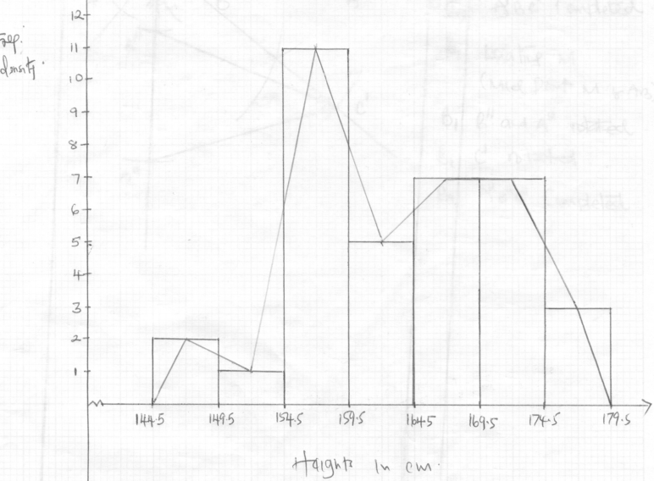 | B1  B1  B1  B1  B1  B1  B1  B1  B1  B1 | Classes  Tally mark column  Freq. column  Freq density column  (can be implied)  Freq. density (y axis  Height (x axis)  Correct spacing as per scale  Histogram drawn (bars)  Joining mid point of the bars  Joining mid point of first class to 144.5  Joining mid point of last class to 179.5
  Class | Tally mark | Freq | Freq D
  145-149 | // | 2 | 2
  150-154 | / | 1 | 1
  155-159 | //// //// / | 11 | 11
  169-164 | //// | 5 | 5
  165-169 | //// // | 7 | 7
  170-174 | //// // | 7 | 7
  175-179 | /// | 3 | 3
 |  | 10

1.
Length  11.5 ≤ x≤ 13.5  13.5 ≤ x≤ 15.5  15.5 ≤ x≤ 17.5  17.5 ≤ x≤ 23.5 | Frequency  6  9  6  3

2. Food: ⁴⁰/₁₀₀ x 360 = 144 °
Transport: ¹⁰/₁₀₀ x 360 = 36°
Education: ²⁰/₁₀₀ x 360 = 72 °
Clothing: ²⁰/₁₀₀ x 360 = 72 °
Rent: ¹⁰/₁₀₀ x 360 = 36°

3. Class Tally Frequency Upper Limit
10 – 29 ∣∣∣∣ ∣∣∣ 8 29.5 B₂ for
30 – 39 ∣∣∣∣ ∣ 6 39.5 all tally
40 – 69 ∣∣∣∣ ∣∣∣∣ ∣∣∣∣ ∣∣∣∣ ∣∣∣∣ ∣∣∣ 28 69.5 B₂ all
70 – 74 ∣∣∣∣ ∣ 6 74.5 - frequency
75 - 89 ∣∣∣∣ ∣∣∣ 8 89.5 - B₁
90 – 99 ∣∣∣∣ 4 99.5 B₁

Modal class 40 – 69 B1

0
9.5
29.5
39.5
69.5
79.5
89.5
995
1.2
1.0

0.8
S₁- scale
B₃- Au Histogram
B₂- any 4
B₁- any 3
0.6

0.4
0.2

4. See the graph paper.
For correct class boundaries
For correct class intervals.
All frequency densities

Correct scale
All the bars drawn.

Top mid pts. Of bars indicated.
For the mid pts. Joint to make a polygon.
For correctly identifying the modal mark point.
For reading correctly the modal mark ≡ 53.5 ± 0.1
= 19.75
5. (a)
Marks | Frequency
5-9  10-19  20-30  40-49 | 20  50  40  30
(b) Modal class is 10-19
(c)(i)
Class | x | f | fx | Cf
5-9 | 7 | 20 | 140 | 20
10-19 | 14.5 | 50 | 725 | 70
20-39 | 29.5 | 40 | 1180 | 110
40-49 | 44.5 | 30 | 1335 | 140
 |  | ΣF = 140 | ΣFx =3380

x = Σfx = 3380 = 24.14
Σf 140
(ii) Median mark is at 70 + 71 = 70.5th position
Median = 119.5 + (0.5) x 20
40
= 19.5 + 0.25

6. Total No. of sessions
= 8 + 7 + 4 + 3 = 22
Chemistry
English
Cre
Maths
Angle for:
English = ⁸/₂₂ x 360 = 130.9°
Maths = ⁷/₂₂ x 360 = 114.5°
Chemistry = ^{4/}₂₂ x 360 = 65.5°
CRE = ³/₂₂ x 360 = 49.01°

7. 180 – 189
Class limits
class | limits | f | cf
149.5 | 159.5 | 2 | 2
159.5 | 169.5 | 9 | 11
169.5 | 179.5 | 12 | 23
179.5 | 189.5 | 16 | 39
189.5 | 199.5 | 7 | 46
199.5 | 209.5 | 4 | 50

Median = ⁵⁰/₂ = 25
179.5 + 25 – 23 x 10
16
= 179.5 + 20 = 180.75
16
179.5 + 26 – 23 x 10
16
179.5 + 30 = 181.38
16
180.75 + 181.38
2
= 181.06

8. a) i) 145 – 153
ii) Median class
(⁴⁰ ⁺ ¹/₂)^{th} value ∴ median class = 145 – 153
This is the 20.5th value
The value also in the 145 – 153 class

b)
Class | x | f | fx
118- 126  127- 135  136 – 144  145 – 153  154 – 162  163 – 171  172 - 180 | 122  131  140 B1  149  158  167  176 | 3  4  10 B2  12  5  4  2 | 366  524  1400  1788  790  668  352
 |  | Ef = 40 | Efx = 5888
B2 for all values of fx correct and B1 for 4 values of fx and above orrect
Mean = Efx = 5888 = 147.2mm
Ef 40
Median 20th = 144.5 + (^{11/}₁₂ x 9) = 152.75
21st = 144.5 + (¹²/₁₂ x 9) = 153.5
Median = 152.75 + 153.5 = 153.125
2
(Alternatively one could work out the 20.5 value directly using median formula)

