Refraction of light
1. The refractive index of paraffin is 1.47 and that of glass is 1.55. Determine the critical
angle of a ray of light travelling from glass to paraffin
2. The diagram figure 1 below shows a ray of light incident on glass air boundary:
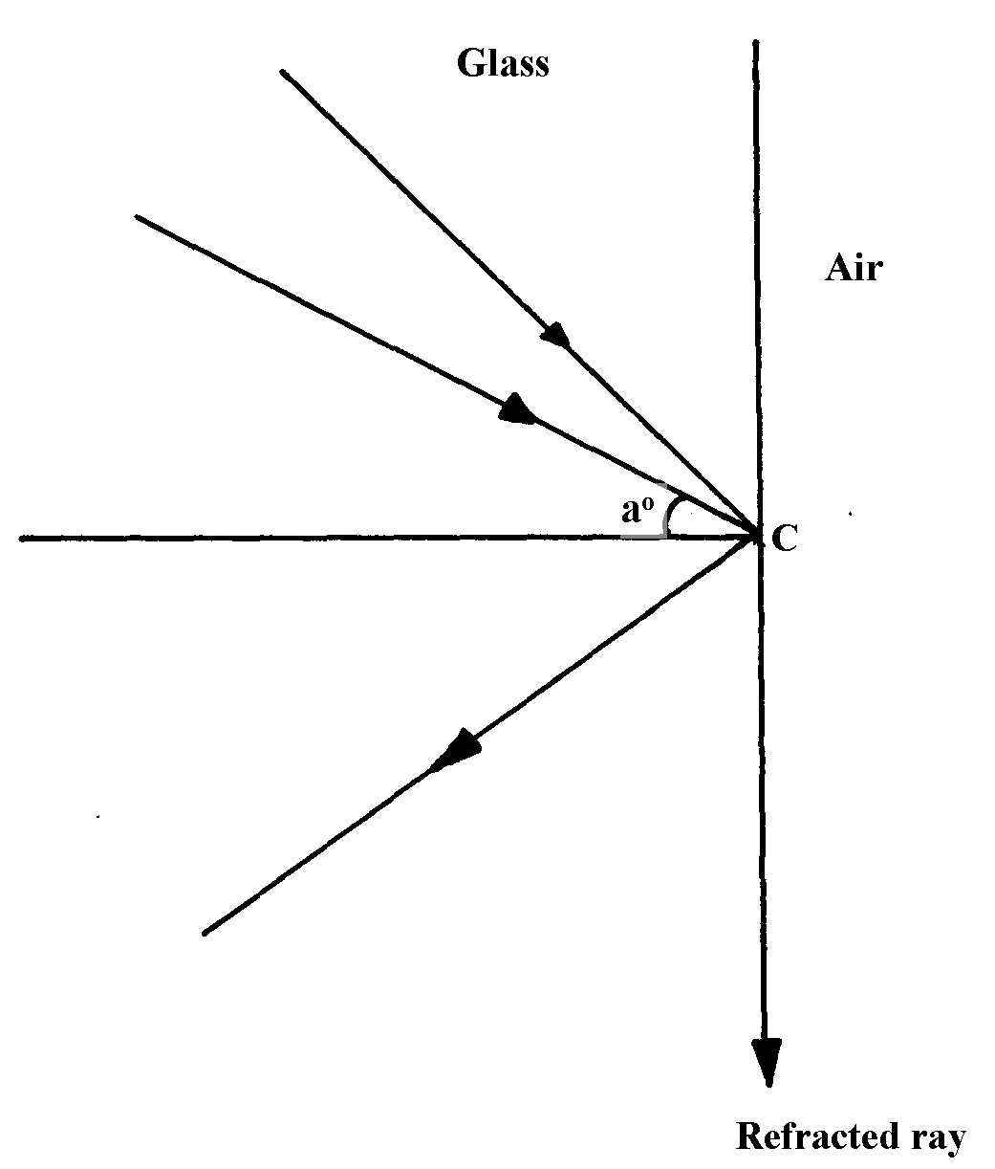
fig. 1

A second ray strikes the boundary at the same point C at an angle of incident greater than aº.
(i) On the diagram, draw the second ray before and after striking the boundary
3. a) State Snell’s law
b) When does total internal reflection occur?
c) The figure below represents a ray of light falling normally on the curved surface of a
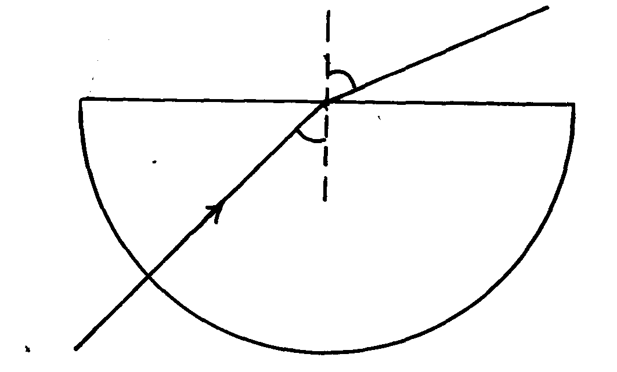
semi- circular glass block A at an angle of 32° at O and emerging into air at an angle of 48°
48º
32º

Calculate the absolute refractive index of the glass of which the block is made.
(Assume air is a vacuum)

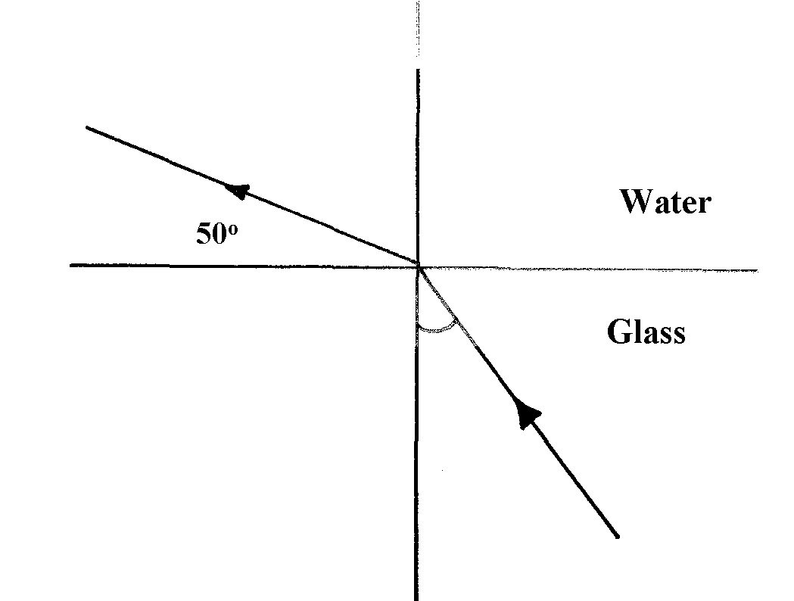
4. Figure 2 below shows a ray of light traveling from glass to water
θ
figure 2

θ
figure 2

Calculate the angle θ if the refractive index of glass and water are ³/₂ and ⁴/₃ respectively (3mks)
5. Figure 3 shows light rays moving from medium 1 to medium 2. If the refractive index of medium
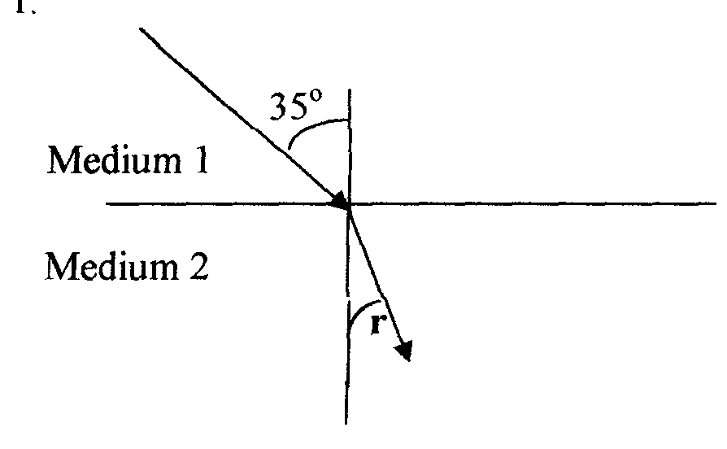
1 is ⁴/₃ and that of medium 2 is ³/₂. Calculate angle r

6. (a) The diagram below shows a glass prism and an incident ray striking the face marked AB.
The critical angle of the glass is 42º. Use it to answer the questions that follow:-
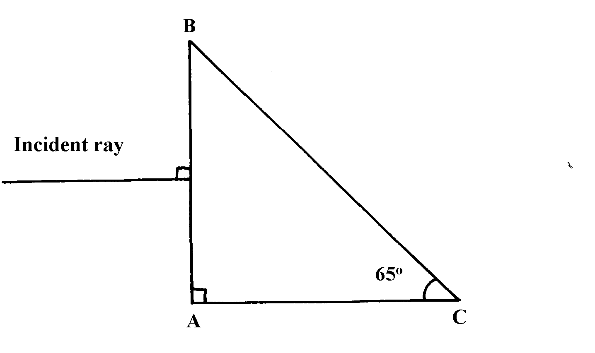

(i) Complete the diagram showing the path of the emergent ray
(ii) Calculate the angle of refraction of the resultant emergent ray
7. (a) (i) What is a critical angle as used in refraction of light?
(ii) State one condition under which total internal reflection occurs
(b) Calculate the value of the critical angle c in the figure below
Water
n₂=1.3
n₁=1.5
Glass
N
c

(c) (i) Show that m = v + 1
f
where m = linear magnification , V= Image distance and f is the focal length of lens
(ii) In the table below shows readings obtained out of an experiment to determine focal length
of a converging lens
Image distance V (cm) | 17.1 | 18.3 | 20 | 23 | 30
Object distance (u) | 40 | 35 | 30 | 25 | 20

Plot a graph of 1 against 1 and determine the focal length of the lens from the graph.
V u (Use the graph paper provided).
8. a) The Fig.9 shows a ray of sunlight incident to face AB of a glass prism. -•
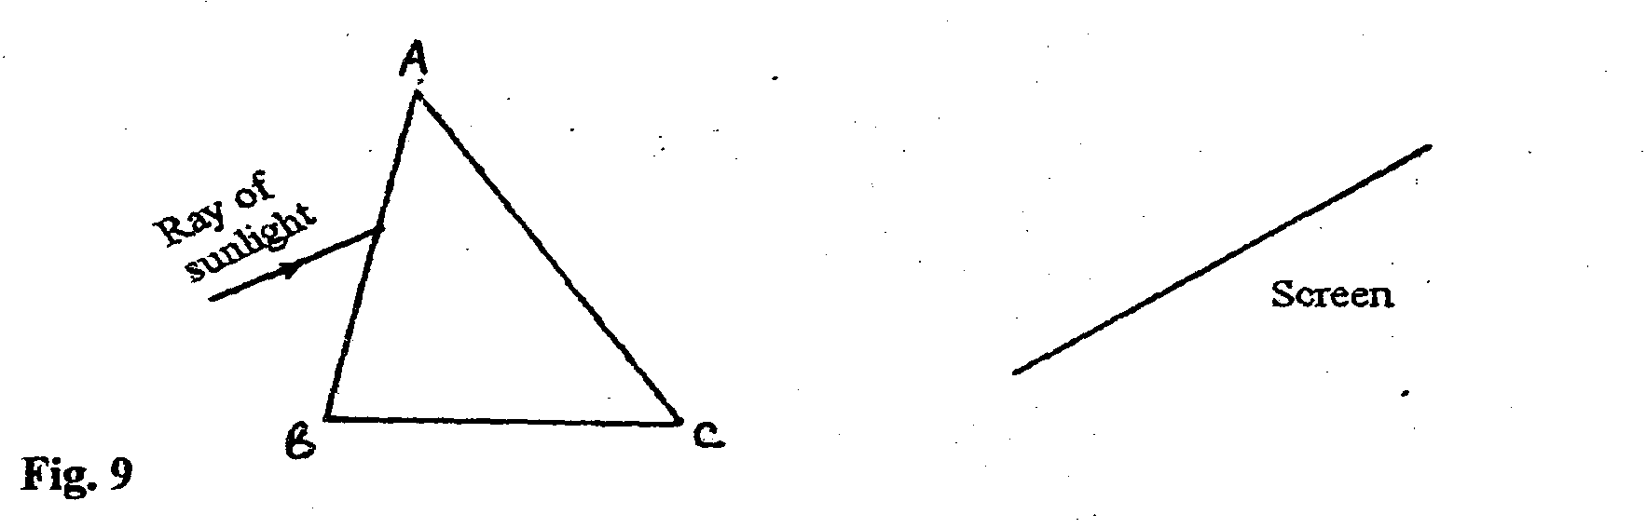
Fig. 9

i) Complete the diagram showing the observation on the screen.
ii) Explain the observation on the screen.
iii) State why the spectrum formed above is not pure.
b) i) You are provided with four equilateral prisms and four convex lenses. Sketch a diagram
showing how all the eight can be arranged to make a simple prism binoculars.
ii) State one reason why prisms produce better optical instruments than plane mirrors.

Refraction of light
1. _{a}η_{p} = 1.47 and _{a}η_{g} = 1.55
_{g}η_{p}= _{g}η_{a} x _{a}η_{p}
_{= a}η_{p}


_{a}η_{g}
= 1.47 =0.9484
1.5


Sin C = 1 = 0.9484
η
C = sin⁻¹(0.9484)
C = 71.5º
2. (i) for incident and reflected ray

(ii) The ray undergoes total internal reflection. Since angle of incident is greater than aº the
critical angle.

3. a) The ratio the sin Ø of the angle of incidence to the sin e of the angle of refraction
is a constant for a pair of media
b) When a ray is moving from an optically dense medium to a less optically dense
medium or when the angle of incidence in the optically dense medium is greater than the critical angle

c) a^{n}_{g} = ^{sin i}/_{sin r}
= ^{sin 48°}/_{sin 32°}
= 1.40, Accept 1.402

d) Separation of colours of light from white light

4. gnw = gna x anw

= ²/₃ x ⁴/₃
= ⁸/₉

⁸/₉ = sinθ
sin 40
sin θ = ⁸/₉sin 40 = 0.5713

= 34.84º


5. If the refractive index of medium 1 is ⁴/₃ and that of medium 2 is 3/2. Calculate angle r n1sinθ1 = n2 sinθ2
⁴/₃ sin 35 = ³/₂ sinθ2
sinθ2 = ⁴/₃ X ²/₃ sin 35 = 0.5098
θ2 = 30.654
6. a) i
ii) n = 1
sin 42
Sin 25 = I√
Sin r R
Sin 25 = sin 42√
Sin r
Sin r = Sin 25
Sin 42
= 0.631593
r = Sin ⁻¹ (0.631593)
= 39.17° (accept 39.2°)√

7. (a) (i)-When a ray is moving from an optically denser medium to a less optically dense medium.
- When the angle of incidence in the optically denser medium is greater than the
critical angle (any 1)
(b) Sin C = n₂ = 1.3 = 0.866
n₁ 1.5
∠C = sin⁻¹0.866 ∴∠C = 60.1º
(c) (i) From the len’s formula 1 = ¹/_{V}+ ¹/_{u} and dividing both sides by V,
V = 1 + ^{V}/_{u} , but ^{V}/_{u} = M
^{V}/_{f} = 1 + M and making M the subject ;
M = ^{V}/_{f} -1
(ii) Graph: - scale used (1mk)
- Labeling axis
- Straight line
- Points
- Gradient/slope
¹/_{V} = ¹/_{u} – ¹/_{f}
¹/_{f} = 1/_{u} + 1/_{V} or ¹/_{V} = ¹/_{f} – ¹/_{u}
Gradient = Negative
¹/_{V} Intercept = ¹/_{f}
Refraction of light
1. _{a}η_{p} = 1.47 and _{a}η_{g} = 1.55
_{g}η_{p}= _{g}η_{a} x _{a}η_{p}
_{= a}η_{p}


_{a}η_{g}
= 1.47 =0.9484
1.5


Sin C = 1 = 0.9484
η
C = sin⁻¹(0.9484)
C = 71.5º
2. (i) for incident and reflected ray

(ii) The ray undergoes total internal reflection. Since angle of incident is greater than aº the
critical angle.

3. a) The ratio the sin Ø of the angle of incidence to the sin e of the angle of refraction
is a constant for a pair of media
b) When a ray is moving from an optically dense medium to a less optically dense
medium or when the angle of incidence in the optically dense medium is greater than the critical angle

c) a^{n}_{g} = ^{sin i}/_{sin r}
= ^{sin 48°}/_{sin 32°}
= 1.40, Accept 1.402

d) Separation of colours of light from white light

4. gnw = gna x anw

= ²/₃ x ⁴/₃
= ⁸/₉

⁸/₉ = sinθ
sin 40
sin θ = ⁸/₉sin 40 = 0.5713

= 34.84º


5. If the refractive index of medium 1 is ⁴/₃ and that of medium 2 is 3/2. Calculate angle r n1sinθ1 = n2 sinθ2
⁴/₃ sin 35 = ³/₂ sinθ2
sinθ2 = ⁴/₃ X ²/₃ sin 35 = 0.5098
θ2 = 30.654
6. a) i
ii) n = 1
sin 42
Sin 25 = I√
Sin r R
Sin 25 = sin 42√
Sin r
Sin r = Sin 25
Sin 42
= 0.631593
r = Sin ⁻¹ (0.631593)
= 39.17° (accept 39.2°)√

7. (a) (i)-When a ray is moving from an optically denser medium to a less optically dense medium.
- When the angle of incidence in the optically denser medium is greater than the
critical angle (any 1)
(b) Sin C = n₂ = 1.3 = 0.866
n₁ 1.5
∠C = sin⁻¹0.866 ∴∠C = 60.1º
(c) (i) From the len’s formula 1 = ¹/_{V}+ ¹/_{u} and dividing both sides by V,
V = 1 + ^{V}/_{u} , but ^{V}/_{u} = M
^{V}/_{f} = 1 + M and making M the subject ;
M = ^{V}/_{f} -1
(ii) Graph: - scale used (1mk)
- Labeling axis
- Straight line
- Points
- Gradient/slope
¹/_{V} = ¹/_{u} – ¹/_{f}
¹/_{f} = 1/_{u} + 1/_{V} or ¹/_{V} = ¹/_{f} – ¹/_{u}
Gradient = Negative
¹/_{V} Intercept = ¹/_{f}

