Radioactivity
1. Complete the following equation by determining the values of U and V.
u

v
234

90
0

-1
Th Pa + e

U……… V……………..

2. (a) Distinguish between nuclear fusion and fission
(b) Compete the nuclear equation below:-
230 230
90
91
+

3. Uranium -238 disintegrates by emitting an alpha particle to form substance Y.
Nuclide Y emits a beta particle to form substance Z. Write down nuclear equations to show how
substance Y and Z are formed (U=At No. 92)

4. (a) What is a nuclide?
(b) The graph below shows the radioactive decay of a certain nuclide. Determine the
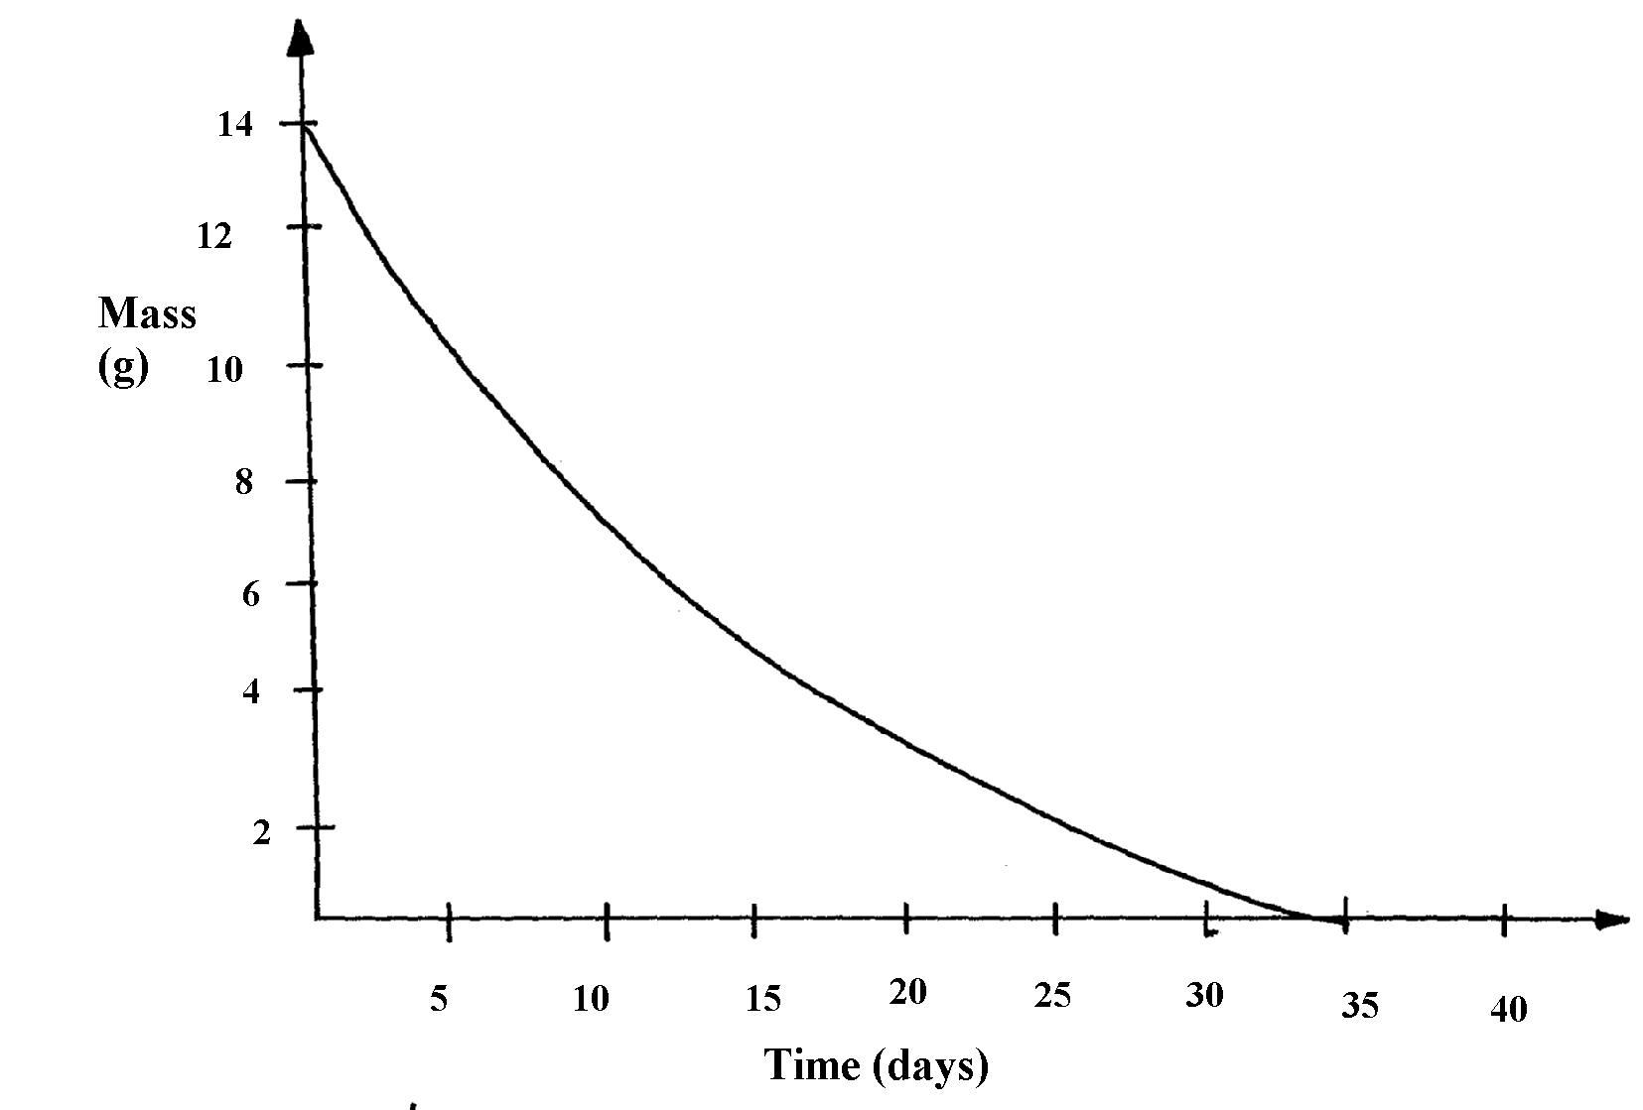
half-life of the nuclide

(e) What effect do excessful exposures of radiation have on metals?
5. (a) State one way in which nuclear reactions differ from ordinary chemical reactions
(b) The following is a part of Uranium decay series
238
U
92
234
Th
90
234
Pa
91
Z
X
A
Step I
Step II
Step III

(i) Which particles are emitted in step I and II
(ii) If a beta particle is emitted in step III, find Z and A
(iii) If the activity of Thorium -234 is reduced to 25% in 48hours, find its half life
6. Substances A and B are represented by the formulae ROH and RCOOH respectively.
They belong to two different homologous series of organic compounds. If both A and B
react with potassium metal:
(a) Name the common product produced by both
(b) State the observation made when each of the samples A and B are reacted with sodium
hydrogen carbonate
(i) A
(ii) B
7. Some two elements are represented as:
16 27
and
8 13

(a) How many protons does X have?
(b) How many neutrons does Y have?
(c) Draw the structure of the compound formed between X and Y
8. Y grams of a radioactive isotope take 120days to decay to 3.5grams. The half-life period
of the isotope is 20days
(a) Find the initial mass of the isotope
(b) Give one application of radioactivity in agriculture

9. Study the nuclear reactions given and answer the questions that follow:
¹²
⁶
Step I
¹⁴
⁶
Step II
¹⁴
⁷
X Y Z

(a) Write an equation for the nuclear reaction in step II (lmk)
(b) Give one use of Y (lmk)
10. Give two uses of radioactive isotopes in medicine.
11. Study the information in the following table and answer the questions that follow. The letters
do not represent the actual chemical symbols of the elements.
ELEMENT | U | V | W | X | Y | Z
NUMBER OF PROTONS | 18 | 20 | 6 | 16 | 19 | 17
NUMBER OF NEUTRONS | 22 | 20 | 8 | 16 | 20 | 20
Which of the above elements are:
(i) Likely to be radioactive?
(ii) Able to form a compound with the highest ionic character?

12. The isotope decays by Beta, β -emission to a stable nuclide. The half-life of the
²⁴
¹¹
isotope is 15hours 2.0g of is allowed to decay. Determine the mass of left after 90hours
13. (a) Complete the following nuclear equation
55

24
55

25
Cr Mn + ____________

(b) 100g of a radioactive substance was reduced to 12.5g within 15.6 years. Determine
the half-life of the substance

