Quality of heat
1. (a) Define the term specific heat capacity.
(b) A block of metal of mass 300g at 100⁰c is dropped into a logged calorimeter of heat capacity
40Jk⁻¹, containing 200g of water at 20⁰c. The temperature of the resulting mixture is 34⁰c.
(Specific heat capacity of water = 4200Jkg⁻¹k⁻¹)
Determine:
(i) Heat gained by calorimeter.
(ii) Heat gained by water.
(iii) Heat lost by the metal block.
(iv) Specific heat capacity of the metal block.

2. (a) State two differences between boiling and evaporation.
(b) 200g of a solid was uniformly heated by a 0.2 kw heater for sometime. The graph in the
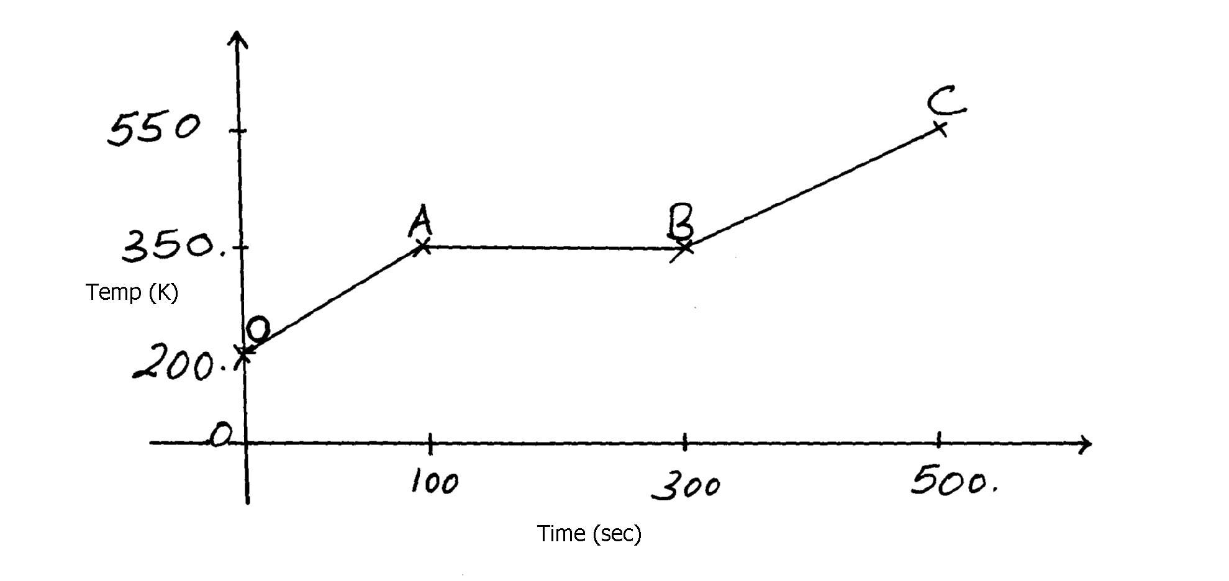
figure below shows how the temperature of the solid changed with time.
Figure 8
550
350
200
Temp (K)
100
300
500 00
C 00
B 00
A 00
0 00
O 00
Time (sec)

(i) Explain what is happening between OA and AB.
(ii) Calculate the specific heat capacity of the solid.
(iii) Calculate the specific latent heat of fusion k of the solid.

3. (a) Define the term heat capacity
(b) A block of metal of mass 150g at 100ºC is dropped into a logged calorimeter of heat capacity
40Jk⁻¹ containing 100g of water at 25ºC. The temperature of the resulting mixture is 34ºC.
(Specific heat capacity of water = 4200J/KgK)
Determine;-
(i) Heat gained by calorimeter
(ii) Heat gained by water
(iii) Heat lost by the metal block
(iv) Specific heat capacity of the metal block

4. (a) Distinguish between evaporation and boiling
(b) A jet delivering 0.44g of dry steam per second, at 100ºC is directed on to crushed ice
at 0.0ºC contained in an unlagged copper can which has a hole in the base. 4.44g of water
at 0.0ºC flow out of the hole per second
(i) How many joules of heat are given out per second by condensing steam and cooling to
0.0ºC of water formed?(Latent heat of vaporization of steam = 2.26 x 10⁶JKg⁻¹,
c for water = 4200JKg⁻¹K⁻¹)
(ii) How much heat is taken in per second by the ice which melts?
(iii) Suggest why these amounts above are different
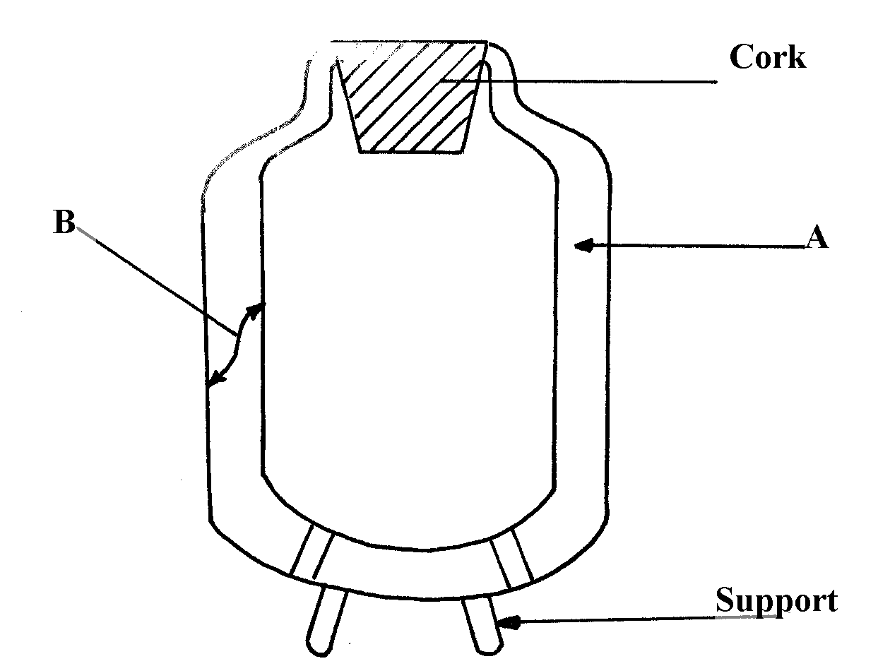
(c) Figure 7 below shows a cross-section of a vacuum flask

(i) Name the parts labelled A and B on the diagram
(ii) Explain how the heat losses are minimized when hot liquid is poured into the flask

5. (a) Figure 2 shows two identical thermometers. Thermometer A has a blackened bulb while
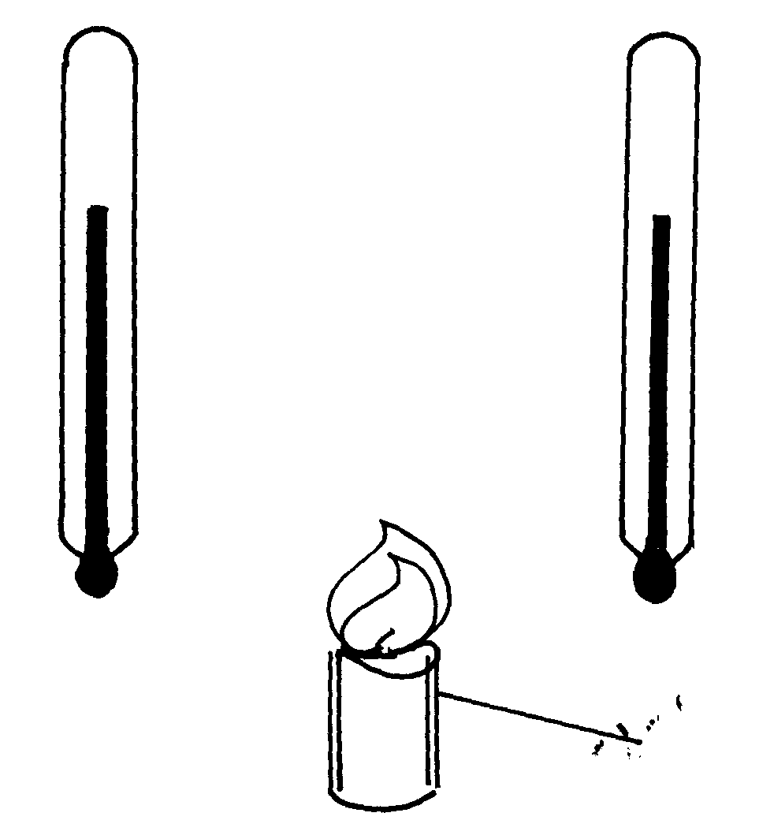
thermometer B has a silvery bulb. A candle is placed equidistant between the two thermometers
Candle
B
A

Fig. 2

State with a reason the observations made after some time
5. (b) Figure 3 shows a test tube partially filled with water. An ice wrapped in wire gauze is
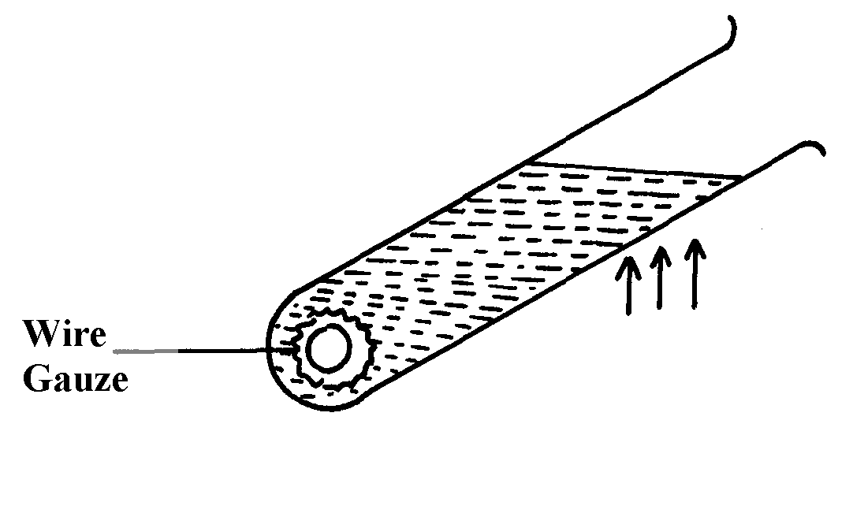
placed at the bottom of the test-tube. It is then held in the flame of a bunsen burner as
shown below

fig. 3

State and explain what will be observed after some time
6. Give any two differences between evaporation and boiling
7. Explain why steel feels colder than wood at the same temperature

8. An electric heater 1KW 240V is used to raise the temperature of a 5kg copper block from
15ºC to 33ºC. If the specific heat capacity of copper is 400JKg⁻¹K⁻¹ and assuming no heat is
lost to the surrounding,
Calculate the time taken

9. (a) Define specific latent heat of fusion
(b) 0.5kg of naphthalene contained in an aluminium can of mass 0.4kg is melted in a water
bath and raised to a temperature of 100ºC . Calculate the total heat given out when the
can and its contents are allowed to cool to room temperature, 20ºC . Neglect losses by
evaporation during heating process and give your answer to the nearest kilojoule.
(For naphthalene melting point = 80ºC , Specific heat capacity for both liquid and
solid =2100J/KgK; specific latent heat of fusion = 170000J/Kg.
For aluminium: specific heat capacity = 900J/Kgk
(c) Briefly explain two ways other than direct heating by which quantity of liquid may be made to
evaporate more quickly
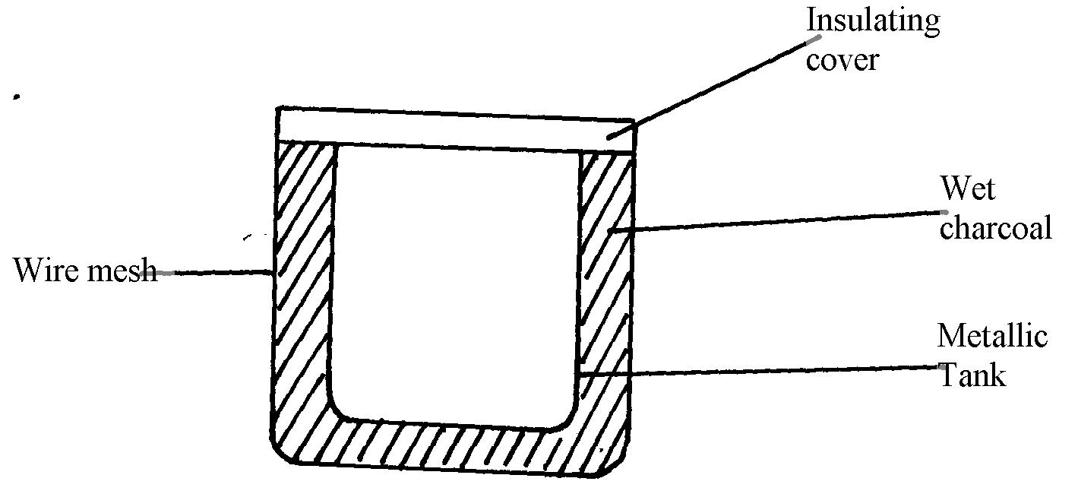
(d) The diagram below shows a charcoal refrigerator

(i) Explain why charcoal is used and why it is sprinkled with water
(ii) What is the role of the metallic tank and the wire mesh

10. An electric kettle with a shinny outer surface would be more efficient than one with a dull
outer surface. Give a reason for this

11. A heating element rated 2.5 KM is used to raise the temperature of 3.0 kg of water through
50ºC. Calculate the time required to Effect this. (Specific heat capacity of water is 4200J/kgK).

Quality of heat
1. a) Specific heat capacity is defined as the quantity of heat required to raise the temperature of
a unit mass of a substance by one Kelvin. 1 mk
b) (i) heat gained by calorimeter
Q_{E} = C∆θ
= 400Jk⁻¹ x (34 – 20)k 1 = 560j 1

(ii) Heat gained by water
Q_{W}= MC∆θ = 200 kg x 4200kg⁻¹k⁻¹ x(34 – 20)k
= 11760j 1
(iii) Heat lost by the metal = heat gained by the calorimeter + heat gained by Water.
= 560j + 11760j = 12320j 1
(iv) Specific heat capacity of the metal.
C = Q 1
M∆θ
= 12320 j 1
0.3 kg x (100 – 34)
= 12320j = 622.22 jkg⁻¹k⁻¹ 1
0.3kg x 66 k
2. (a)
Boiling | Evaporation
- Takes place at constant temperature  - Not affected by surface area of liquid exposure  - Vigorous, visible process al over the liquid | - Takes place at all temperatures  - Increases with increase in surface area  - Slow invisible process at the liquid surface
(each for any two correct)
(b) (i) A – Temperature of the solid in increasing;
AB- solid is melting;

(ii) Heat supplied = Heat gained
p x t = MCΔθ
200 x 100 = 0.2 x C x 100
20 x 100 = 0.2 x C x (350 – 250)
C= 1000JKg-1 K-1;

(iii) Heat applied = heat gained; OR
p x t = Mlf;
200 x 200 = 0.2 x lf;
lf = 200,000J/Kg;
3. (a) The quantity of heat required to raise the temperature of a given mass of a material
by one Kelvin.
(b) (i) C = Q
θ
Q = Cθ
= 40 x (34-25)
= 40 x 9 = 360J
(ii) M_{w}C_{w}D = (0.1 x 9 x 4200) = 3780J

(iii) Heat lost = heat gained by calorimeter + heat gained by water
= 3780 + 360 = 4140J or 4.14KJ
(b) 150 x C_{m} x Δθ = 4140
1000
0.15 x (100 – 34) C_{m} = 4140
9.9C = 4140
Cm = 4140 = 48.18JKg⁻¹K⁻¹
9.9
(b)
Boiling | Evaporation
- Temperature is constant  - Affected by impurities and pressure  - vigorous with bubbles  - takes place in the whole liquid | - Temperature can vary  - Not affected with impurities  - not vigorous, no bubbles  - takes place at the surface
4. (a) Evaporation is change of liquid to gas at any temperature while boiling is change of liquid
to gas at constant temperature;
(i) Heat – ml_{v} + MCΔθ
= 0.44 x 2.26 x 10⁶ + 0.44 x 4200 x 100;
1000 1000
=994.4 + 184.8 = 1179.2J;
(ii) Q = mLf;
t t
= 4.4 x 10⁻³ x 3.34 x 105
= 1336J;
(iii) - Heat is absorbed from the surrounding since the can is unlagged;
(c) A = Vacuum;
B = Silvered (shiny) surfaces/polished/smooth;
(ii) - Loss of heat by conduction is reduced by cork and vacuum;
- Loss of convection is reduced by vacuum;
- Loss by radiation is reduced by silvered wall;
5. Thermometer A gives a higher reading than B; √ 1 Black surface is better absorber of heat than silvery surface√1
5. Water at the top part of the boiling tube boils while the ice remains unmelted. This is because
water is a poor conductor of heat and hot air less dense remain at the top.
6. – Evaporation is silent while boiling is a vigorous visible process
- Evaporation takes place at all temperatures while boiling takes place at a specific
temperature
- Evaporation takes place on the surface of the liquid but boiling takes place in the whole
liquid
7. Steel is a good conductor of heat; therefore draws heat from your body unlike wood
which is a poor conductor of heat
8. Pt = MCDT DT = 35 – 15 = 18K
T = MCDT
= 5kg x 400JKg⁻¹K⁻¹ 18K
1000JS⁻¹
= 36s

9. (a) It is the quantity of heat required to convert a unit mass of the substance from the solid to the liquid state without change of temperature (1mk)
Heat lost by naphthalene
T = 100-80=20k
H1 = 0.5kg x 2100JKg⁻¹K⁻¹ x 20K = 2100J
Lf = mLf = 0.5kg x 170000JKg⁻¹ = 85000J
T = 80 -20 = 60k , H₂ = 0.5kg x 2100JKg⁻¹K⁻¹ x 60k = 63000J
Heat lost by aluminium
T = 100 – 20 = 80k
H = 0.4kg x 900JKg⁻¹K⁻¹ x80k = 28800J
Total heat lost = 169000J + 28800J = 197800J
= 197.8KJ
= 198KJ
(c) Blowing wind over the surface of the liquid increases the kinetic energy of the
liquid molecules
- It can also be made to evaporate faster by bubbling air though the liquid as it increases the
surface area from which the liquid molecules may escape
(d) (i) – Charcoal is a black body and therefore a batter absorber of heat
- Sprinkled with water, so that it takes latent heat from the air around the air around
and evaporates , causing cooling in cabinet
(ii) Heat is conducted by the by the metallic tank and the wire mesh to the surrounding air
10. Loss of heat through radiation is reduced/ minimized √

Quality of heat
1. 500g of a metal is heated to 100ºC and then placed in a 200g mass of water at 15ºC. If the
final temperature rises to 21ºC, calculate the specific heat capacity of the metal.
(Specific heat capacity of water = 4200J⁻¹kg⁻¹

Quality of heat
1. Heat lost by the metal = Heat gained by the water
MmCm= MWCW
0.5 x CM(100-21)ºC = 0.2 x 4200 x(21-15)ºC
Cm = 5040 = 127.59JKg⁻¹K⁻¹
39.5

