- Quadratic equations
1 |  | M₁  A₁ | Comparing terms or equivalent
 |  | 2

1. (3x + 5)² + ( 611)² = ( 7x = 2)²
(9x² + 30x + 25) + 611 = 49x² + 28x + 4
- 40x² + 2x + 632 = 0
20x² - x = 316 = 0
x = 1 ± 2581
40
= 160 OR x = 4
40
Area = ( ½ x 611 x 17
= 210.1cm²

2. 7x – 4 ≤ 9x + 2 9x + 2 < 3x + 14
-6 ≤ 2x 6x < 12
2 2 x < 2
-3≤ x
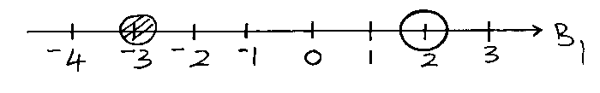
∴-3 ≤ x <2

Integral values are -3, -2, -1, 0 and 1

