FORM ONE , BIOLOGY HOLIDAY ASSIGNMENT 2013, TERM 3.
5. Transport in (a) plants (b) animals
1. a)xplain why a fresh wound on the skin bleeds more on a hot sunny day than on a cold chilly day
b)State three adaptations of red blood cells to their functions.
3. How are sieve tube elements adapted to their function
4. Name the polysaccharides found in the following structures:-
(a) Exoskeleton

(b) Xylem vessels
5. State three factors that maintain transpiration stream
6. (a) List three forces that facilitate the transport of water and mineral salts up the stem.
(b) Name the tissue that is removed when the bark of a dicotyledonous plant is ringed.
7. Study the dental formula of an organism below..
I ³/₃, C ¹/₁, Pm ^{3/}₂, M ¹/₁ = x
(a) (i) What is the total number of teeth this organism possess?
(ii) What is the mode of feeding of the organism?
(b) State two functions of mucus produced along the alimentary canal.
(c) State the functions of part A.
8. What is the destination of materials translocated in plants.
9. A person whose blood group is AB requires a blood transfusion, name the blood groups of the
donors.
10. Explain why capillaries are:
(i) Thin walled
(ii) Branched
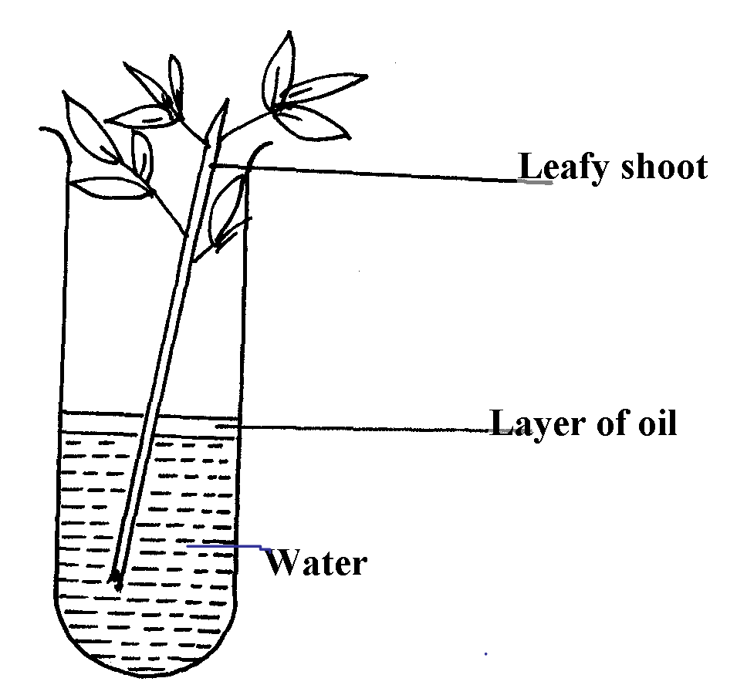
11. An experiment was set-up as shown below to investigate a certain plant process:

(a) What process was being investigated above?
(b) What observation was made if;
(i) The experiment was left in strong wind for one hour? (ii) All the leaves were removed from the plant?
12. How is aerenchyma tissue adapted to its function
13. (a) State three structural differences between arteries and veins in mammals
(b) Name a disease that causes thickening and hardening of arteries 14. Identify two forces that help in upward movement of water in plants 15. State three ways in which red blood cells are adapted to their functions 16. (a) Distinguish between tissue fluid and lymph (b) Explain why deficiency of vitamin K leads to excessive bleeding even from small cuts
17. Name the type of circulatory system found in the phylum Arthropoda
18. Name the blood vessel that nourishes the heart
19. a) In which form is oxygen transported in the blood. b) Why do plants not take in oxygen during the day although they need it for respiration
20. Name a disease of the blood characterized by excessive production of white blood cells
22. Laboratory analysis of a patient’s urine revealed the following concentration of various
substances:
Blood proteins 0.00%
Water 50%
Glucose 48%
Salts 0.8%
Urea 1.2%
a) From the analysis above, which disease is the patient suffering from
b) Name two symptoms of the disease in 3(a) above
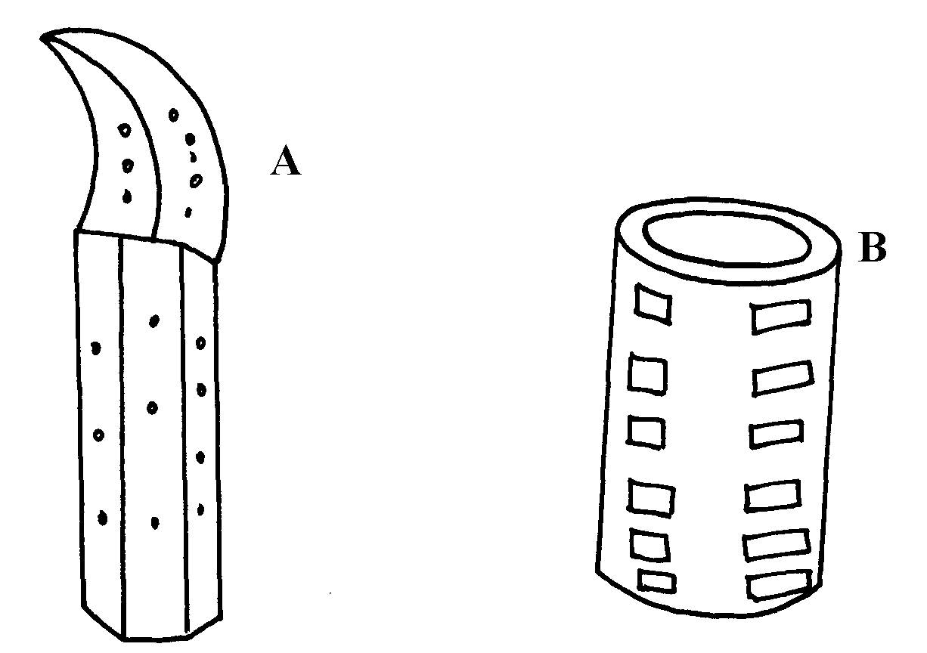
23. The diagrams below show two conducting elements of the xylem tissue

a) Identify each of them A and B
b) What makes the cellulose side walls of both A and B able to prevent collapsing?
24. Explain why the rate of transpiration is reduced when humidity is high 25. (a) State two functions of the xylem vessels, (b) List two structural adaptations that make xylem vessels suitable to their function
26. (a) What is peristalsis? (b) Explain how the process above is brought about.
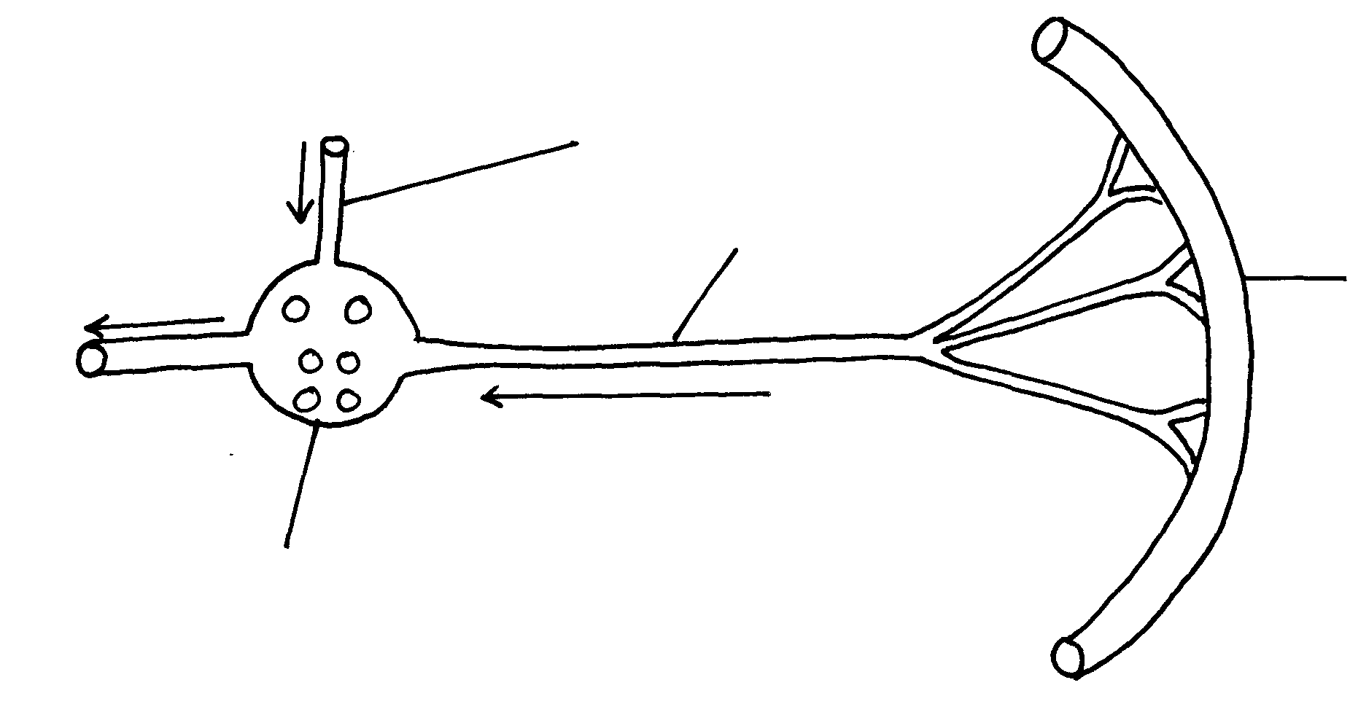
27. The diagram below shows a part of a circulatory system. The arrows indicate the direction of the
A
B
C
Ileum
flow of blood;

(a) Identify the blood vessels labeled A and B
(b) Explain why it is important to transport food substances to organ C before being released
for circulation to the rest of the body
28. Name four methods plants employ to remove excretory waste products
29. a) State the form in which oxygen is transported in the mammalian blood b) Why is it dangerous to sleep in an enclosed room with a burning jiko
c) Why do plants not take in oxygen during the day although they need it for respiration
30. Name a disease of blood characterized by excessive – production of white blood cells
31. The table below is a representation of a chromosomal mutation
Before mutation | L | M | N | O | P | Q
After mutation | L | O | N | M | P | Q
(a) Name the type of chromosomal mutation represented above (b) Name one mutagenic agent
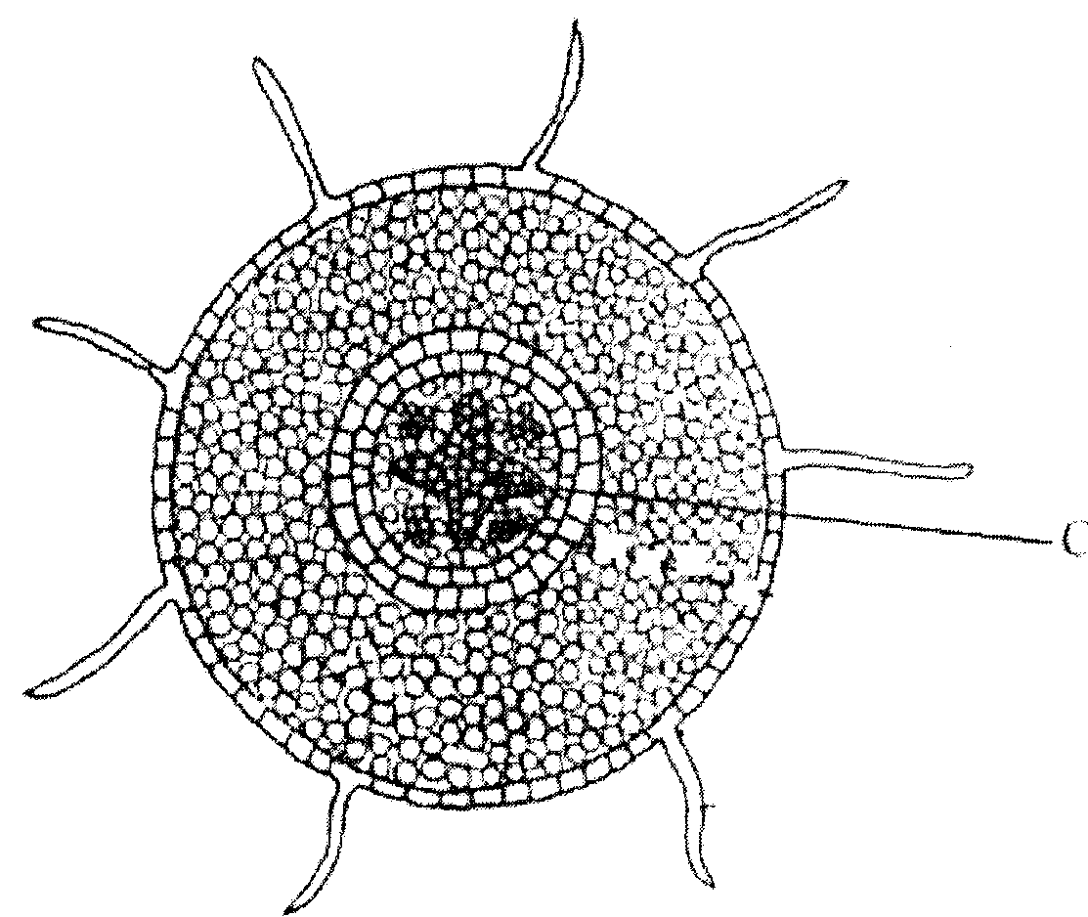
32. The diagram shows a section through a plant organ.
C

(a) (i) Name the class of the plant from which the section was obtained belong.
(ii) Give a reason for your answer in (a)(i) above (b) How is the part labelled C adapted to its functions? 33. State two roles of transpiration to a plant 34. Uptake of water by plants is not affected by metabolic poisons. Explain.
35. The diagram below represents a plant tissue.
B
A
A

(a) Identify each of them. (b) What property makes B to be more efficient in function? (c) What makes the walls of both A and B impermeable to water and solutes?
36. A woman gave birth to a child of blood group B+ (B positive). Name the two antigens that
determined her child’s blood group. 37. A transfusion of RH⁺ blood was given to a patient with Rh⁻ blood. After one week a similar
transfusion was given to the same patient. What was likely to be the effect of the second
transfusion?
38. The diagrams below show stages in the process of feeding shown by amoeba.
Food
Nucleus
A
B

(a) Name the part labeled A. (b) Name the process illustrated in the diagram above. (d) Name the type of cell in human beings that exhibit this process. 39. (a) Why are xylem vessels more efficient in the transport of water than tracheids?
(b) What is the significance of xylem vessels being dead? 40. Distinguish between guttation and transpiration 41. Other than transport, state one other function of xylem tissue in plants
42. State two functions of aerenchyma tissue in plants
43. (a) What is sickle-cell anaemia? (b) Identify the part of the heart that initiates the heart beat
44. (a) Give a reason why the left ventricle muscles are thicker than the right ventricles muscles
(b) State the forms in which carbon (IV) oxide is transported in the blood 45. Explain how the following adaptation reduce transpiration in xerophytes
(a) Sunken stomata
(b) Thick waxy cuticle 46. Name the: (a) Material that strengthens xylem tissue
(b) Tissue that is removed when the bark of a dicotyledonous plant is ringed
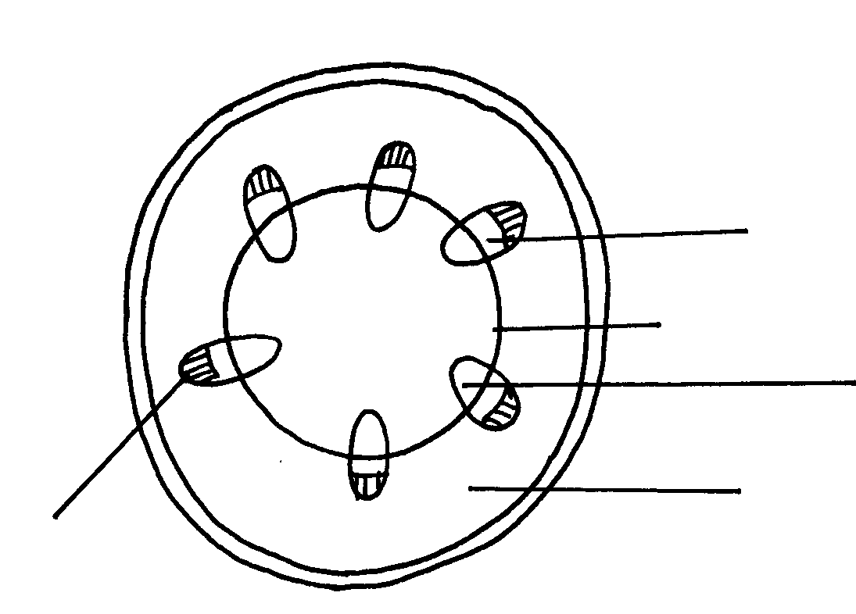
47. The diagram below shows the traverse section of a young stem.
E
A
B
C
D

(a) What are the functions of the structures labeled A, B and C (b) What type of cells are fonjd in the parts labeleld D
(c) Name the tissue labeled E 48. Name the components of blood that do not enter the renal tubule in mammals
49 Outline the route taken by a molecule of glucose from the ileum up to the kidney.
50. The flow chart below shows a blood transfusion pathway
AB
A
O
B

(a) What three conclusions can you draw from the flow chart? (b) State two precautions that must be observed during blood transfusion (c) Explain how blood clot is formed once a blood vessels is injured
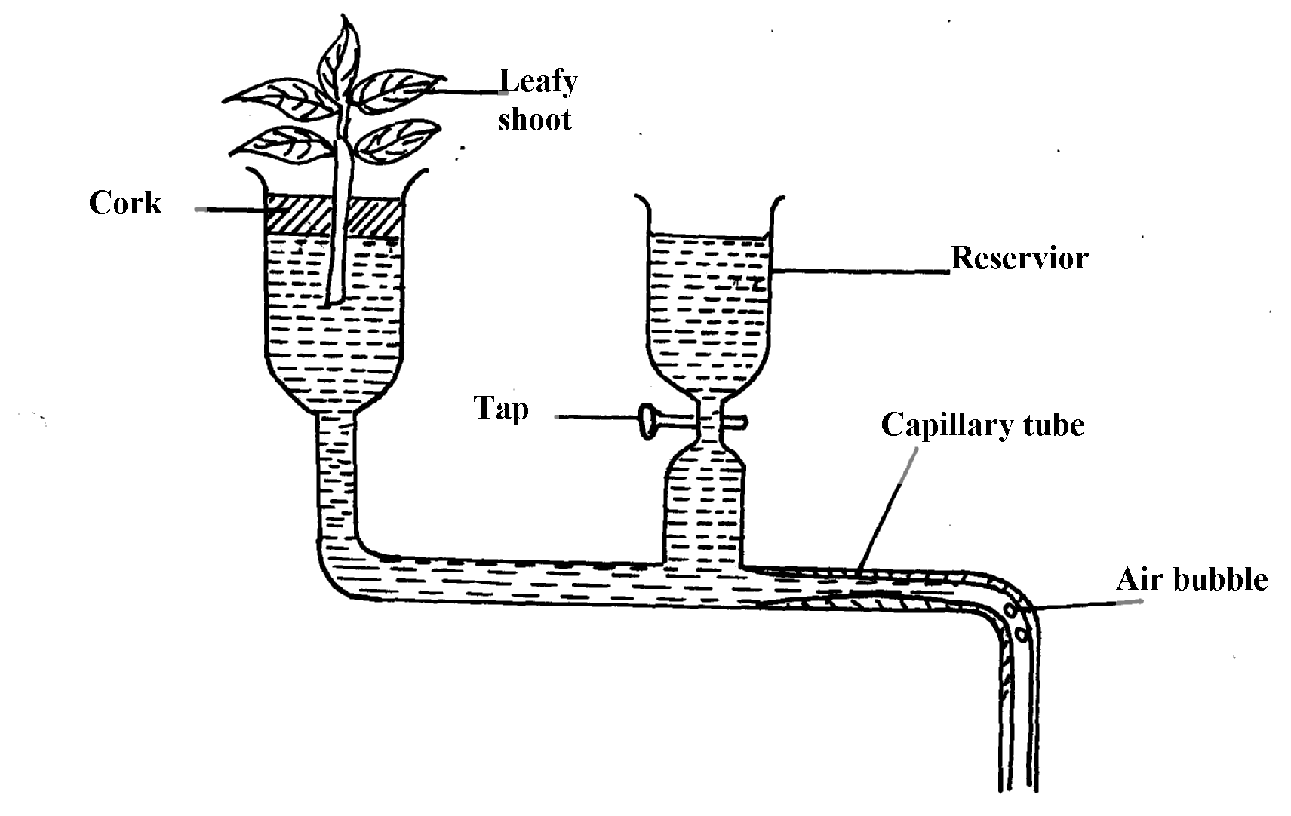
51. The figure below represents a diagram of a photometer;

(a) What is the photometer used for ? (b) State the precautions which should be taken when setting up a photometer
(c) Explain what you will expect if set up was placed under the following environmental
conditions;
(i) Dark room
(ii) Leafy shoot enclosed in polythene bag
(iii) In a current of air created by a fan
52. The amount of blood flow through various parts of the body of a mammal was measured in
cm³ per minute at rest and during different physical activities. Results are shown below.
 | Blood flow in cm³/min
 | At rest | During light Exercise | During strenuous Exercise
Heart muscles | 200 | 300 | 1050
Gut | 1300 | 1000 | 400
Skeletal muscles | 1100 | 5050 | 23000
Kidneys | 900 | 650 | 250
Skin | 400 | 1300 | 600
a) Calculate the percentage change in blood flow through the skeletal muscles and gut when the
mammal was exposed to strenuous exercise.
i) Skeletal muscles
ii) Gut
b) Account for the differences in amount of blood flow through the gut and skeletal muscles;
i) At rest
ii) During streneous exercise
c) Account for the result obtained for the skin during light exercise
d) Name two substances which are removed from the body by the kidney
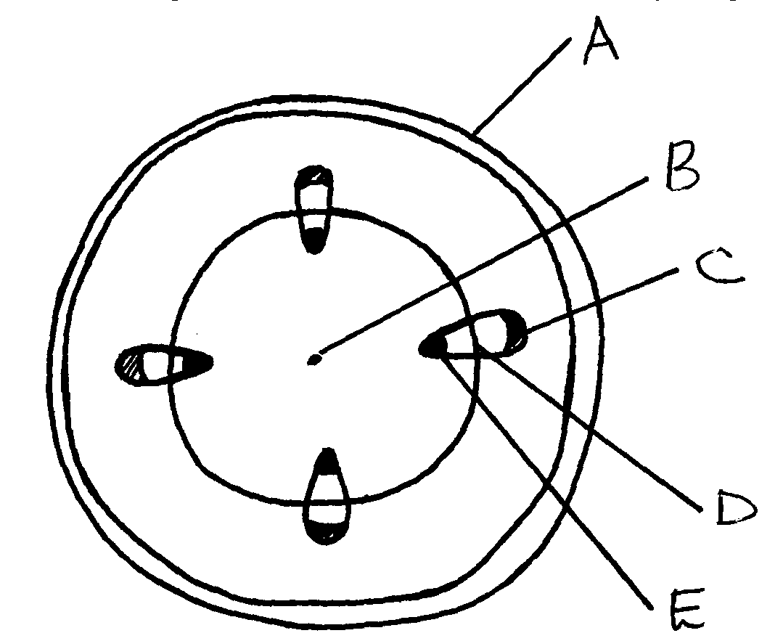
53. The diagram below represents a transverse section of a young stem.

(a) Name the parts labeled A, B and D
(b) State the functions of the parts labeled C and E
(c) List three differences between the section above and the one that would be obtained from
the root of the same plant
54. Describe the functions of the various components of the mammalian blood

MERRY XMASS AND HAPPY NEW YEAR 2014.
MADAM OPILI CHRISTINE.

