5. Support and movement in (a) Plants (b) animals
1. Explain how the following tissues are adapted to provide mechanical support in plants:-
a) Parenchyma
b) Collenchyma c) Selerenchyma
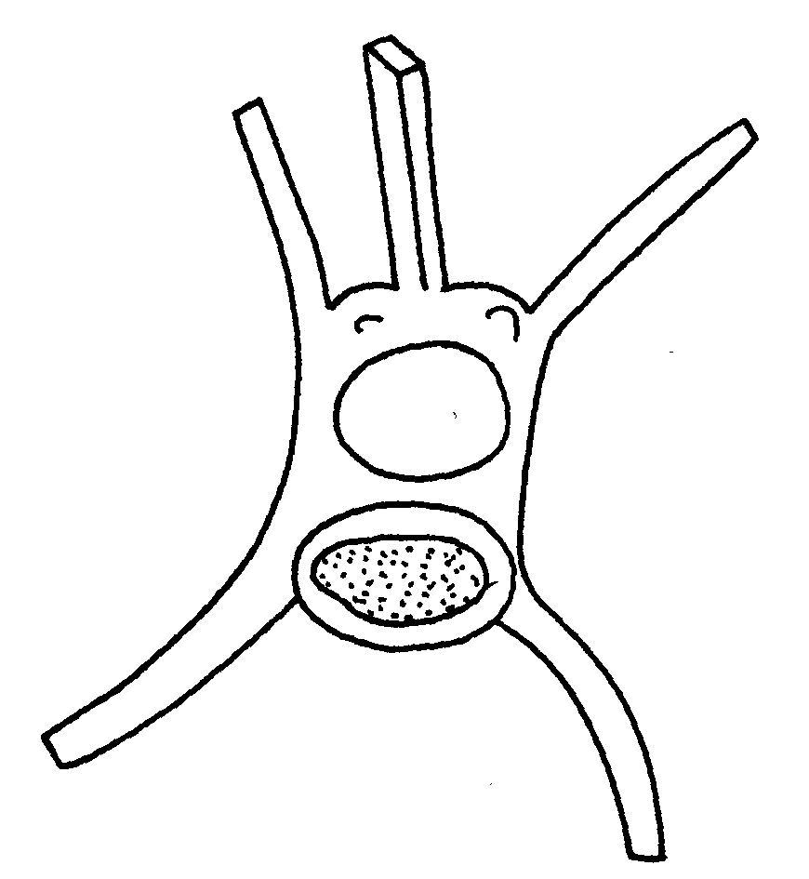
2. The diagram below represents a bone in the mammalian skeleton
D

a) Identify the bone with a reason
b) State the function of the part labeled D
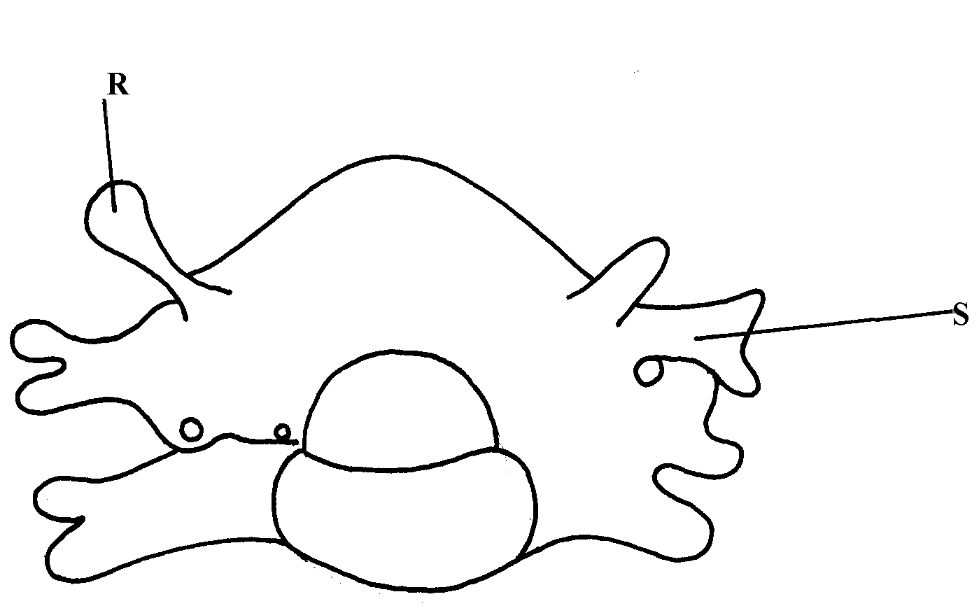
3. The diagram below represents a mammalian bone

(a) Identify the bone shown above
(b) State the function of the parts labelled R and S
(c) State the region of the body in which the bone is found
4. (i) Name two bones that form the ball and socket joint in the fore limb of a mammal
(ii) Name the fluid that is found in the above mentioned joint and its function
5. State three types of skeleton found in Kingdom animalia
6. State three differences between an animal’s muscle cell and plant’s palisade cell
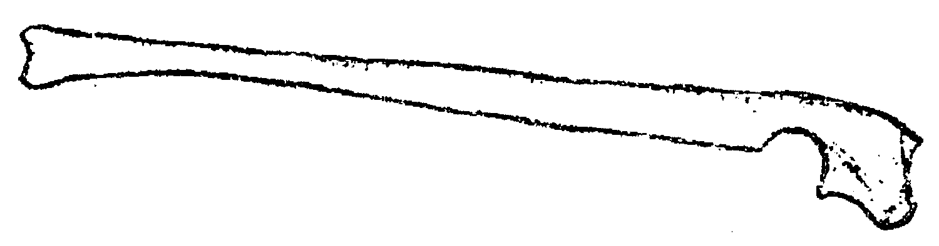
7. The diagram below represents a mammalian bone

(a)Name the bone
(b) (i) Which bone articulates with the bone shown in the diagram at the notch
(ii) Name the type of joint formed when the bones in b(i) articulate
8. (a) Name the hard outer covering of the members of the phylum Arthropoda
(b) State two roles played by the structure named in (a) above
9. (a) State the role of lignin in the wall of the xylem vessel
(b) How does vascular bundles contribute to support in plants
10. (a) Distinguish between tendons and ligaments
b) State one way through which herbaceous plants achieve support
11. Name the ;
a) i) Material used to strengthen the xylem tissue
ii) Tissue that is removed when the bark of a dicotyledonous plant is ringed
b) State the areas of the plant where translocated materials are taken
12. Give three importance of mammalian skeleton
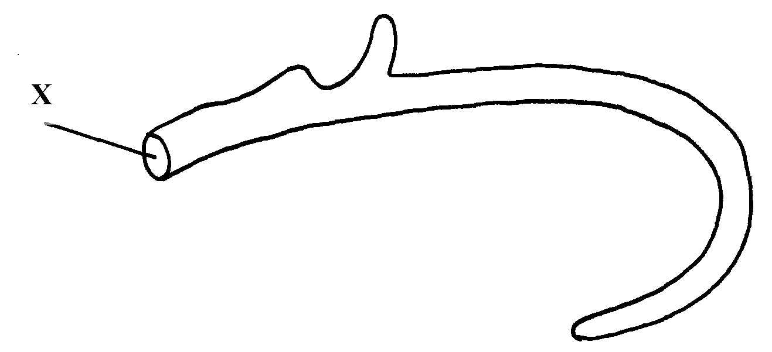
13. The diagram below represents the anterior view of a rib

Name the part labelled X

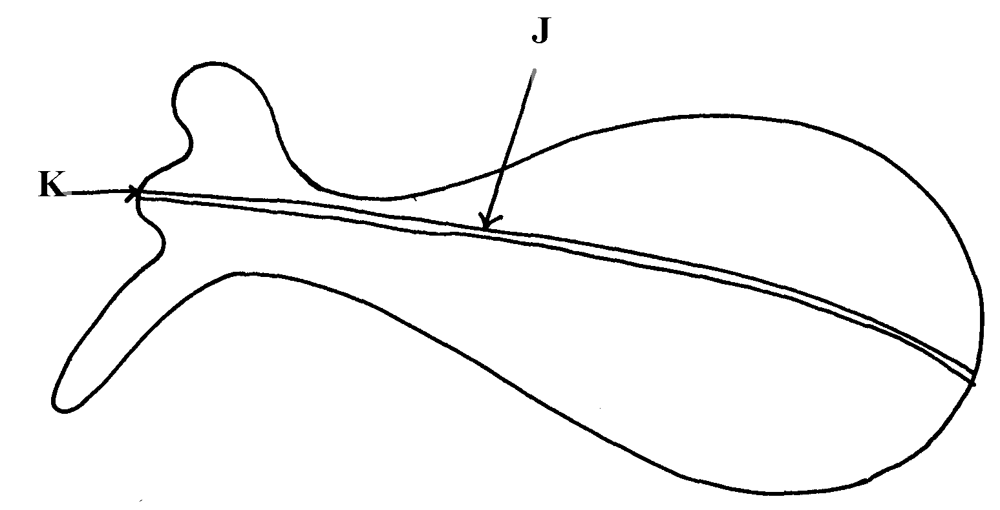
14. The diagram below represents a bone obtained from a mammal

a) Name the bone

b) Name the:
i) Bones which articulate with the bone named in (a) above at the cavity labelled K
ii) Joint formed by the two bones at K
c) State functions of part labelled J

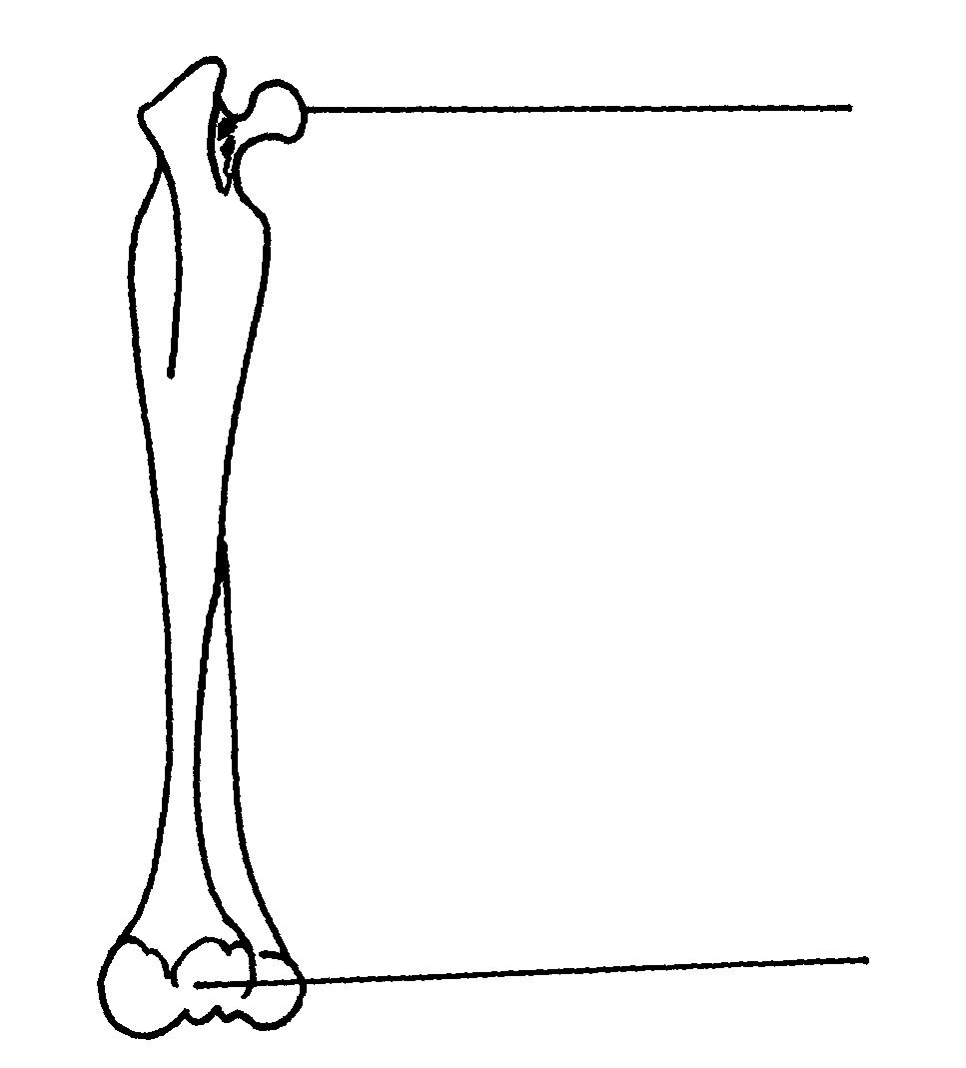
15. The diagram below represents a bone obtained from a mammalian skeleton:
A
B

(a) Identify the bone
(b) Name the:
(i) Bone it articulates with at point A
(ii) Type of joint that forms at point B in articulation with other bones
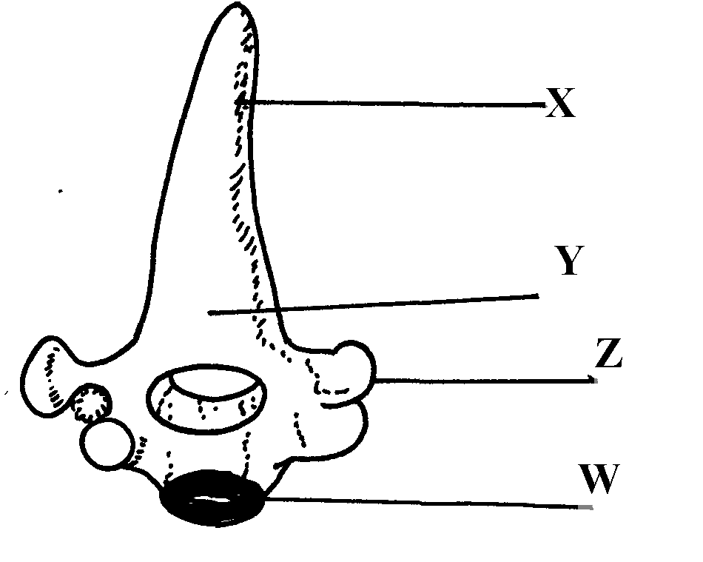
16. The diagram below represents a bone obtained form a mammal

(a) Identify the bone
(b) Name the structures labeled X and W
(c) Name the bone that articulate with structure labeled Z

17. (a) Name the vertebra in a mammalian body that is characterised by presence of odontoid
process.
(b) State the function of the odontoid process
18. a) Name three supporting tissues in plants
b) Study the diagram below and answer the questions which follow:
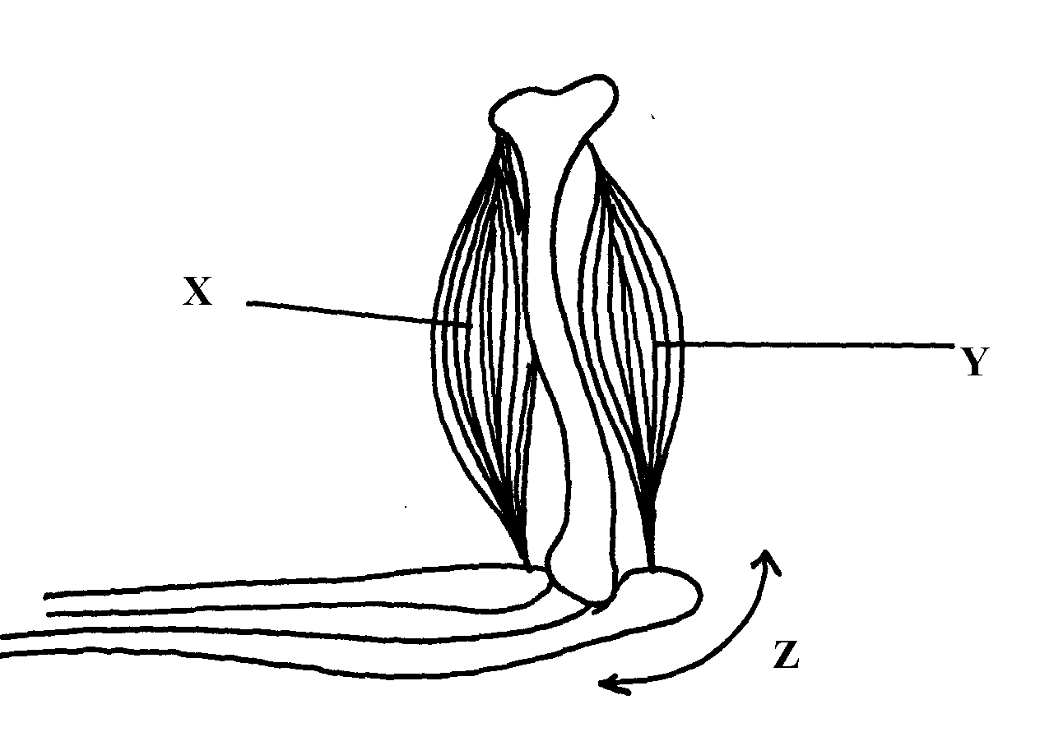

i) Identify the muscle represented by X and Y
ii) Describe how muscles x and y cause straightening of the joint z
c) Name the joint z
19. (a) What is the importance of locomotion in animals? (b) Explain how a bony fish is adapted for movement in its habitat

