14. Irritability and sensitivity in (a) plants (b) animals
1. Give two functions of the exoskeleton in arthropods.
2. When shoots of young plants are exposed to unidirectional light they bend towards light;
a) Name the type of response exhibited by the young shoots
b) Explain the cause of the observation above
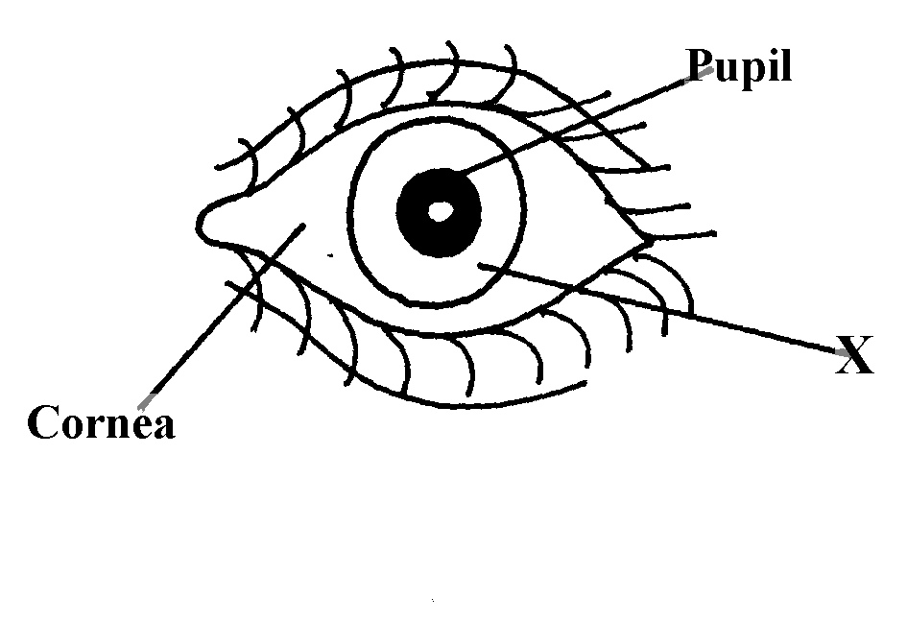
3. Study the drawing below and use it to answer the questions that follow :-

a) Name the part labeled X.
b) Describe the changes that occur in the structure X in dim light.
c) What is meant by the term accommodation with reference to the eye?
4. (a) State two differences between taxes and tropisms
(b) Give two survival values of tactic movements to organisms
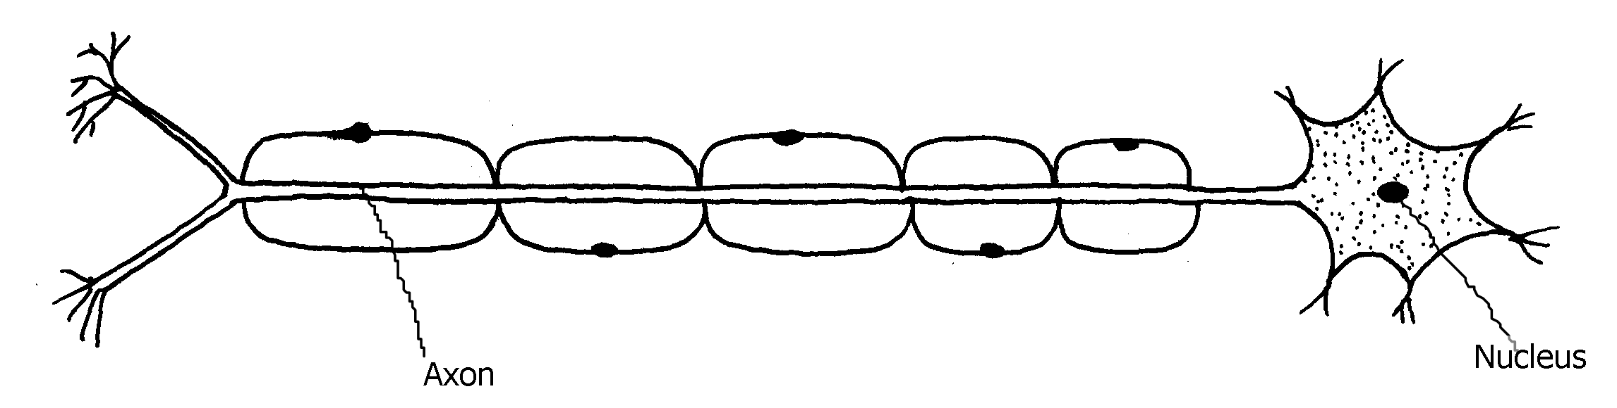
5. The diagram below represents a type of neurone.

(a) (i) identify the neuron above.
(ii) Give a reason for your answer in a (i) above.
(b) With an arrow, indicate on the diagram the direction of an impulse through the neurone.
(c) Name the chemical substance that brings about transmission of impulse across a synapse
6. A student was traveling from Nairobi to Mombasa. As the bus descended down hill he felt an
unpleasant sensation in the ear.
(a) How did the sensation come about? *
(b) How can the unpleasant sensation be relieved?
7. An experiment was carried out to investigate a growth response in maize seedling as shown
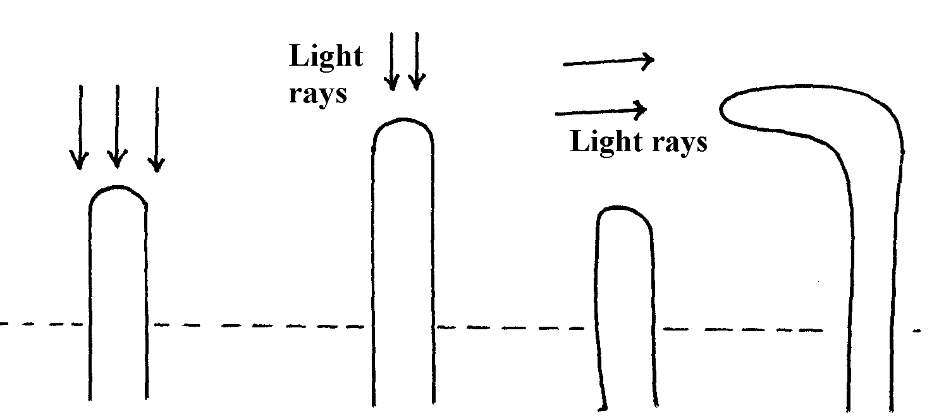
in the diagram below:

(a) State the type of response that is being investigated ...........
(b) Explain the response exhibited by the shoot
8. State three genetic disorders caused by gene mutations
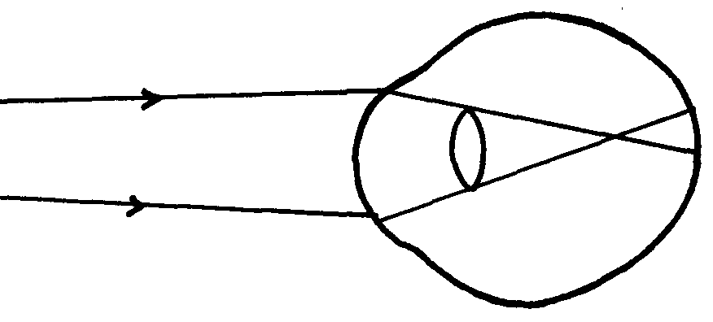
9. The diagram below shows the position of an image formed in a defective eye:-

(a) Name the defect
(b)Explain how the defect named in (a) above can be corrected
10. (a) State three structural differences between arteries and veins in mammals
(b) Name a disease that causes thickening and hardening of arteries
11. (a) Name the part of the eye in which the light sensitive cells are located
(b) List the two types of sensory cells found in the part named in (a) above
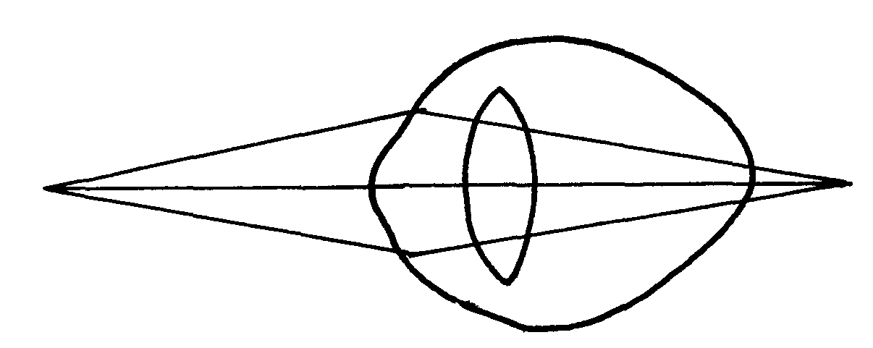
12. The diagram below illustrates a certain eye defect

(a) State the defect
(b) On the diagram illustrate how the defect can be corrected
(c) State one advantage of having two eyes in human beings
13. Briefly explain the role of the following part of skin
a) Cornified layer
b) Malpighian layer
14. State the functions of the following structures of the mammalian ear
a) Eustachian tube
b) Essicles
15. a) Distinguish between conditioned and simple reflexes
b) State how the nerve cell structure is suited to its function of impulse transmission
16. (a) Name the part of the mammalian eye that:
(i) Transmits impulses to the brain
(ii) Regulates the amount of light entering the eye (b) State the changes that occur in the part of the eye named in (a) (ii) above when one moved
from bright light to dim light conditions
16. Name the type of response exhibited by the following:
(a) A pollen tube growing towards the embryo sac
(b) Maggots moving from lit side of a box to the dark side

17. A response exhibited by a certain plant tendril is illustrated below:

(i) Name the type of response
(ii) Explain how the response named in (i) above occurs
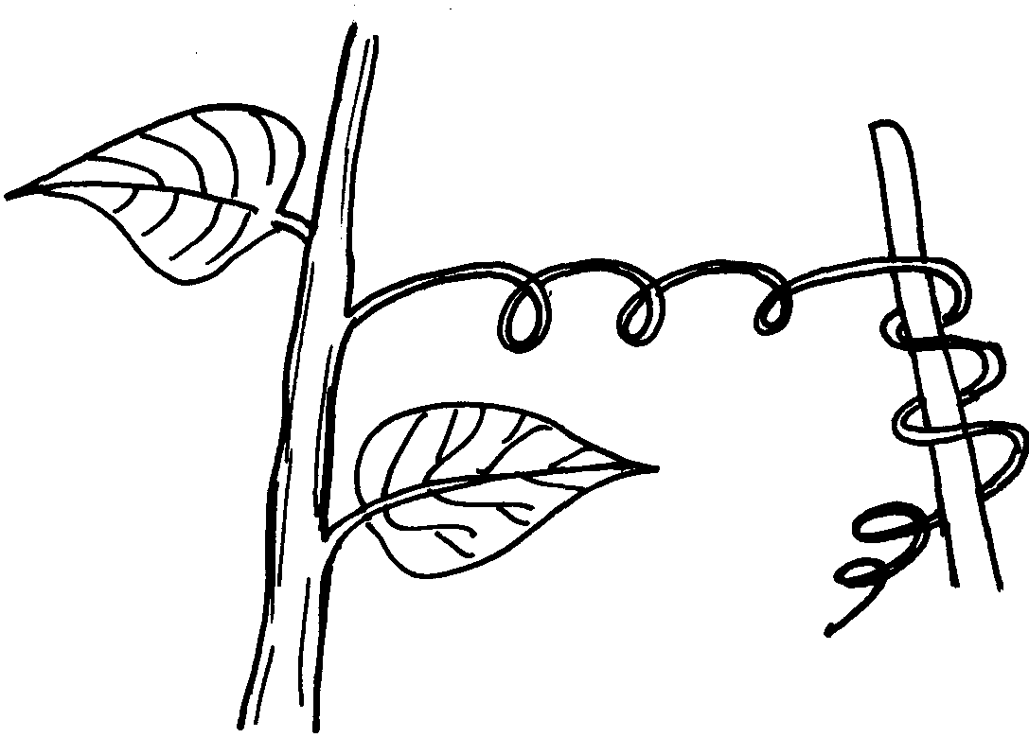
18. A response exhibited by a certain plant tendril is illustrated below:-

Name the type of response
19. Removal of the apical bud from a shrub is a practice that results in the development of many
lateral buds which later form branches
(a) Give reasons for the development of lateral branches after the removal of the apical bud
(b) Suggest one application of this practice?
20. In an accident a victim suffered brain injury. Consequently he had loss of memory which
part of the brain was damaged?
21. A person was able to read a book clearly at arm’s length but not at normal reading distance (a) State the eye defect the person suffered from
(b) Why was he unable to read the book clearly at normal distance?
(c) How can the defect be corrected?

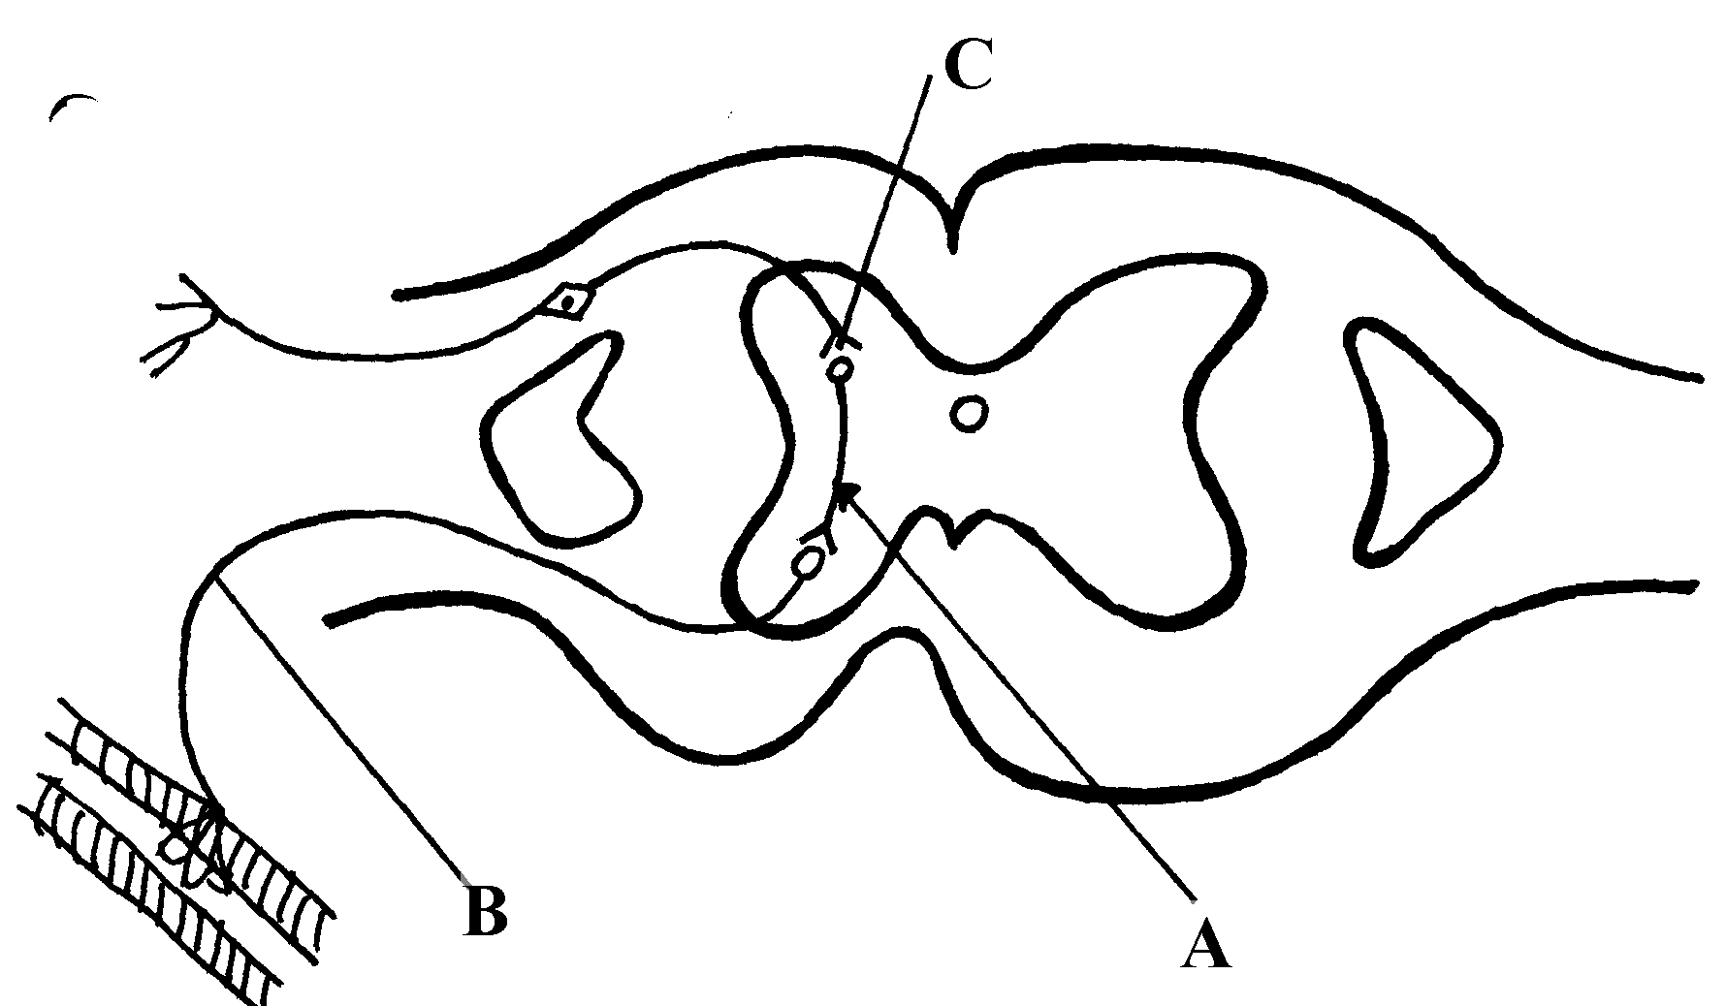
22. The diagram below represents a simple reflex arc;

(a) Name the parts labeled A and B
(b) Explain how an impulse is transmitted across the gap labeled C
23. (a) State two functions of a mammalian ear
(b) How is the cochlea suited to its function
24. State one function of potassium ions in the human body.
25. State two functions of vitamin B₅ (pantothenic acid).
26. (a) What is the biological importance of tactic responses?
(b) A person had an accident and had problems with his vision, hearing and memory.
Identify the part of the brain that was affected
27. Identify the following responses shown by plants:- (a) Shoots grow towards light
(b) Roots grow towards gravity
(c) Tendril intertwine around an object
28. Name the type of responses exhibited by:-
(a) (i) Marine crabs burrowing into the sand to avoid dilution of their body fluids
(ii) Chlamy domonas plant moving towards a region of high light intensity
(b) (i)What type of neuron is drawn above?
(ii) Using an arrow, show the direction of the nerve impulse
(iii) Name the part labelled X
(iv) State the function of part labelled Y .
(c) Give two differences between reflex action and conditioned reflex action
29. In an experiment to investigate the effect of heat on germination of seeds, 12bags each
Containing 60 pea seeds were placed in a water bath maintained at 85ºC .
After every two minutes a bag was removed and seeds contained in it planted. The number that
germinated was recorded. The procedure used for pea seeds was repeated for wattle seeds. The
results were as shown in the table below:-
 | Number of seeds that germinated
Time (min) | Pea seeds | Wattle seed
0  2  4  6  8  10  12  14  16  18  20  22 | 60  60  48  42  34  10  2  0  0  0  0  0 | 0  0  0  2  28  36  40  44  46  48  49  47
(a) Using a suitable scale and same axes, draw graphs of number of seeds that germinated against
time in hot water for each plant
(b) (i) At what time would number of seeds that germinated for each plant be same?
(ii) How many wattle seeds would have germinated if the 13th bag was available and was
removed and seeds contained in it planted at 24minutes?
(c) Explain why the ability of pea seeds that germinated declined with time of exposure to heat
(d) Explain why the ability of the wattle seeds to germinate improved with time of exposure
to heat
(e) Account for the shape of the graph for the wattle seeds which germinated between 20-24
minutes (f) Some of the pea seeds were allowed to germinate and placed in a large air tight flask
and left for four days:-
(i) Suggest the expected changes in the composition of gases in the flask on the fifth day
(ii) Give reasons for your answer in (f)(i) above
(g) Name three factors other than those investigated in (a) above which would affect dormancy
30. How is the mammalian skin adapted to its functions?
31. Explain how the mammalian skin is adapted to it’s functions
32. Explain the structure and functions of the human eye.
33. The diagram below shows the position of an image in a defective eye.
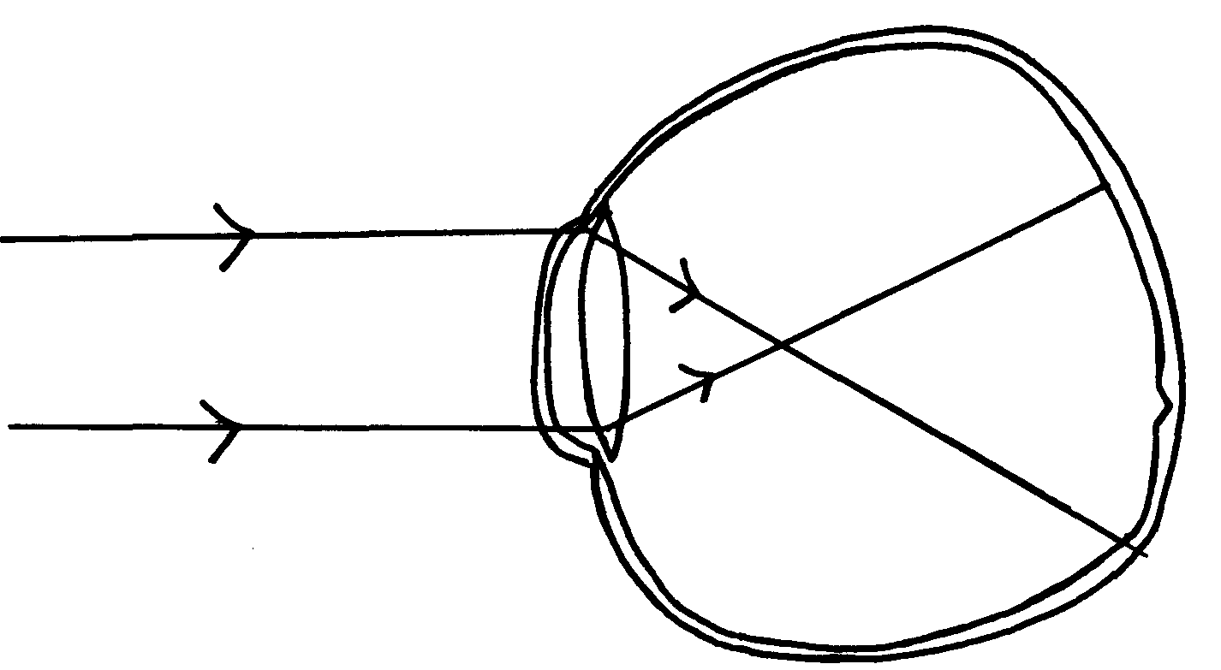

(a) (i) Name the defect
(ii) State the causes of the defect
(b) Explain how the defect in a(i) above can be corrected.
(c) State the functions of cones
(d) How are nocturnal animals adapted to seeing?

