16. Human health
1. a) Name the causative agent of cholera.
b) Name the intermediate hosts in the life cycle of the following parasites;
i) Ascaris lumbricoides.
ii) Schistosoma haematobium.
c) How does the parasite plasmodium vivax gain entry into its host?
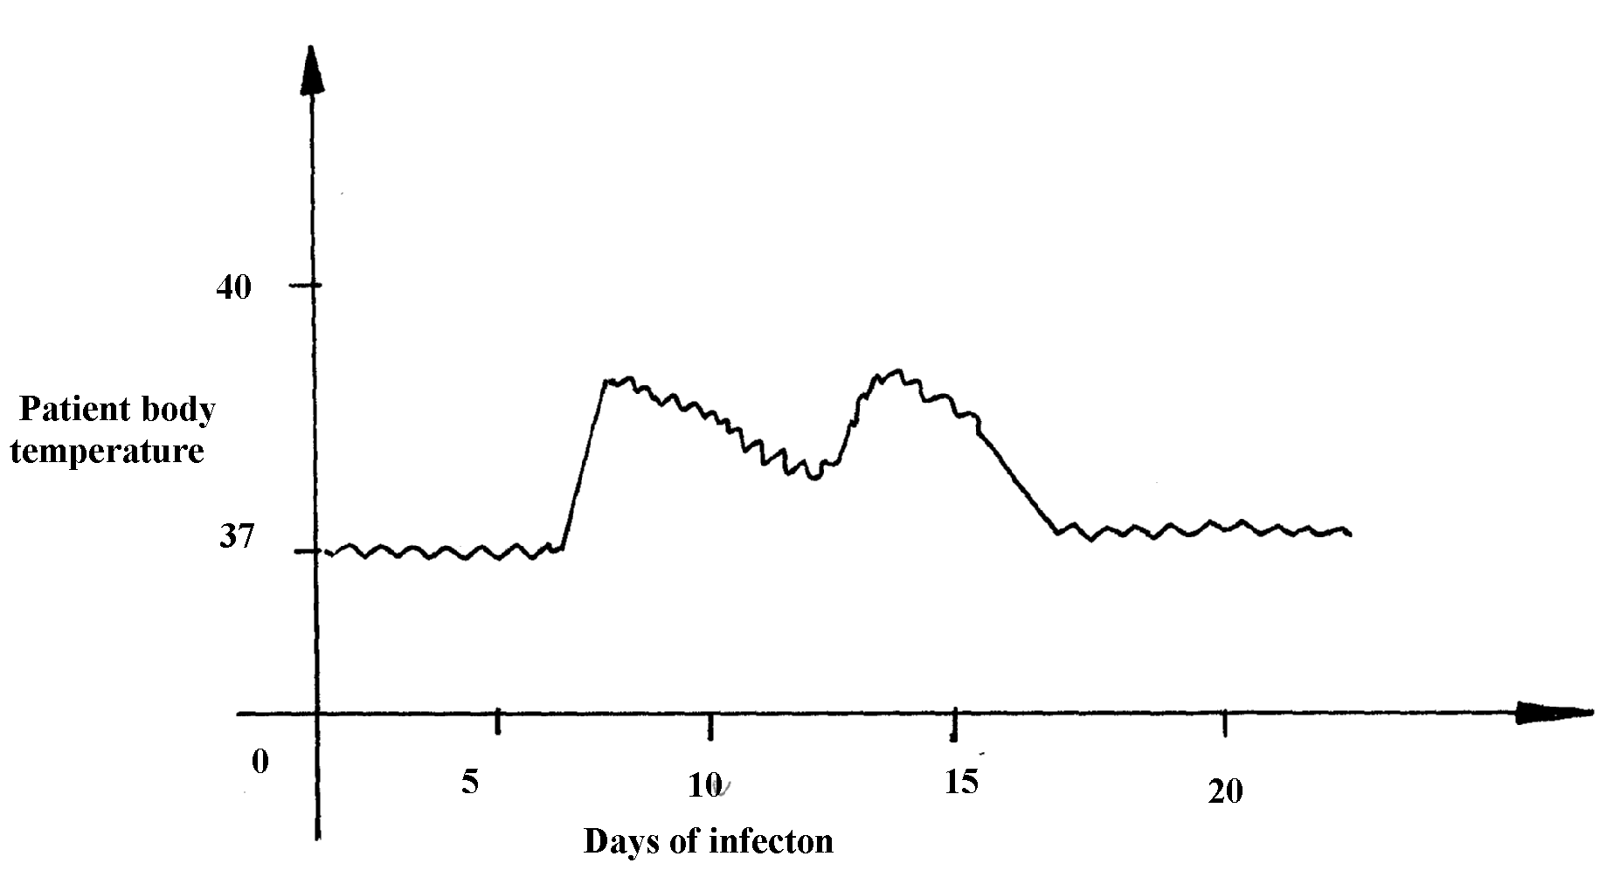
2. The graph below shows body temperature of a patient suffering from malaria

(a) What symptom of the disease is shown in the graph?
(b) Name the organism that causes malaria
(c) Suggest one method of controlling spread of malaria
3. Name the causative agent of typhoid
4. Malaria is a common disease in Kenya:-
(a) What causes the disease?
(b) State one control measure of the disease
5. a) Name the causative agents of the following disease in humans:-
i) Typhoid;
ii) Amoebic dysentery;
b) Name the disease in human cased by plasmodium falciparum
6. Below are diagrams of disease causing micro-organisms. Use them to answer the questions that follow:
B
A
.

(a) State the kingdom to which they are found.
(b) Name the diseases caused by the organisms: A and B (c) State one way in which the disease named for organism B can be prevented
7. Explain why it is important to go for voluntary counseling and testing (VCT) on HIV/AIDS
8. Name one human disease caused by each of the following parasites.
(a) Plasmodium falciparum……………………………………………………
(b) Entamoeba histolytica …………………………………………………….

