12. Genetics
1. A woman with blood group A gave birth to twins both having blood group AB.
Determine the genotype of:
a) Father
b) Mother
2. 50 black mice and 50 white mice were released into an area inhabited by a pair of owls. After four
months, the mice in the area were recaptured and only 38 of the black mice and 9 of the white
mice were remaining.
a) How would this observation be explained ?
b) Name the theory of evolution that supports the results in (a) above.
3. State three mechanisms that prevent self pollination in a flower that has both male and female
Parts.
4. (a) Distinguish between complete and incomplete dominance
(b) State two sources of variation
5. Part of one strand of a DNA molecule was found to have the following base sequence.
G – T – C – A – G – T
(a) What is the sequence on m-RNA strand copied from this DNA portion?
(b) State two roles of DNA molecule.
6. State three ways by which plants compensate for lack of ability to move from one place to
another.
7. A student mixed a sample of urine from a person with Benedict’s solution and heated, the colour
changed to orange.
(a) What was present in the urine sample?
(b) What did the student conclude on the health status of the person?
(c) Which organ in the person may not be functioning properly?
8. Differentiate between continuous and discontinuous variations
9. Members of the same species of organism tend to differ due to variation. State three causes of
variation in organisms
10. Identify the type of gene mutations represented by the following pairs of words:-
(i) Shirt instead of skirt
(ii) Hopping instead of shopping
(iii) Eat instead of tea
11. A DNA stand has the following base sequence: GCCTAGATCAC
What is the sequence of the : (i) Complementary DNA strand?
(ii) M-RNA strand coped form this DNA strand
12. The figure below represents the distribution of height of pupils in a school
Number of individuals
Height

(a) Name the type of variation represented by the curve
(b) Outline two possible causes of variation in height of individuals in man
13. a) Wekesa and Wanjiku who are siblings are both normal as their parents but have a hemophilic
brother. Give the Genotype of their parents.
b) i)What are linked genes?
ii) What do you understand by the phase a test cross?
14. There are at least 205 known sex – linked recessive disorder
a) Name any two of them.
b) State a reason why sex – linked recessive why traits tend to effect the male child.
c) State why if a mother has the trait all her sons will have it
15. The table below is a representation of a chromatide with genes along its length. It undergoes
mutation to appear as shown below:
Before mutation | L | M | N | O | P | Q
After mutation | L | O | N | M | P | Q
a) Name the type of chromosomal mutation represented
b) Name one mutagenic agent
16. The figure below is a structural diagram of a portion from a nucleic acid strand
a) Giving a reason, name the nucleic acid to which the portion belongs
b) Write down the sequence of bases of a complementary DNA strand
17. In an experiment, plants with red flowers was crossed with plants with white flowers.
All the plants in the F₁ generation had pink flowers.
a) Give a reason for the appearance of pink flowers in the F₁ generation
b) If plants in F₁ were selfed, state the phenotypic ratio of the F₂ generation
c) Explain; i) Why women should drink extra milk during pregnancy
ii) A pregnant women might want to urinate more often in late pregnancy
18. State the meaning of the following terms giving an example in each case:
(a) Sex-linked genes
(b) Multiple alleles
19. In a certain breeding experiment, a plant species with red flowers was selfed. It produced 119
red flowered and 41 white flowered offsprings.
(a) Using letter R to represent allele for the red flowers, state the genotype of the red flowered
parent plant
(b) Determine the phenotypic ratio of red and white flowered plants. Show your working
20. Give an example of a sex-linked trait in human on: (i) Y – Chromosome
(ii) X – Chromosome
21. Explain why growth of long hair on the pinnae of the ears in human occurs in males only
22. Explain why prophase 1 of meiosis contributes towards genetic variation in living
organisms.
23. A pure Red flowered plant was crossed with a pure white flowered plant. All the F₁ generation
plants had pink flowers.
(a) Give an explanation for the absence of Red and white flowered plants in the F₁ generation. (b) If the F₁ generation pea plants were selfed, state the phenotypic ratio of the F₂ generation
plants.
24. (a) Name a genetic disorder due to gene mutation that affects the malpighian layer of the
skin in man.
(b) Give two functions of the fluid produced by sebaceous glands.
25. (a) Define the term “Gene mutation.”
(b) Name the genetic disorders that result from gene mutation in human beings.
26. (i) What are mutations
(ii) Name two mutagens
27. A section of a DNA strand contains the following sequence CGGATAC
(a) Write the; (i) Complementary DNA strand
(ii) MRNA strand
(b) Name the site for protein synthesis in a cell
28. In a certain bird species, red flight feathers is controlled by gene R while white flight feathers is
controlled by gene r. The heterozygous condition Rr results into pink flight feathers. The two
genes are also sex linked and transmitted on x-chromosome.
a) By use of fusion lines, find the genotypes of across between a male with pink flight
feathers and a female with white flight feathers
b) Which type of dominance is illustrated here?
c) i)Identify the nucleic acid whose base sequence is shown below:
G-A-C-U-A-G-A-C-G
ii) Give a reason for your answer in c (i) above
iii) If the nucleic acid was involved in protein synthesis, how many amino acids would be
present in the protein synthesized? Give a reason
29. Study the genetic chart below showing the inheritance of the gene responsible for haemophilia
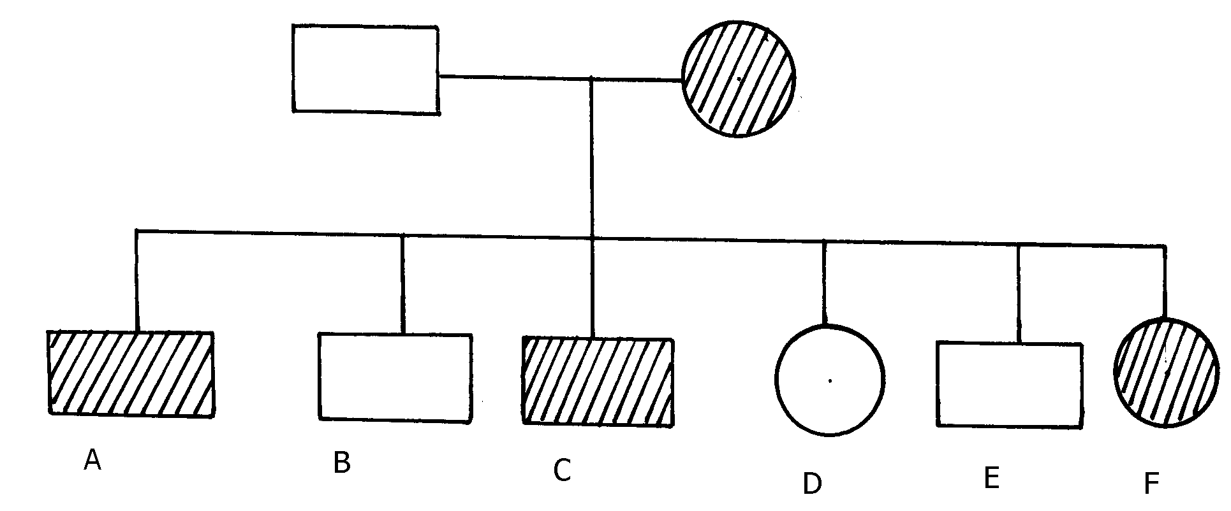
in a family.

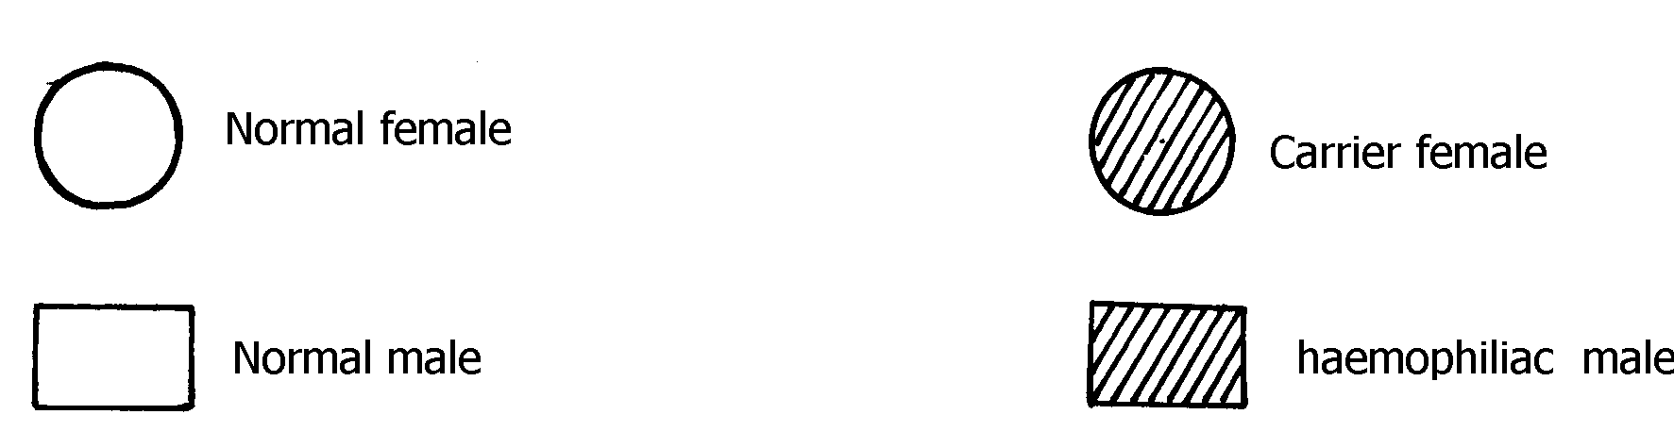

a) Write the genotype of individuals A, B, F
b) A member of this family labelled F marries a haemophiliac male. What will be the phenotypic
ratio of the offspring? Show your workings
c) Other than the condition stated above, state any other two common genetic disorders that
result from gene mutation.
30. Haemophilia is due to a recessive gene. The gene is sex-linked and located on X chromosome.
The chart below represents the offspring of parents who are phenotypically normal for
haemophillia
Normal Female
Normal Male
Haemophiliac male

(i) What are the parental genotypes?
Explain your answer in (i) above
(ii) Work out the genotypes of the offspring

31. A cross between a red-flowered and a white flowered plant produced only pink –flowered
F₁ plants
(a) There was neither a red nor white –flowered F₁ plants. Explain
(b) The F₁ offspring were selfed to get F₂ generation. Using appropriate letter symbols, work
out the genotypes of F₂ generation
(c) Give the genotypic and phenotypic ratios of F₂ generation
(d) Distinguish between dominant and recessive genes
32. A true-breeding purple maize variety was cross-pollinated with a true-breeding yellow
maize variety.
The offspring produced all purple fruits.
The plants grown from these F₁ grains were interbred among each other.
A typical cob of F₂ generation is shown below:
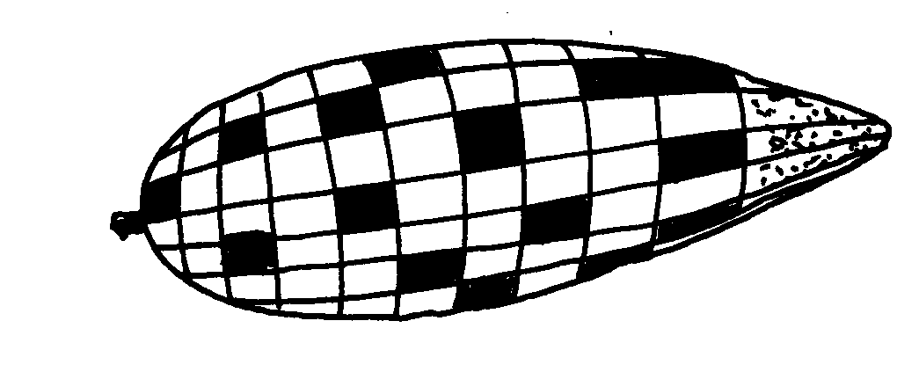
The yellow fruits are shaded while the purple ones are un-shaded.

(a) (i) In terms of flowers only, state why it is easier to work out genetic crossings using maize
(ii) Count separately the yellow and purple grains and therefore find the rations of purple
grains to yellow grains
(b) Using appropriate symbol, work out a genetic cross for F₂ generation
(c) From the above information, give the dominant gene
(d) State two practical applications of genetics in identity determination

33. The figure below is a pedigree chart showing incidence of albinism which is transmitted through a
recessive gene-a. Study and answer questions that follow;
KEY
Normal Female
Albino Female
Normal male
Albino male
1
2
3
4
6
5
7
8
9
11
10
12
13
14
15
16
17
18
19
20
21

(a) Write down the genotype of persons 1 and 2. Give a reason for your answer
(b) Giving your reason state the most likely genotype of person 3
(c) The cross between person 15 and 16 represents mating between first cousins. Comment
why it is not advisable for close relatives to marry
(d) Apart from albinism name two other effects of gene mutation
34. The table below shows results of test to determine blood groups of persons Y and Z.A tick (√)
Represents, agglutination while a cross (x) represents no agglutination;
Person | Test with  antibody (a) | Test with  antibody (b) | Test with  Rhesus antibody | Blood group
Y- (male) | √ | X | √
X- (female) | X | √ | X
(a) Fill the blank space in table to show the blood group of the persons Y and Z
(b) In order to investigate the inheritance of Rhesus factor, work out a cross between a male
with Rh⁺ and female with Rh⁻ .Let D represent the presence of Rhesus factor and d to
represent the absence of the Rhesus factor
(c) Determine the genotype of the cross in (b) above.
(d)Which of the children can donate blood to their mother?
35. Describe the behavioural adaptations of animals to temperature
36. In man blood group inheritance is controlled by multiple alleles in which allele A is co dominant
to allele B. a woman laterozygous for blood group A married a man heterozygous for blood
group B
a) State the genotype of both parents
b) Using a pun net square, show the genotypes of F₁ generation
c) State one application of knowledge of blood group inheritance in man
d) The nitrogenous bases in nucleic acids are Adenine (A), cytosine(C), Guanine (G),
Thiamine (T) and uracil (U). Input of a molecule of DNA the sequence of bases is CTT.
Using the letters A, C, G, T, U where appropriate, write down the base sequence in;
i) Corresponding part of the complementary strand of DNA molecules
ii) Corresponding part in mRNA
iii) A change in the DNA molecules caused the base sequence in the triplets to change from
CTT to CAT. State one factor which could have caused the change
37. In an investigation plants with red flowers were crossed with plants with white flowers. All the
plants in the F₁ generation had pink flowers when the F₁ plants were crossed, he counted 480
plants in F₂ generation
(a) Using appropriate letter symbols, work out the cross between the F₁ plants to get the F₂
generation
(b) Give the phenotypic and genotypic ratios for the F₂ generation
Phenotypic ratio
Genotypic ratio
(c) How many plants in the F₂ generation had pink flowers? (show your work)
38. In an experiment, a black mouse was mated with a brown mouse. All the off springs in F₁
generation were black. The off springs grew and were allowed to mate with one another. The total
number of F₂ generation offspring were 96.
(a) Using letter B to denote the gene for black colour. Work out the genotype of the F₁ generation.
(Use a punnet square)
(b) State the following for the F₂ generation
(i) Genotypic ratio
(ii) Phenotypic ratio
(iii) The total number of brown mice

39. (a) Distinguish between Homologous structures and analogous structures. Give an example
in each case.
Homologous structures
Example
Analogous structures
Example
(b) Explain why parasites develop resistance to certain drugs after a long time of exposure.
(c) (i) What is non— disjunction?
(ii) Give one example of a genetic disorder associated with non-disjunction .

