8. Excretion and homeostasis
1. Explain the following:- i) Fresh water fish excrete ammonia
ii) Glucose is absent in urine yet present in glomerular filtrate
2. (a) State two functions of the kidney
(b) Name two substances that are not found in urine of a healthy person
(c) Name two diseases that affect the kidney
3. (a) State two structural modification of the kidneys of deserts animals like kangaroo rat.
(b) Describe how ingestion of very salty food may reduce the amount of water excreted in urine.
4. A student mixed a sample of urine from a person with Benedict’s solution and heated, the colour
changed to orange.
(a) What was present in the urine sample?
(b) What did the student conclude on the health status of the person?
(c) Which organ in the person may not be functioning properly?
5. (a) If the human pancrease is not functional:-
(i) Name the hormone which will be deficient
(ii) Name the disease the human is likely to suffer from
(b) What is diuresis?
6. State one structural adaptation of nephron in the kidney of a desert mammal
7. Name the nitrogenous wastes excreted by the following organisms:-
Animal Nitrogenous Waste
(i) Desert mole
(ii) Marine fish
(iii) Tilapia
8. The table below shows description of sizes of glomeruli renal tubules of two animals which are
living in different environments
 | Animal X | Animal Y
Glomeruli | Large and few | Small and many
Renal tubules | Short | Long
(a) Name the likely environment in which each animal lives : (i)Animal X
(ii) Animal Y
(b) What role does vasoconstriction play in thermoregulation?
9. The table below shows the approximate percentage concentration of various components in blood
plasma entering the kidney, glomerular filtrate and urine of a healthy human being
Component | Plasma | Glomerular filtrate | Urine
Water | 90 | 90 | 94
Glucose | 0.1 | 0.10 | 0.00
Amino acids | 0.05 | 0.05 | 0.00
Plasma proteins | 8.0 | 0.00 | 0.00
Urea | 0.03 | 0.03 | 2.00
Inorganic ions | 0.72 | 0.72 | 1.50
(a) Name the process responsible for the formation of glomerular filtrate
(b) What process is responsible for the absence of glucose and amino acids in urine?
(c) Explain why there are no plasma proteins in the glomerular filtrate?
10. What is the importance of sebaceous glands in the human skin?
11. Explain why sweat accumulates on a person’s skin in a hot humid environment
12. Distinguish between diabetes mellitus and diabetes inspidus
13. State two processes through which plants excrete their metabolic wastes.
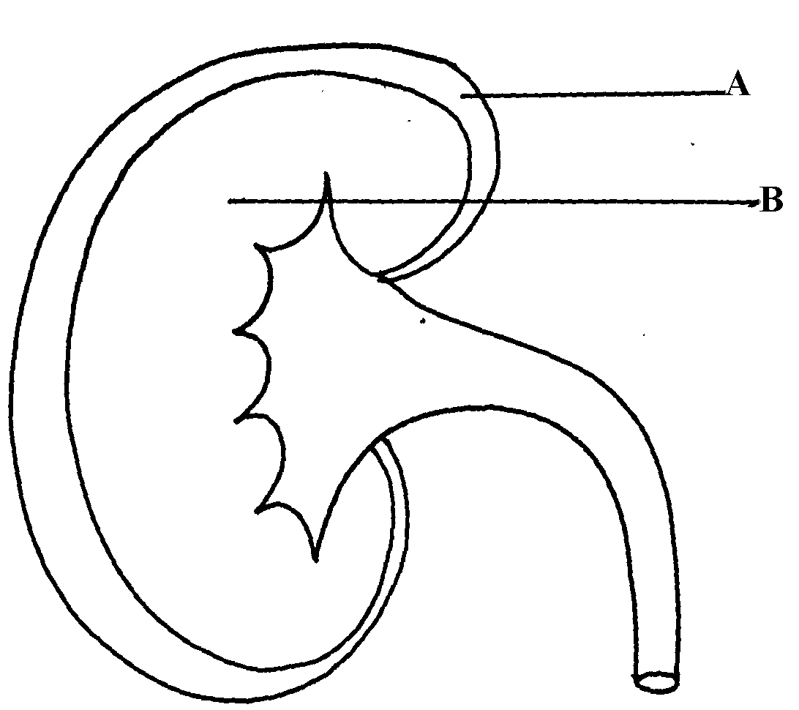
14. The figure below shows a vertical section through a mammalian kidney.

(a) Label the parts A and B
(b) Which part is the Bowman’s capsule found?
15. (a) Explain the effects of the production of large amounts of Antidiuretic hormone in the human
body
(b) State two functions of the loop of Henle
16. Study the homeostatic scheme below:
Excess
Less hormone A
released
Normal concentration of sodium ions in the blood
Release of hormone A
Normal concentration of sodium ions in the blood
Further deficiency
D
Deficiency
C
C

(a) Identify the hormone labeled A
(b) Name the site of action of hormone A
(c) Identify the feedback labeled D
17. State three importance of Osmosis in plants
18. A patient was complaining of thirst most of the times. A sample of the patient’s urine was found
not to contain a lot of sugar but was dilute:-
(a) Name the hormone the person’s body was deficient of
(b) Which gland produces the above hormone
(c) Name the disease that the patient was most likely suffering from
19. State two features in the nephron that facilitate ultra filtration
20. The table below shows a description of size of glomeruli and renal tubules of two animals
which are adapted to living in different environment:-
Animal A Animal B
Glomeruli large and few small and many
Renal tubules short long
a) Name the likely environment in which animal A lives b) Suggest the main nitrogenous waste produced by animal B c) Name the organelle of osmoregulation in each of the following animal: i) Paramecium
ii) Insects
21. What role is played by the liver in excretion?
22. The equation below represents a metabolic process that occurs in the mammalian liver: Amino acids organic compound + urea
Enzymes
a) Name the process
(b) What is the importance of the process to the mammals?
23. A person was found to pass out large volume of dilute urine frequently. Name the:-
(a) disease the person was suffering from?
(b) hormone that was deficient
24. Explain the effects of the following on the quantity and composition of urine
(a) Drinking large amount of clean water
(b) Drinking very salty soup
(c) Removal of pancreas
25. (a) Distinguish between excretion and egestion
(b) State the importance of excretion in the bodies of living organisms.
26. The diagram below shows simplified structures of kidneys from two different animals.

Animal N
Animal M

(a) Suggest possible habitat in which animal N is found.
(b) Give two reasons for your answer in (a) above.
27. (a) What is poikilotherm?
(b) State two classes of phylum chordata where all members are poikilothermic .
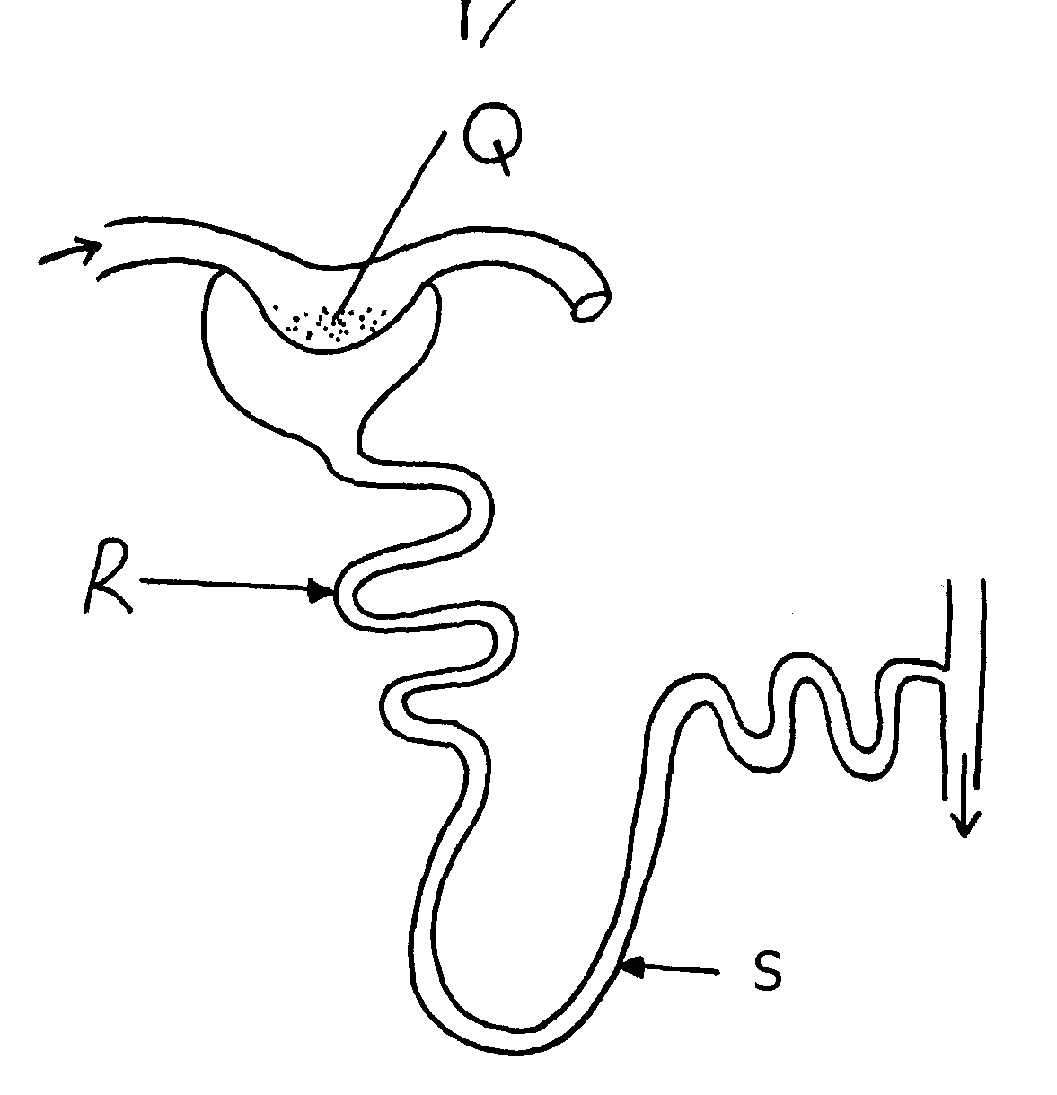
28. The diagram below represents a mammalian nephron

(i) Name the structure labelled Q ....................................................................................
(ii) State two adaptations of part labeled R
29. Distinguish between internal environment and external environment as used in
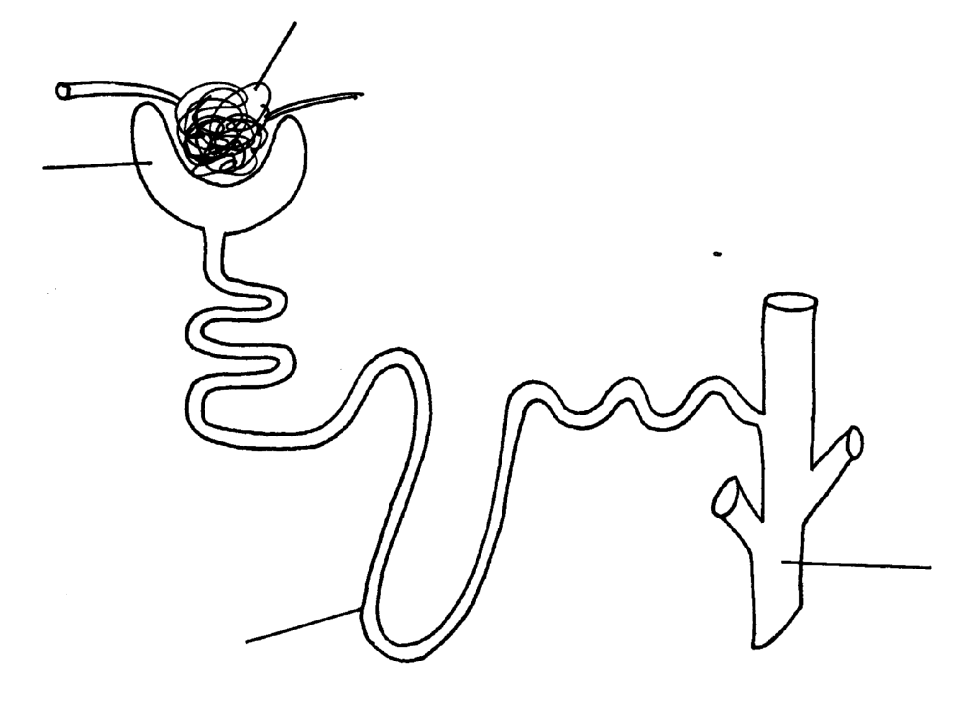
30. The diagram below represents a nephron of a mammal:
A
D
C
B

(a) Name the parts labeled A, B and D
(b) Name a major substance in glomerular filtrate whose concentration remains the same
between A and C
31. Name the parts of the flower that are responsible for the production of gametes
32. The equation below represents a metabolic process that occurs in a certain organ in the m
mammalian body:-
Ammonia enzymes Organic compound Q + water
Carbon (IV) oxide
a) Name the process represented in the equation.
b) Name the organ in which the process occurs.
c) Why is the process important to the mammal?
d) Identify the organic compound Q.
e) Explain the source of ammonia in the organ named in (b) above. f) What happens to organic compound Q?
33. Kosgei and Onyancha collided during a football match and each got bruised. Kosgei’s bruise stopped bleeding after ten minutes while Onyancha’s bruise continued bleeding and he had
to be taken to hospital for treatment.
(a) Explain the process which brought about stoppage of Kosgei’s bleeding
(b) Distinguish between blood clotting and haemagglutination.
(c) Name the disease, that Onyancha could be suffering from.
34. The table below shows the percentage of some substances in the glomerular filtrate and urine
of a certain mammal:-
Substances | Contents in glomerular filtrate | Contents in urine
Water | 90 | 90
Sodium ions | 0.3 | 0.35
Chloride ions | 0.37 | 0.60
Glucose | 0.1 | 0.0
Urea | 0.03 | 2.0
Proteins | 0.0 | 0.0
(a) From the above table, account for ; (i) The absence of glucose in urine (ii) The absence of protein in both glomerular filtrate and urine
(b) Explain the significance of the flow system in the nephron where the glomerular filtrate
flows in opposite direction to that of blood in the surrounding capillaries
(c) Name the hormone that controls the percentage of water in urine and that which control the
amount of salts Percentage of water
Amount of salts
(d) List any two diseases /disorders of the kidney
35. Study the diagram below and answer the questions that follow
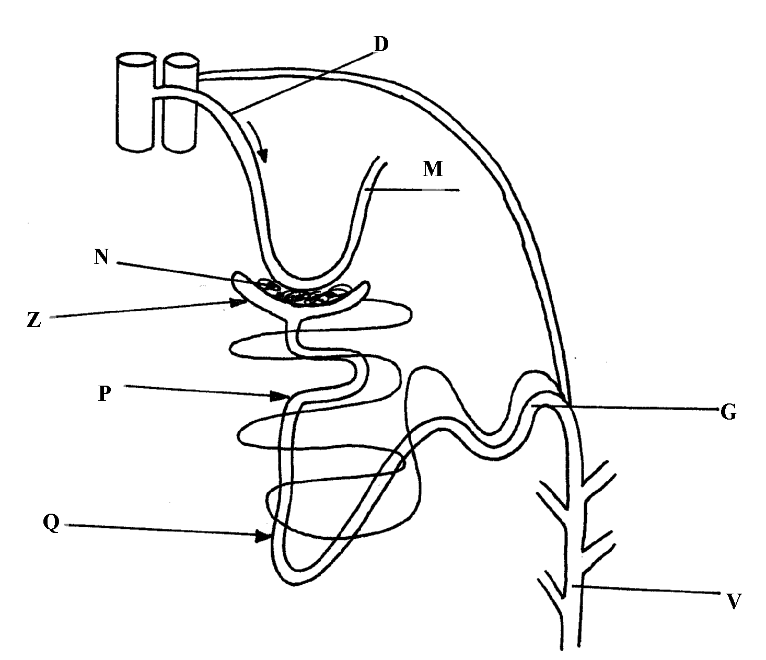

(a) Name the structure represented by the diagram
(b) (i) Name the parts labelled D and M
(ii) Name the hormones whose sites of action are Q and G (c) Name one substance that is present in part N but absent in part Z
(d) The contents of part V were boiled with Benedicts’ solution and an orange precipitate was
formed. Account for the results
36. In an investigation, two persons A and B drunk the same amount of glucose solution. Their blood
sugar levels were determined immediately and thereafter at intervals of one hour for the next six
hours.
The results were as shown in the following table:-
Time (hrs) | Blood glucose level (mg/100ml)
 | Person A | Person B
0 | 90 | 120
1 | 220 | 360
2 | 160 | 370
3 | 100 | 380
4 | 90 | 240
5 | 90 | 200
6 | 90 | 160

(a) Draw a graph of blood sugar levels of persons A and B against time on the same axis
(b) Explain each of the following observations;-
(i) Blood sugar level increased in person A between 0 and 1 hour
(ii) The blood sugar level dropped in person A between 1 and 4 hours
(c) From the graph, what is the normal blood glucose sugar level for human beings
(d) Suggest a reason for the high sugar level in person B
(e) How can the high blood sugar level in person B controlled?
(f) What is the biological significance of maintaining a relatively constant sugar level in a human
being
(g) Account for the decrease in the blood glucose level of person B after 4 hours
37. An experiment was carried out to determine the effect of drinking on excess amount of water on
the flow of urine. A person drinks one litre of water and urine was collected at intervals of 15minutes.
The results were as shown below:
Time in minutes | 0 | 15 | 30 | 45 | 60 | 75 | 90 | 105 | 120 | 135
Urine output ml/min | 1.6 | 1.6 | 1.6 | 5.4 | 9.0 | 9.0 | 7.6 | 3.0 | 0.8 | 0.8
(a) Plot a suitable graph to represent urine output with time.
(b) Explain the rate of flow of urine between the following times;
(i) 15 and 60minutes.
(ii) 60 and 75minutes.
(iii) 75 and 135 minutes.
(c) Name two hormones responsible for regulation of relative amount of salts and water in man.

38. a) Explain how urea is formed in the human body
b) Describe the path taken by urea from the organ where it is formed until it is released from
the human body
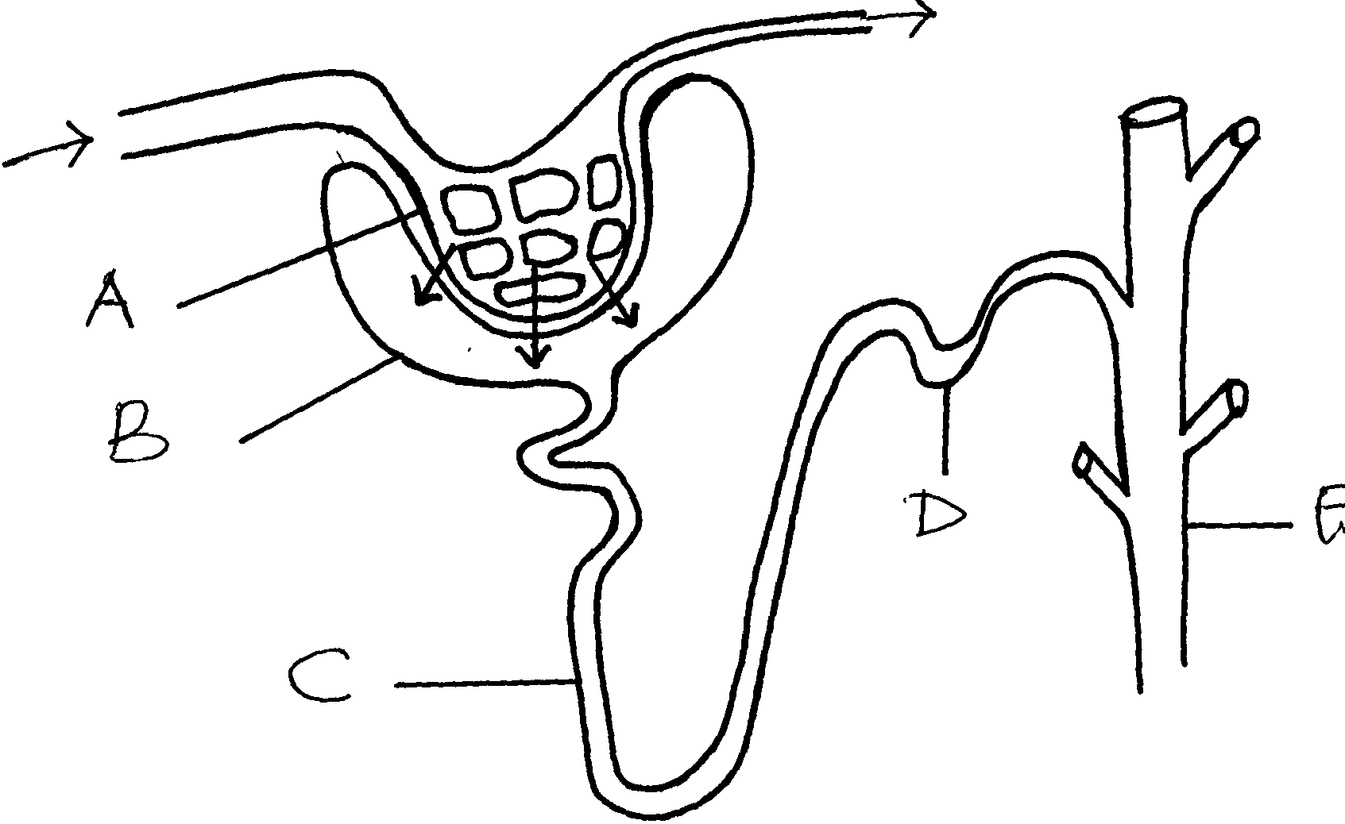
39. The diagram below represents a mammalian nephron.

(a) Name the structures labeled B,C and D
(c) Name the process by which substances are reabsorbed from structure C into blood capillaries
(d) How is the pressure in structure A achieved?

40.
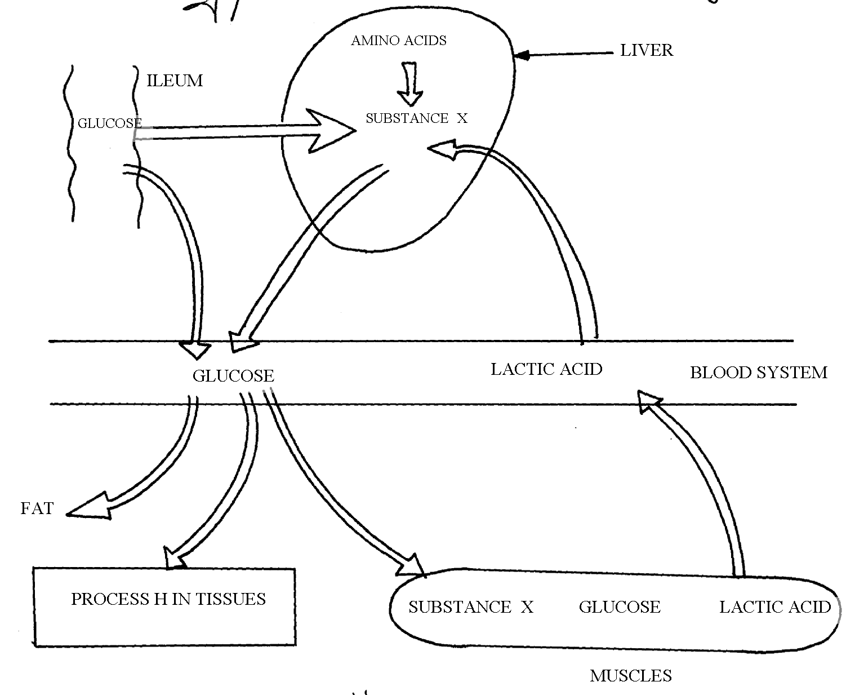
PROCESS H IN TISSUES

a) Identify substance X
(c) Give the end products of the process labelled H
(d) Give three other functions of the liver
41. The flow diagram below represents blood clotting process
Prothrombum
Vitamin K
Platelets
Z
X
Ca²⁺
Y
Fibrinogen

a) Name the proteins represented by the letters; V, Y, Z b) State the importance of blood clotting
c) Why doesn’t the physiological process above occur in undamaged blood vessels
42. How does an Endotherm respond to both heat gain and heat loss?

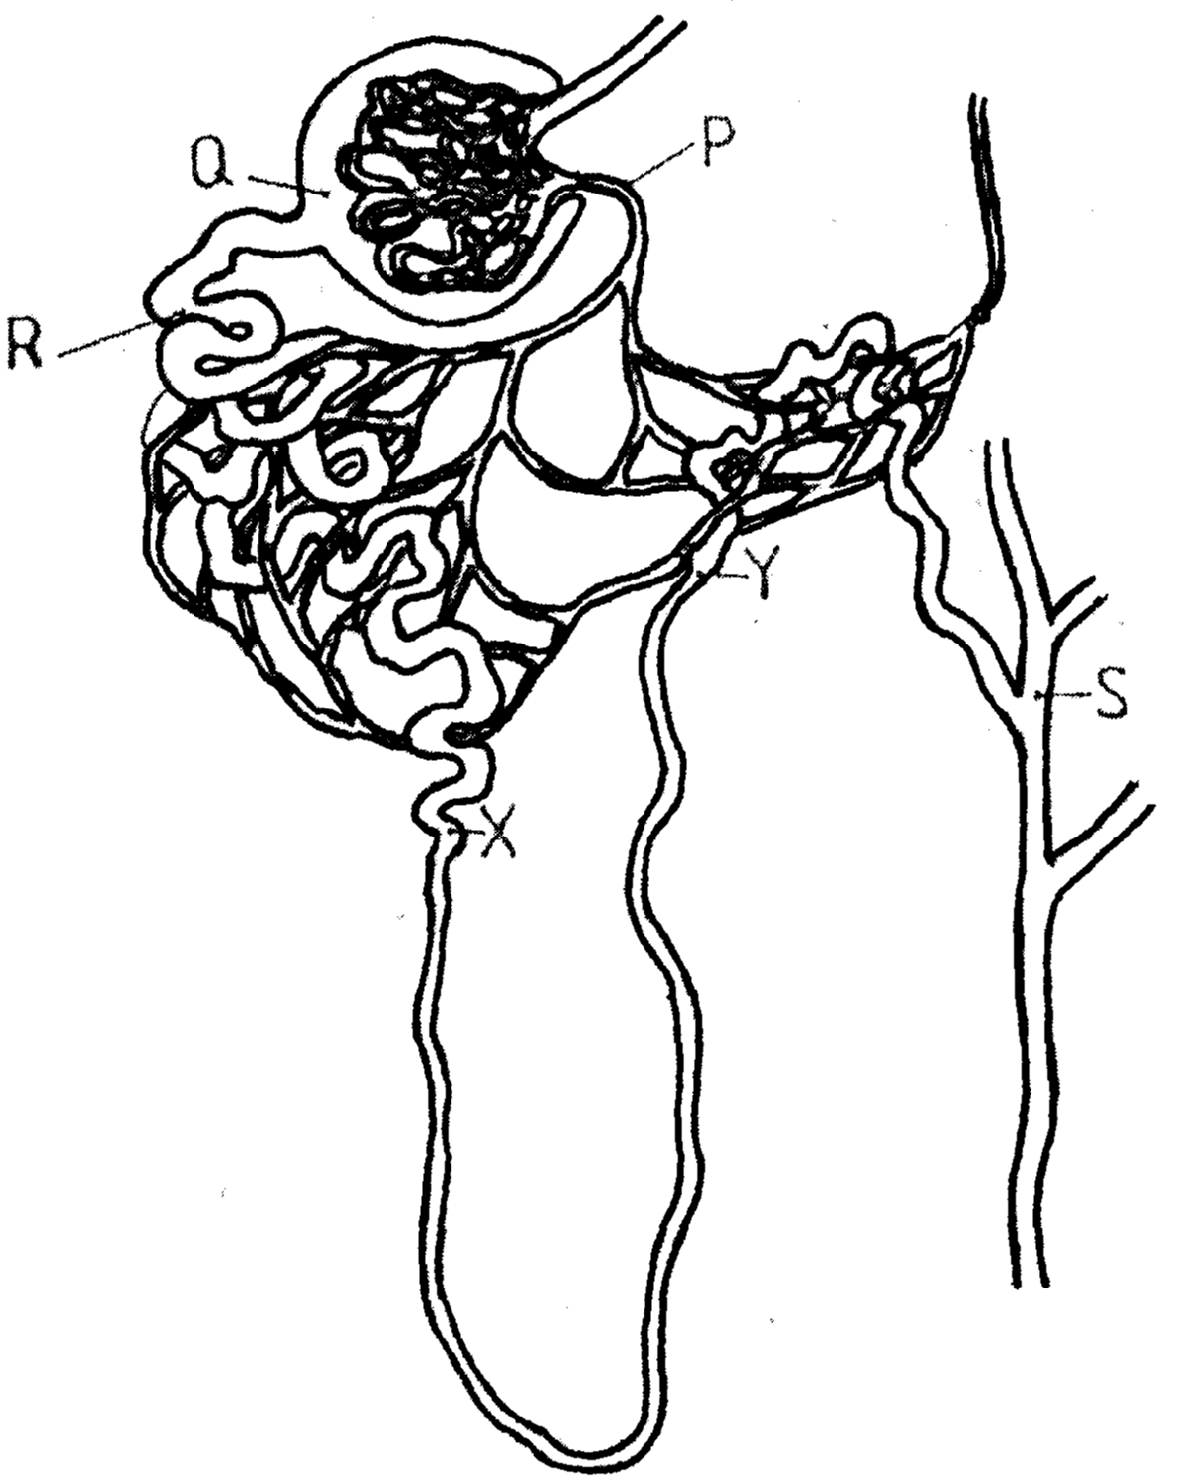
43. The diagram below represents a mammalian nephron

(a) Name the: (i) Structure labelled P
(b) State the structural modifications of the part label led Q for
(i) Desert mammals
(ii) Fresh water mammals
(c ) (i) Name one substance present at point R but absent at point S in a healthy mammal.
(ii) The appearance of the substance you have named in (c)(i) above is a symptom of a
certain disease. Name the disease
44. Describe how the mammalian skin regulates body temperature

