Pressure
1. State the possible reason why, if water is used as a barometer liquid, the glass tube required
to hold the column of the liquid is longer
2. State the definition of atmospheric pressure
3. What is the density of alcohol?
4. A person’s lung pressure as recorded by a mercury manometer is 90 mm Hg. Express this
pressure in SI units.
5. The figure below shows to light pith balls arranged as shown.
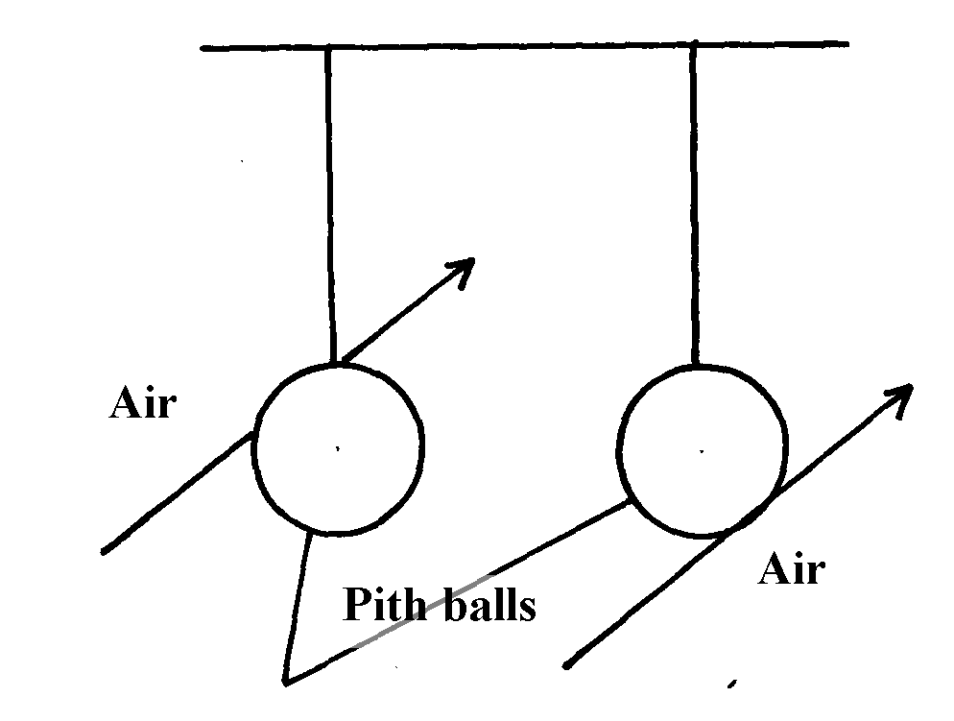

Pith balls

State what is observed when air is blown on the outer sides of the pith balls.
7. The barometric height at sea level is 76cm of mercury while at a point on a highland it is 74cm
of mercury. What is the altitude of the point? (Take g = 10m/s² , density of mercury = 13600kg/m³ and density of air as 1.25kg/m³)
8. a) Define specific latent heat of fusion of a substance
b) Water of mass 200g at temperature of 60°Cis put in a well lagged copper calorimeter of mass
80g. A piece of ice at 0° C and mass 20g is placed in the calorimeter and the mixture stirred
gently until all the ice melts. The final temperature, T, of the mixture is then measured.
Determine:
i) The heat absorbed by the melting ice at O°C
ii) The heat absorbed by the melted ice (water) to rise to temperature T (answer may be
given in terms of T)
iii) The heat lost by the warm water and the calorimeter (answer may be given in terms of T)
iv) The final temperature of the mixture
(Specific latent heat of fusion of ice = 334 000 J kg⁻¹
Specific heat capacity of water = 4 200 J kg⁻¹ K⁻¹
Specific heat capacity of copper = 900J kg⁻¹ K⁻¹)
9. Figure 4 below shows a measuring cylinder of height 30cm filled to a height of 20cm with
water and the rest occupied by kerosene
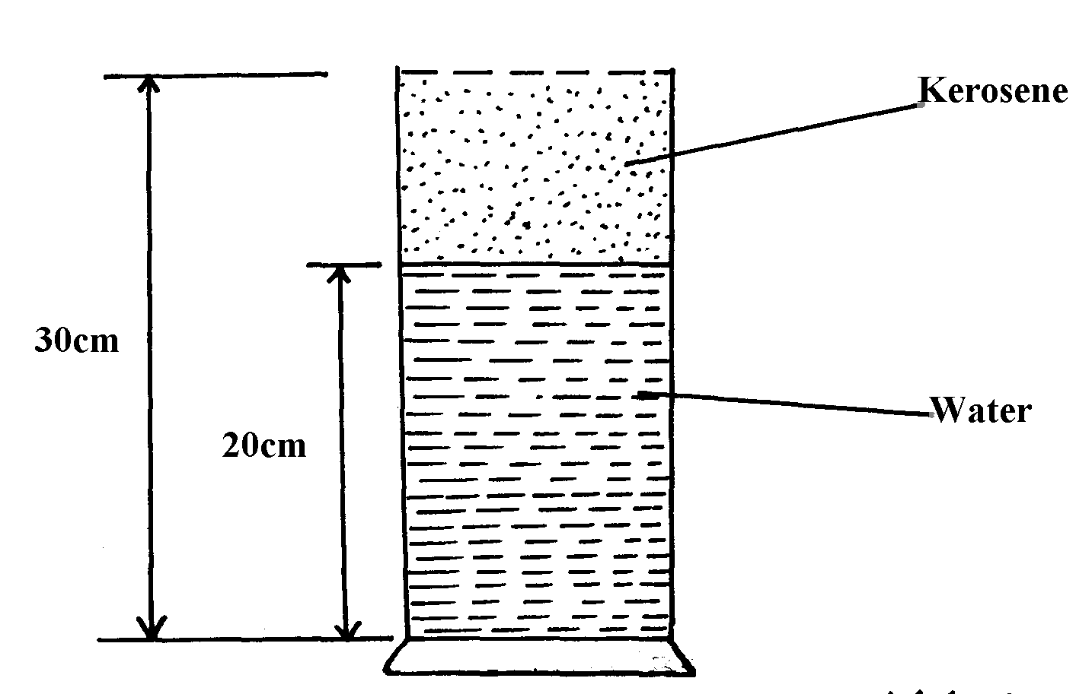

Fig. 4

Given that density of water = 1000Kgm⁻³, density of kerosene = 800Kgm⁻³ and atmospheric
pressure = 1.03x10⁵ pascals, determine the pressure acting on the base of the container
10. State Pascal’s principle of transmission of pressure
11. A helical spring extends by 1 cm when a force of 1.5N is applied to it. Find the elastic potential
energy stored in it.
12. Two immiscible liquids are poured in a container to the levels shown in the diagram below.

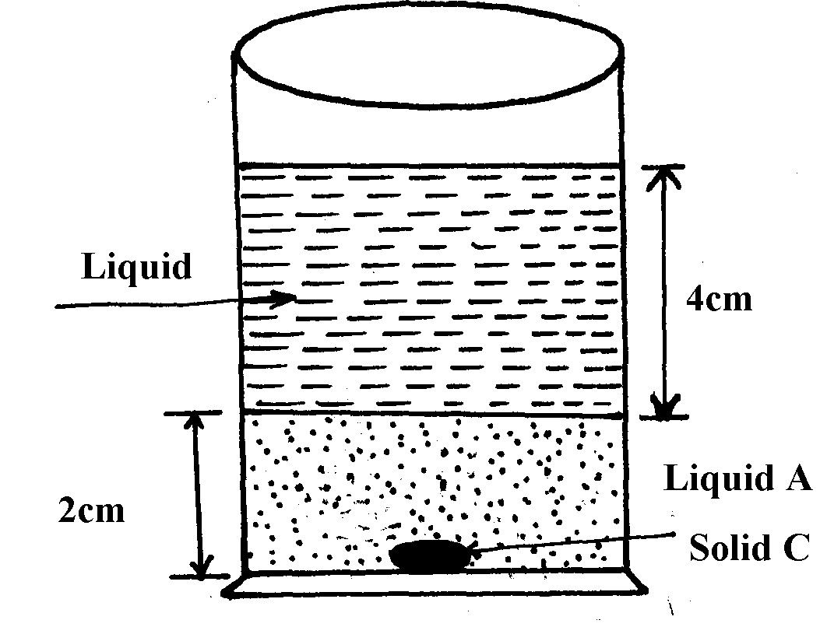

Figure 5

If the densities of the liquids A and B are 1g/cm³ and 0.8g/cm³ respectively, find the pressure
acting upon solid C at the bottom of the container due to the liquids

13. Mark the position of the water levels in the manometer when the gas supply is fully turned on
14. Calculate the pressure of the gas supply (Atmospheric pressure = 1.0x10⁵Pa)
figure 1
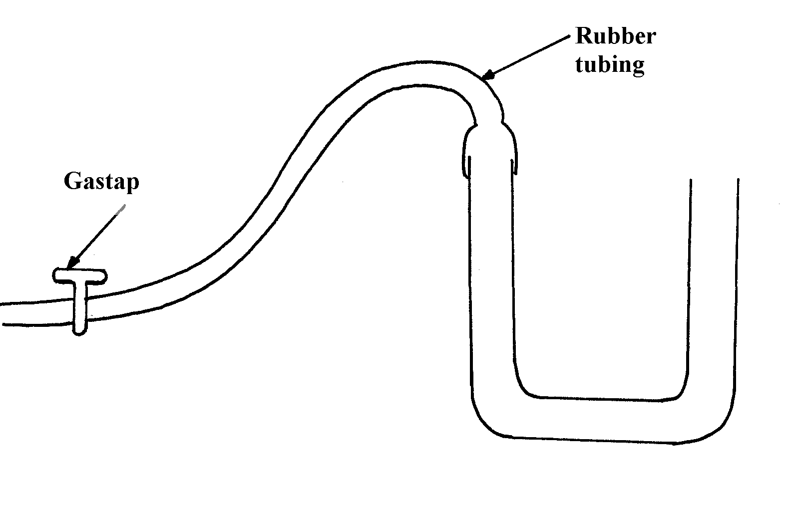

15. A small nail may pierce an inflated car tyre and remain there without pressure reduction
in the tyre. Explain the observation
16. (a) State two ways of increasing pressure in solids
(b) The figure 1 shows a liquid in a pail

fig. 1

Suggest a reason why pail manufacturers prefer the shape shown to other shapes
17. Figure 8 shows a funnel inverted over a light ball.
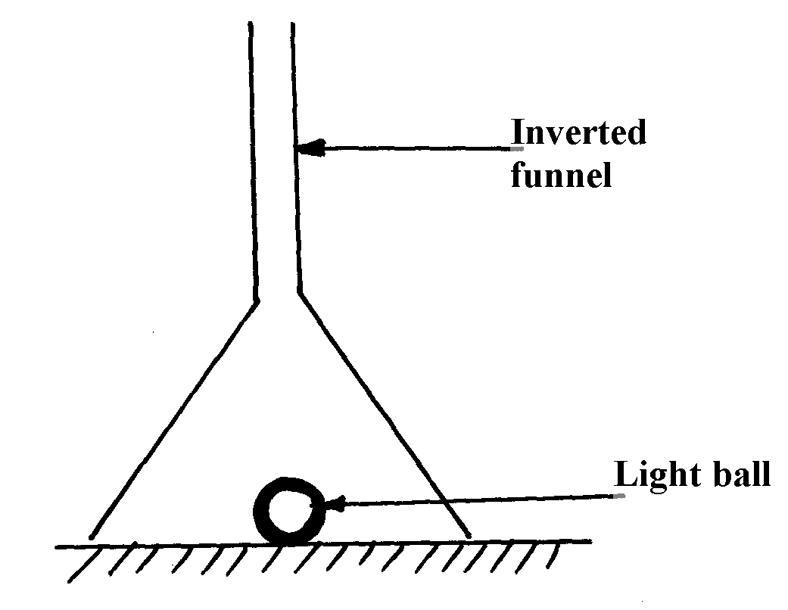

fig. 8

Explain the observation that would be made when streamlines of air is blown strongly down
the narrow section of the funnel
18. A block measuring 20cm x 10cm by 5cm rests on a flat surface. The block has a weight of 3N.
Determine the maximum pressure it exerts on the surface.
19. The figure below shows a hydraulic press P which is used to raise a load of 10KN. A force
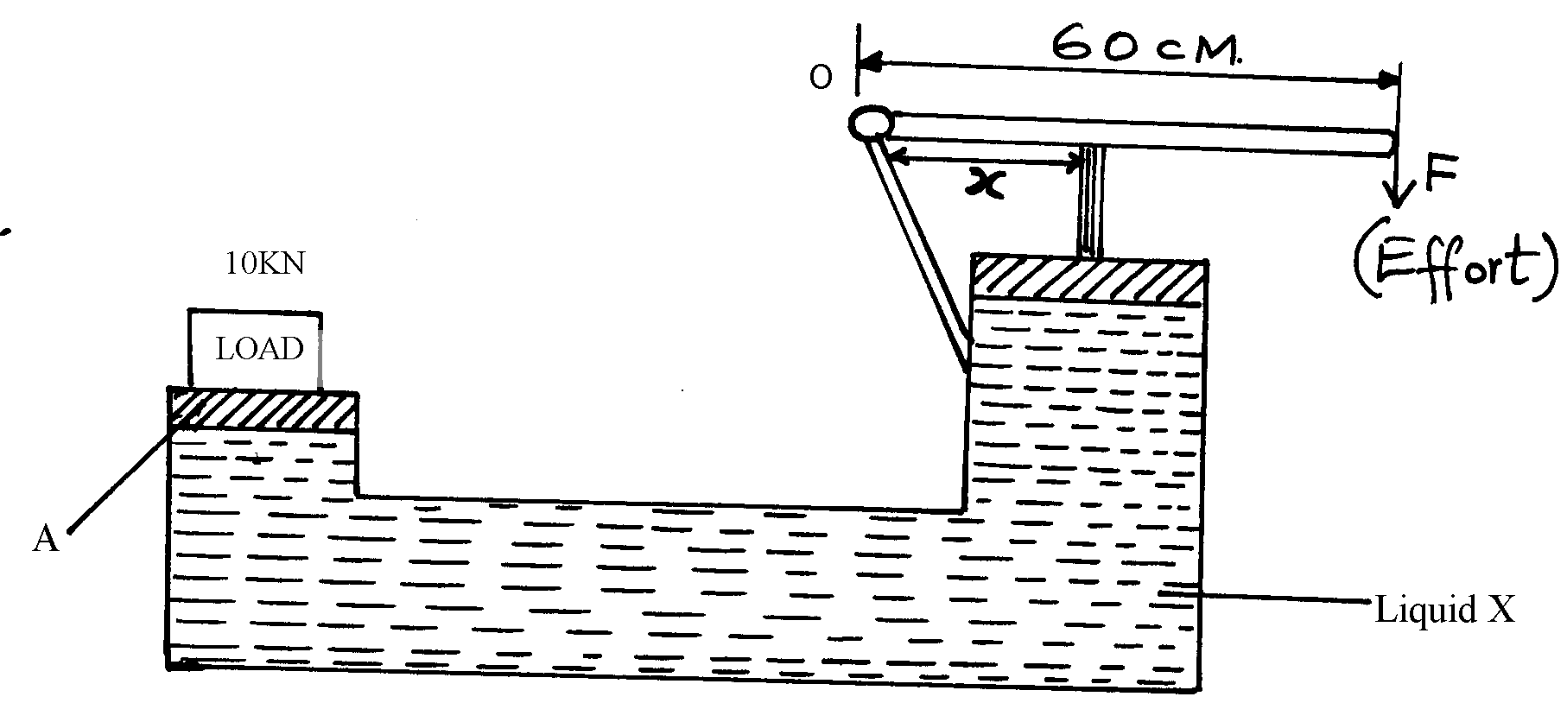
F of 25N is applied at the end of a lever pivoted at O to raise the load
P
B
(Effort)
10KN
LOAD
X
Liquid X
60cm
F

(a) State one property of liquid X
(b) Determine the distance x indicated on the press if force on piston B is 100N
19. A mercury –in-glass barometer shows a height of 70cm. What height would be shown in the barometer at the same place if water density 1.0 x 10³kg/m³ is used.
(Density of mercury = 13600kgm⁻³)
20. The total weight of a car with passengers is 25,000N. The area of contact of each of the four
tyres with the ground is 0.025m². Determine the minimum car tyre pressure
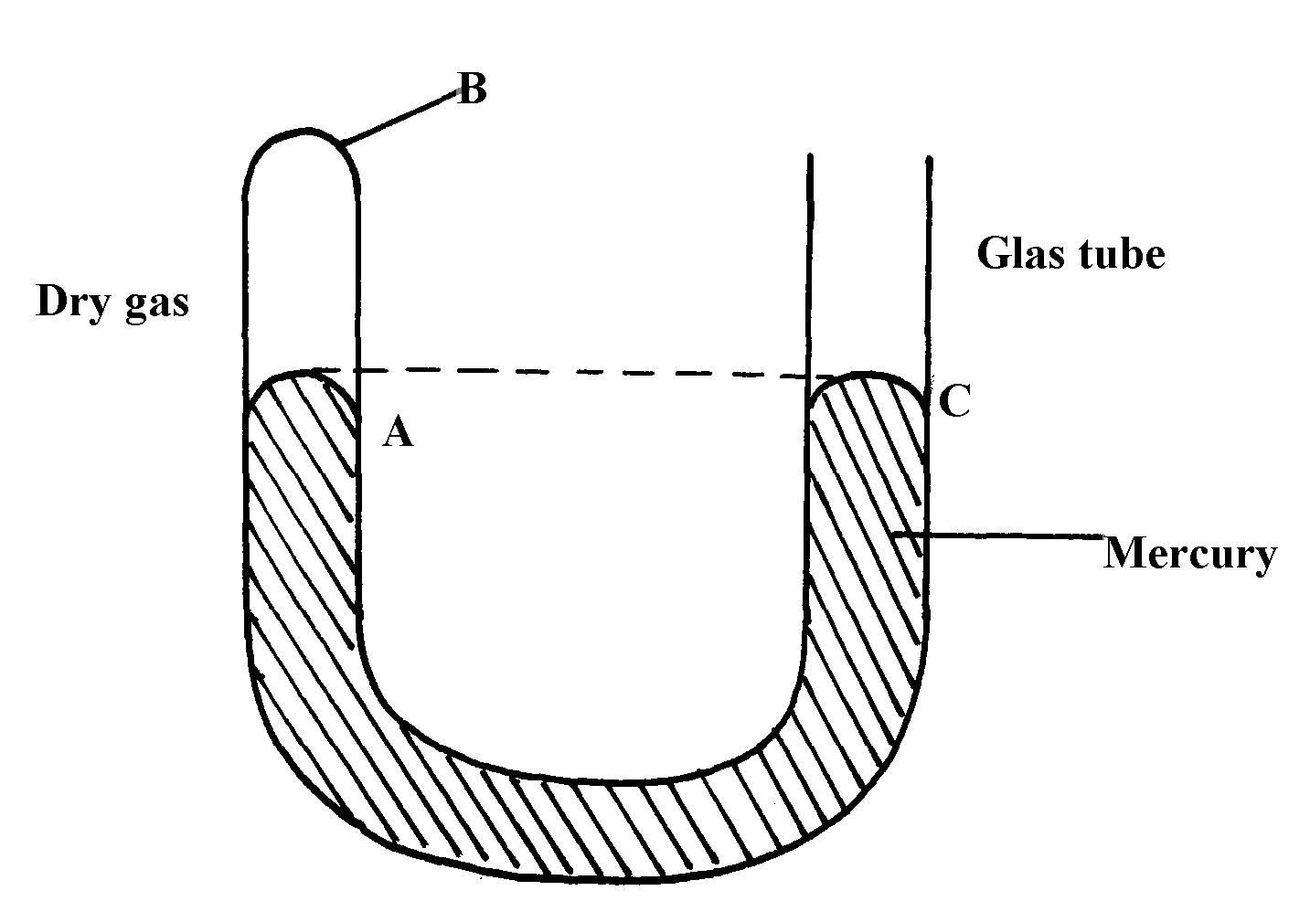
21. (a) The diagram below represents a u-shaped glass tube sealed at one end and containing mercury

(i) What is the pressure of the gas as shown in the diagram above?
(ii) Explain why the gas should be dry if it is to be used to verify a gas law
(iii) Describe how the arrangement can be used to verify Boyle’s law.
(b) Use the kinetic theory of gases to explain why;
(i) the pressure of a gas increases with temperature increase
(ii) The pressure of a gas decreases as volume increases
22. The reading on a mercury barometer at Mombasa is 760mm. Calculate the pressure at Mombasa
(density mercury is 1.36xl0⁴Kgm⁻³ )
23. The figure below is a manometer containing water. Air is blown across the month of one tube
and the levels of the water changes as the figure below.
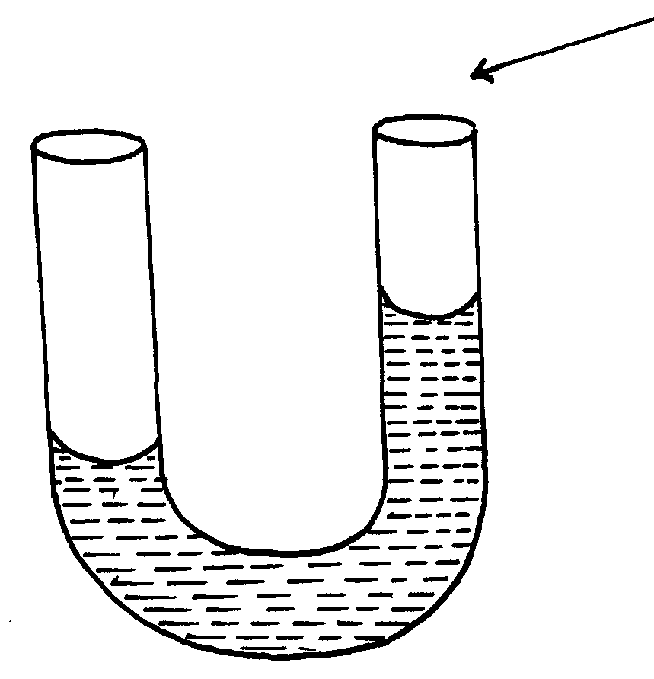
Blow air

Explain why the level of water in the right limb of manometer is higher.

Pressure
1. Because of its low density

2. Atmospheric pressure is the pressure exerted on the surface of the surface of the earth by the weight of the air column

3. h_{w}ƍ_{w}g = h_{w}ƍ_{w}g
∴ h_{w}ƍ_{w} =h_{a}ƍ_{a} 1
Density of alcohol = 16 cm x 1g/cm³ x 1000
20 cm
= 800 kgm⁻³ 1
4. P = hƍg
= 90 m x 13600kgm⁻³ x 10Nkg⁻¹ 1 mk
1000
= 12 240NM⁻² 1 mk
5. The balls move apart since the pressure on the sides is reduced by the fast moving air. High pressure between the balls pushes them outwards.

6. (76 – 74) X 13600 X 10 = hX 1.25 X 10
100
H = 2 X 13600
100 1.25
= 217. 6 m

7. a) This is the heat energy required by a unit mass of a solid to change to liquid state at
constant temperature.
b) i) The heat absorbed by the melting ice at O°C
H₁ = ML_{f}

= 20kg X 334000Jkg⁻¹ = 6680J
1000
ii) The heat absorbed by the melted ice (water) to rise to temperature T (answer may be given in
terms of T)
H₂ = 20 kg X 4200jkg⁻¹ ( - 0)
1000
= 84 ( -O)
= 84 Joules

iii) The heat lost by the warm water and the calorimeter (answer may be given in terms of T)

H₂ = 200 kg X 4200 Jkg⁻¹k⁻¹ + 80 x 900 ( -O ) H₃ = 912 (60- )
1000 1000
= 840 +72 (60 - )
= 54720 – 912T

iv) The final temperature of the mixture
(Specific latent heat of fusion of ice = 334 000 J kg⁻¹
Specific heat capacity of water = 4 200 J kg⁻¹ K⁻¹
Specific heat capacity of copper = 900J kg⁻¹ K⁻¹)

Heat lost = Heat gained.
6680 + 847 = 54720 – 912
912 + 84 = 54720 – 6680
996 = 48,040
996 996
= 48.233⁰ ≈ 48.2⁰

8. Pressure due to kerosene = ∫K hkg
= 800 x 0.1 x 10 = 800p.a√1
Pressure due to water = w hwg
= 1000 x 0.2 x 10 = 2000p.a√1
Atmospheric pressure = 103,000p.a
Total pressure = 800 + 2000 + 103000
= 105800 p.a√1

9. Pressure applied at one pat in a liquid is transmitted equally to all other parts of the enclosed liquid.

10 . Elastic PE = ½ Fe
= ½ x 1.5 x 0.01;
= 7.5 x 10-3 J;

11. Pressure on = Lfg;
Solid at c = (0.02 x 1000 x 10) + (0.04 x 800 x 10);
= 200 + 320
= 520N/m² ;

12. Difference in the level of water should be 20cm

13. Pressure of the gas = Atmospheric pressure + ehg;
= 1.0 x 10⁵ + 20 x 1000 x 10
100
= 1.0 x 105 + 2.0 x 103Nm⁻²
= 1.02 x 105Pa;
14. - Rubber is elastic; and when a nail is pushed through it stretches and grips firmly the nail without allowing air leakage;
or – Valve effect pressure from inside causes tyre rubber to press firmly on the nail;

15. (a) – Increasing the force (weight)
(b) Slanting sides increase the area supporting the weight of the liquid, hence its effect
on the bottom of the container
1

17. In the narrow section of the funnel, air moves with high velocity hence followed by 10N pressure and when they emerge into the wider section, they spread, hence more min-low velocity resulting to high pressure. The high pressure below the ball lifts the ball up to the neck of the funnel.
1

18. Max pressure = ^{Force}/ _{Min Area} √ 1
= ^{3N}/ 0.1 X _{0.05}√1
= 600N/m² √ 1

19. (a) – Incompressible
– Not corrosive
– Has low freezing point and high boiling point (any one)

20. h₁p₁g = h₂p₂g
h₂ = h₁p₁
p₂
= 0.7 x 13600Kg/m³
1000kgm⁻³
= 9.52m

21. Pressure = Force
Area
= 2500
4 x 0.025
= 250,000Pa

22. a) i) Atmospheric pressure 1.05 x 10⁵N/M²
ii) Any water vapour available is near its condensing point. Intermolecular forces
are therefore appreciable √, so it does not behave like an ideal gas
iii) - Fix a millimeter scale to read the length ( L) of air column B √ and the difference in height (h) between the levels A and C√
- Adjust the level of C by adding more mercury a little at a time and record the
corresponding values of L and h each time √
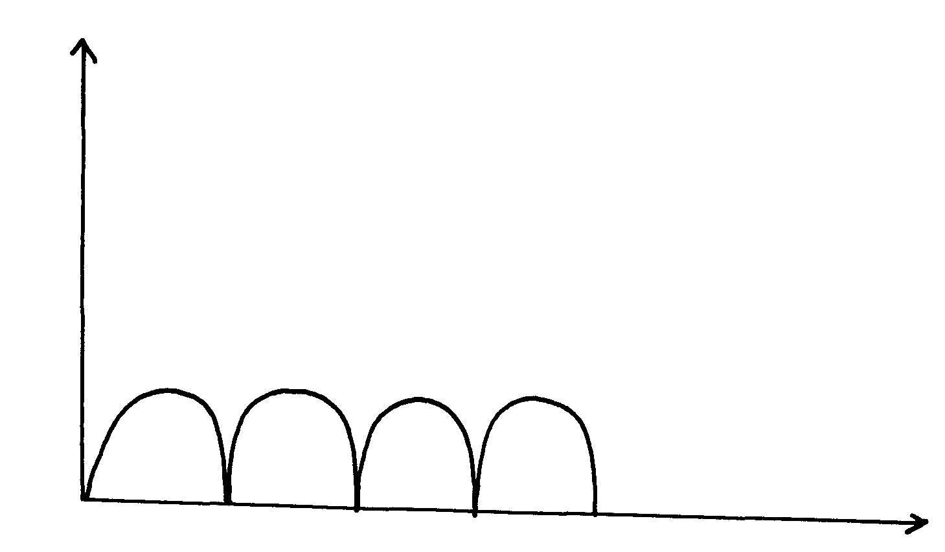
- A graph of L against h represents Boyle’s law √

- i) Increase in temperature causes gas molecules to move faster(increases in kinetic energy), √ hence they generate greater/ higher impulsive force on impact √
ii) With increase in volume gas molecules are sparsely spaced √ so the rate of collision is reduced/ lowered

Pressure
1. In the diagram below, the U-tube contains two liquids; X and Y which do not mix. If the density
of liquid Y is 900Kgm⁻³ and that of X is 1200Kgm⁻³, calculate the height of liquid Y
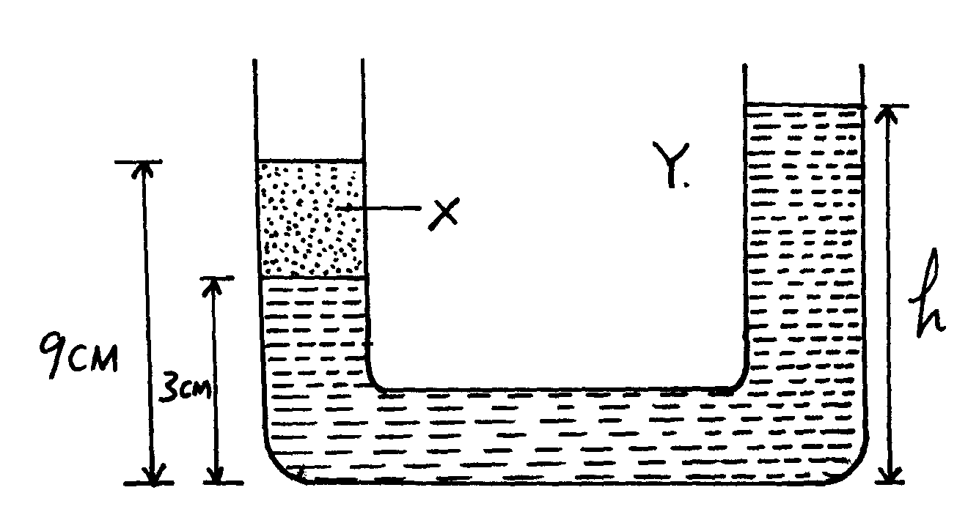

 1

