Eldoret east inter school examination
232
Physics
Paper 1
Theory

Section A
- The figure below shows Perspex container with a square base of side 5 cm carrying water to a height of 7cm.
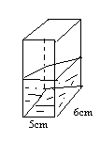

When pebble is immersed into the water, the level rise to 10 cm. what is the volume of the pebble? (2 marks)

- When smoke particles are observed through a microscope in a smoke cell which is illustrated form the side.
  - What observation are made?
………………………………………………………………………………………………………………………………………………………………
  - What change would be observed if the temperature of it smoke cell is increased? ( 1 mark)
……………………………………………………………………………………………………………………………………………………………………
- Estimate the of an oil molecule if a drop of oil volume 6 x 10 -9 m3 forms a patch of area 0.0755 m2 on a water surface. ( 2 marks)
- The figure below shows a uniform bar of length 1m. if the weight of the bar is 1N . Determine the distance x (2 marks)
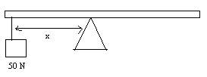

- A ball bearing is released from rest just below the surface of lubricating contained is a tall measuring cylinder.
  - State any one force acting on the ball bearing (1 mark)
…………………………………………………………………………………………………………………………………………………………………..
  - Sketch a velocity time graph for the motion briefly explain the nature of your graph. ( 2 marks)
- water flows through the horizontal pipe at the rate of 400 cm3/s . what is the speed of the water if the diameter of the pipe is 1.4 cm? ( 2 marks)
- a bullet of mass 0.8 g traveling at 400 m/s is stopped by a concrete wall. Calculate the amount of heat energy transferred to the wall. ( 2 marks)
- state two ways in which the stability of an object can be reduced . (2 marks)
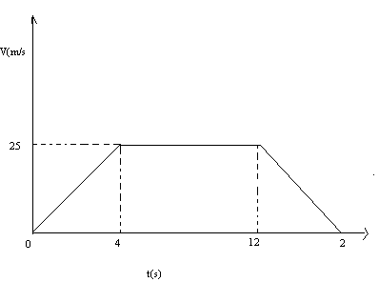
- the figure below shows a velocity time graph for a racing car.

Determine the total distance covered by a racing car?
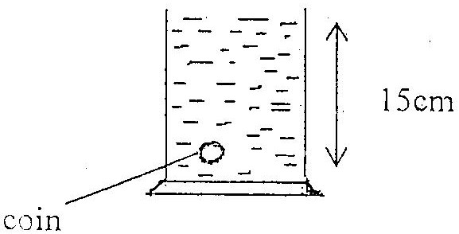
- the following diagram shows a beaker filed with petrol and ac oin placed in. determine the total pressure acting on the coin. ( Take : Atmospheric pressure is 1.03 x 10 5 pa, density of petrol = 800 kg/cm 3 acceleration due to gravity = 10 m/s 2) 3marks

- Explain how a submarine is made to float and sink in water ( 1 mark)
- The hydraulic machine below has an effective of 80%
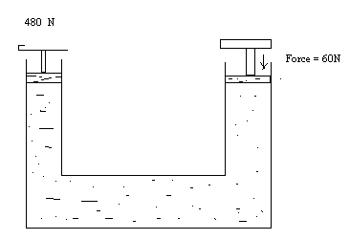
The machine is used to lift a load 480N using an effort of 60 N. Calculate the velocity ration of this machine ( 3marks)
- Describe how the vacuum flask is adapted to its function ( 2 marks)
- An electric heater rated 300 w heats some liquid of heat capacity 1680 J/K for 2 minites . find the rise in temperature . ( 3marks)
SECTION B ( 55 MARKS)
- a) Define work . state its S.I units ( 2 marks)
b) A crane lifts a load of 5000 kg through a vertical distance is 8 seconds
determine
- Work done by the crane ( 2 marks)
- Power developed by the crane ( 2 marks)
- Efficiency of the crane given that its operated by all electric motor rated 2.8 KW ( 2marks)
- State two effects which contribute to the efficiency being less than 100% ( 2 marks)
- a) State the law of conservation of linear momentum ( 1 mark)
b) A mini bus A of mass 2500 kg traveling at a speed of 40m/s collides head on with another mini bus B of mass 3500
- a) Define the absolute zero temperature ( 1 mark)
b) The following results were obtained in an experiement to investigate the relationship between pressure and temperature of a fixed mass of a gas.
Pressure in Kpa | 90 | 96 | 103 | 110 | 117 | 123
Temp in  ºC | 0 | 20 | 40 | 60 | 80 | 100
ABS. TEMPERATURE
1 mark
i) Plot a graph of pressure ( y-axis ) against absolute temperature (5marks)
ii) Describe using the graph the relationship between pressure and
temperature of the gas ( 1mark)
c) At the start of the journey , the temperature and pressure of inside a car
tyre were 17 0c and 300 K
i) Calculate the temperature during the journey 3 marks
ii) State assumption you have considered answering ( ii) a above ( 1 mark)

- a) State Archimedes principle .
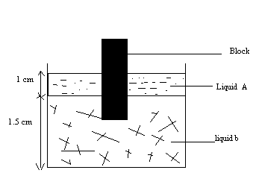
b) The figure belowshows a rectangular bolock of height 4cm floating vertically in abeaker containing two immiscible liquid A and B . rhe densities of the liquid are 8000 kg/m 3 and 12000 kg/m3 respectively.

The cross sectional area of the block is 2cm3
Determine
- The weight of the liquid A displaced by the block ( 2 marks)
- The weight of the liquid B displaced by the block ( 2 marks)
- The mass of the block ( 1 mark)
- The density of the block ( 1 mark)
c. A body weight 3,8 N in air and 2.8 N when fully immersed in water. Find the relative density of the body ( Density of water is g/cm 3) ( 3 marks)
d. State the special features of a hygrometer ( 2 marks)

- a) Distinguish between centripetal and centrifugal force ( 1 mark)
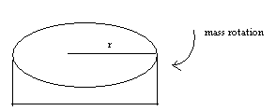
b) The figure shows a motor used by a student in the laboratory to investigate the variation of speed and force on a 10.0 kg mass kept at a fixed distance r from the centre of the rotation

The speed corresponding force were entered in the table as shown below.

V²(M/S²) | 0.2 | 0.4 | 0.8 | 1.4 | 2.2 | 3.0 | 3.4 | 3.6
F(N) | 0.6 | 1.2 | 2.4 | 4.08 | 6.48 | 8.90 | 10.0 | 10.7

On the grid provided , plot a graph of F (y- axis ) against v² ( 5 marks)
ii) calculate the slope of the graph ( 2 marks)
iii) Given that F = mv ² find the radius of the rotor ( 2 marks)
r
c. State two factors that affect the centripetal force on a body dencibly circular motion ( 2marks)
PHYSICS PAPER 2 (232/2)
- The figure below represents an object O place infront of a plane mirror M.
m
O
E

Fig. 1
Using rays, locate the position of the image as observed by the eye E. (2mks)

- Figure 2 shows an object O, in front of a convex mirror of focal length 4 cm and image, I obtained after reflection.
O
I
2 cm

Fig. 2
- On the same diagram draw appropriate rays to locate the centre of covertures, C
(2 mks)

- Hence or otherwise locate the other ray intersecting at head I.
(1 mk)

- Figure 3 below shows the propagation of a certain water wave in air.

510m

Fig. 3
Find the frequency of the wave (speed of wave in air = 340m/s)
(3 mks)

- A ray of light in incident on a glass oil interface as shown in figure 4. Determine the value of r.
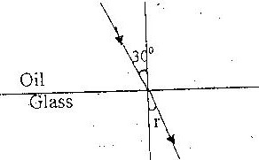

Take refractive index of glass and oil as 3/2 and 6/3 respectively.
(3mks)

- Figure 5 shows a circuit consisting of ideal diodes.
8Ω
D2
6Ω
D1
4Ω
20V

Determine the current flowing through the resistors
- Figure 6 shows an object place in front of a prism.

45⁰
45⁰

Using two rays show the image of the object as observed by an observer at E

- (a) Sketch the mode of vibration for a first overtone for air open pipe.

(b) Determine the frequency of the sound by the pipe in question 7 (a)

- Sketch a graph current against voltage for an electrolyte solution such as dilute sulphuric acid.

- Arrange the following radiations in order of increasing wavelength.
Radio waves, Gamma rays infrared and ultraviolet.

- The figure 7 shows a current – carrying conductor in a magnetic field direction of force on the wire is as shown by the arrow.
R
A
F

State the polarities of A and B.
A _________________________
B. _________________________

SECTION B (55 MARKS)

- (a) Define capacitance.

(b) Explain briefly how a dielectric material affects the capacitance of parallel plate capacitor

(c) A positively charged rod with appointed end is brought near a candle flame as shown. In figure 8.
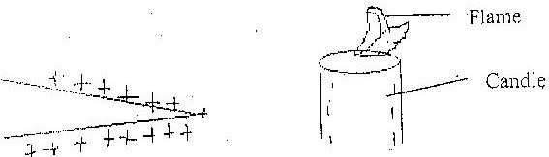

- State and explain the observation made.

- The rod is then brought very close to the flame. Use a diagram to explain what happen to the flame.

- The figure 9 below shows a part of a circuit containing two capacitors of 4 and f and 6 f respectively.

6µf
6µf
B
A

Determine the p.d across AB given that the total charge in the capacitors is 1.0x10.6c

- Figure 10 below shows an object in front of a lens.
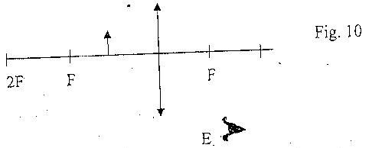

- Using rays locate the image of the object as seen by observer E.
- Give one application of such a lens as used above.
- Write three similarities between an eye and a camera

b) Figure 11 (a) and (b) show diagram the human eye
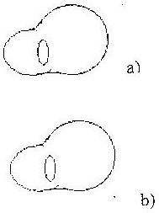

- In figure 11 (a) sketch array diagram showing long sightedness
- In figure 11 (b) sketch array diagram showing how a lens is used to correct the long sightedness.

c) A object of height 10.5cm stands before a diverging lens of focal length 20cm and a distance of 10cm from the lens. Determine.
i) Image distance
ii) Height of the image
iii) Magnification

- a) Give a reason why a fluorescent tube is preferred to a filament bulb for
domestic lighting
(b) What property does a fuse wire have that makes it suitable for controlling excessive current in circuit?

c) State two factors which affect heating in electric circuits.

d) An electric heater takes a current of 12.5A from 240V power supply.
i) Calculate
a) Its power rating.
b) Its resistance
e) State Faraday’s law of Electromagnectic induction.
- (a) In the circuit below figure 12, the e.m.f of the cell is 1.5V. its internal
resistance is r ohms. Resistors P and Q are 3.0. if 0.3A current flows through P. find the value or r.
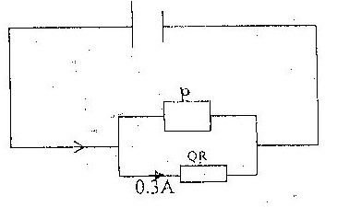

b) Fig 13 shows the circuit
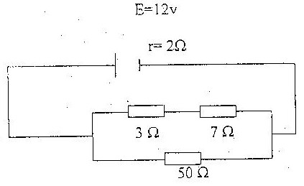

Calculate

c) i) The current draw from the cell.
ii) The “Lost voltage”, in the cell
iii) The potential different across the 7 resistor.

- (a) State the motor rule.

b) Sketch the resultant field pattern around the following current carrying conductors and show the direction of the forces acting on the conductor.
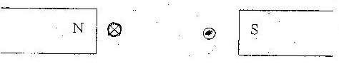

c) Explain briefly how a loud speaker can be used as a microphone.

PHYSIC PAPER 3 (232/3) PRACTICALS
- You are provided with the following
One dry cell an ammeter (0-2.5A) or (0-1)A, a voltmeter (0-3)V, 6 connecting wires each at least 50cm long and at least four with crocodile clips nichrome wire fixed on a metre rule, one cell holder, one switch and micrometer, screw gauge.

Proceed as follows
- i) Connect the circuit shown in the figure.
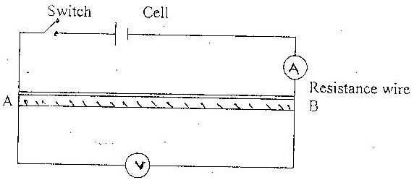

ii) Close the switch and used the current I and the p.d across AB,V.

iii) Calculate the resitance R of the wire using the values of V and J

iv) Measure the diameter of the wire using the micrometer screw gauge and
calculate its area of cross sections

v) Determine the quantity e given that R =

Part B
You are provided with the following apparatus:
- Two retors stands
- A metre rule
- Some cotton thread (approximately 1.2 long)
- A small bal of plasticine
- Stop watch or clock
- A protractor
- Half metre rule.

- i) Attach one end of a string to metre rule at 10cm by fastening a loop of
string lightly around the metre rule. Fix the string at this point with a small piece of plasticine. Tie the other end of the string around the metre rule at the 90cm mark. Fix this loop with another small piece of plasticine.

ii) Attach the pendulum bob to the centre of the string so that the centre of gravity of the bob is 15.0cm below point of suspension.
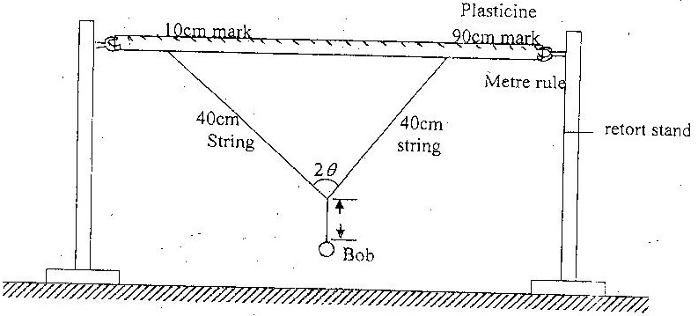

- i) Measure the angle 2
ii) Pull the pendulum towards you throuogh a small distance, release it and measure the period, T of the motion by timing 10 complete oscillations.

iii) Remove the plasticine, slide the loops to the 12cm and 88 cm marks RE fix the plasticine. Measure the angle 2 and period T as before.

iv) Reap (iii) above with the loops at 15cm and 85cm, 20cm and 80cm, 25cm and 75cm, 30cm and 70cm, 35cm, and 65cm marks

v) Enter all you results in the table below.
2θ
θ
Cos θ
Time for 10 oscilators (t) s
T (s)
T²(s²)

- i) Plot a graph of T² (y-axis) against cosθ

ii) Find the incerpt on the T² axis and the slope of your slope.
- i) Measure the length “n” of the pendulum when 2

using your graph, determine the period “T” of the pendulum when 2

using the formular T = 2∏√¹/_{g} determine the value “g” given T=2.0

- You are provided with the following:
- a candle
- a metre rule
- a white screen lebelled S
- a lens labeled L, mounted on a lens holder.
- Cross wires labeled O, mounted on a cardboard
- A match box
- Plasticine
Proceed as follows:
- Place a metre rule on a bench and hold it in position using plasticine

Arrange the screen S, the lens L, and the crosswire O, along the metre rule as shown in the figure below. The cross wires should be placed next ot the zero centimeter mark of the metre rule. The distance between O and L is the labeled u and the distance between L and S is labeled V.
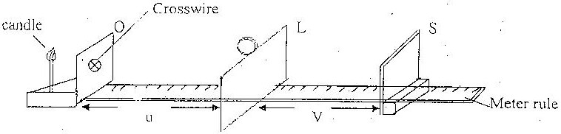

- Light the candle and palce it next to the cross-wires such tht the falme is at the same level with cross-wires and the crosswire coincide with the middle part of the flame. (White part).
- Adjust the position of the lens so that u = 15cm. now adjust the position of the screen S, until a sharply focused image of crosswire is obtained on the S. Record the values of V in the table.
- Repeat the procedures in c above for the values of u equal to 17,19,21,23,25,27 and 29cm. complete the table. (8mks)
U (cm | V (cm) | (U+V) cm
15
17
19
21
23
25
27
29

- On the grid provided plot a graph of (u+v)cm on the y-axis against v.

- From the graph determine the value of v and u+v for which the graph has a minimum value
- V minimum, Vm
- (u+v) minimum (u+v)m

- i) Calculate the values of the h1 and h2 from the equation below.
h₁ = ^{Vm}/₂

h₂ = ^{(U+V)m}/₂

ii) Determine h, the difference between h1 and h2
- Using the graph determine the value of v when u+v=39.8cm
V =

