**Name**:…………………………………………………ADM: ………………...… **CLASS:** ………………………

**INDEX NUMBER: ………………………………………………… CANDIDATES SIGNATURE: ……………..**

**DATE: ……………………………**

**232/3**

**PHYSICS**

**PRACTICAL**

**PAPER 3**

**JULY 2024**

**TIME: $2\frac{1}{2}$ HRS**

**MOKASA II ~ 2024 EXAMINATION.**

***Kenya Certificate of Secondary Education (K.C.S.E.)***

**INSTRUCTIONS TO CANDIDATES**

* *Write your name and index number in the spaces provided.*
* *Mathematical tables and non-programmable calculators may be used.*
* *This paper consists of* ***TWO*** *questions.*
* *Attempt all the questions in the spaces provided.*
* *ALL working MUST be clearly shown.*
* ***This paper consists of 8 printed pages. Candidates should check to ascertain that all pages are printed as indicated and that no questions are missing.***

**For Examiner’s Use:**

|  |  |  |
| --- | --- | --- |
| **QUESTIONS** | **MAXIMUM SCORE** | **CANDIDATE’S SCORE** |
| **1** | **20** |  |
| **2A** | **12** |  |
| **B** | **08** |  |
| **TOTAL** | **40** |  |

**QUESTION 1**

You are provided with the following apparatus:

* Rectangular glass block
* Two plain papers
* Four optical pins
* Four paper pins or thumb pins
* Protractor
* Half meter rule

**Proceed as follows;**

1. Place the glass block on the plain paper on its largest area, trace it’s outline and mark it’s sides **ABC** and **D**. Mark the point **P0** on the center of side **BC** as shown in **Figure 1** below.

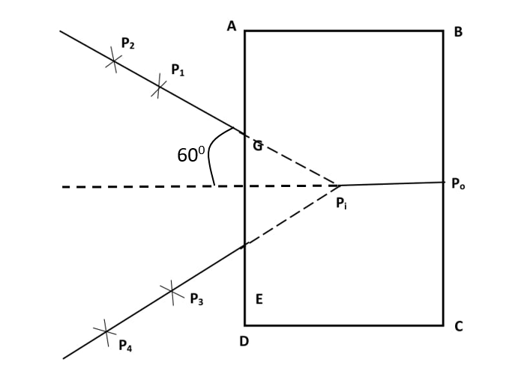

**Fig. 1**

1. Measure the breadth of the glass block. (1mark)

**b = ……………………… cm**

c)Replace the glass block and fix an object pin at **P0** such that the pin lies along the surface of the glass block.

d)With your eye on the side **AD** approximately 600 from the line through **PoP1**, fix pins **P1** and **P2** such that they are in line with the image **Pi** of **Po** as seen from the side **AD** through the glass block.

e) From the same side **AD** closer to **D**, fix pins **P3** and **P4** such that they are in line with the image **Pi** of **P0** seen through the glass block.

f) Remove the glass block and join **P1** and **P2**, and **P3** and **P4** to meet at **Pi**.

g) Join **P0** to **Pi** and measure length **P0Pi**

P0Pi =………………………………….. **m**  (1mark)

h)Determine the ratio; $\frac{b}{b-P_{o}P_{i}}=n$ (2marks)

**(Hand in the outline with the question paper.)** (1mark)

**Using another plain paper, proceed as follows;**

1. Trace the outline of the glass block again on the second plain paper and label it **ABCD** as shown in thefigure below.

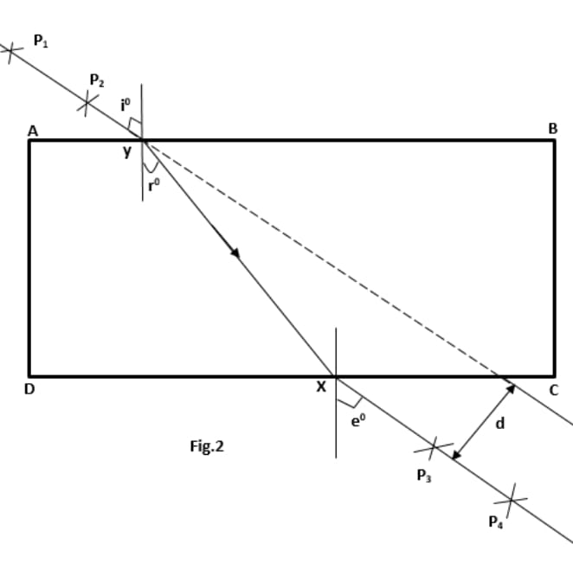

1. Construct a normal on the side **AB** approximately **3cm** from **A** and measure angle of incidence **i =350** (secure the plain paper using paper pins).
2. Replace the glass block on the outline and fix pins **P1** and **P2** along the line of **350**.
3. Viewing from the sides **CD** through the block, fix pins **P3** and **P4** such that they appear in line with the images of **P1** and **P2**.
4. Join **P3** and **P4** to **x** and join **x** and **y**.
5. Extend the line **P1** and **P2** to obtain lateral displacement as shown in the figure and measure the lateral displacement **d** and angle **r0.**
6. Tabulate your results in table 1 below.
7. Repeat the procedure in **(i)** to **(n)** for angles of incidence **400**,**450,500**, **550**,**600** and tabulate your results below.

**(Hand in the plain paper on which you have done your experiment together with the exam paper)** (1mark)

**Table 1** (6marks)

|  |  |  |  |  |  |
| --- | --- | --- | --- | --- | --- |
| $$i^{0}$$ | **35** | **40** | **50** | **55** | **60** |
| $$r^{0}$$ |  |  |  |  |  |
| **d (cm)** |  |  |  |  |  |

1. Plot a graph of **d(cm)** against $r^{0}$ (5marks)



1. From your graph:
2. Determine the value **r**0 where the lateral displacement **d** equals to the breadth **b** of the block.

**r0 =** ……………………………………………………… (1mark)

**ii)** Given that **k** sin **r**0=1, determine the value of **k.** (2marks)

**k = …………………………………..**

**QUESTION 2**

**PART A**

You are provided with the following

* + A spiral spring
  + A retort stand, boss and clamp
  + 3 masses each 100g
  + A stop watch
  + A vernier calipers

1. Measure the length and the diameter of the spiral spring provided using Vernier calipers.
   1. Length cm (1/2 mk)
   2. Diameter cm (1/2 mk)
2. (i) Attach the spiral spring on the stand and clamp as shown in the figure below:

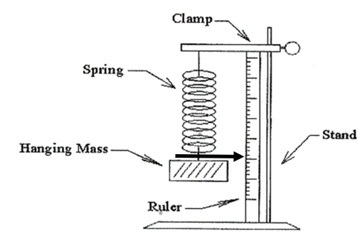

**Fig . 3**

(ii) Hang a **200g** mass at the lower end of the spiral spring and record the extension **e**

Extension **e** …………………… **cm**  ……………………………**m** (1mk)

Give the mass a small displacement downwards and then releases it so that it oscillates vertically. Using the stopwatch, time 20 oscillations and record.

Time for 20 oscillations =  **s** (1mk)

(iii) Calculate the periodic time, **T** for one oscillation

**T** =  **s** (1mk)

1. Repeat the same procedure using **300 g** mass as in the table below. Fill the table. (6mks)

**Table 2**

|  |  |  |  |  |  |
| --- | --- | --- | --- | --- | --- |
| Mass m(kg) | Extension **e**  (m) | Time for 20  Oscillations(s) | Periodic time  T (s) | T2(s2) |  |
| 0.2 |  |  |  |  |  |
| 0.3 |  |  |  |  |  |

1. Determine the value of $\frac{4π^{2}e}{T^{2}}$ and hence find its average value **g**

**g** = ……………………………………………. (2mks)

**PART B**

*You are provided with the following:*

* A voltmeter **(0-5V)**
* **Six** connecting wires
* A capacitor **220µF**
* **Two** dry cells size **D**
* Cell holder
* A stopwatch
* A switch

**Proceed as follows**

1. Connect the circuit as shown in the figure below.

**V**

**+**

**-**

Capacitor

**Fig. 4**

Make sure that the terminals of the capacitor and those of the battery are correctly connected.

1. Close the switch, read and record the maximum voltage Vo, across the capacitor.

**Vo**=............................................ **volts** (1mk)

1. While the voltmeter shows the maximum voltage Vo, open the switch, start the stop watch and record the time **t** it takes to reach the value of $\frac{V_{O}}{2}$.

**t** =………………………………… **s**  (1mk)

(d)Switch on the circuit for the voltmeter to read maximum **Vo .** Start the stopwatch while simultaneously switching off the circuit and record time it takes to reach **2.0V** and tabulate the results .

(e) Repeat for the other values of **V** in table 3 below.

**Table 3** (4mks)

|  |  |  |  |  |
| --- | --- | --- | --- | --- |
| Voltage (V) | 2.0 | 1.75 | 1.50 | 1.25 |
| Time ,t (s) |  |  |  |  |

(e) Determine the resistance **R** of the voltmeter given that **t= 0.693CR** where **C** is the capacitance of the capacitor and **t= time to drop from Vo to $\frac{V_{O}}{2}$** (2mks)

**R= …………………………………… Ω**

**THIS IS THE LAST PRINTED PAGE**